Kia Ora and Welcome to Enabling Good Lives Waikato.

In this pack is some information about Enabling Good Lives Waikato, we would be happy to talk this through with you.
If you would like to get to know other participants and families involved with the Enabling Good Lives demonstration please join our Facebook group called, “Enabling Good Lives Waikato.”

Our team look forward to getting to know you.

Kind regards,

Kelly Woolston,
Senior Connector/Tūhono,
Enabling Good Lives Waikato
07 957 1561 │kelly.woolston007@msd.govt.nz │029 201 2743

What is Enabling Good Lives Waikato?

Enabling Good Lives gives disabled people and their families/whānau more choice and control over their support.
Enabling Good Lives asks disabled people and their family and whānau to think about what a good life means for them.

Enabling Good Lives can help you decide what information and support could help you work towards your good life.

Funding will be pooled from the Ministries of Health and Social Development into one pot of money that the disabled person and their family/whānau will have control over.

Who can use Enabling Good Lives Waikato?
There are three action areas that participants of Enabling Good Lives Waikato can be a part of.

 | Disabled people who want to have more choice about where you live, who you live with and what you do during the day
 | Families who have a child with disability that is 0-17 years old
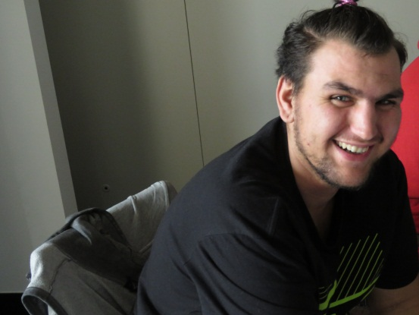 | Māori disabled people

You also need to be:

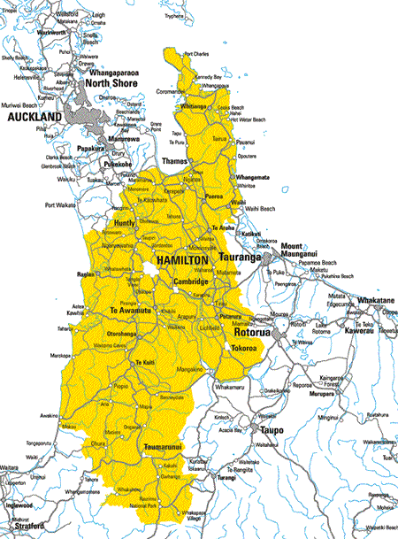 | Living in the Waikato
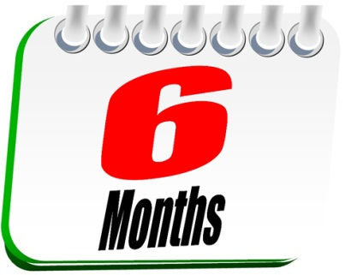 | A person with “a physical, intellectual or sensory disability which is likely to continue for at least six months and limits their ability to function independently, to the extent that on-going support is required”.
 | A New Zealand citizen or permanent resident.

What Enabling Good Lives can do for you.

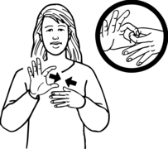 | First meet with a Connector/Tūhono.  This will be the person you will work with during the time you are using Enabling Good Lives.
You can choose to find out more

Then we will get to know you better

Working together will turn your ideas into action, by linking with people and opportunities.
You can do a self-assessment called ‘Understanding Me and My Life’

Talk about and agree to the money that the government will put towards supporting you.

You can manage your budget and supports or choose someone to assist you to put your ideas into action

Your Connector/Tūhono will continue to check in with you to see how you are doing
Getting ready for your first meeting with your Connector/Tūhono
The most important thing is to relax!
Some things you can think about if you want to are:
Do you want to bring someone to your meeting?
What is the best way for your Connector/Tūhono to work with you?
What supports you have at the moment?
- What do you like about these supports?
- What don’t you like about these supports?
How will you know if you have got what you wanted from being an Enabling Good Lives participant?

Evaluation
Enabling Good Lives is a new way of doing things.
We want to know how these new ways worked for disabled people and their whānau. Did it give you more choice and control?
We also want to know if you got what you wanted from Enabling Good Lives
To do this we need to listen to you. We want you to tell us about what Enabling Good Lives has been like for you.

Some people call this an evaluation.
When you meet with your Tūhono/Connector they will ask you if you are happy to talk to someone else.
Their job will be to ask you about what is working well and what could be better.

Enabling Good Lives Waikato Staff
Agnes Moke Marino is the first person you will talk to if you email or call at Enabling Good Lives Waikato. She is the Team Administrator.
Connectors/Tūhono are the people in the Enabling Good Lives team who work with participants. Connectors/Tūhono assist participants to think about where they’re at, make links and connections in the community, make their plan, understand their budget, and link with the information and support that they choose.
Kelly Woolston is the Senior Connector/Tūhono.
Paul Lawrence, Bella Martin, Maria Johnson, and Linda Brown are the Connector/Tūhono.
Kate Cosgriff is the Director; she manages Enabling Good Lives in the Waikato.
Andrew Carpenter is the Business Manager for Enabling Good Lives Waikato.

Principles
Enabling Good Lives works to put eight ideas into action.

Self-determination
Being the boss in your life.
Beginning Early
Supporting families and whānau as soon as possible after they find out that their child has a disability.
Person-centred
Supports are made to work with a disabled person when and how they want it.
Ordinary Life Outcomes
Disabled people are able to do the same things as other people their age are doing.
Mainstream First
Services that are for everyone are used before services that are just for disabled people.
Mana Enhancing
This is about respect.
Easy to use
Relationship building
Friends, families/whānau and other people that the disabled person knows are valued.

How to make a complaint

If you have a complaint about Enabling Good Lives Waikato we want you to tell us so we can do something about it.

You can express your complaint in any way you choose: in writing, by phone, in person, by e-mail, by video, in the language of your choice e.g. NZSL, by text, or through another person.

You can make a complaint to the EGL staff person directly, to the Senior Connector, Kelly, or the Interim Director Kate.

We will:
- treat your concern seriously
- respond to you straight away or within three working days of receiving your complaint
- if we cannot resolve your complaint within two weeks we will keep you informed about what we intend to do and how long it will take
- discuss the outcome with you
- welcome any support people you may wish to have involved
- respect your right to privacy and confidentiality throughout the process

If you remain dissatisfied
If you are unhappy with the response you are given or the complaint is taking too long to resolve you can go to the Director or the General Manager at the Ministry of Social Development and tell them about your concern.

You can also take your concerns to the Health and Disability Commissioner. They have advocates who can help you. These people are independent and provide a free service to people using health or disability support services. They help to resolve specific complaints.

What if I do not like something Enabling Good Lives Waikato or my connector has said or done?

You can do any step with the support person of your choice. If you think it is really serious then you can skip to any step you want to.

First talk to your Connector/Tūhono or the Enabling Good Lives team member and tell them what they have said or done that you do not like

Talk to the Senior Connector, Kelly Woolston

Talk to the Director, Kate Cosgriff

If you are still not happy you can talk to the General Manager
James Poskitt at the Ministry of Social Development

You can make a complaint to the Health and Disability Commission at www.hdc.org.nz/complaints

Contact Details for Complaints:

Senior Connector/Tūhono Kelly Woolston,
Text or phone: 029 201 2743
Kelly.Woolston007@msd.govt.nz

Director Kate Cosgriff
Phone: 07 9571587
Email: Kate.Cosgriff001@msd.govt.nz

General Manager James Poskitt at the Ministry of Social Development
Phone: 04 9163051
Email: James.Poskitt004@msd.govt.nz

You can also make a complaint to the Health and Disability Commission online at www.hdc.org.nz/complaints, on the phone by calling 0800 11 22 33, or by using the relay service.

