The Purchasing Approval Process  Ministry of Health Purchasing Guidelines | March 2018

This document explains the approval process to follow when disabled people and providers (on behalf of disabled people) buy disability supports (supports), using the Ministry of Health Purchasing Guidelines.

Using the Enabling Good Lives principles
Use the Enabling Good Lives Principles when thinking about how people buy supports.
- Self-determination: People have control over what supports they buy.
- Mana enhancing: The abilities and contributions of people and their families are recognised and respected when any support purchase is approved.
- Easy to use: Any process that governs how people access funding must be easy to use.

The approval process
1. A person (or their family/whānau or nominated agent) chooses how they want to be supported and what they want to purchase with government disability support services funding.
The person needs to think about how each purchase meets the Purchasing Guidelines before they make purchases. The person can use government disability support services funding to buy the support if they reasonably believe that the support meets the Purchasing Guidelines.
2. If the person is unsure whether a support meets the Purchasing Guidelines, they (or their provider, Independent Facilitator or funding manager acting on their behalf) can get advice from a purchasing advisor.
3. If, after getting advice from a purchasing advisor, it is still unclear whether the support meets the Purchasing Guidelines, then the purchasing advisor sends a purchasing proposal to the purchasing review panel. Send all purchasing proposals in writing.
4. Always refer to a purchasing review panel if the purchase is:
a. a good (not service) with a total value of $5,000 or more
b. a contribution towards a vehicle.
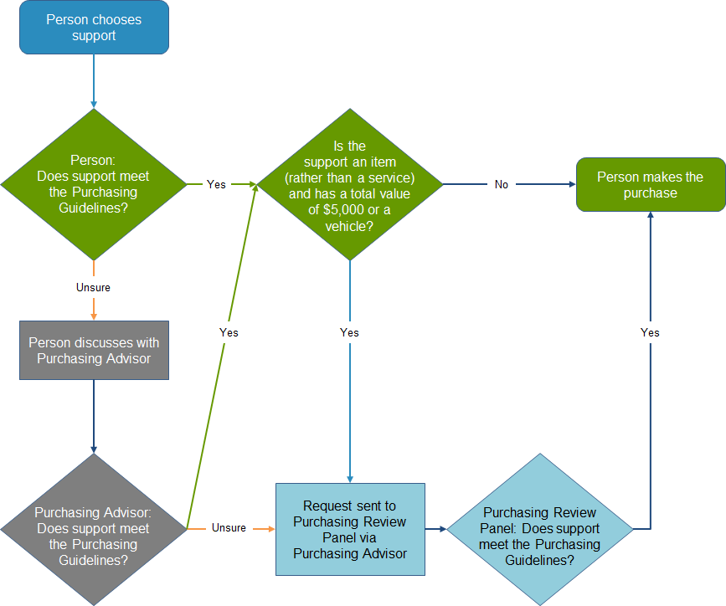

Roles for decision-making and approval
Table 1: Parties involved in decision-making and approval processes
Person | The disabled person with a disability support budget allocation. The person may also be represented by their family/whānau or a nominated agent, at the person’s request.
Family/whānau | Those most closely involved in assisting the person with care and decision-making.
Nominated agent | An individual (chosen by the person) who is most closely involved in helping the person with their care and decision making and is able to make decisions on behalf of the person that relate to managing the person’s supports. This individual will be identified through the assessment process.
Provider | An organisation who offers services to help a person with a disability. This may include Flexible Disability Supports provider, Host provider or Choice in Community Living provider.
Independent Facilitator | A person who helps people to think about and plan for their lives and how to make this happen, including natural supports and involvement from the community. This term includes Local Area Coordinators (LACs) and Navigators, Connectors or Tūhono.
Funding manager | The organisation or individual who allocates funding, such as a Needs Assessment and Service Coordination (NASC) organisation.
Funder | The Ministry of Health (or the combined government departments responsible for the funding that is provided to the person).
Purchasing advisor | An appointed representative of the funder who has experience and knowledge of what supports are available in the community and can provide advice to providers, funding , managers (eg, NASC) or the person (or their family/whānau or nominated agent).
Purchasing review panel | The panel containing representatives of the disability community and the Ministry of Health.

The person
The person is responsible for considering how all supports that they buy meet the Purchasing Guidelines. They are responsible for getting advice where they are unsure whether a proposed support meets the Purchasing Guidelines.
The person may be supported by their family/whānau or a nominated agent who may make decisions about the use of funding on the person’s behalf.
The person may be asked to explain how a support meets the Purchasing Guidelines when their use of funding is reviewed.

Provider
The person (or their family/whānau or nominated agent) may engage a provider to help them administer or manage their funding. The provider can support the person with making decisions on how they plan to use their funding.
Depending on the situation, the provider may be a Flexible Disability Supports provider, Host provider or Choice in Community Living provider.
Where the person gets advice from a provider, that provider is responsible for helping the person access advice from a purchasing advisor or approval from the purchasing review panel.

Independent Facilitator, funding manager
The person (or their family/whānau or nominated agent) may discuss proposed supports with an Independent Facilitator or their funding manager.
Where the person seeks advice from an Independent Facilitator or Funding Manager, that Independent Facilitator or Funding Manager can access advice from a Purchasing Advisor.

Purchasing advisor
A purchasing advisor represents the funder. A purchasing advisor has experience and knowledge of what supports are available in the community and can provide advice to the person (or the other party asking for advice on behalf of the person).
The purchasing advisor is also responsible for presenting proposed supports to a purchasing review panel and communicating purchasing decisions to the person (and their provider).

Purchasing review panel
A purchasing review panel meeting is convened (when necessary) to determine if a proposed support meets the Purchasing Guidelines. At least half the membership of the purchasing review panel must be from the disability community.
The purchasing review panel is responsible for giving advice to people who are making support purchasing decisions and for publishing any decisions they make.
The purchasing review panel’s terms of reference is developed by each specific purchasing review panel.

Disputes
Disputes may arise when:
- the person (or their family/whānau or nominated agent) does not agree with the advice given by a purchasing advisor or provider
- an organisation who is reviewing the person’s use of funding does not believe that the purchase fits the Purchasing Guidelines
- the person (or their family/whānau or nominated agent) does not agree with a decision made by the purchasing review panel.

Send disputes to a purchasing advisor in the first instance. From there, if necessary, they can be referred to the purchasing review panel.

The purchasing review panel will review all appeals of purchasing review panel decisions.

A purchasing review panel decision can only be appealed against if the person (or their family/whānau or nominated agent) can supply information that was not originally considered by the purchasing review panel.

Send any new information that supports an appeal to the purchasing review panel within two weeks of the person (or their family/whānau or nominated agent) being notified of the original decision.

HP 6801

A disability support is a good or a service that helps a person overcome barriers related to having an impairment within a disabling society.
Organisations who might review a person’s use of funding include Funding Managers and Ministry of Health officials.

