A new disability support system for New Zealand
January 2018 update

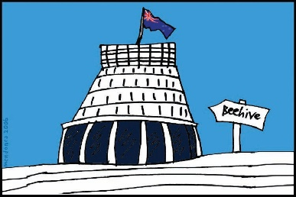
The Government of New Zealand is making big changes to the disability support system.

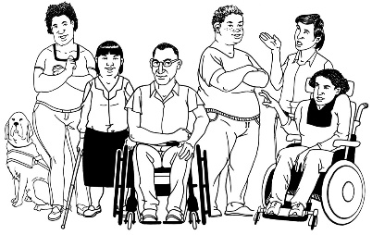
The Government has been planning the changes to the disability support system together with:
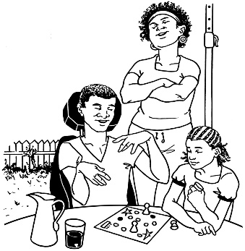
- disabled people

- family / whānau
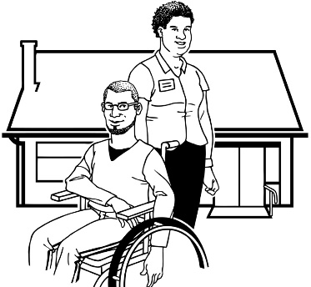
- disability support services.

Working together like this is called co-design.

This is an update to let you know what:

- has been happening

- is going to happen next.

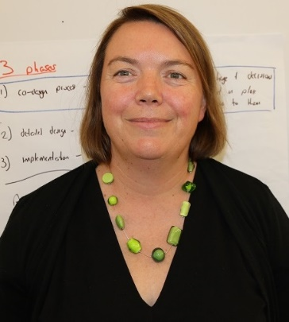

This update is from Sacha O’Dea from the Ministry of Health.

Sacha is working with the disability community on this work.

Happy New Year
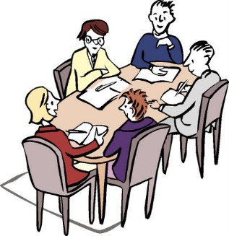
Last year we were all working very hard right up until Christmas!

We met with Minister Julie Anne Genter.

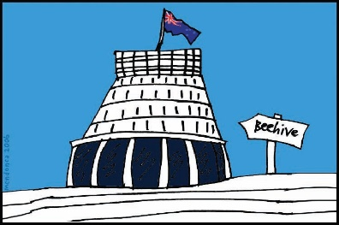
She is 1 of the new Ministers who will be working on Health and Disability in the new Government.

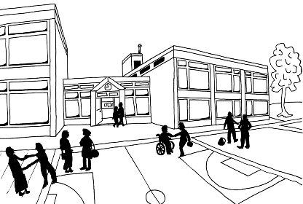
We also had the last workshop of the year that was looking at how the education system and the new disability support system will work together.

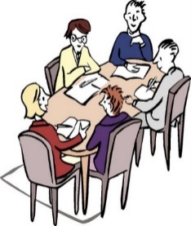
Then we had a good break!

This year is going to be a big year for the plans around making the new disability support system.

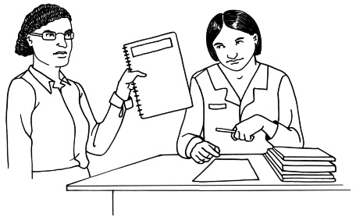
The main thing we are going to be working on is a paper for Cabinet.

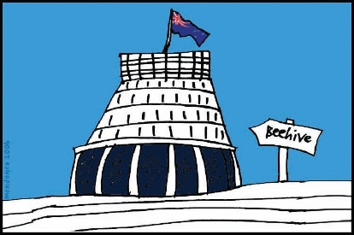
Cabinet is a group of senior Government Ministers.

We will be working on the paper together with:

- Minister Julie Anne Genter
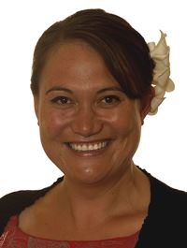

- Minister for Disability Issues Carmel Sepuloni.

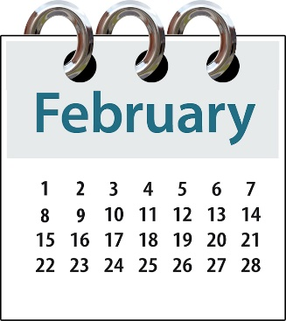
We were hoping the paper would be ready to go to Cabinet in February.

It is not ready yet.
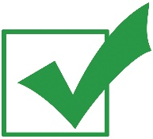
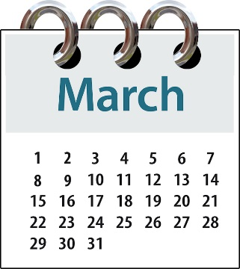

We want it to be ready to go to Cabinet in March.

What other things are we working on?

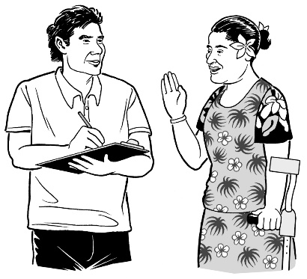
We are getting feedback from people around New Zealand on the plans for the new system.

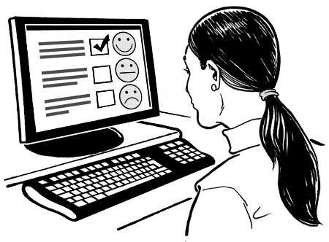
We are hoping to do more virtual testing.

People on virtual testing groups use online tools to see if the new disability support system will work well.

Online tools are things like email and Facebook.

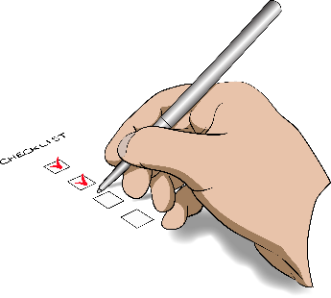
These are the things we are about to do virtual testing for:
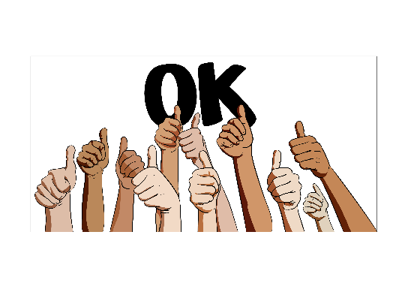
- how the new disability support system will work together with other parts of the Government

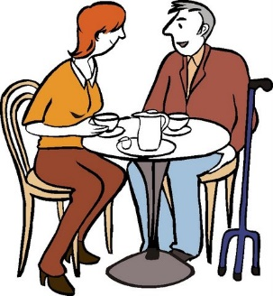
- how to support disabled people to have better links with people in the community

- safeguarding adults

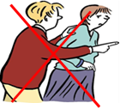
Safeguarding adults means things that need to be done to:

  - stop abuse from happening in the first place
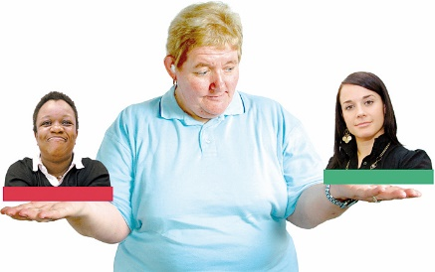
  - protect your rights to:

    - make your own choices about your life
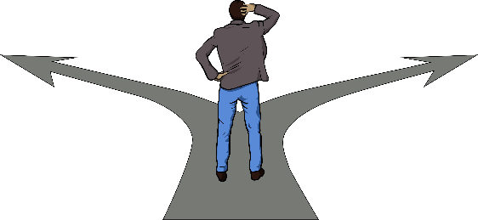
    - be in control of your own life

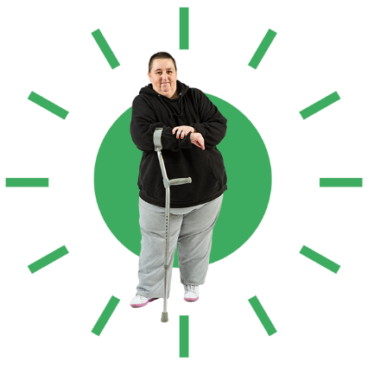
    - be safe

    - feel safe

    - be part of your community

    - be treated with respect.

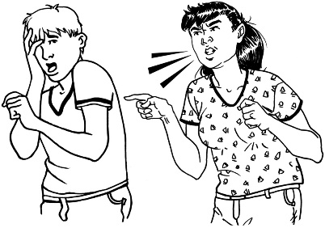
Safeguarding adults also means that when abuse has happened to disabled people they:
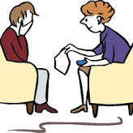
- have the support they need and want

- are treated equal to non-disabled people

- can get justice just like non-disabled people.
We are also going to have more workshops on:

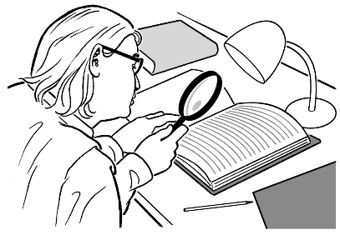
- checking to make sure the new disability support system is working well

- funding

Funding means the money the Government gives for disabled people to be able to get the support and the things they need for their disability.

What next?

Thank you to all of the people who have been part of the virtual testing groups so far.

If you want to take part in the virtual testing groups you can still email us on:
STfeedback@moh.govt.nz

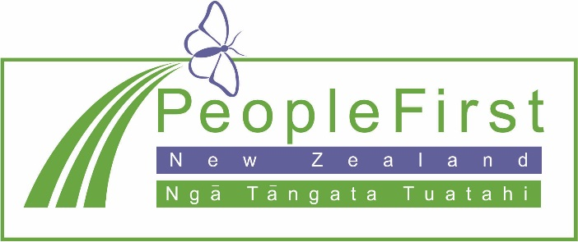

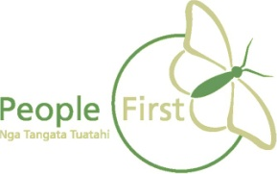
This information has been translated into Easy Read
by People First New Zealand Inc. Ngā Tāngata Tuatahi
