A new disability support system for New Zealand
November 2017 update

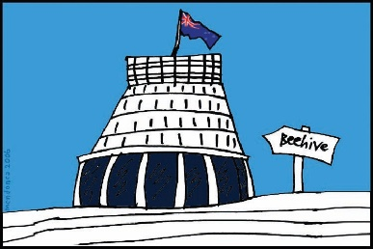
The Government of New Zealand is making big changes to the disability support system.

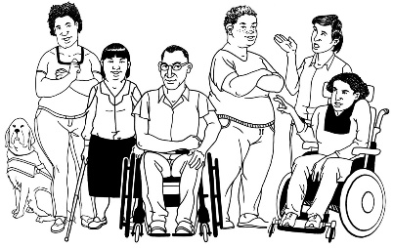
The Government has been planning the changes to the disability support system together with:
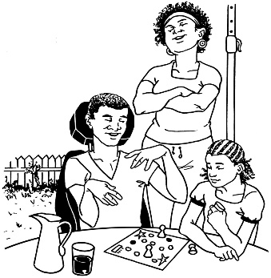
- disabled people

- family / whānau
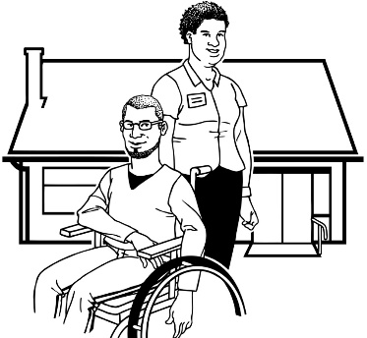
- disability support services.

This is an update to let you know what:

- has been happening

- is going to happen next.

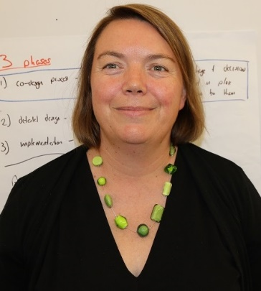

This update is from Sacha O’Dea from the Ministry of Health.

Sacha is working with the disability community on this work.

Working groups – what has been happening?

Over the last month we have been very busy with working groups.

People on working groups get together in meetings to see if the new disability support system will work well.

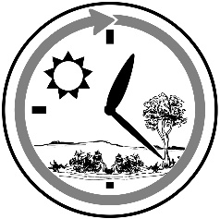
We have had working group meetings almost every day!

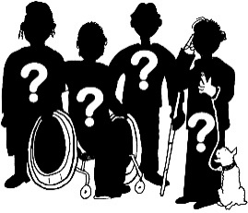
In the working groups there are:
- disabled people
- family / whānau
- people who work in disability support services
- people from the Government.
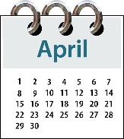
In the last month many of the working groups have been working on the changes that will be tried in the MidCentral area in April 2018.

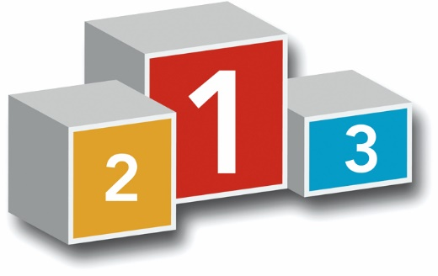
People who live in the MidCentral area will be the first to try the new disability support system out.

The working groups have been looking at questions like:
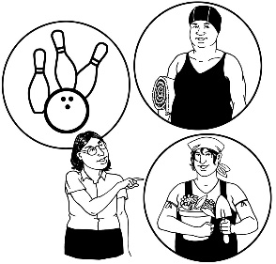
- How will people use the new disability support system?

- Where will people be able to find out information in the new disability support system?

Some more questions the working groups have been looking at are:

- How will we make sure the new disability support system can change if it needs to be made better?

- How can we make sure that the new disability system safeguards disabled people?

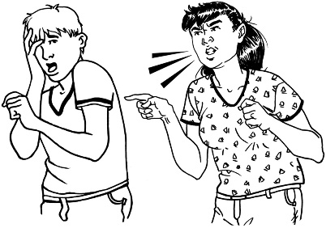
Safeguarding means making sure that disabled people can make their own choices in a way that keeps them safe from abuse

What is going to happen next?

Over the next months we will be looking at:
- starting more working groups

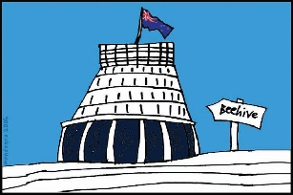
- how all of Government can work with the new disability support system

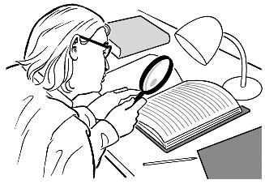
- how we can check to see if the new disability support system is working well or not

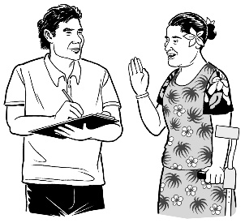
- how we can make sure all disabled people can let us know what they think about the new disability support system.

Some of the working groups will not start until 2018.

The reason for this is that we have so many working groups!

We are setting up virtual testing groups.

People on virtual testing groups will use online tools to see if the new disability support system will work well.

Some of the virtual testing groups are starting soon.

Who will be in charge of the new disability support system?

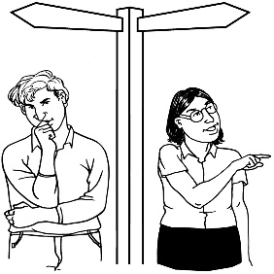
As I go around New Zealand people are asking me questions like who will be in charge of the new disability support system?

The Ministry of Health is in charge of the disability system we have now.

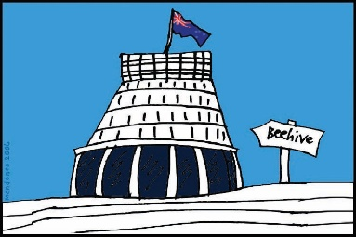
The Ministry of Health is part of the New Zealand Government.

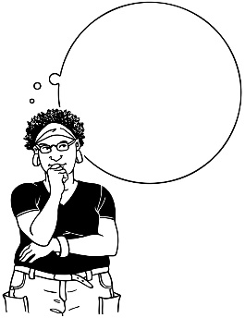
We are still thinking about if the Ministry of Health is the best agency to be in charge of the disability support system.
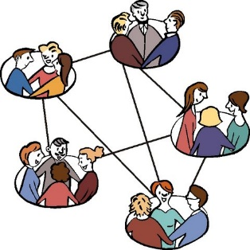
We also have 16 NASCs in New Zealand.

NASC means Needs Assessment and Service Coordination.

NASCs are places that decide how much funding people get for their disability needs.

People around New Zealand are asking if this will change in the new disability support system.

We cannot say yes or no to this question right now as we do not know what things will be like.
We have heard what many people around New Zealand think should change for the new disability support system.

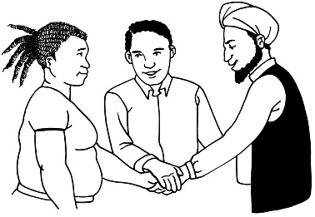
It is very important that all the parts of the new disability support system work well together.

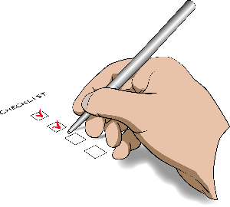
As you can see we still have a lot of:
- questions
and
- answers to work out.

I think it may take us 1 more year to have answers for these questions.

We will not have all of the answers before the new system starts up in the MidCentral area.

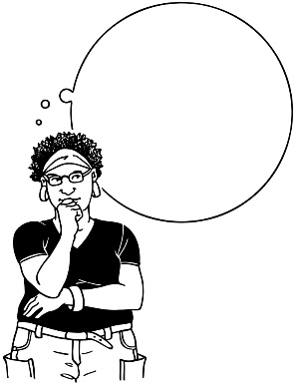
We will be trying out new ways of doing things in the MidCentral area to see what works best.

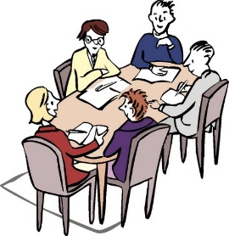
We also need to talk to Cabinet and the new Government about our plans.

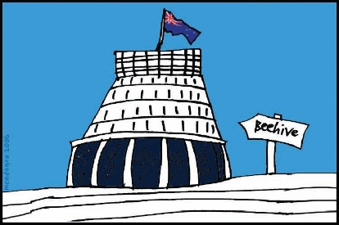
Cabinet is a group of senior Government Ministers.

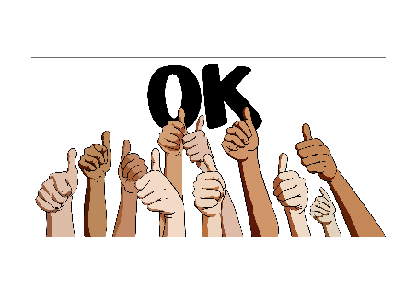
I hope this update will help to explain why we have not got all the answers for you yet about the new disability support system.

I want to thank:
- everyone who has been part of the work so far

- everyone who is going to take part in the working groups and virtual testing groups.

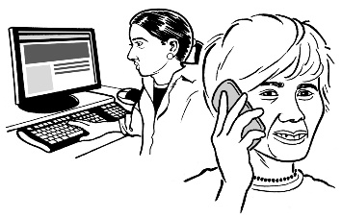
I will be in touch with those people as soon as I can.

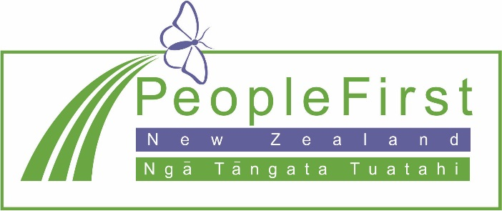

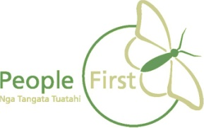
This information has been translated into Easy Read
by People First New Zealand Inc. Ngā Tāngata Tuatahi
