‘System Transformation co-design process’
Easy Read key points from the
4th May 2017 workshop:

What is this about?

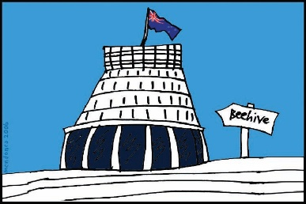
The Government of New Zealand is looking at making big changes to the disability support system.

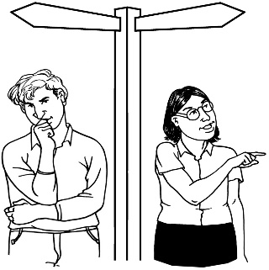
The long name for this is system transformation.

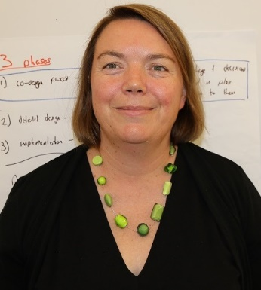
Sacha O’Dea from the Ministry of Health is leading this work.

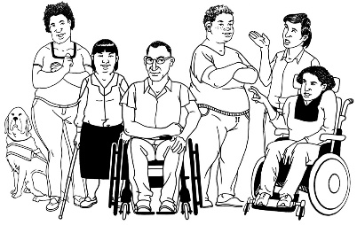
The Government has said it will plan the changes to the disability support system together with:
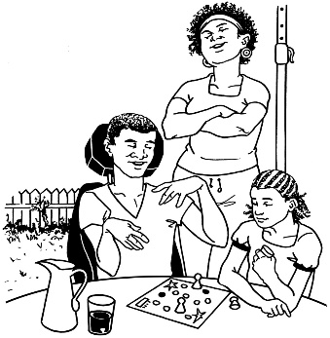
- disabled people

- family / whānau
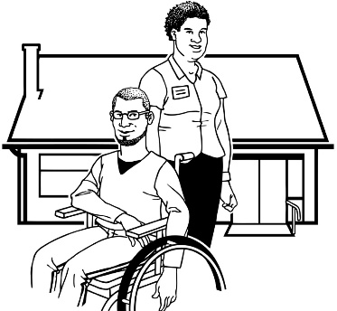
- disability support services.

Working together like this is called co-design.
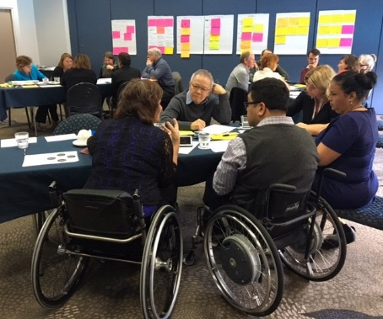

A co-design group has been put together.

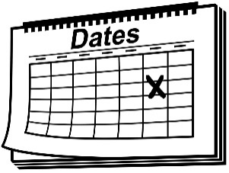
The co-design group will work together over 9 workshops.
9

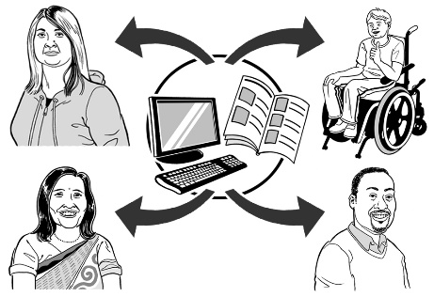
The key points of every workshop will be sent out so the rest of New Zealand can see what is being talked about.

4 May 2017
The third co-design workshop was on 4 May 2017.

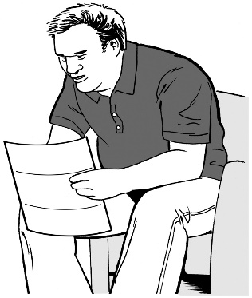
Keep reading to find the key points from that workshop.

Key point 1

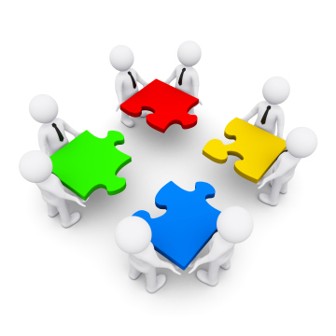
A document has been made that will help the co-design group to work:
- together

- with other groups.

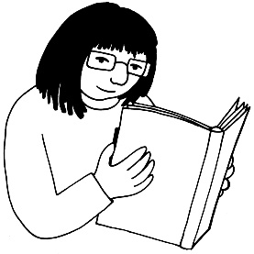
This document is called a Terms of Reference.

The co-design group looked at the document.

Some changes will be made to it.

Key point 2

The co-design group talked about:
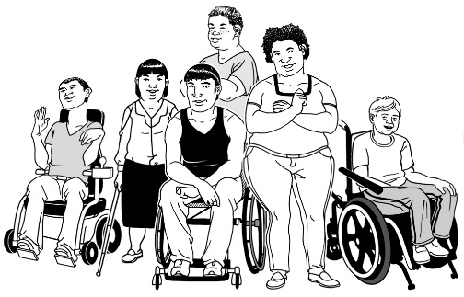
- who will use the new disability system

- how disabled people are not all the same.

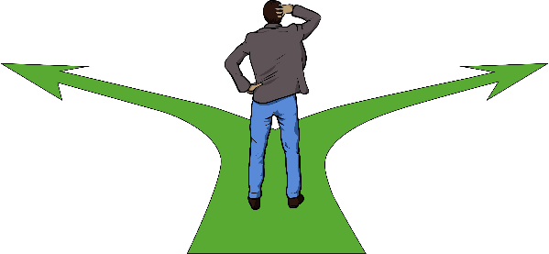
Some disabled people and their families / whānau do not know how to:
- speak up for what they need

- push for what the life they want.

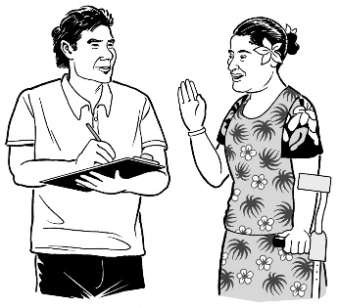
Other disabled people and their families / whānau know how to do these things.

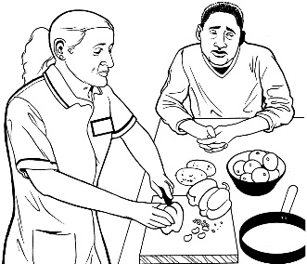
Some families / whānau and support workers worry that if disabled people take risks things may not always go well.
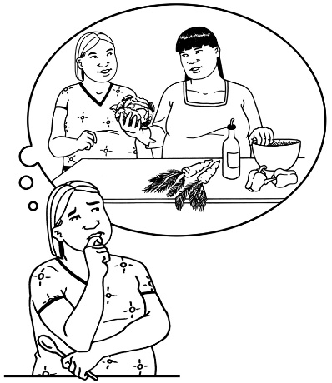

Taking risks means trying something new even if you do not know if it will work out well.

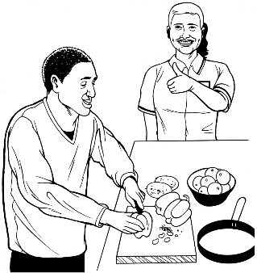
Other families / whānau and support workers support disabled people to:
- take risks

- make their own choices.

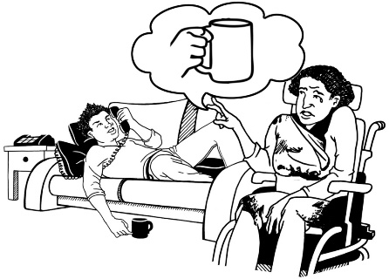
Some disabled people and their families / whānau do not trust or want to use the disability support system.

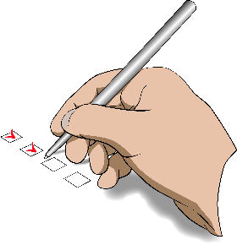
There could be many reasons for this.

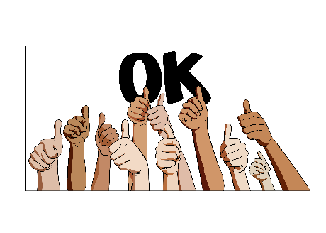
Other disabled people and their families / whānau trust the disability support system and the people who work in it.
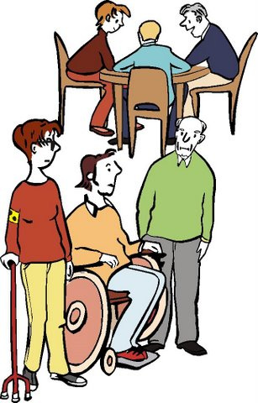

Some disabled people do not feel like they belong to any group, like the disability community.

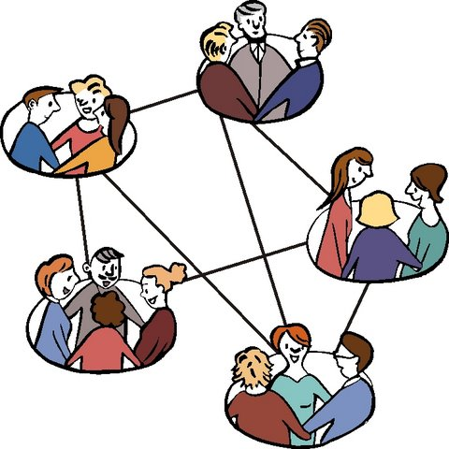
Other disabled people do feel like they are part of a group or groups.

Some people feel welcome in groups like the disability community.

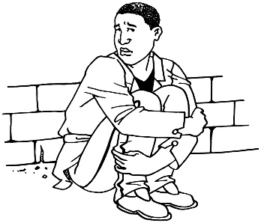
Some disabled people and their families / whānau do not have many friends or family in their lives.

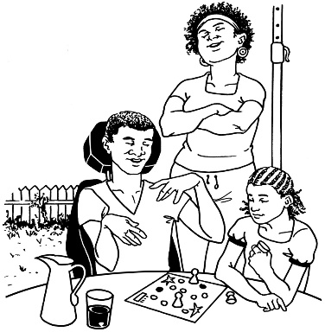
Other disabled people and their families / whānau do have friends or family in their lives.

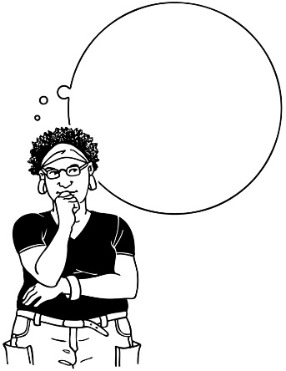
Sometimes other people can tell if a person has a disability.

Sometimes people cannot tell if a person has a disability.

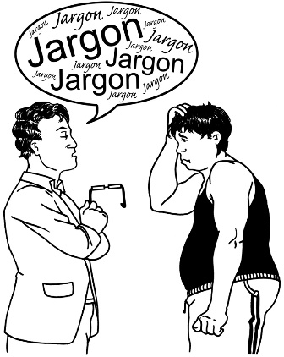
If people cannot tell you have a disability you may find it harder to get the support you need.
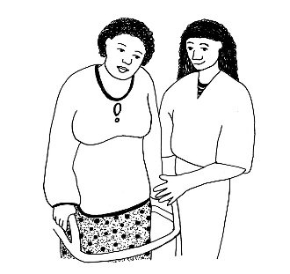
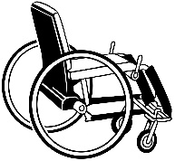
Some disabled people have support or equipment needs that change a lot.

Support needs might be things like:
- support to get ready in the mornings

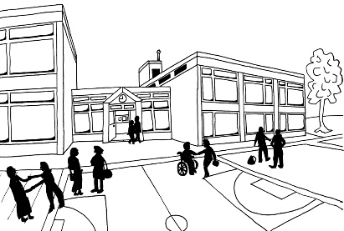
- support to get and keep a job

- support to learn at school.

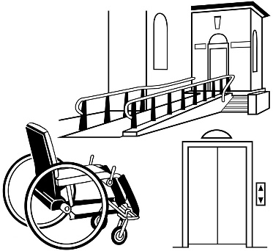
Equipment needs might be things like:
- a cane

- a wheelchair

- a computer that writes down what you say.
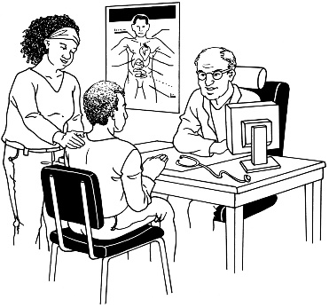
Sometimes the disability that people have can change.

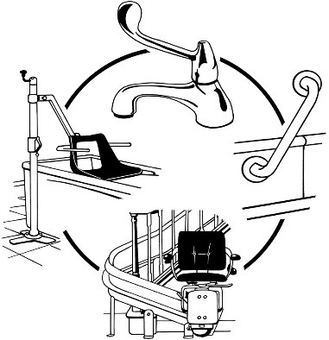
This may mean that at some times in people’s lives they need:
- more support and equipment

- less support and equipment

- different support and equipment to what they used before.

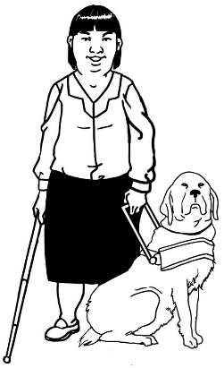
Some disabled people have support or equipment needs that do not change very much.

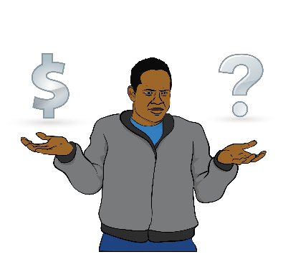
Some disabled people do not have much money.

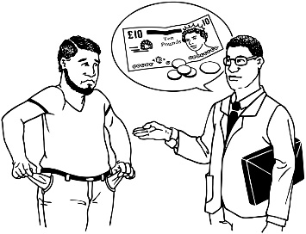
This can make it hard for people to have a good life.

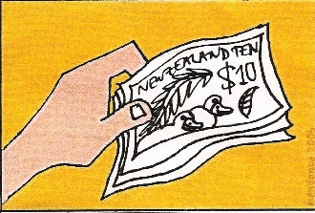
Other disabled people have the money they need to do the things they want.

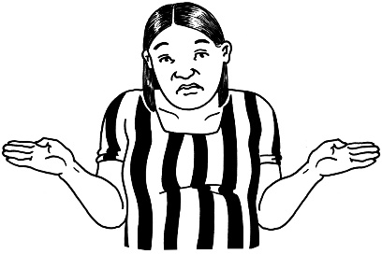
Some disabled people do not have or know how to use technology.

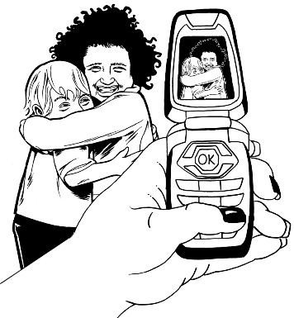
Technology means things like:
- mobile phones

- computers.
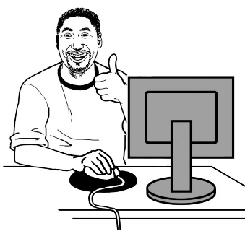
Other disabled people do have technology and know how to use it.

Key point 3

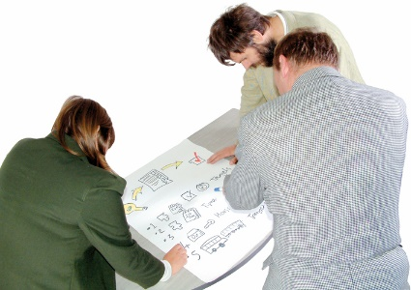
The co-design group did some mapping.

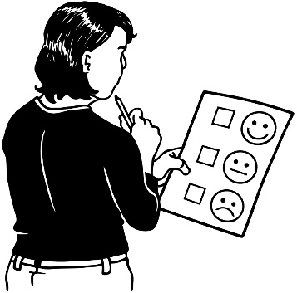
This is where you look at what the new disability support system would be like for:
- different groups of people

- people with all kinds of disabilities.

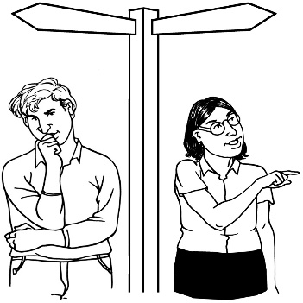
The co-design group also talked about what parts of the disability support system need to change to make it better for people.

Key point 4

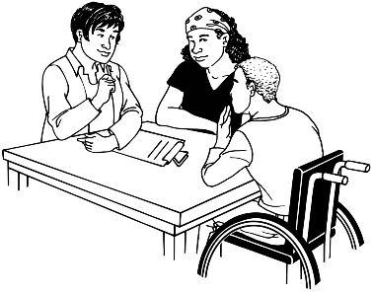
We have got the stories of some of the people in the co-design group.

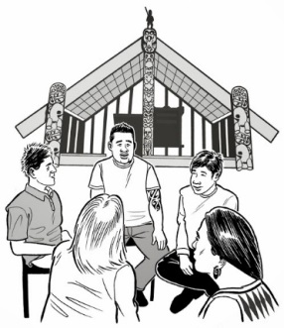
We have got the stories of:
- 5 disabled people

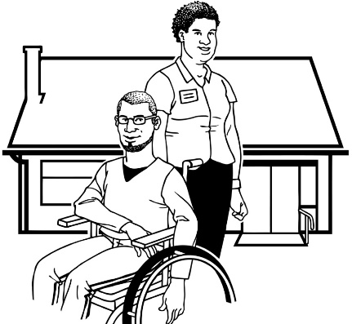
- 2 people from family / whānau groups

- 2 people from Disability Service organisations.

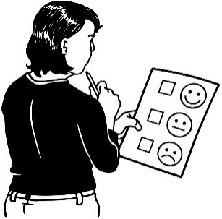
We asked them about:
- their lives

- what has happened to them in the disability support system we have now – both good and bad things.

We have given these stories to some people who work for Thinkplace – a design company.
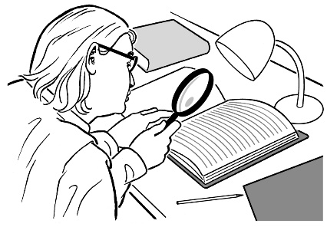

Thinkplace will look at the stories.

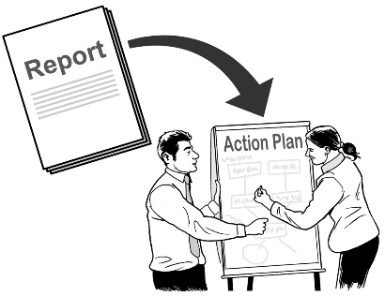
Thinkplace will send the main points from the stories back to the co-design group.

What now?

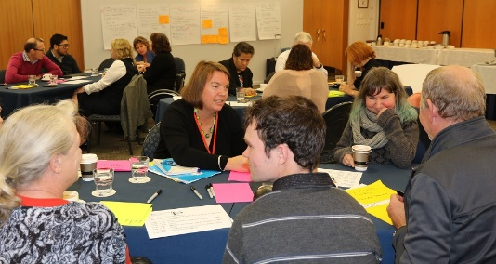
At the last workshop the co-design group made a list of things they will need to think about when they are doing the work, like:
- what we have learned in the past
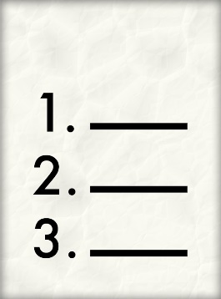
- the things we know

- research that has been done.

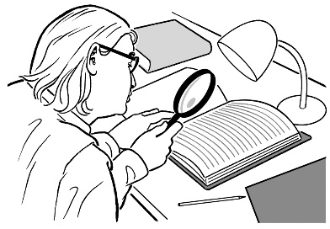
Research is:
- looking to find an answer to a question you have

- trying to find out how to do things better.

Before the next workshop we will look at this list and write down:
- what we need to do in the new system
- what we must not do in the new system.

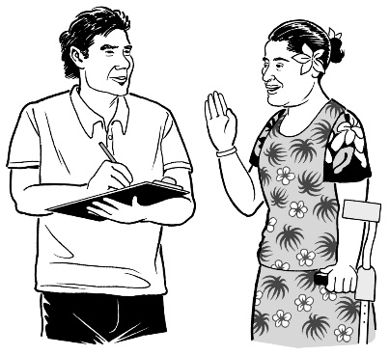
Another thing the co-design group needs to do before the next workshop is have a big think about what the disability support system is like for Māori and Pasifika disabled people.

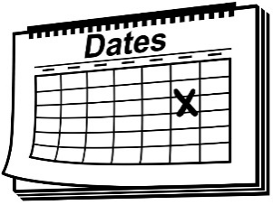
This is very important.

The next workshop will be on 11 May 2017.

Talk to us
?

You can talk to us if you:
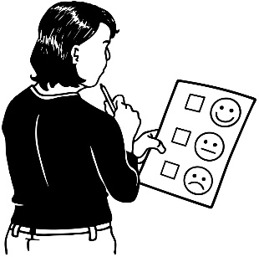
- have any questions

- want to tell us what you think about the work that is being done
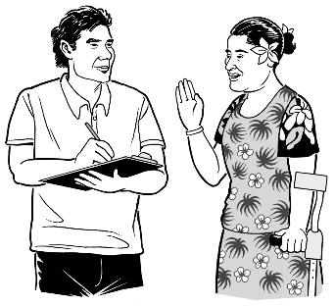
- want to tell us an idea.

Our email address is:
STfeedback@moh.govt.nz

Thank you,
Sacha O’Dea

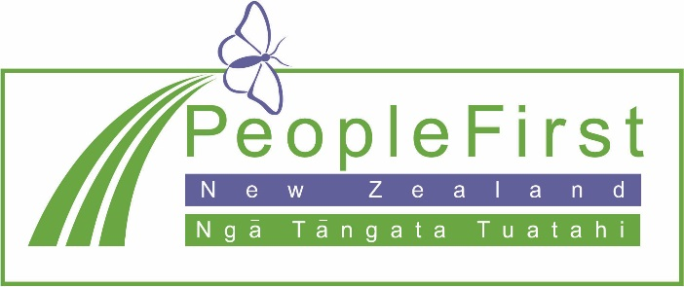

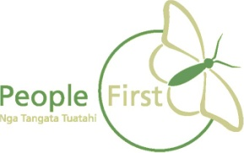
This information has been translated into Easy Read
by People First New Zealand Inc. Ngā Tāngata Tuatahi
