‘System Transformation co-design process’
Easy Read key points from the
16 and 17 May 2017 workshop:

What is this about?

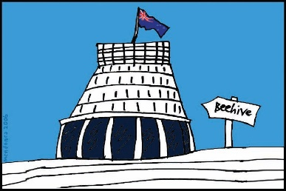
The Government of New Zealand is looking at making big changes to the disability support system.

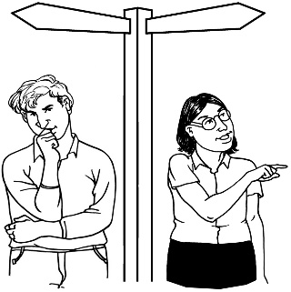
The long name for this is system transformation.

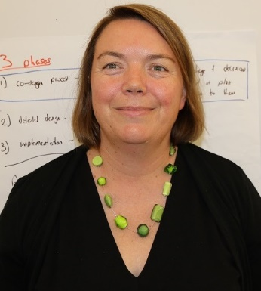
Sacha O’Dea from the Ministry of Health is leading this work.

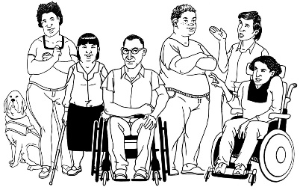
The Government has said it will plan the changes to the disability support system together with:
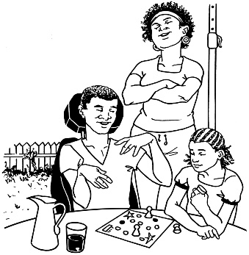
- disabled people

- family / whānau
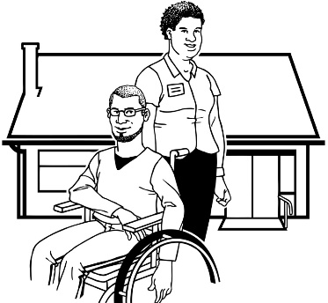
- disability support services.

Working together like this is called co-design.
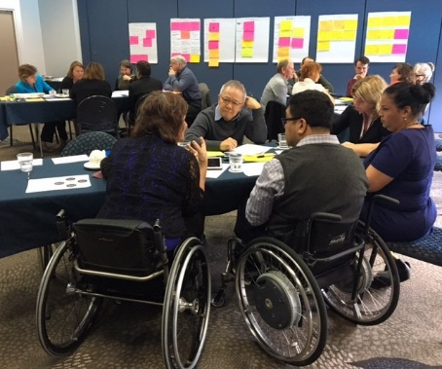

A co-design group has been put together.

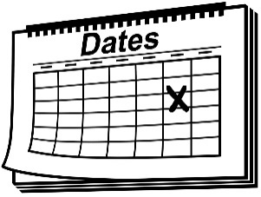
The co-design group will work together over 9 workshops.
9

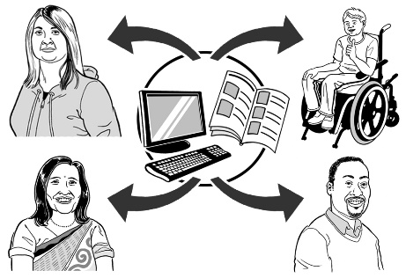
The key points of every workshop will be sent out so the rest of New Zealand can see what is being talked about.

16 - 17 May 2017
The 5th co-design workshop was on 16 and 17 May 2017.

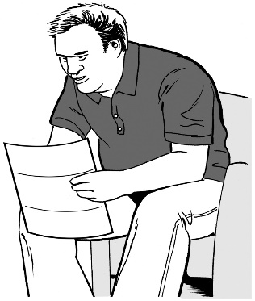
Keep reading to find the key points from that workshop.

Key point 1

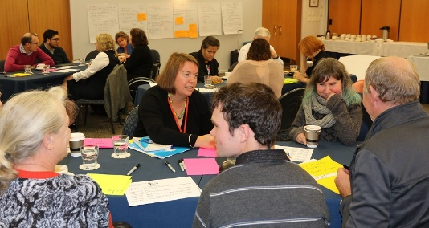
The co-design group met for 2 days this time.

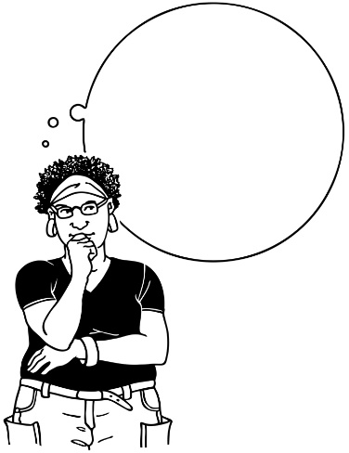
The group had to:

- work very hard

- keep in mind how a new disability system will affect disabled people and their families / whānau
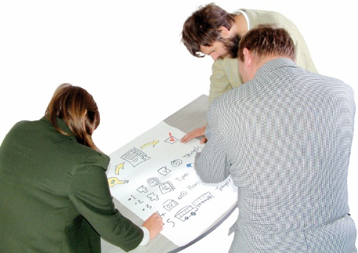
- think about new ideas or ways of doing things

- get the new ideas down on paper.

Key point 2
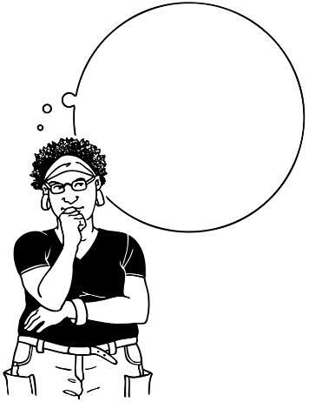

At the workshop the co-design group talked more about what a really good disability support system would be like for different people.

We want to make sure the disability system is easy to use.

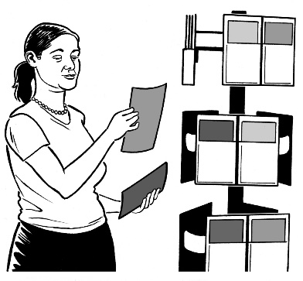
We also want to make sure that it is easy for people to get information in the new system.

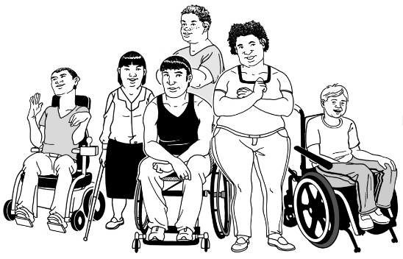
The co-design group talked more about how not every disabled person is the same or needs the same things.
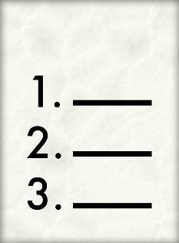
We have a list of the ways that people can be different from each other.

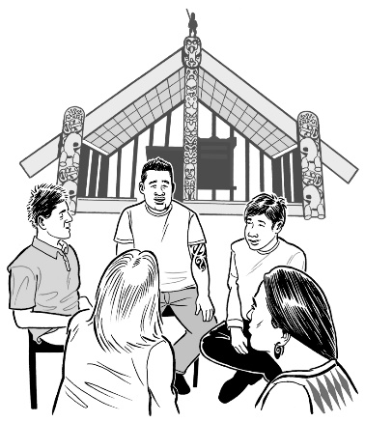
This list is helping the co-design group to think about what the disability system will be like for different people.

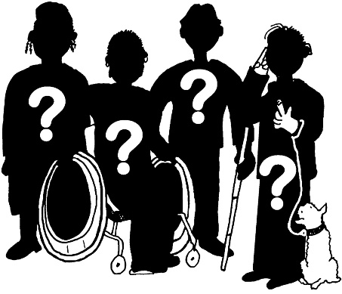
We have used the list to make up some disabled people and different kinds of families / whānau.

These made up people and families / whānau are not real people.

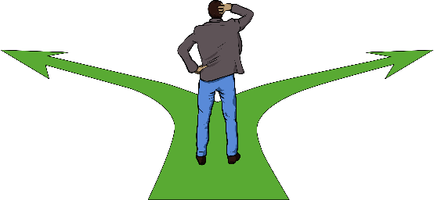
We did this so that we could test what it would be like for different people to use the new disability support system.
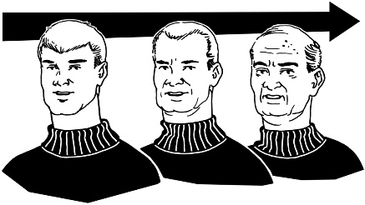
We gave the made up disabled people and families:
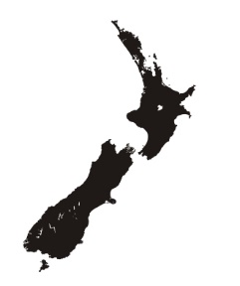
- ages
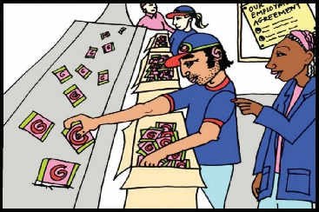
- somewhere in New Zealand to live

- jobs or something to do.

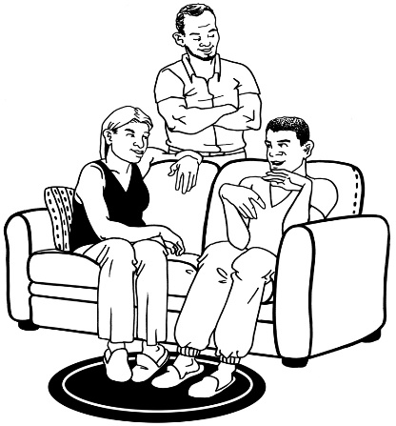
We decided how much support each of our made up disabled people and their families / whānau had in their lives.

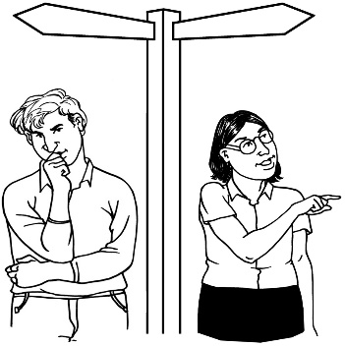
We also decided if our made up disabled people needed:
- no support to make choices

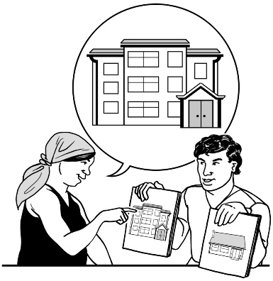
- a little bit of support to make choices

- lots of support to make choices

- support all the time to make choices.

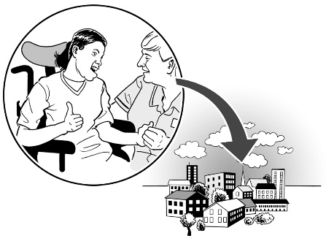
The co-design group talked about what kind of lives we would want for each of these made up disabled people in a new disability system.

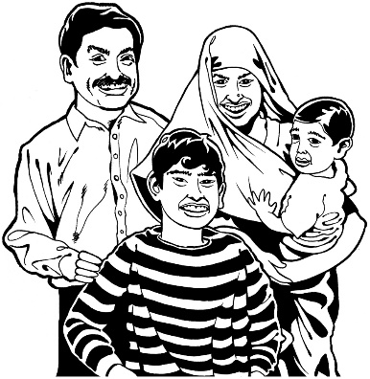

There are lots of ways that disabled people and their families / whānau will use the disability support system.
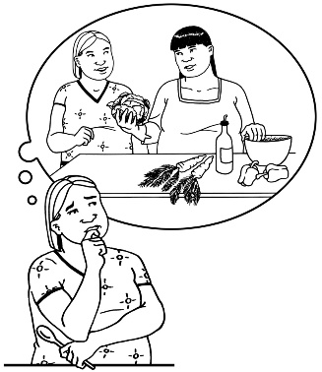
People will have to:
- think about and plan what they want in their lives

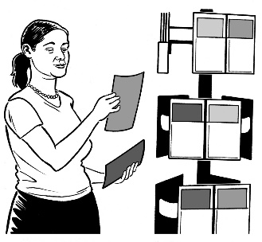
- learn how the disability system works

- get funding to pay for their support or the things they need for their disability

- get the support they need

- be in control of their support.

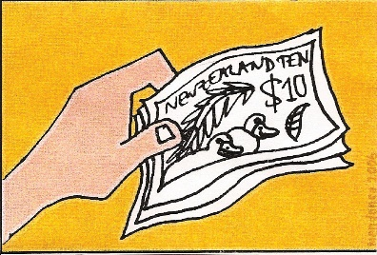
Funding means:
The money the Government gives for disabled people to be able to get the support and the things they need for their disability.

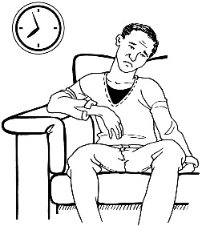
The co-design group had to think about the feelings of the made up:
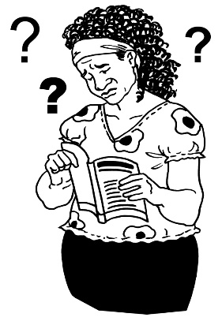
- disabled people

- families / whānau

- support staff.

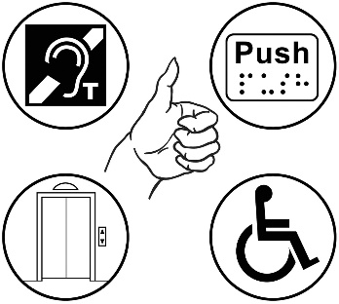
?
We asked ourselves what these people would feel if there was a good disability support system.

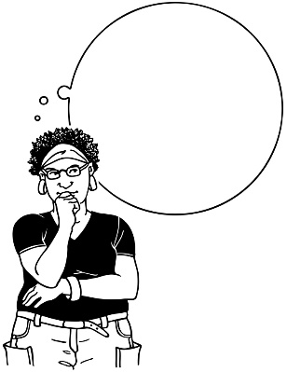
1 person in the co-design group said using made up disabled people helped them to think about what life may be like for other people.

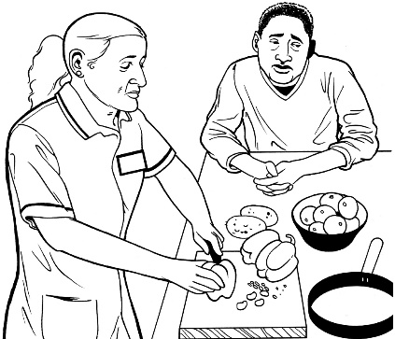
The co-design group also talked about the ways that many people think about support now.

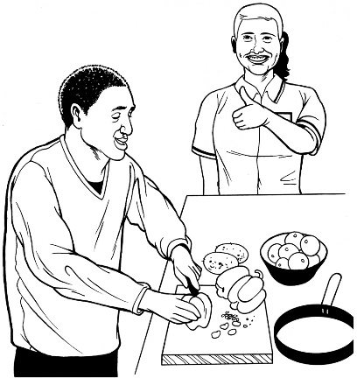
Some of the ways people think about support will need to change in a new system.

Sacha O’Dea from the Ministry of Health is leading the work to make a new disability support system.

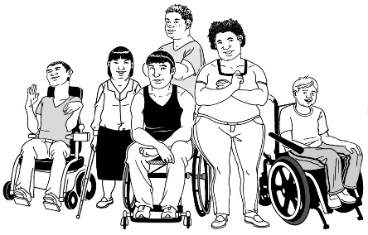
Sacha O’Dea listened to what the co-design group said about:

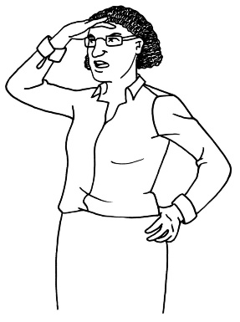
- how not every disabled person is the same or needs the same things

- what a good disability system should be like for everyone.

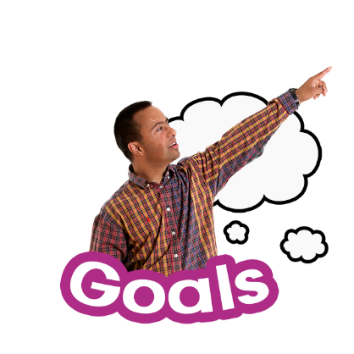
This work made Sacha think about how some parts of living your good life do not involve the Government.

For example: people’s dreams for what they want in life.

This work also made Sacha think about:

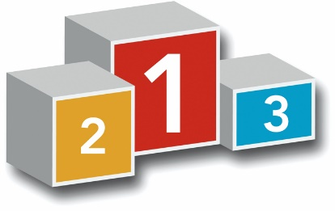
- how important it is that we have lots of ways to support people to make their own choices

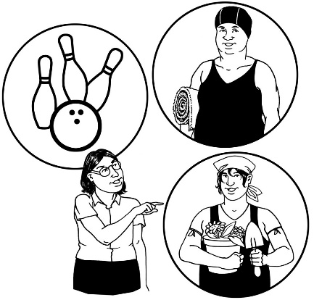
- how important it is we think about all the different parts of people’s lives, not just their disability

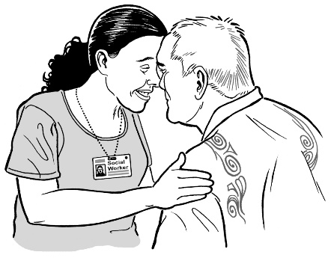
- how every disabled person and their family / whānau will need different support that is right for them

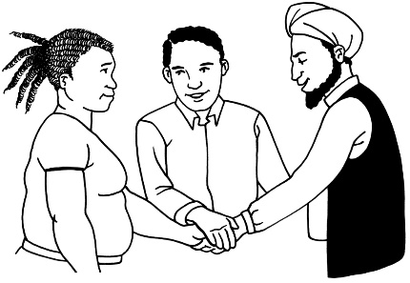
- how important it is to have disability support that follows Māori culture for Māori disabled people and their families / whānau, if they want it

- how we would like people who work with disabled people to think and act.
Key point 3

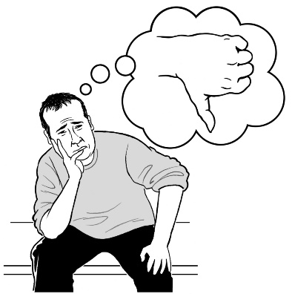
The co-design group talked about some of the parts of making a new disability support system that we think will be the hardest to do.
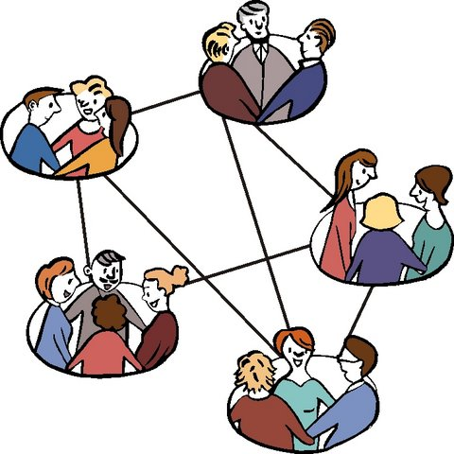

We split into small groups to think.

Each group had 1 new idea to think about.
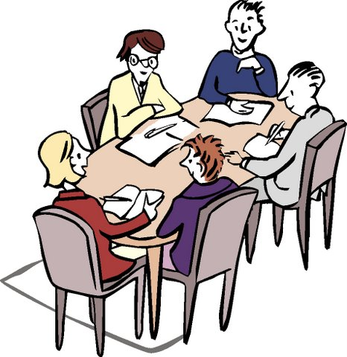

Each group had to think about how the idea could work in real life.

1 group had to think about how the funding will work in the new disability support system.

They had to use the ideas of Enabling Good Lives.

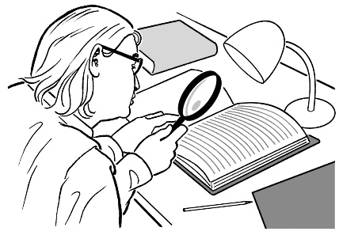
This group work was very hard but also very good.

Key point 4

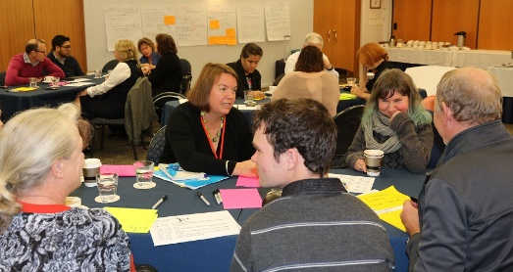
The co-design group split into 4 small groups again for another activity.

The groups had to think more about what it would be like for a disabled person to use the new disability system.

For this activity the co-design group had to keep in mind that disabled people and their families / whānau should:
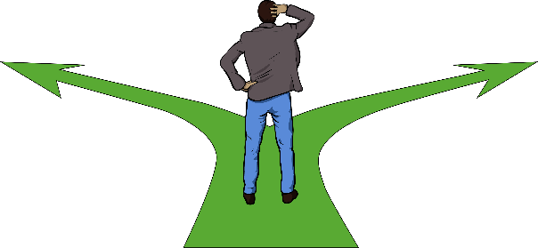
- be in control

- have more choices.
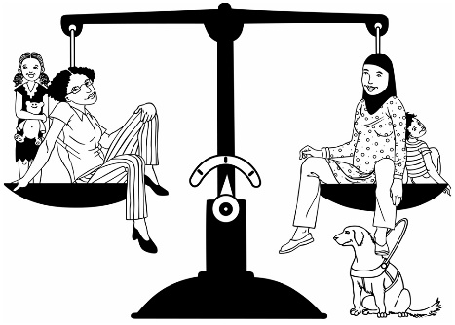
The co-design group also had to keep in mind that all disabled people should have the same chances as each other.
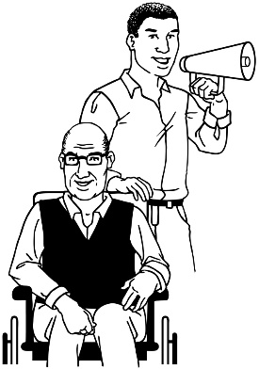

Some disabled people:
- need more support to make choices
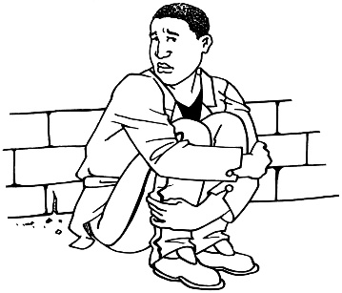
- do not have family / whānau or friends to assist them.
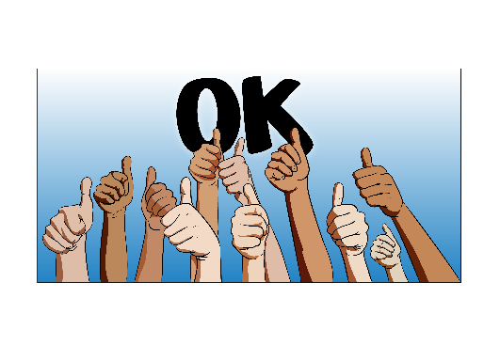

These disabled people should not get less chances to do things than others.

Group 1
This group had to think about how disabled people and their families / whānau could find out about:

- the new disability system

- the support they could get.

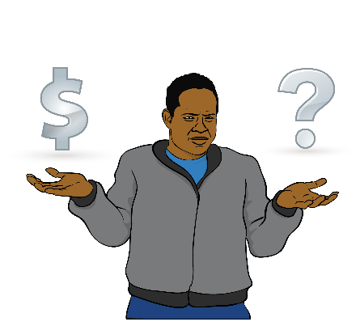
Group 2
This group had to think about how disabled people could ask for and get funding for their disability support in the new disability system.

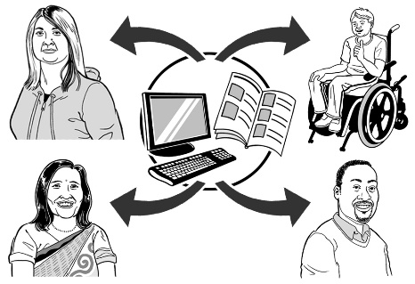
Group 3
This group had to think about how disabled people and their families / whānau could find information in the new disability system about:
- choosing support

- how to manage the support and funding they get.

Group 4
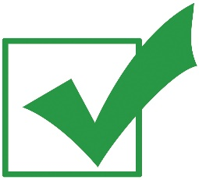
This group had to think about how to make sure:
- the new system is strong

- disabled people and their families / whānau:
  - are strong

  - can get the support and things they need.

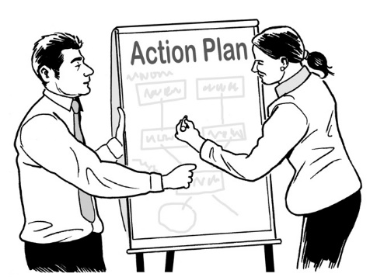
The co-design group also did some mapping.

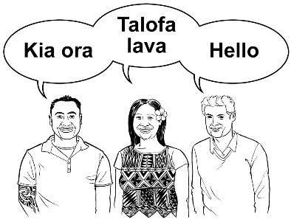
This is where you look at what the new disability support system would be like for:
- different groups of people

- people with all kinds of disabilities.

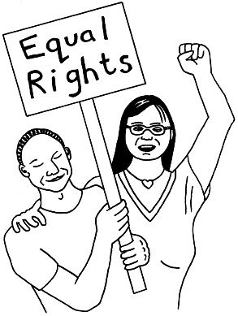
It also means thinking about:
- how the new disability system will work

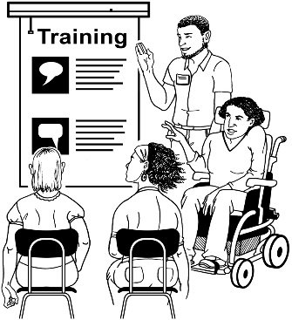
- how people working in the system should act

- how much funding is needed

- the training disability staff need.
Key point 5

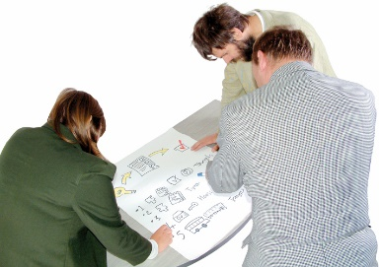
The 4 small groups looked at the plans they had made for a new disability system.

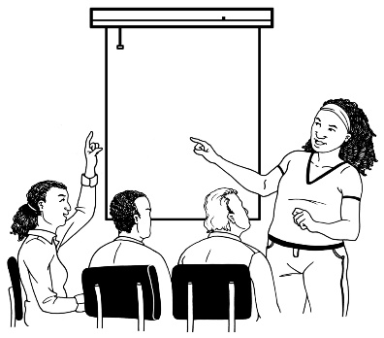
They made some changes.

Then the 4 small groups showed their plans to each other.

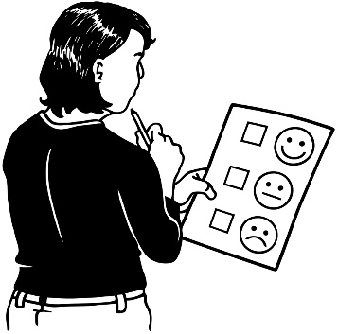
People asked questions and told each other what they were thinking about their ideas.

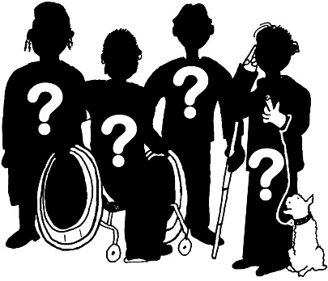
The co-design group then used 1 of the made up disabled people to test the new disability system.
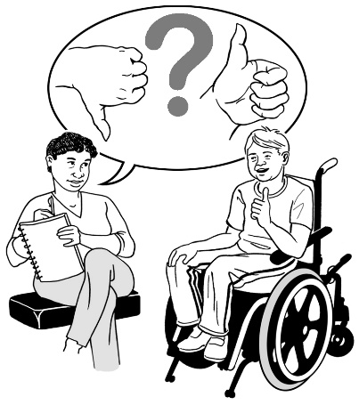

This was to see if the system worked for that person.

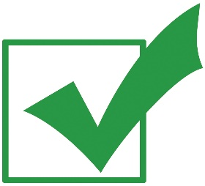
More changes were made and more testing was done.

Key point 6

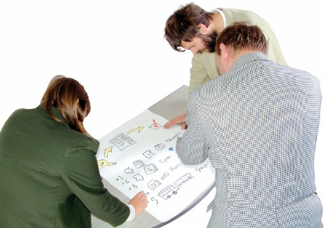
The co-design group has:
- done some hard work

- talked about some hard things.
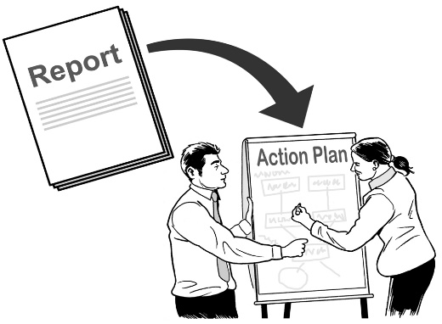
Ideas

The group said it feels like the new disability support system is getting planned now.
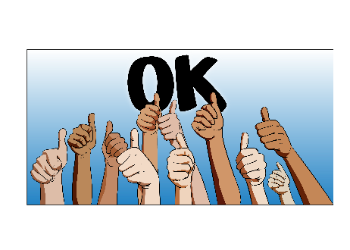

The group is excited about this.

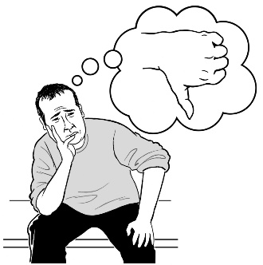
The group also said some parts were very hard to think about.

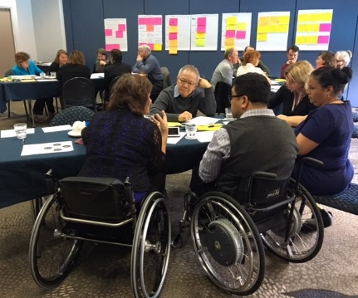
The co-design group wants to make sure that they think about everything so the new system does not make things worse for people.

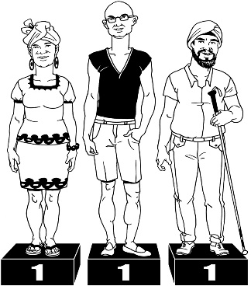
The group also wants to be careful that the new system works for everyone.

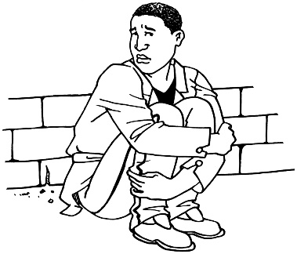
They do not want some people to miss out on things getting better.

The co-design group said it wants the new disability system to respect and work for:
- Māori culture

- other cultures.

The new disability support system needs to be planned together with:

- disabled people
- family / whanau

- disability support services.

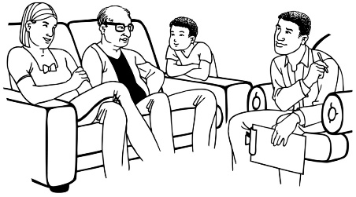
The co-design group knows it is so important that families / whānau are part of making any changes to the system.

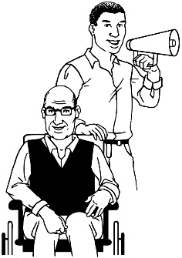
Families / whānau can assist disabled people and disability support services to make things better so we need to work together.

What now?

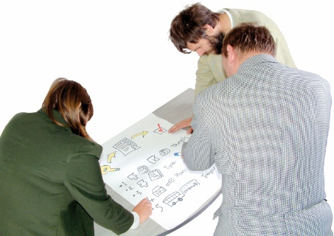
The co-design group will keep working on the plans for the next week.

What we need to do now is map all of the new disability support system and test it.
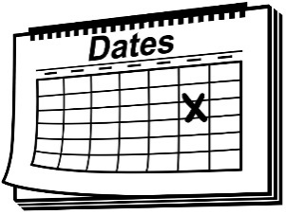

The next workshop will be on 30 and 31 May 2017.

Talk to us
?

You can talk to us if you:
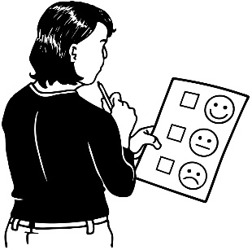
- have any questions

- want to tell us what you think about the work that is being done
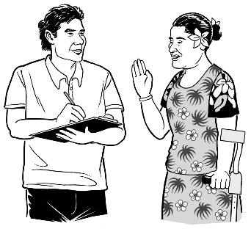
- want to tell us an idea.

Our email address is:
STfeedback@moh.govt.nz

Thank you,
Sacha O’Dea

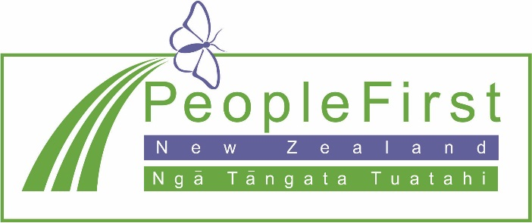

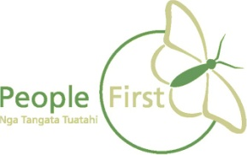
This information has been translated into Easy Read
by People First New Zealand Inc. Ngā Tāngata Tuatahi
