‘System Transformation co-design process’
Easy Read key points from the
30 and 31 May 2017 workshop:

What is this about?

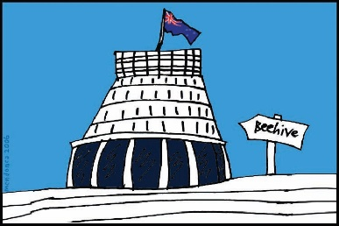
The Government of New Zealand is looking at making big changes to the disability support system.

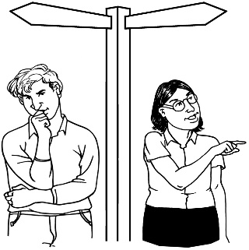
The long name for this is system transformation.

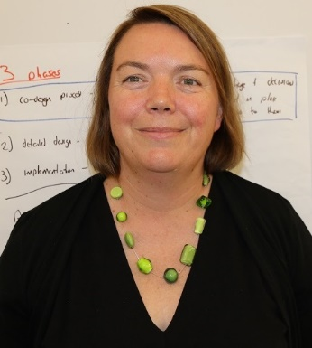
Sacha O’Dea from the Ministry of Health is leading this work.

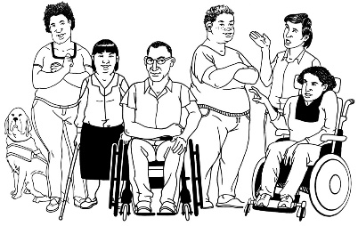
The Government has said it will plan the changes to the disability support system together with:
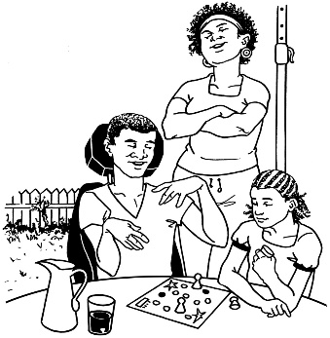
- disabled people

- family / whānau
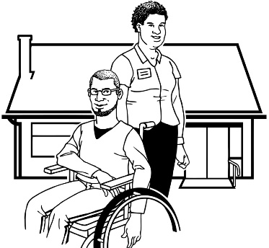
- disability support services.

Working together like this is called co-design.
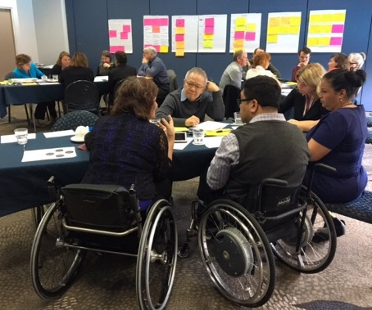

A co-design group has been put together.

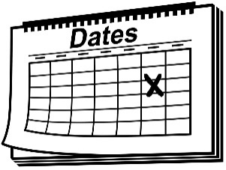
The co-design group will work together over 9 workshops.
9

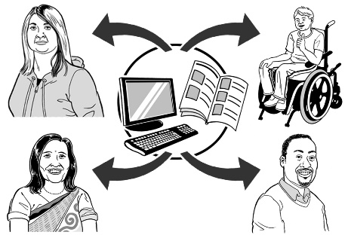
The key points of every workshop will be sent out so the rest of New Zealand can see what is being talked about.

30 - 31 May 2017
The 6th co-design workshop was on 30 and 31 May 2017.

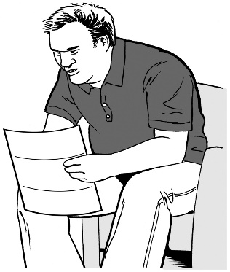
Keep reading to find the key points from that workshop.

Key point 1

Since the last workshop a lot of work has been done.

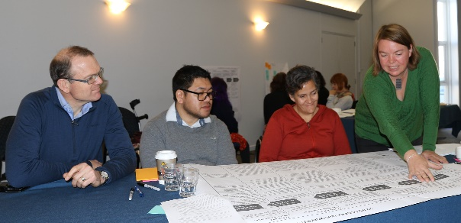
The people in the co-design group have:
- been looking at all of the ideas we have had so far
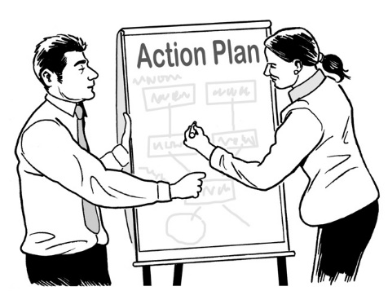
- put the ideas all together into a plan for a new disability support system.

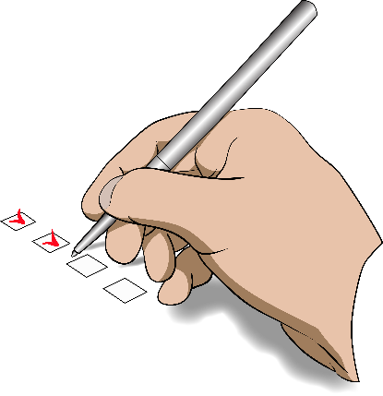

The co-design group was happy that the new system used all of the ideas they felt were important.

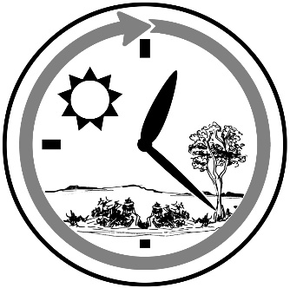
The co-design group worked hard for 1 day testing and making changes to the plan for the new system.

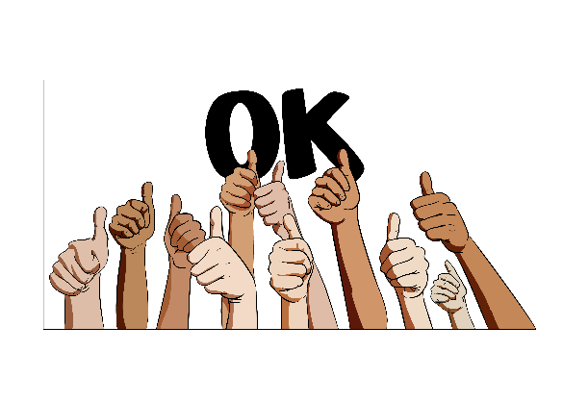
They tested and made changes to:

- make sure the system will be easy and good for disabled people and their family / whānau to use
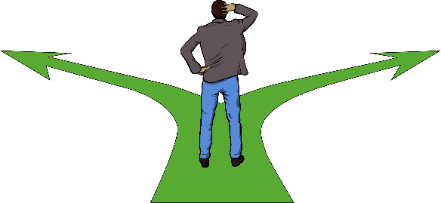
- plan how we will get from the system we have now to the new one
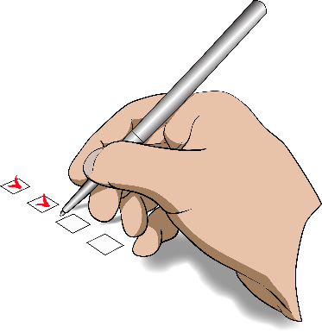
- more than 20 different parts of the new system.

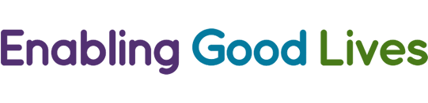
The co-design group has been making sure the plan for the new disability support system fits with the values of Enabling Good Lives.

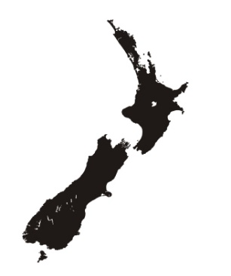
Enabling Good Lives is a way of giving disability support that has been tried in some parts of New Zealand.

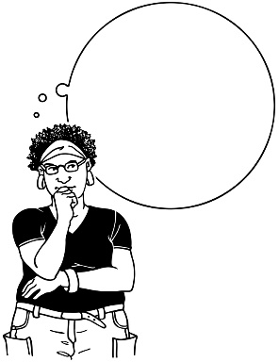
Values are important ideas.

Values are sometimes called principles.

The co-design group has also been thinking about:

- Will the new disability support system make it easy for disabled people to live lives that follow the values of Enabling Good Lives?
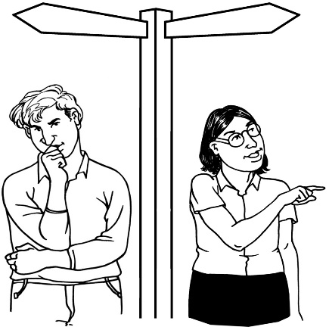

- In the new disability support system:

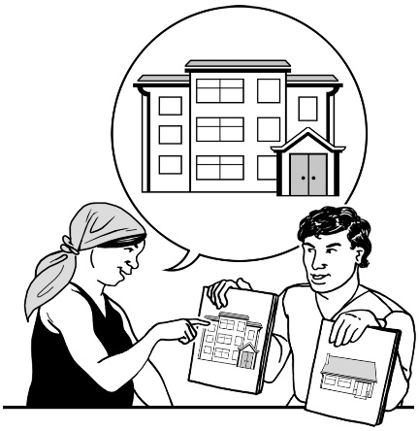
  - can the system change to fit the needs of each person?

  - do disabled people and their family / whānau have choices?

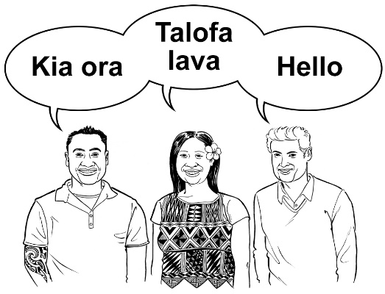
  - can the new system change to meet the needs of people from different cultures?

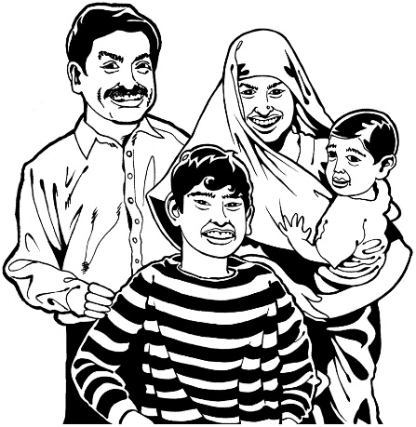
- Will the new disability support system work for:

  - all disabled people?

  - family / whānau of disabled people?

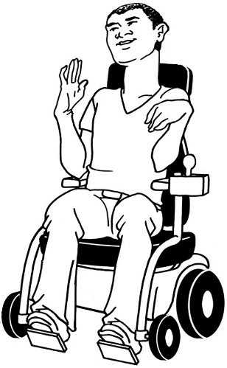
  - disabled people who need a lot of support?

  - disabled people who do not have a lot of support from family / whānau and friends?
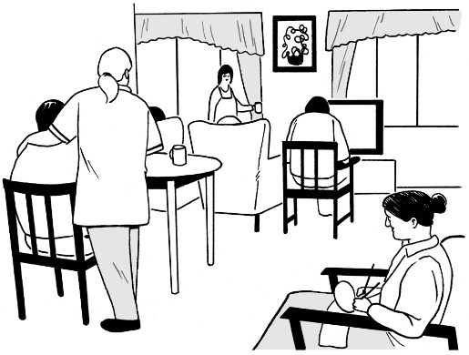
  - disabled people who live in group homes?

The co-design group are very happy with some of the ideas for the new disability system.

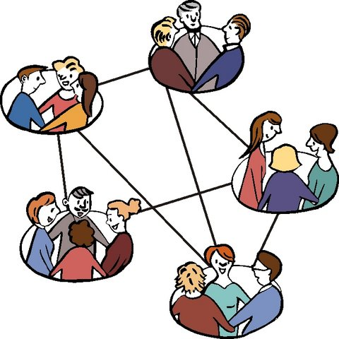
1 of the ideas is to set up new ways for disabled people to find out about the disability support system, like:

- groups of disabled people and family / whānau that can connect with each other
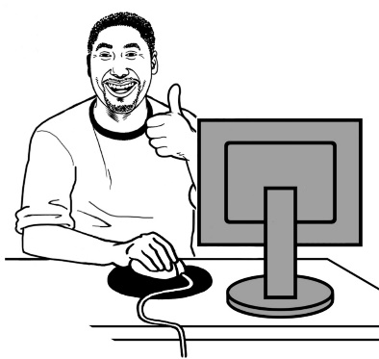
- a digital hub – this would be online and would be a place where you could get lots of information and support.

Online means on the internet.

Another idea for the new disability system is to make a new tool that disabled people can use to:
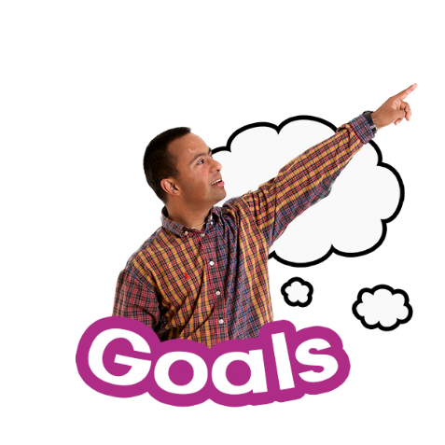
- see how they are going with their goals

- think about what they have learned
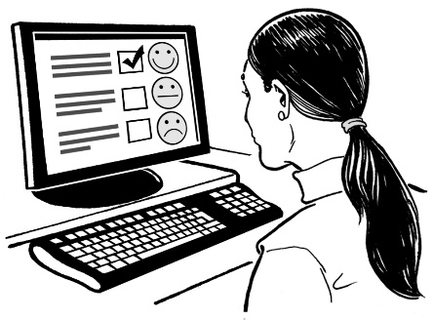

- tell us how they are getting on in the new system.

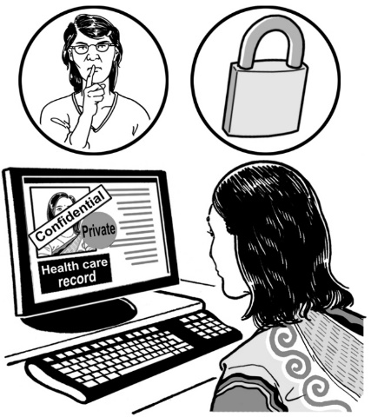
Disabled people will be able to have control over who can see this information about them.

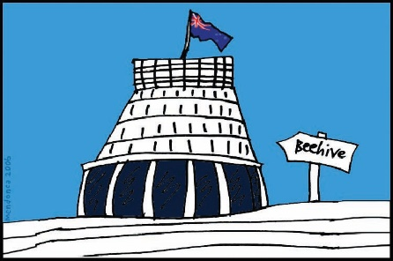
Another thing we want to do in the new disability system is to share the things we know with:
- government

- all of the different parts of the disability support system.

The things we know are:

- what is working for disabled people and family / whānau
- what is not working for disabled people and family / whānau.

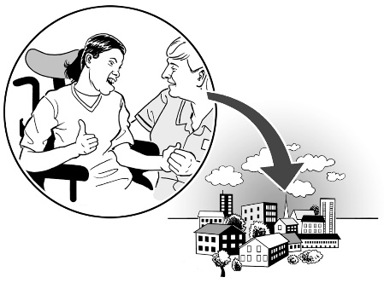
Another idea for the new disability support system is to work with the community more.
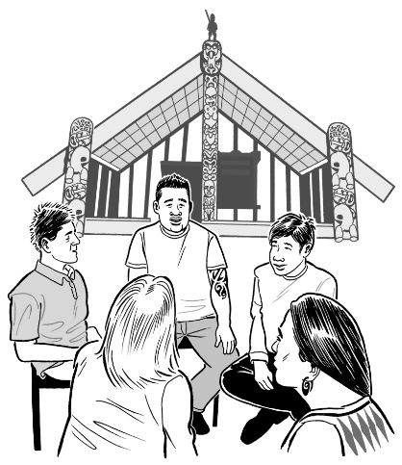

This will help to change the way that communities think about disabled people.

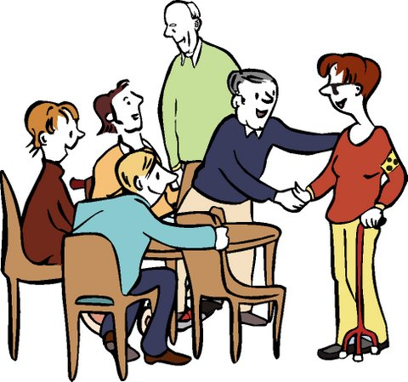
It will also help to make disabled people feel like they can really be part of the communities they live in.

By the middle of the second day the co-design group was happy with the plan we had made so far for the new disability support system.

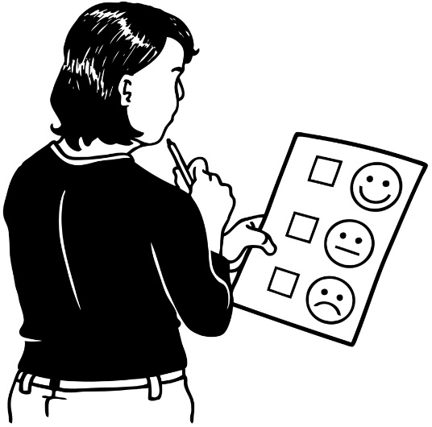
Some parts of the plan had to have small changes.

Other parts of the plan needed a lot more work.

Key point 2

4
There were 4 parts of the plan for the new disability support system that needed a lot more work.

The 4 parts that needed more work were:

- How to make sure disabled people and their families / whānau:

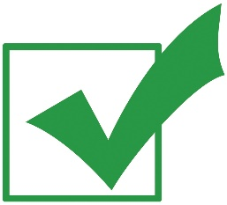
  - are strong

  - can get the support and things they need

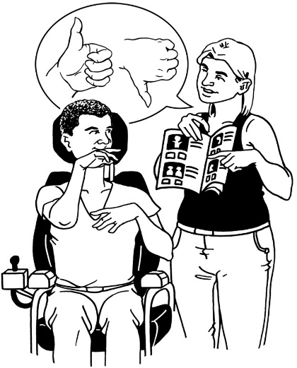
- How to make sure disabled people and their families / whānau:

  - have support around them from people like family / whānau and friends

  - have support to make their own choices if they can.

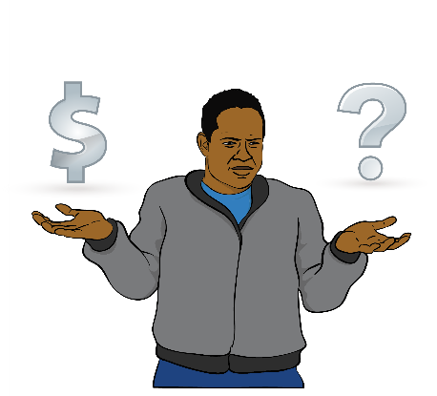

- How funding for disability support will work in the new disability system.

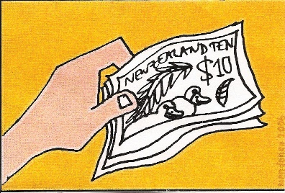
Funding means:
The money the Government gives for disabled people to be able to get the support and the things they need for their disability.

- Thinking about the people who will work with disabled people and their family / whānau.

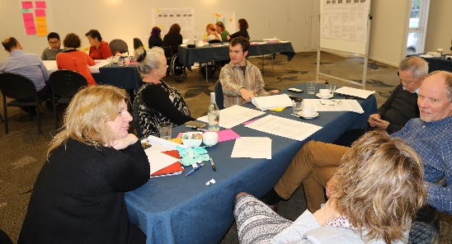
The co-design group split into 4 groups to work on these 4 things.

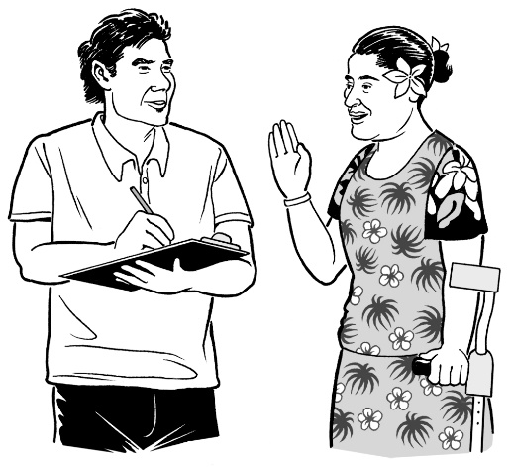
The groups worked hard on these things for 1 hour.

The groups came up with some good ideas.

Key point 3

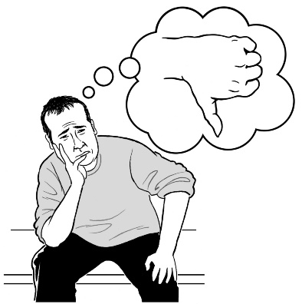
There are some important things the co-design group need to think about when they are making the plan for a new disability support system.

1 of the most important jobs of the co-design group is to make sure disabled people and their family / whānau will have more choice and control in the new disability support system.

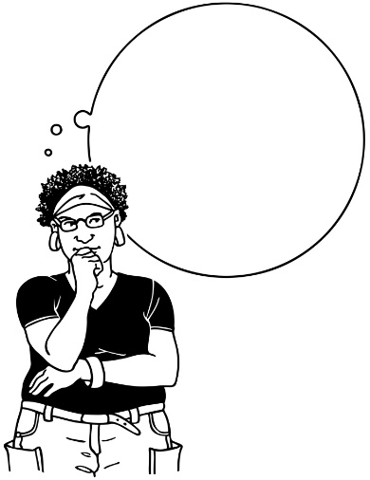
The people on the co-design group need to keep this in their minds when they are doing the work.

Some of the other things the group need to think about are:
- The values of Enabling Good Lives

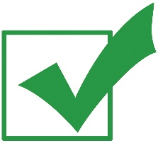
- Making sure that the chance to have more choice and control in the new system is not just for:

  - disabled people who have a lot of support

  - disabled people who can say what they need and want.
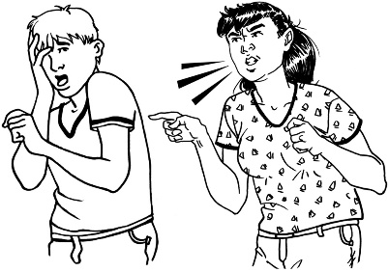
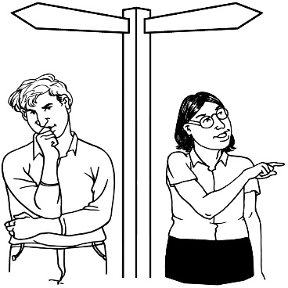
- Safeguarding – making sure that disabled people can make their own choices in a way that keeps them safe from abuse

- The new disability support system needs to be able to change to make sure it is a good system.
Key point 4
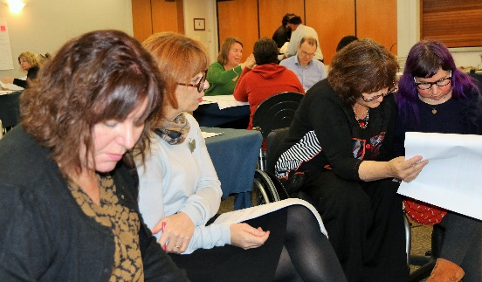

The co-design group talked about what we need to work on next.

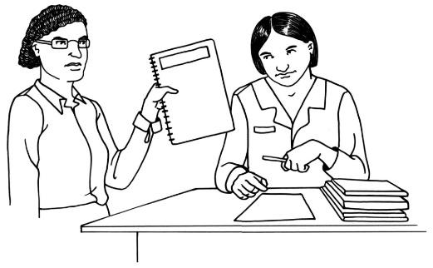
The group feels sure that we will have a good plan to give the Government next month.
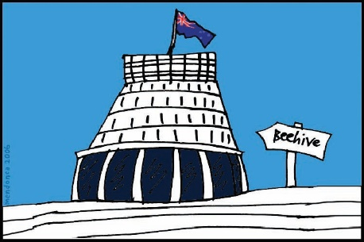

There is still a lot of work to do.

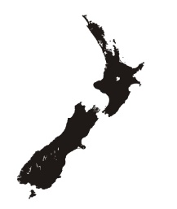
A lot of work will be done in the next 9 months on planning the new system for the mid-Central region.

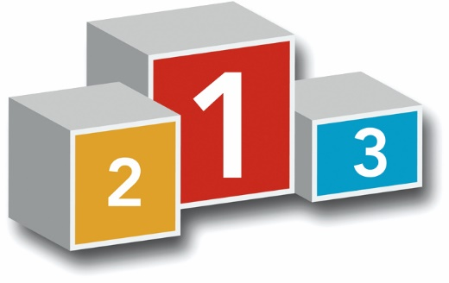
People who live in the mid-Central region will be the first to try the new disability system out.

At the next workshop the co-design group will be working on:

- what needs to be done in the next part of the plan
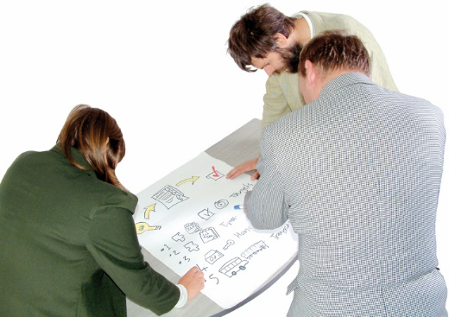

- planning how to get from the system we have now to the new system.

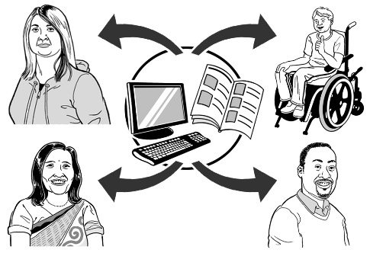
The co-design group talked about how to get information about the next part of the plan to the disability community.

The co-design group talked about how important it is to:

- make sure disabled people and their families / whānau can have a say on all of the different parts of the new system

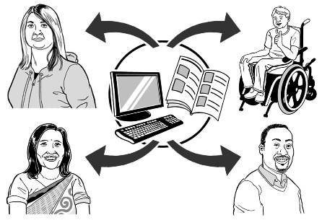
- make sure people get good information about what is going to change and why

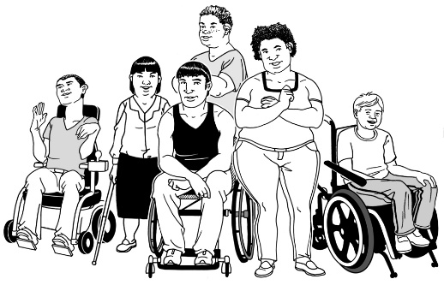
- make sure different groups of disabled people can take part in testing out the new disability system.

Different groups means groups like:
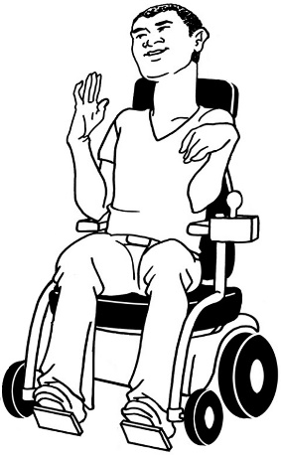
  - disabled people who need a lot of support

  - disabled people who do not have a lot of support from family / whānau or friends
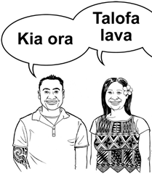
  - Māori and Pasifika disabled people

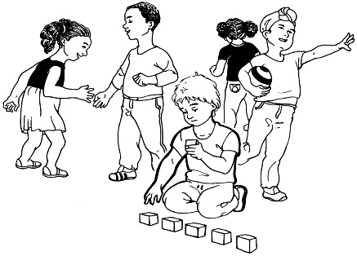
  - disabled people who have moved to New Zealand from other countries

  - people with Autism

  - young disabled people
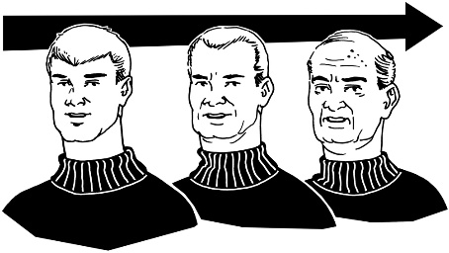
  - older disabled people.

This is to see if the new system will work for everyone.
The co-design group will be talking more about these things at the next workshop.

What now?

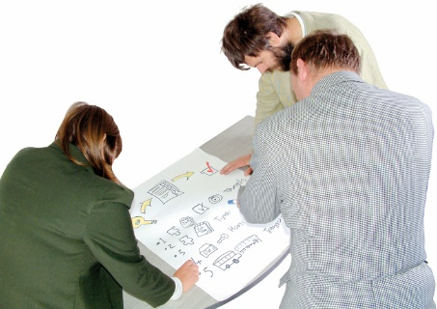
The co-design group feels good about the:

- work that has been done

- plan that has been made.

The group has worked hard and had some fun.

We are looking forward to doing the next part of the work.

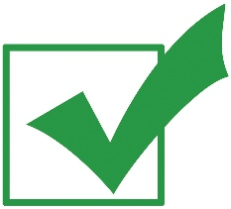
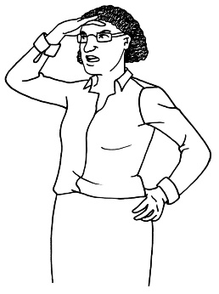
We are looking forward to making the new disability support system happen for disabled people and their families / whānau.

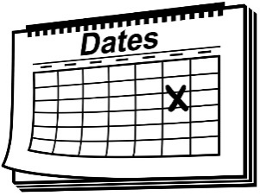
The next workshop will be on 8 June 2017.
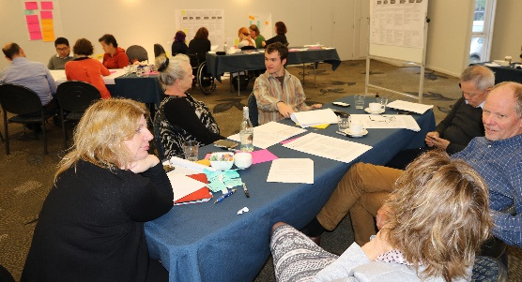

Talk to us
?

You can talk to us if you:
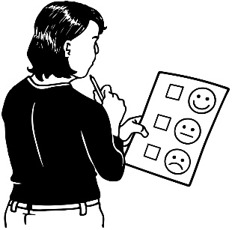
- have any questions

- want to tell us what you think about the work that is being done
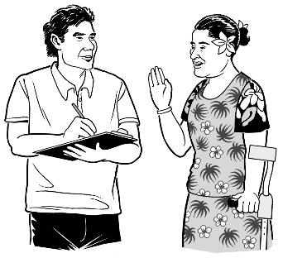
- want to tell us an idea.

Our email address is:
STfeedback@moh.govt.nz

Thank you,
Sacha O’Dea

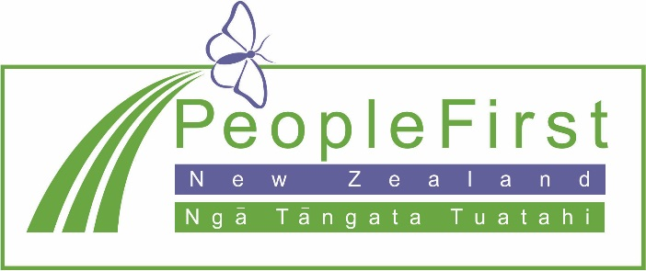

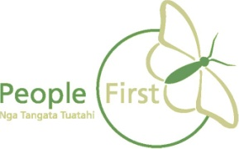
This information has been translated into Easy Read
by People First New Zealand Inc. Ngā Tāngata Tuatahi
