‘System Transformation co-design process’
Easy Read key points from the
7 June 2017 workshop:

What is this about?

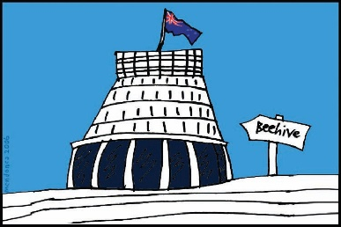
The Government of New Zealand is looking at making big changes to the disability support system.

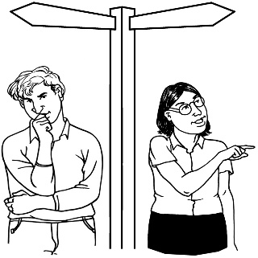
The long name for this is system transformation.

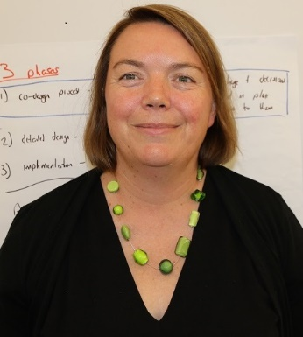
Sacha O’Dea from the Ministry of Health is leading this work.

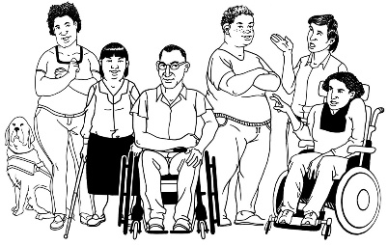
The Government has said it will plan the changes to the disability support system together with:
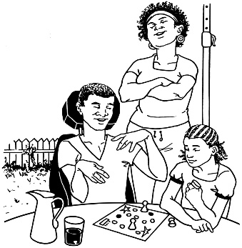
- disabled people

- family / whānau
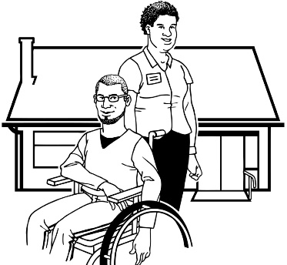
- disability support services.

Working together like this is called co-design.
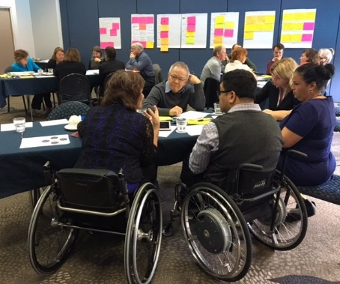

A co-design group has been put together.

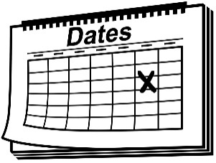
The co-design group will work together over 8 workshops.
8

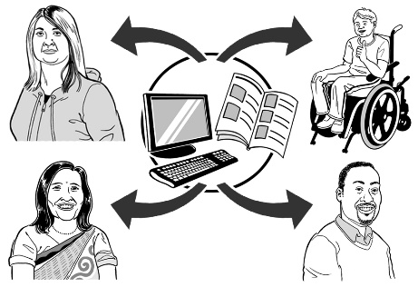
The key points of every workshop will be sent out so the rest of New Zealand can see what is being talked about.

7 June 2017
The 7th co-design workshop was on 7 June 2017.

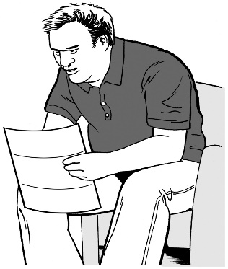
Keep reading to find the key points from that workshop.

Key point 1
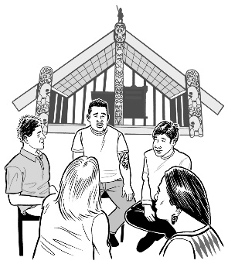

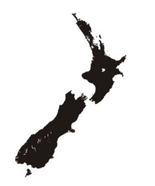
At this workshop the co-design group talked about some meetings that have just happened in the mid-Central region.

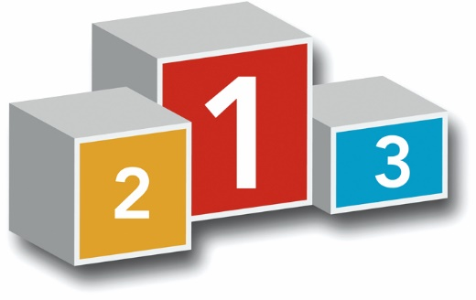
People who live in the mid-Central region will be the first to try the new disability support system out.

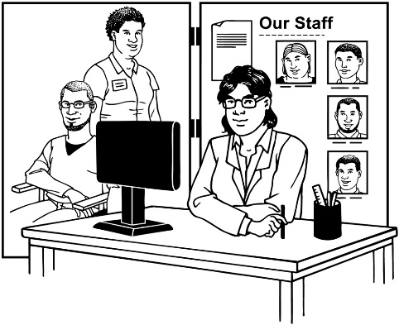
The meetings were about the new disability support system.

Meeting 1:

This meeting was for:

- disabled people

- family / whānau.

This meeting was about how the new disability support system is being planned together with:

- disabled people

- family / whānau

- disability support services.

More than 50 people came to this meeting.
50

Meeting 2:

This meeting was for people who work for disability support services.

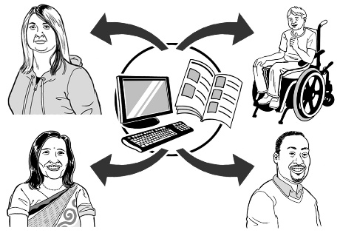
People at this meeting said they need more information about what is going to happen to their services in the new system.

6
6 services came to this meeting.

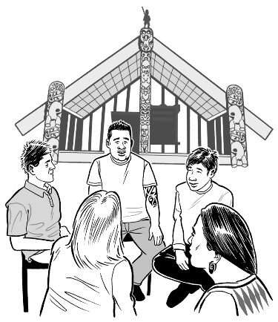
Meeting 3:

2 people from the co-design group met with Mana whenua / local Māori.

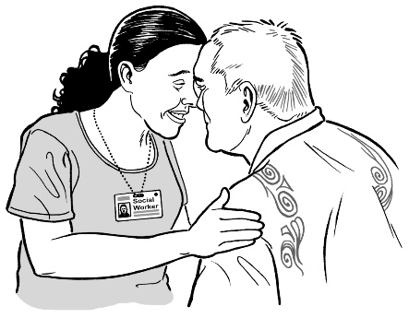
Meeting 4:

1 person from the co-design group went to a hui / meeting of local kaumatua / Māori elders and leaders.

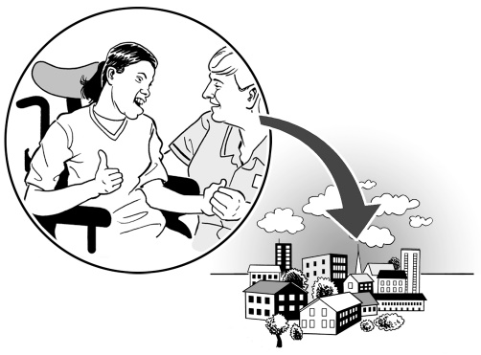
At Meeting 3 and Meeting 4:

- the people from the co-design group talked about the work they have been doing to plan the new disability support system

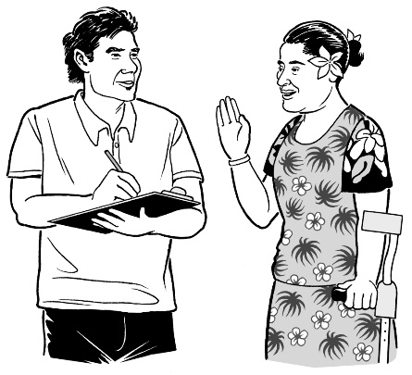
- local Māori wanted to know more about:

  - the work that is being done

  - what is going to happen next
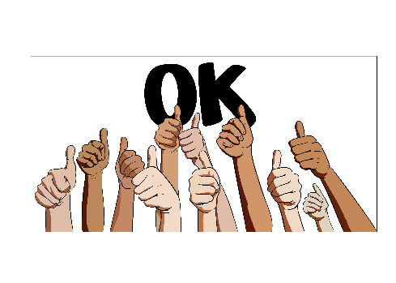

- local Māori said they support the work that is being done

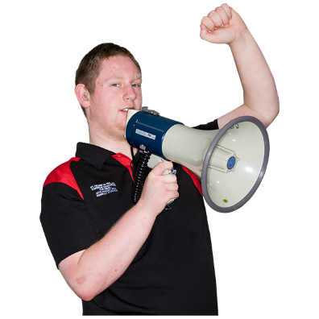
- local Māori said it is important the right words in Te Reo Māori are used for this work.

Key point 2
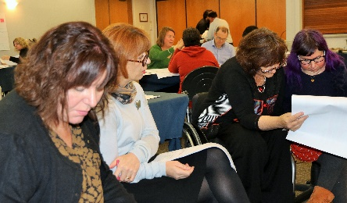

At this workshop the co-design group did more work on:
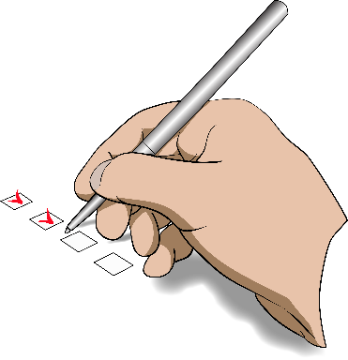
- making some last changes to the plan for the new disability support system
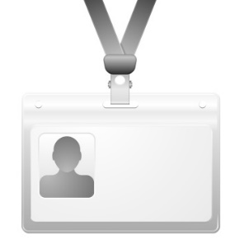

- the words and names for things that will be used in the new disability support system
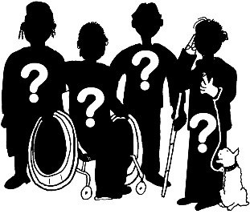

- what kinds of jobs the new disability support system will need
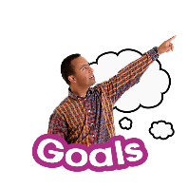
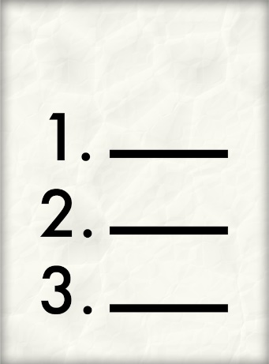
- thinking about how not all disabled people will use or want to have a plan for their goals

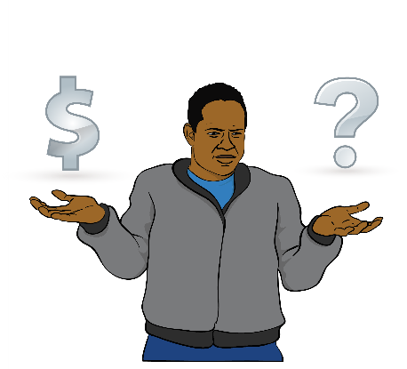
- how funding for disability support will work in the new disability system.

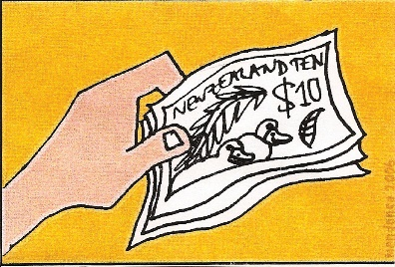
Funding means:
The money the Government gives for disabled people to be able to get the support and the things they need for their disability.

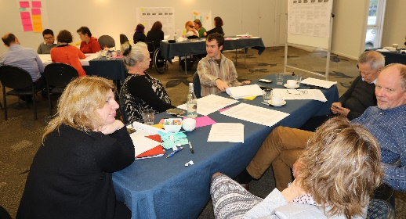
The co-design group said:

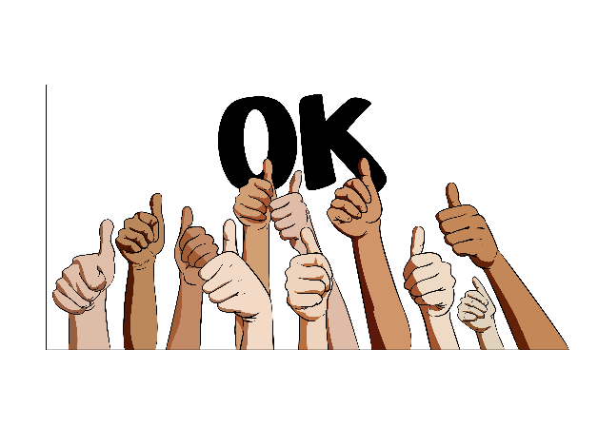
- the plan looks good

- the words are easy to understand

- the plan is very close to being finished.
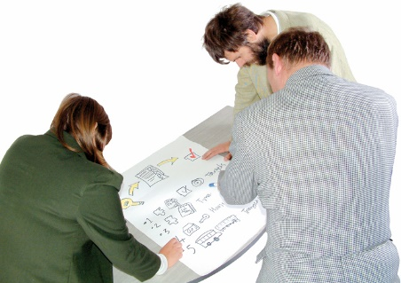
The co-design group also looked at 3 pictures that have been made to show what the new disability support system will look like.

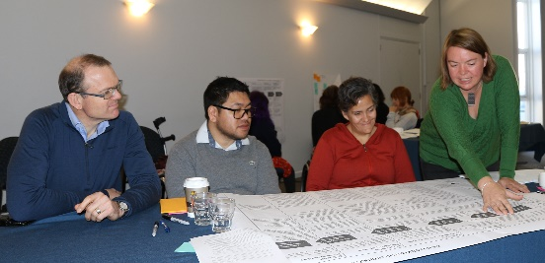
The group talked about:

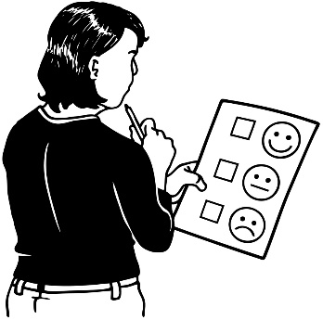
- what changes should be made to the pictures

- which picture was the best.

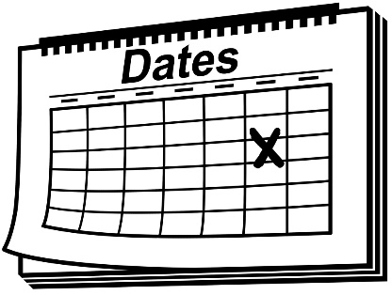
1 of these 3 pictures will be put in the plans that will be given to Cabinet in early July 2017.

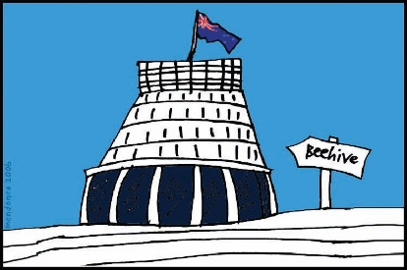
Cabinet is a group of senior Government Ministers.
Key point 3

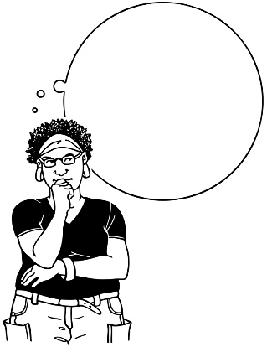
The co-design group had a think about what the next steps are to make the new disability system happen in the mid-Central region.

The group will work on this more in the next workshop.

Key point 4

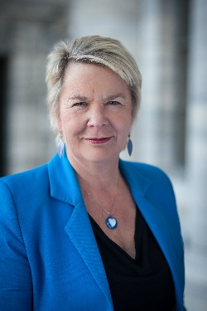
The Minister for Disability Issues is Nicky Wagner.

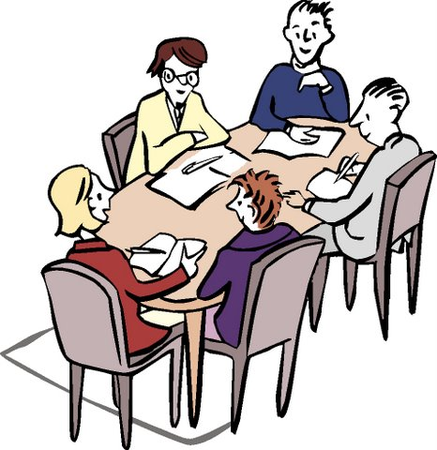
The Minister came to meet with some of the people on the co-design group.

On the co-design group there are:

- 5 disabled people

- 2 people from family / whānau groups

- 2 people from disability services

- 4 people from the Government.
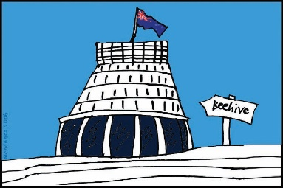
The Minister met with the people on the co-design group who are not from the Government.
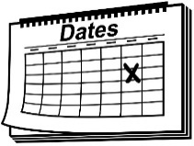

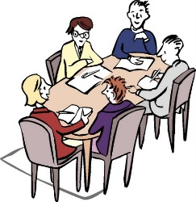
This was the second time the Minister has met with the co-design group.

The people from the co-design group talked with the Minister about:
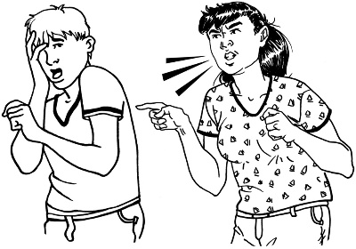
- some of the things that are going on for disabled people in New Zealand

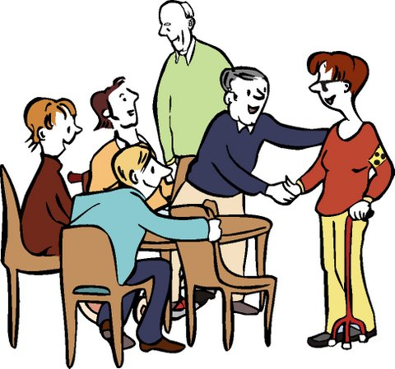
- some of the things that people in the disability community want to happen.

Key point 5

The co-design group did some work on how to talk about the plans they have made for a new disability support system.
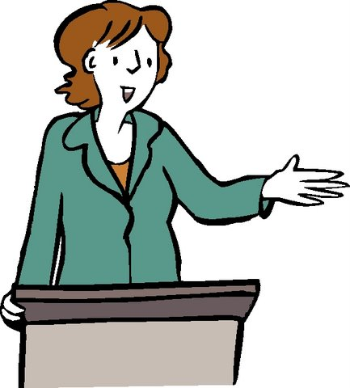

Then 5 of the people from the co-design group gave a talk to a Ministerial Group.

The Ministerial Group has these people in it:

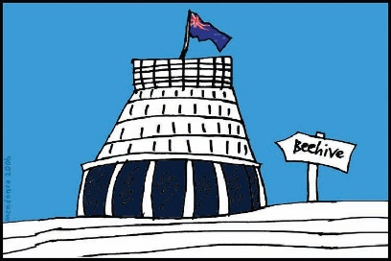
- the Minister for Disability Issues

- other Ministers from the Government.
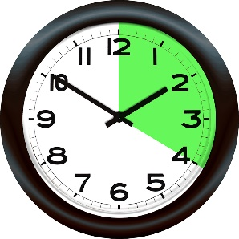
The co-design group was asked to talk for 20 minutes.

The co-design group had a good talk with the Ministers.

The Ministers asked lots of questions.

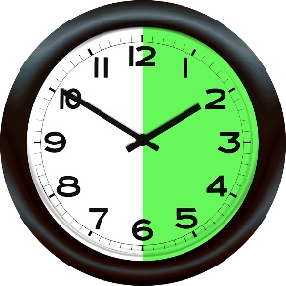
The talk went so well that they spent 35 minutes talking to the Ministerial Group.

What now?

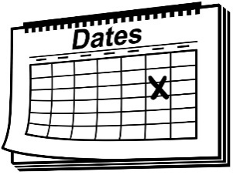
The next workshop will be on 13 June 2017.
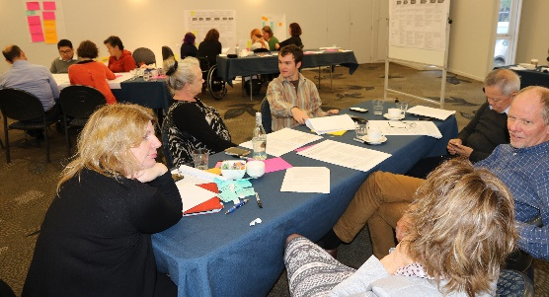

Talk to us
?

You can talk to us if you:
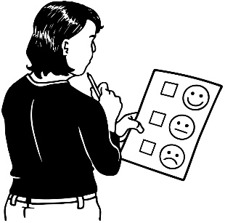
- have any questions

- want to tell us what you think about the work that is being done
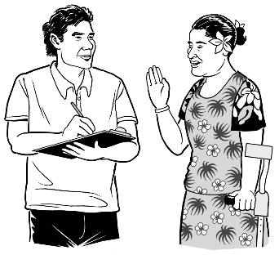
- want to tell us an idea.

Our email address is:
STfeedback@moh.govt.nz

Thank you,
Sacha O’Dea

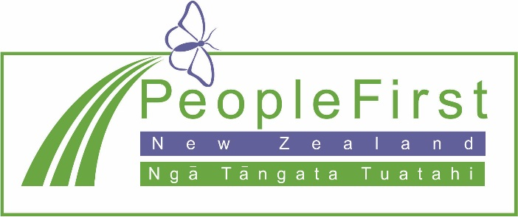

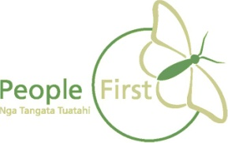
This information has been translated into Easy Read
by People First New Zealand Inc. Ngā Tāngata Tuatahi
