‘System Transformation co-design process’
Easy Read key points from the
13 June 2017 workshop:

What is this about?

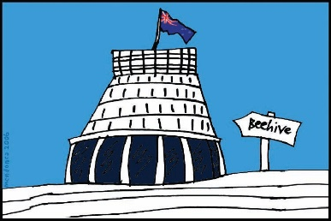
The Government of New Zealand is looking at making big changes to the disability support system.

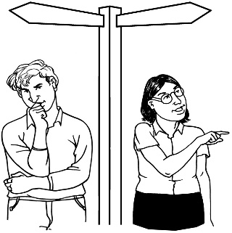
The long name for this is system transformation.

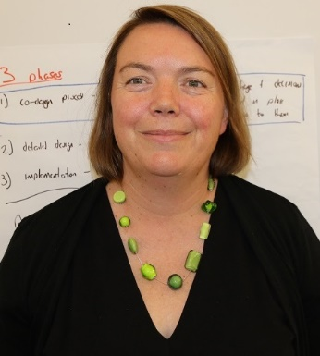
Sacha O’Dea from the Ministry of Health is leading this work.

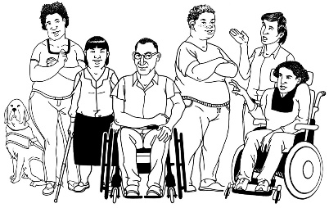
The Government has said it will plan the changes to the disability support system together with:
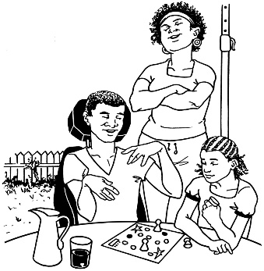
- disabled people

- family / whānau
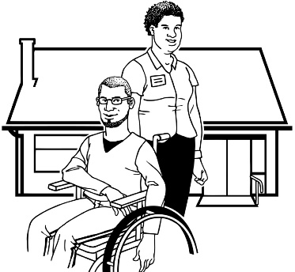
- disability support services.

Working together like this is called co-design.
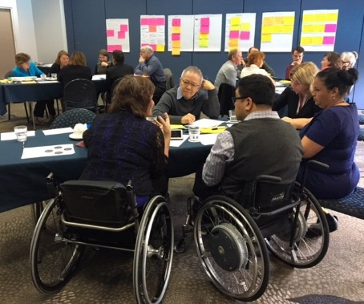

A co-design group has been put together.

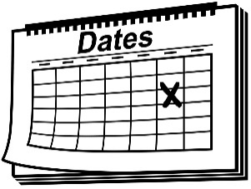
The co-design group will work together over 8 workshops.
8

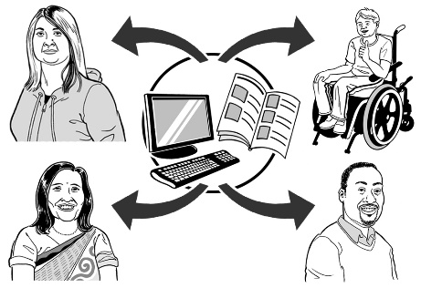
The key points of every workshop will be sent out so the rest of New Zealand can see what is being talked about.

13 June 2017
The 8th co-design workshop was on 13 June 2017.

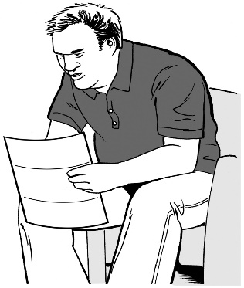
Keep reading to find the key points from that workshop.

Key point 1
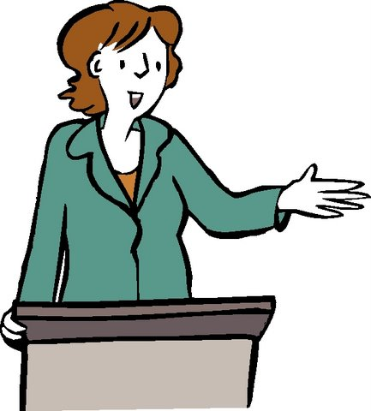

Last week 5 of the people from the co-design group gave a talk to a Ministerial Group.

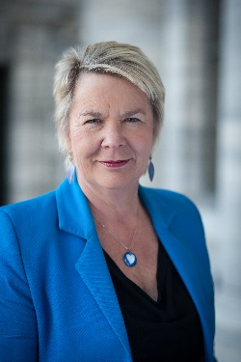
The Ministerial Group has these people in it:

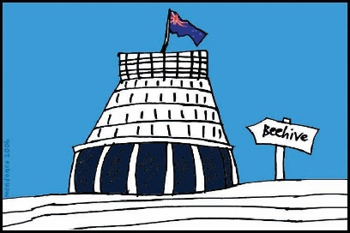
- the Minister for Disability Issues

- other Ministers from the Government.

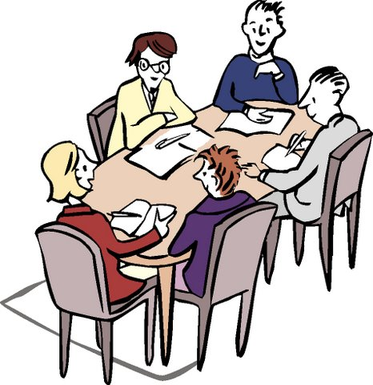
The people from the co-design group talked with the Ministerial Group about the plans the group has made for a new disability support system.
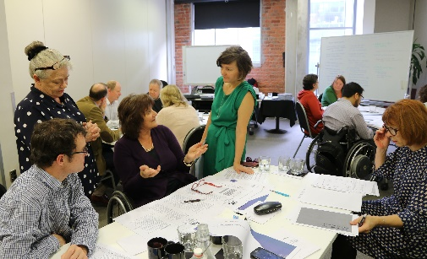
At this workshop the 5 people who talked to the Ministerial Group told the rest of the co-design group:

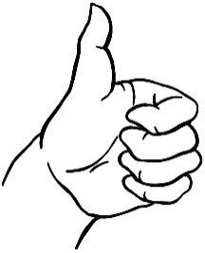
- they liked talking with the Ministerial Group

- they felt the talk went very well
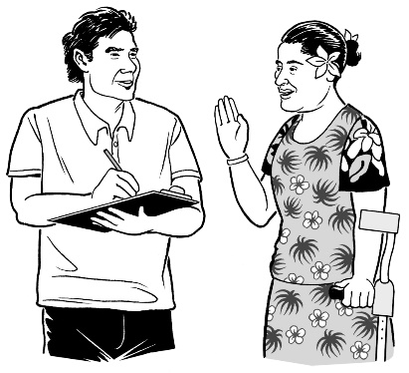
- the talk got better as it went on

- the Ministers listened to what they said

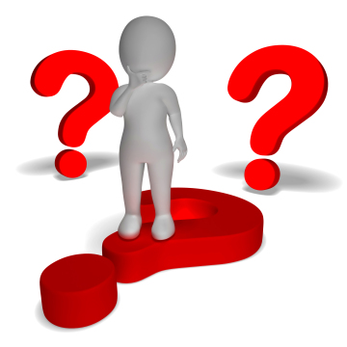
- the Ministers asked some hard questions

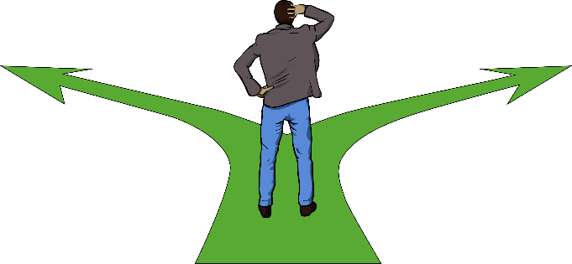
- they felt the Ministerial Group was really thinking about all of the changes that are going to happen
The 5 people who talked to the Ministerial Group also told the rest of the co-design group:
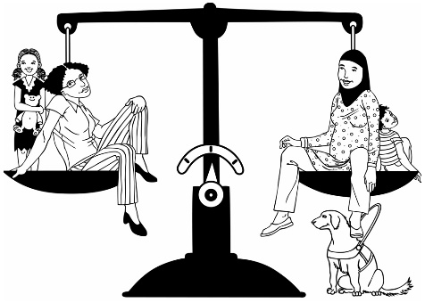
- the Ministers did not treat them differently because of their disabilities

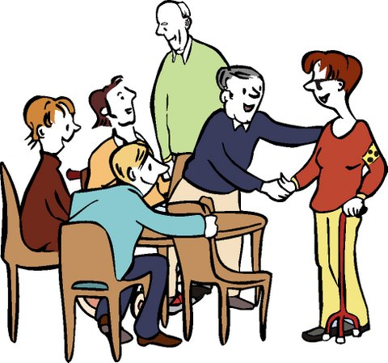
- the Ministers treated them like a project team – with respect

Respect means:

  - treating a person well

  - making sure a person has their rights

  - thinking well of them for the work they have done.

Key point 2

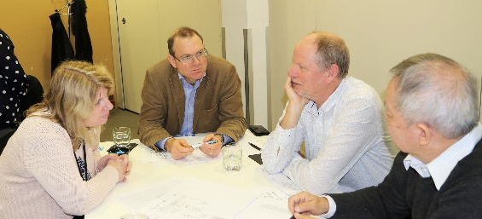
The co-design group did more work on:

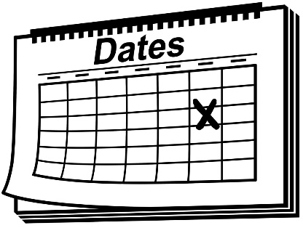
- the plans for the new disability support system that will be given to Cabinet in early July 2017

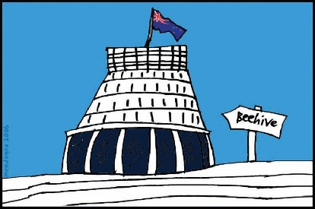
Cabinet is a group of senior Government Ministers.

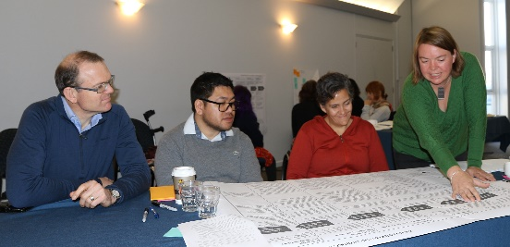
- the picture that will be used to show what the new disability support system will look like

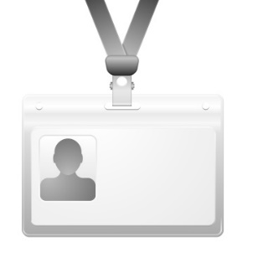
- the words and names for things that will be used in the new disability support system
The co-design group also did more work on:

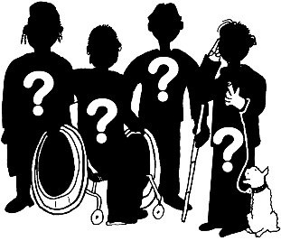
- what kinds of jobs the new disability support system will need
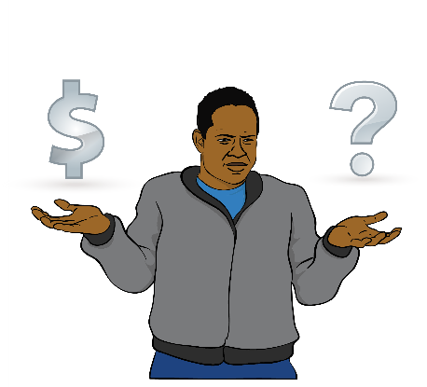

- how funding for disability support will work in the new disability system.

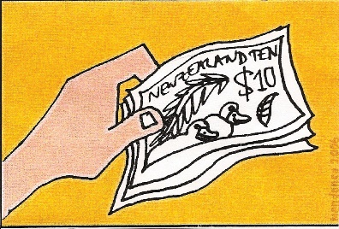
Funding means:
The money the Government gives for disabled people to be able to get the support and the things they need for their disability.

Key point 3

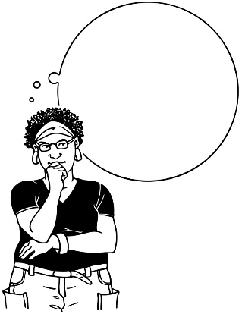
The co-design group had a think about:

- what the next steps are to make the new disability system happen in the MidCentral region
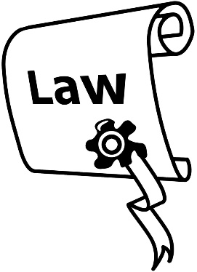

- what laws need to be changed to make the new disability support system?
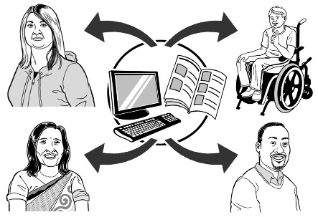

- who do we need to tell about the changes that will be made to the disability support system?
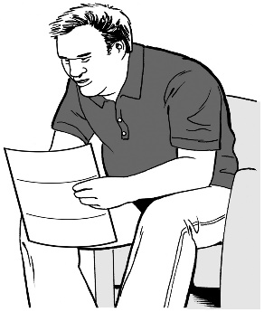

- what do we need to tell people?

The co-design group also had a think about:

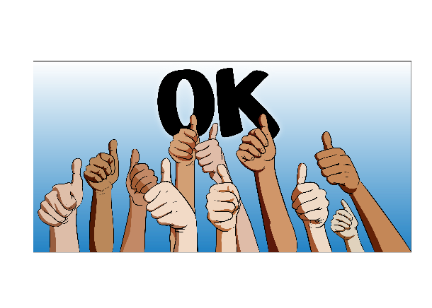
- what do we need to do to make sure that the changes are easy for different groups, like:

  - disabled people

  - families / whānau
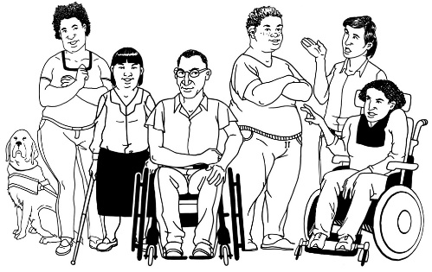
  - disability support services

  - government

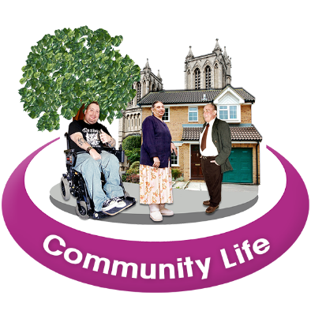
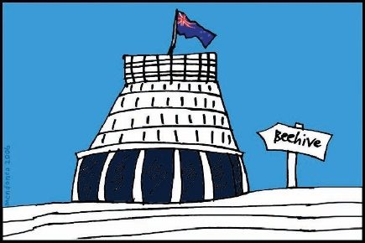
  - places that decide how much funding people get for their disability needs, like Needs Assessment and Service Coordination services – these are also called NASCs

  - the rest of the community.

The co-design group also had a think about:

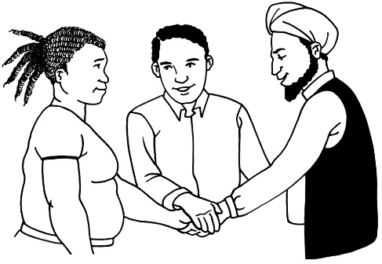
- what people and groups do we need to work together with to make the changes work well?

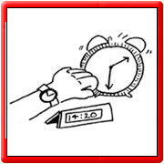

- when is a good time to start working together with these people and groups?

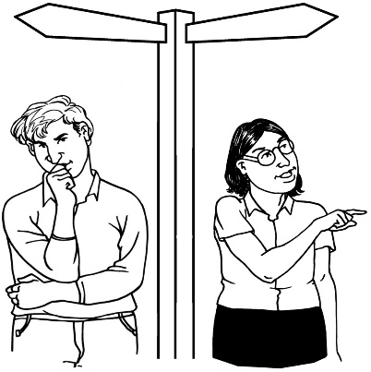
- how can we make sure that people can keep the support they have now if they do not want it to change?

Key point 4

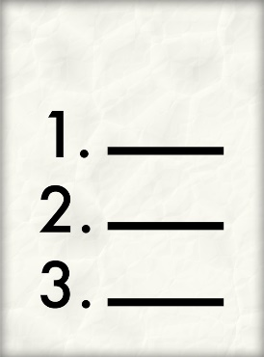
The co-design group made a list of the good things about co-design.

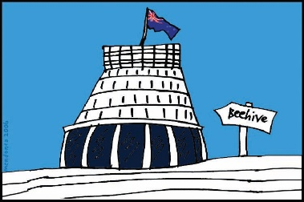
Co-design means the Government working together with:
- disabled people

- family / whānau

- disability support services.

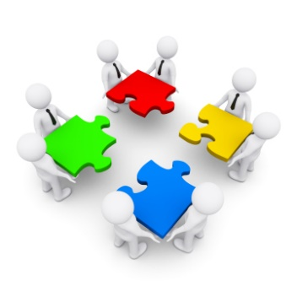
Here is the list of good things about co-design:
- Disabled people are treated as equal to the non-disabled people in the group

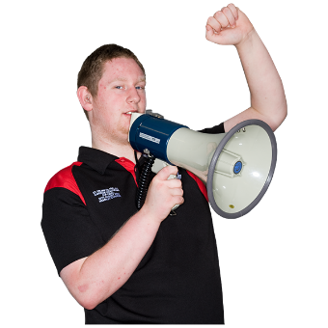
- Disabled people felt better about taking part and speaking up as the work went on

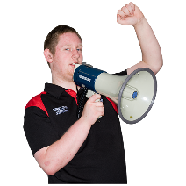
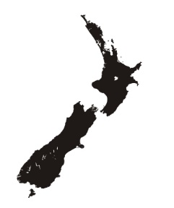
- People felt it was ok to say what disabled people around New Zealand really want

- Everyone worked together

- Everyone on the group was equal – no one had more power than other people
Here is more of the list of good things about co-design:

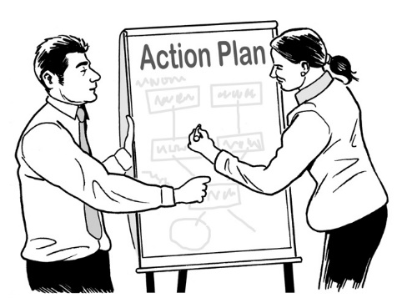
- In the new disability support system Māori disabled people will have their culture:

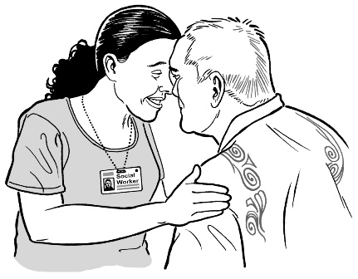
  - thought about when their services are being planned

  - respected

- In the new disability support system the support that people have from family / whānau and friends will be:

  - thought about when their services are being planned
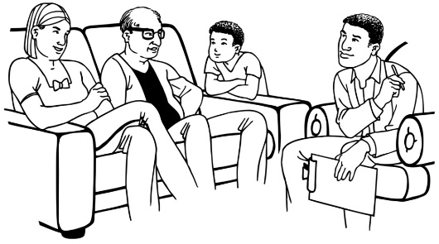
  - respected

Here is more of the list of good things about co-design:
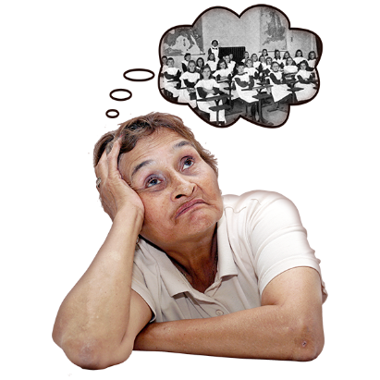
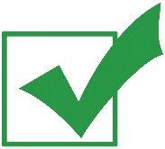
- It was ok for people to talk to the group about what has happened in their own lives

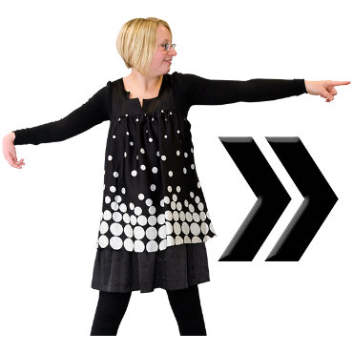
- working together as a group helped us come up with new ways to fix old problems and move forward

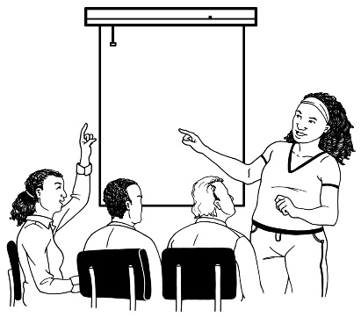
- It was good to be able to talk as a group about the problems in disability support

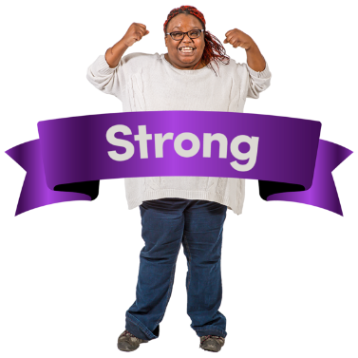
- It was good to see disabled people have control in the planning of the new disability support system

Here is more of the list of good things about co-design:
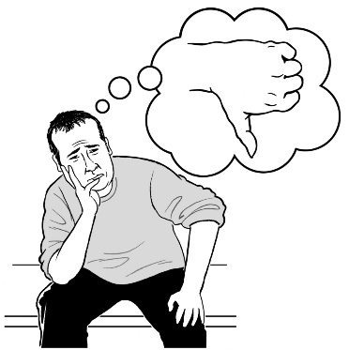
- It helped us to change some of the things we used to think

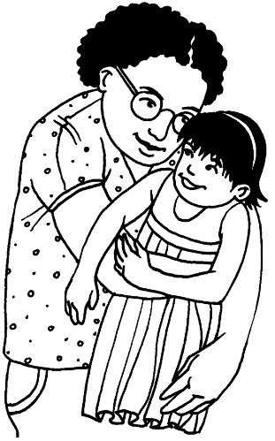
- We have a good plan for the new disability support system that will make life better for families / whānau

- We are happy about disabled people and their families / whānau having good lives in the future.

Sacha O’Dea from the Ministry of Health is leading this work.

Sacha also made a list about what she learned about co-design.

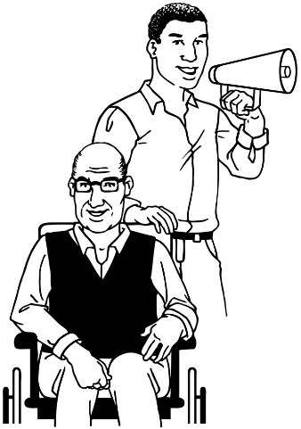
Sacha learned that as the leader of the co-design group it is important:

- not to try and control the co-design group
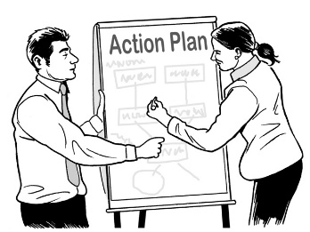
- to trust that the co-design group will be able to make a good plan.

Key point 5

The co-design group spent some time with Wai Campbell.

Wai is a parent of a child with disability.

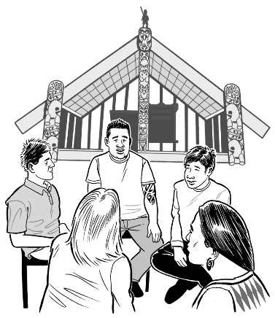
Wai talked with the co-design group about some important parts of Māori culture.

Wai talked about:
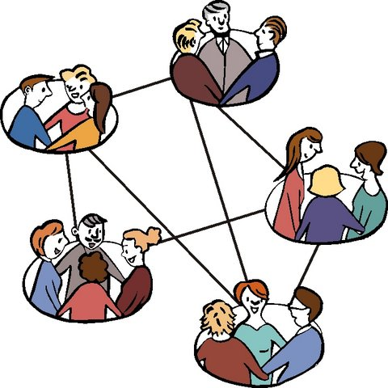

- whakawhanaungatanga – how people are connected to each other and their families / whānau

- mihimihi – introducing yourself and where you come from

- Te Wheke – Māori ways of thinking about keeping healthy and well.

There are 8 parts of Te Wheke.

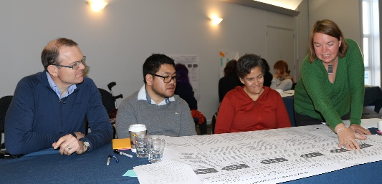
Wai gave the co-design group some activities to do.
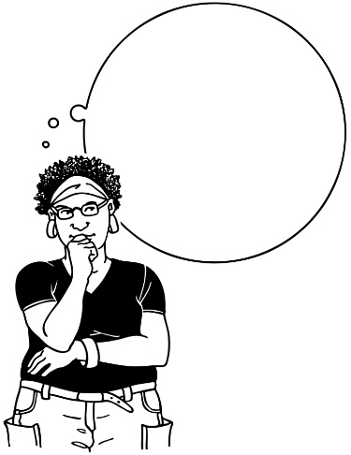

Activity 1

The people in the co-design group worked in small groups to think about:
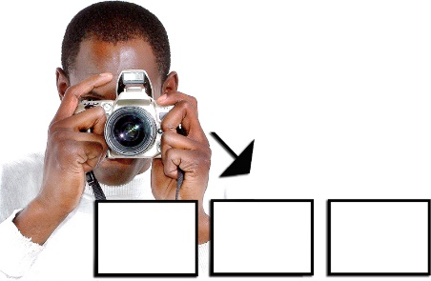
- who they are

- where they come from
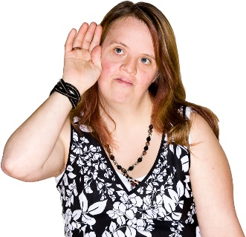
- how to show other people these things using a picture or a sound.

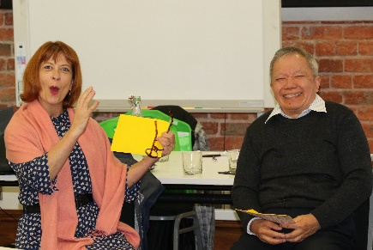
Everyone shared their work with the group.

Activity 2
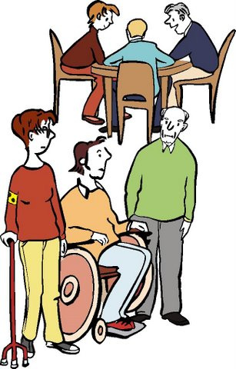
The people in the co-design group split into 2 groups:

- men

- women.

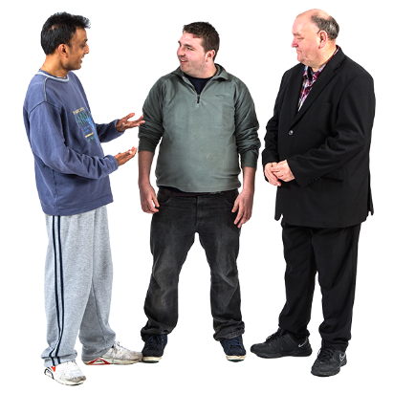
The men looked at 4 parts of Te Wheke – Māori ways of thinking about health.

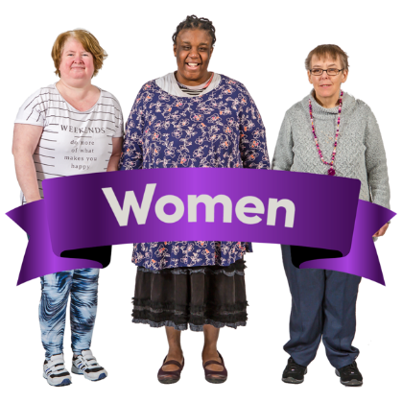
The women looked at the other 4 parts of Te Wheke.

What now?

For the next month we will be working on the paper we will give to Cabinet in early July 2017.

Cabinet is a group of senior Government Ministers.

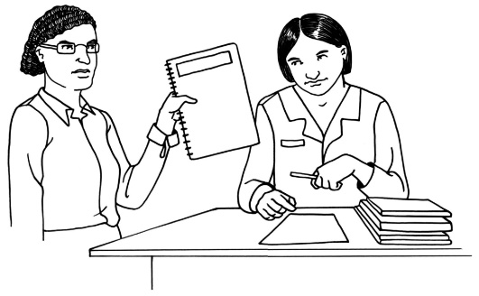
The paper will show Cabinet the plans for the new disability support system.

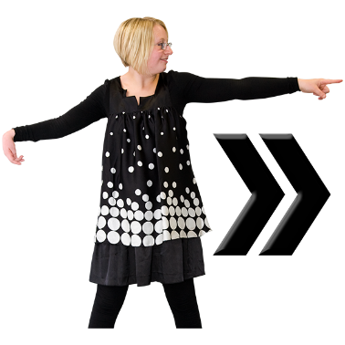
We will be in touch again at the end of July 2017 about what is going to happen next.
Talk to us
?

You can talk to us if you:
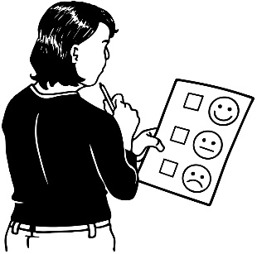
- have any questions

- want to tell us what you think about the work that is being done
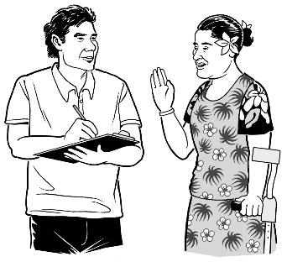
- want to tell us an idea.

Our email address is:
STfeedback@moh.govt.nz

Thank you,
Sacha O’Dea

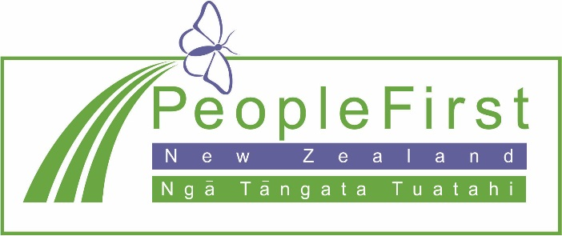

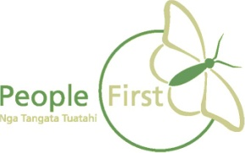
This information has been translated into Easy Read
by People First New Zealand Inc. Ngā Tāngata Tuatahi
