Being able to have a good life in
New Zealand
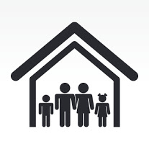

A report to the Minister for Disability Issues
August 2011
Easy Read information
What is this report about?
This report:
- talks about the future
- says what disabled people need to have a good life, like other New Zealanders
- says what changes the government should make for disabled people to have a good life.
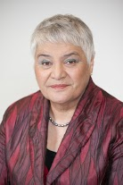
This report was written for the Minister for Disability Issues.

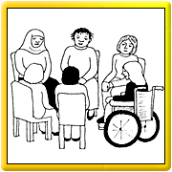
This report was written by a Working Group of people who work in disability organisations:
- Lorna Sullivan from Standards Plus
- Anne Wilkinson from Parent to Parent
- Charmeyne Te Nana-Williams from What Ever It Takes
- Grant Cleland from Workbridge
- John Taylor from Community Connections and the New Zealand Disability Support Network
- Mark Benjamin from SAMS
- Tess Casey from VASS
- Wendy Isaia from SAMS
The report says what the Working Group thinks needs to happen.

The Working Group was asked to look at two things:

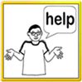
- day services for disabled people

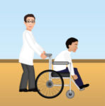
- how disabled people who use day services are supported to get out and about in the community.

The Working Group:
        - said they did not think it was right to just report on what disabled people did during the day
        - thinks it is important to look at the person’s whole life
        - thinks that the way people are supported during the day needs to change.

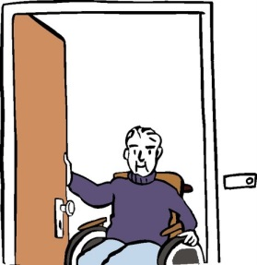
At the moment a lot disabled people go to day bases or day services during the day.

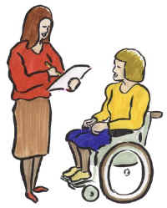
The Working Group thinks that in the future what people do during the day should be different.

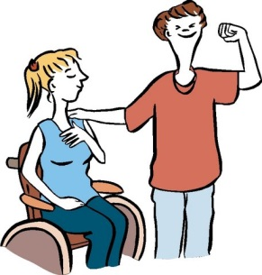
The Working Groups goal is that disabled people have a good life just like other New Zealanders.

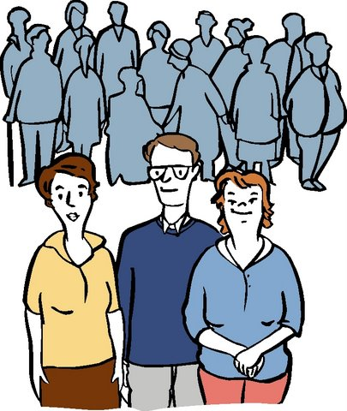
A good life would mean disabled people:
- do everyday things in the community
- will not have to go to special places that just provide support for disabled people
- says the kinds of support they need and makes sure the money for their support is spent on these things.

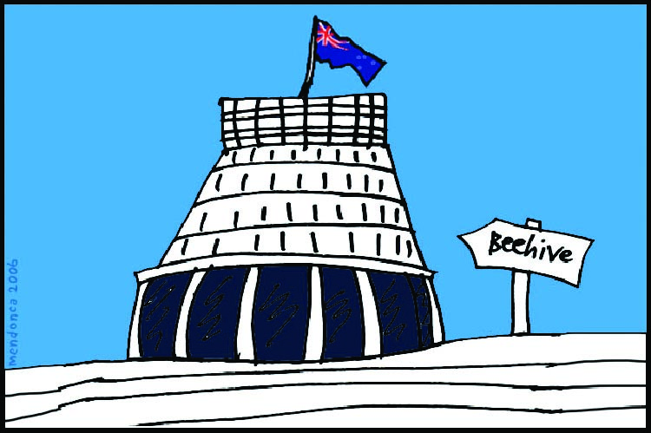
Government support for disabled people
As New Zealanders we:
- expect all people to be included
- have human rights that are protected.

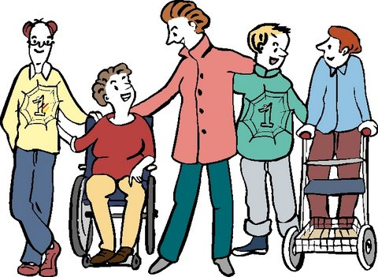
The government must support disabled people to be included in communities.
If the government sees this NOT happening, then something must be done to fix it.

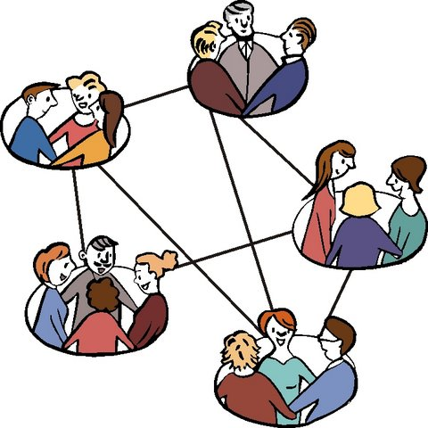
This reports looks at:
- why the government should support disabled people
- what the government should be doing to support disabled people
- how to get disabled people’s support, families and communities working together.

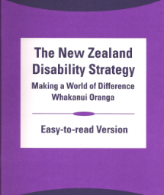
The New Zealand government has 2 important documents they need to always think about. These documents are:

- The New Zealand Disability Strategy

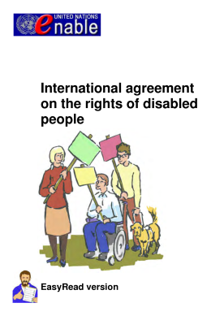
- The United Nations Convention on the Rights of Persons with Disabilities – The Disability Convention.

The New Zealand Government must work hard to make sure the goals in these 2 documents happen so that disabled people have a good life in New Zealand.

Who should get support?

The Working Group thought disabled people should get support if they:
- find it hard to get out and about in the community
- do not have family/whanau to help
- need more support than the family/ whanau can give
- cannot speak up for themselves.

The Working Group said there are some disabled people who need support for everyday things like:
- communicating
- moving around
- looking after themselves
- looking after their families
- making choices and decisions.

The Working Group said the government should provide extra support to make sure disabled people:
- can take part in community
- have opportunities like other new Zealanders
- have equal rights
- are included.

A new way for the future
There has been a focus on supporting people to be included and doing things in the community.

The Working Group said disabled people now want:
- to have more chances to take part
- to be included
- more choices about the people and organisations that can give support
- more control over who gives support.

There are 2 problems with the way support is at the moment:
- day services are being run from centres

- that the way the funding is used can’t be changed.

Some people still think that it is ok for disabled people to go to day services in centres if they do not have paid work.

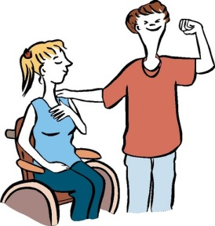
Some disabled people need this level of support.

The Working Group thinks:
- there are people going to day services who don’t need this level of support
- day services supports people in groups and people miss out on doing what they want to do.

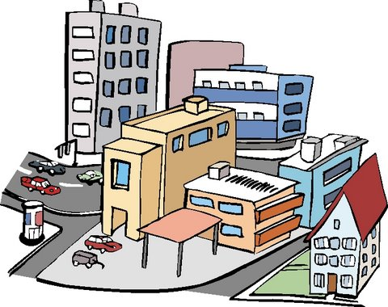
All disabled people would be better off being more included and involved in their communities.

In the future most support will not be based at a day base or centre.

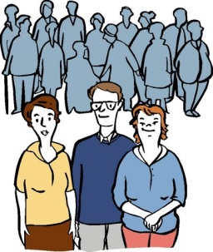
In the future support will be around the person’s whole life.

The Working Group:
- knows that there will still be some people who need day services in a centre
- says any support should be focused on a person, not a group of people.

The Working Group says the new way of supporting people will give disabled people everyday lives, in everyday places.

Goals for supporting disabled people in to the future
The Working Group came up with 10 goals they thought were important when planning support for disabled people:
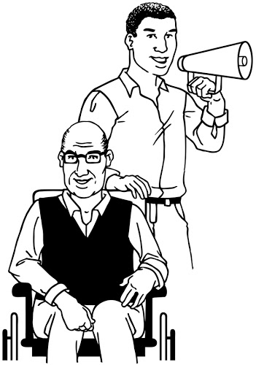
- Control
- disabled people are in control of their lives and who supports them.

- disabled people are supported to set their own goals and take part in activities of their own choice.

- Support
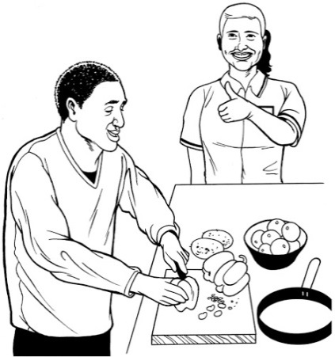
- look at what support a person needs across their whole day, rather than split up the support into the support you need during the day and support where you live.

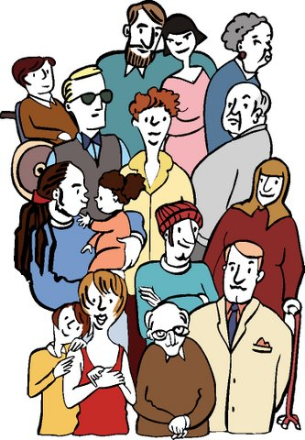
- Having a life
- disabled people and their family/ whanau are supported to dream about what a good life might look like and how this can happen.

- Respect
- what disabled people and their families say is taken seriously.

- support should always be a good experience.

- Being in the community
- services everyone can use are easy for disabled people to get into and use.

- separate disability supports are not the first or only choice.

- Relationships
- disabled people and their families will be supported to connect with other people.

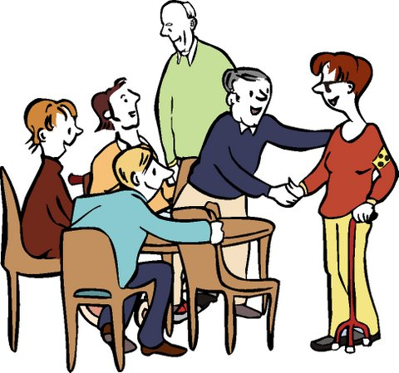
- Inclusive communities
- work with and support communities to be more welcoming and include disabled people.
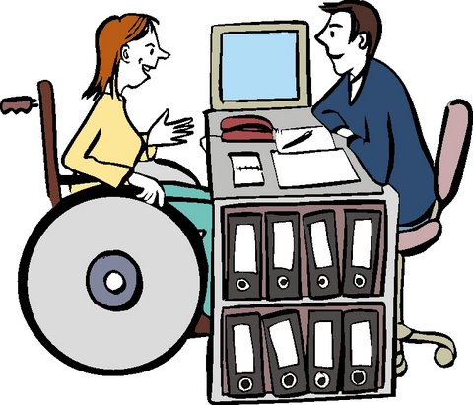
- Support is easy to get
- any supports for disabled people are easy to get, use and understand.
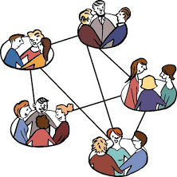
- Start early
- talk to family/ whanau when children are very young.
- support family/ whanau to:
- dream big for their disabled child
- have community networks
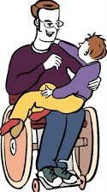
- have support outside of paid support services
- know how to support their child to grow up to be independent, skilled adults.
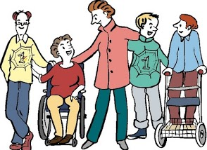
- Have the right support
- support comes in different ways for different people.

- support changes as people’s lives change.

If the new way of supporting people was in place what would be happening?

The new way of supporting people would mean disabled people could have everyday life in everyday places.

The new way would support people to achieve goals in:
- learning new things
- working
- spending time with friends
- having relationships and a family
- taking part in the community
- taking part in cultural activities.

Some important information about the new way of supporting people:
- funding will focus on supporting disabled people to take part in regular community and social activities not day base centres
- people and their family/ whanau will have more choice about the supports they use
- people will do what they want to do during the day
- people don’t have to get up and go to a day base each day
- disabled people will be choosing to use natural supports and community services as a first choice
- supports will look at a person’s whole life and work how where the support is needed
- the money for support comes from one place in the government.

How will it work?
The disabled person will choose a skilled person to help them. This report calls the skilled person a Facilitator. The Facilitator‘s job would be to work with the disabled person to:
- talk about their dreams for the future and set goals
- make a plan to make sure these goals happen
- build and keep up connections to other people
- do things in the community
- use regular services in the community
- say what support they need.
The Facilitator will only do this work. They will not be involved in any other parts of a person’s life.
There will be people checking to make sure the goals happen.
How will the money for supports work?
The money would come from one part of the government.
It would be best if the disabled person had control over how and when the money was used.
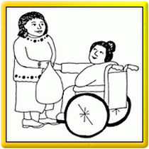
Families/ whanau will be shown how to support disabled people.

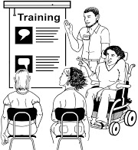
Families/ whanau would be taught about family-to-family support and whanau groups.

There would be money to pay families to do support.
Making the Community better

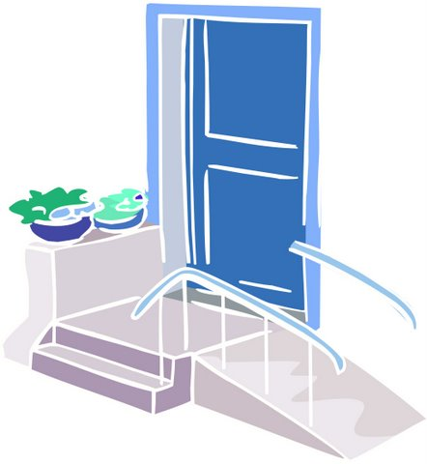
There would be support for community to:
- learn about making buildings easy for disabled people to get into and around in.

- teach bosses how they can support disabled people to be workers in their workplaces.

How will the disabled person and their Facilitator work together?
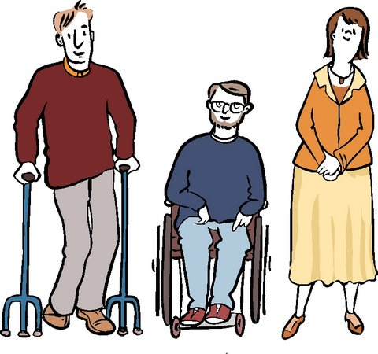
The disabled person with their family/ whanau will choose a Facilitator.

The Facilitator will help the person to speak up about what their dreams and hopes are for the future.
A plan with goals will be written. The plan will have how the goals will happen.

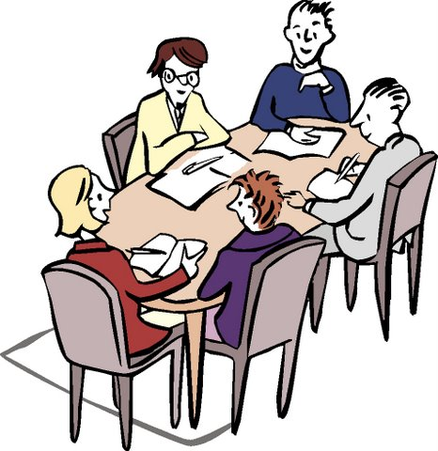
The plan will say:
- where the activities the disabled person wants to do could happen
- where the support can come from
- where natural support can come from
- where there needs to be extra money
- what other kinds of support from the government are needed.

How money for support could be used
Disabled people will have their own money for support.
The Working Group thinks money for support should match people’s needs and the goals in their plan.

Making the change to giving the money for support to disabled people needs to happen carefully so that services supporting disabled people can keep going.

Making the change to having a Facilitator
Services will be asked to work towards the 10 main goals in this report.
People who use day services can change to having a Facilitator work alongside them.

People could make the change themselves and don’t need the service provider or agency to do it for them.

This model of funding is a lot like the New Model for Supporting Disabled People that the Ministry of Health has been using.

Getting started
The people who could start using the new way of supporting people could be:
- young disabled people leaving school or who have not long left school

- disabled people living in certain parts of New Zealand

- disabled people living in Christchurch because of the changes after the earthquake

- people working in services that have shown they want to try new ways of working.

The first steps to take
Talk about the changes with:
- disabled people
- families/ whanau
- the wider disability sector.

Talk about:
- why change is needed
- how the new way of supporting people will work
- who will be involved
- when it could be started
- where it will be started.

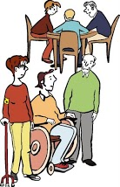
Disabled people and their families/ whanau have wanted this kind of support for long time.

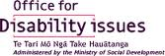
Recommendations – what should happen
The Working Group asks the Office for Disability Issues to:
      - Agree that the 10 main goals for supporting disabled people should be the way that all disability support is provided in New Zealand.
      - Share the 10 main goals with disabled people, families/ whanau, disability support providers and other funders.

      - Support the ideas in this report –the change from people having to go to day services in a centre to people getting support how and where they want it.

      - Use the new way of supporting people with each disabled person to make a plan.
Support disabled people to make the decisions about their everyday lives.

      - It is important to understand that the new way of supporting people means:
- each disabled person has a Facilitator
- the Facilitator supports the person to make a plan
- each disabled persons plan says what they want their life to be like, what the goals are and what needs to happen to make sure the goals happen
- there is support for the family/ whanau
- the Facilitator will help the disabled person and family/ whanau to connect to services in the community
- the Facilitator will also connect with any government agencies.
      - Talk to the wider disability sector about the new way of supporting people. Ask them how they think this could happen.
      - Fund the new way of supporting people. Join the money for support from the Ministry of Health and Ministry of Social Development together.

      - Spend time training and helping support services to get ready for the change to the new way of supporting people.
Training

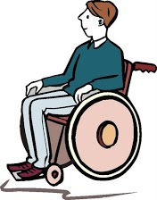
      - Start using the new way of supporting people. Let services start as soon as they are ready.

Start with:
- services who are already trying new ways of supporting people
- young disabled people coming out of or just out of school
- disabled people in Christchurch.

      - Make sure there is a good system for checking how the new way of supporting people is working.
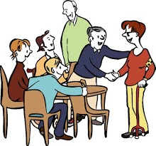
- have ways to talk to family/ whanau.
- have ways for people to say if there are problems with the new way of supporting people.
- have ways for people to say if they think there is anything missing.

3 important things that also need to happen to make sure the new way of supporting disabled people works well
- Have strong leadership from disabled people.

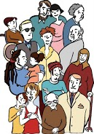
- Disabled people, their families/ whanau and supporters must work together to make it a success.

- Disabled people, their families/ whanau and supporters should be the people making sure the project is working well for disabled people.

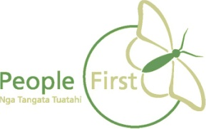

This information has been translated into Easy Read by People First New Zealand Inc.

