‘System Transformation co-design process’
June 2017 Cabinet paper

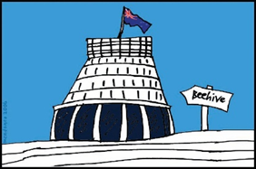
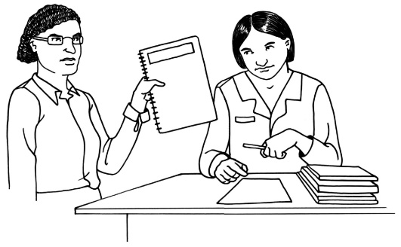
Easy Read
information
Before you start

This is a long document.

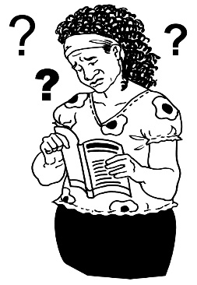
While it is in Easy Read it can be hard for some people to read a document this long.

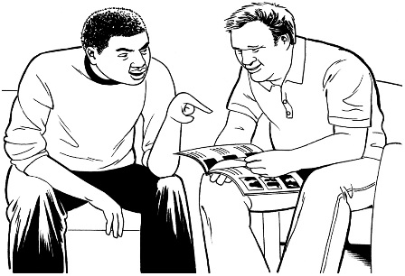
Some things you can do to make it easier are:
- read it a few pages at a time
- have someone to assist you to understand it.

What is in this paper?

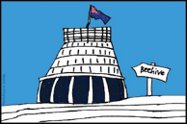
Page

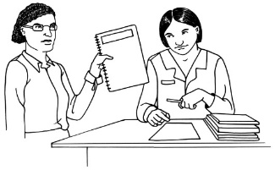
What is this about? 4

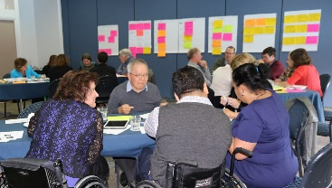

Point 1: About the plan 7

Point 2: What is in the plan? 9

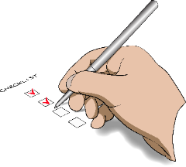
Point 3: How to make sure the 20
system works

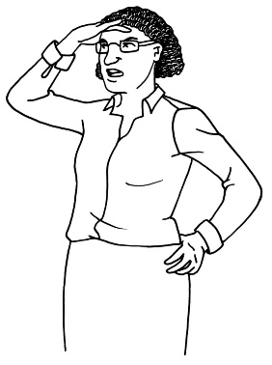

Point 4: Checking the new system 28

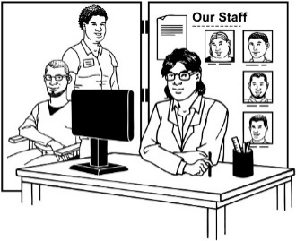
Page
Point 5: What the changes mean 29
for agencies

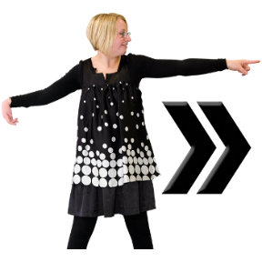

Point 6: Future work 30

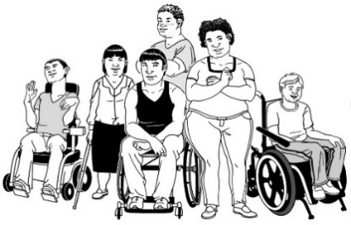

Point 7: Working with the disability 32
community

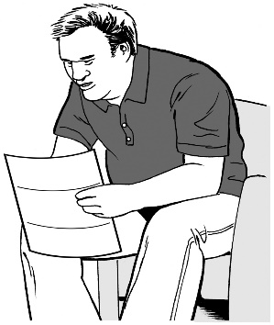
Point 8: A note from the co-design 35
group

What is this about?

This document is about the main points of a Cabinet paper.

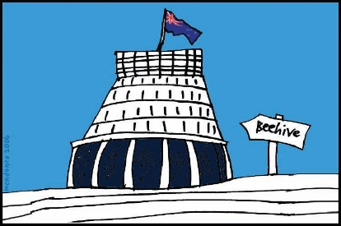
Cabinet is a group of senior Government Ministers.

A Cabinet paper has information in it that Cabinet needs to:

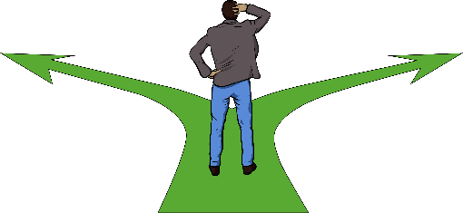
- know

- make a decision about.

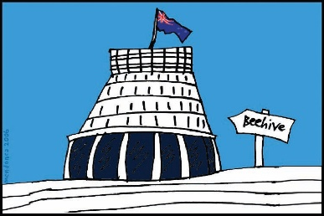
This Cabinet paper is about plans for a new disability support system for New Zealand.
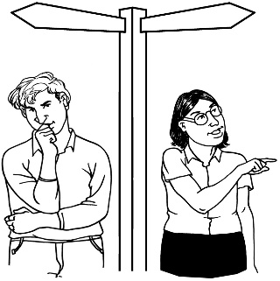

The long name for this is system transformation.

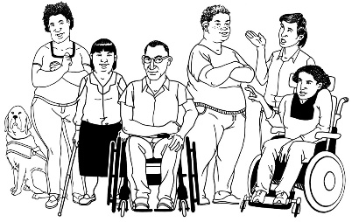
The Government has said it will plan the changes to the disability support system together with:
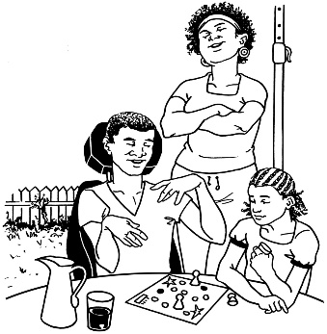
- disabled people

- family / whānau
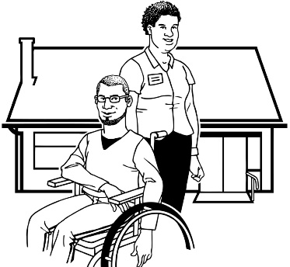
- disability support services.

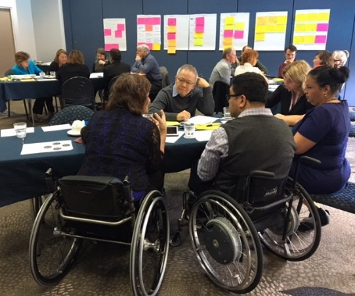
Working together like this is called co-design.

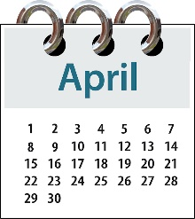
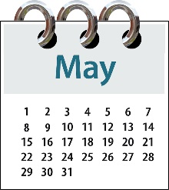
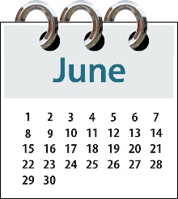
A co-design group has been working on the plan for a new disability support system since April 2017.

This Cabinet paper will show Cabinet the plan for the new disability support system.

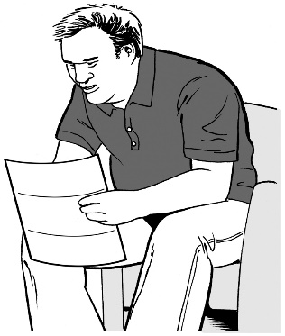

Keep reading to find the main points from the Cabinet paper.

Point 1: About the plan

The plan for a new disability support system has been made by:
- disabled people

- family / whānau

- disability support services

- government workers.

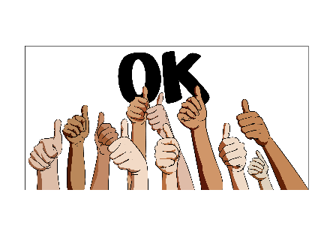
This means the plan is more likely to work than if it was only planned by government workers.

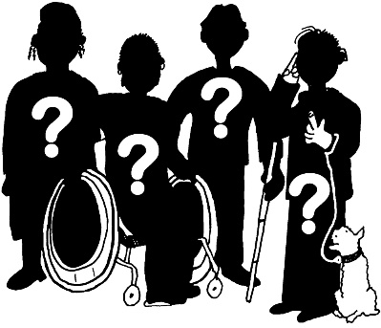
Disabled people are not all the same.

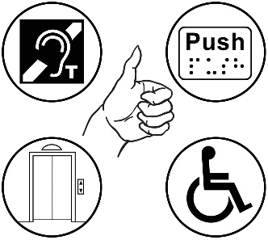
The co-design group has worked hard to make sure all different people and groups have been thought about.

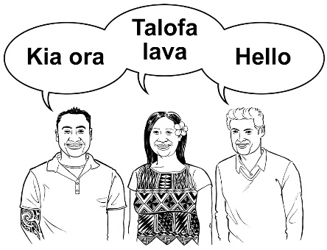
Having so many different people work on the plan means the plan should be good for more people.

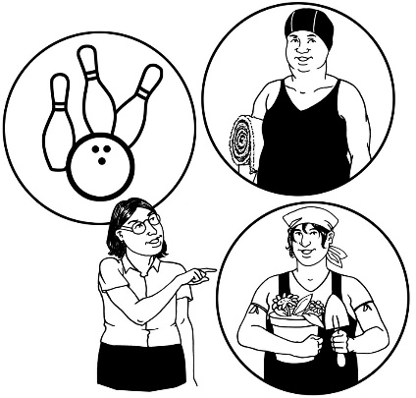
The new disability support system will mean disabled people and their families / whānau have more choice and control over their:

- lives

- support.

Point 2: What is in the plan?

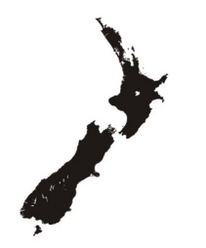
The new disability support system is going to be tried and tested in the MidCentral region first.

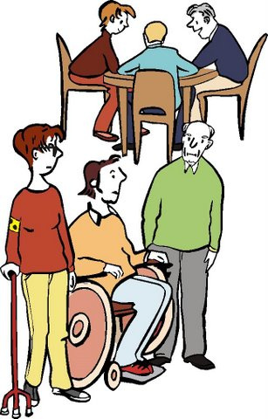
While the system is being tried and tested it will only be able to be used by people who:

- get funding and support

- live in the MidCentral region.

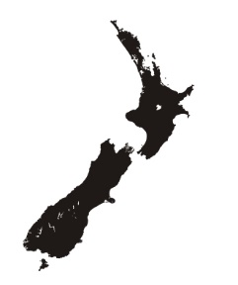

After the testing has been done and the new system is ready it will start up in other parts of the country.
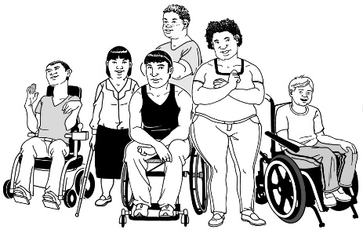
When the new system is working all over New Zealand it will be there for all disabled people – not just the people who get funding and support.

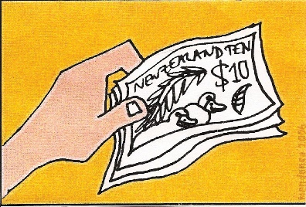
Funding means:
The money the Government gives for disabled people to be able to get the support and the things they need for their disability.

The new disability support system will:

- give the same advice and support all over New Zealand

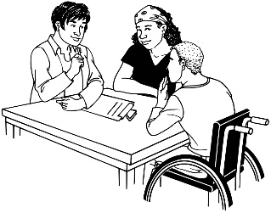
- be easy to get in contact with by:

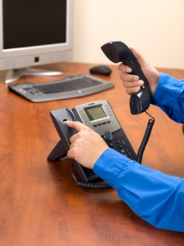
  - talking to someone face-to-face

  - phone

  - email

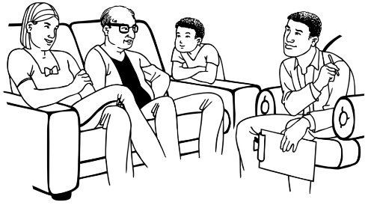
- try to get in contact with all disabled people and their family / whānau to let them know what support they could get

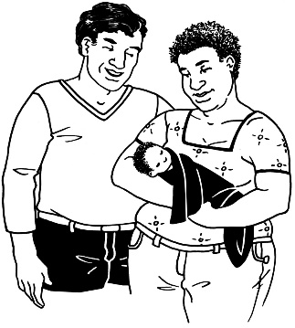
- get in contact with disabled people and their families / whānau when they first find out about the disability.
The new disability support system will also:
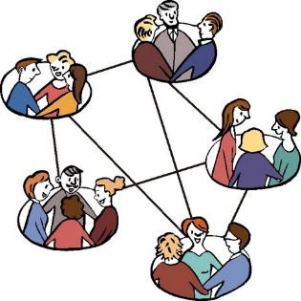
- have groups of disabled people and family / whānau that can connect with each other

- have a digital hub – this would be online and would be a place where you could get lots of information and support.

Online means on the internet.

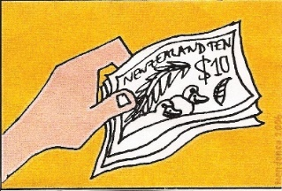
In the new disability support system there will be funding for making sure disabled people and their families / whānau:
- are strong

- can get the support and things they need.

There will also be funding for making sure disabled people:

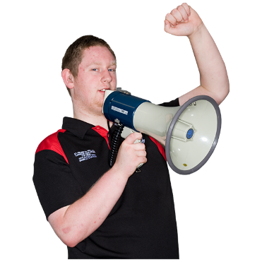
- can be leaders

- can speak up about things that affect disabled people.

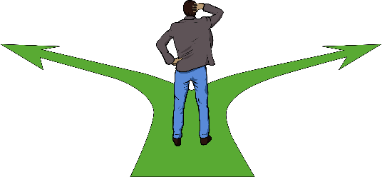
The ways that people use the new disability support system will be different for everyone.

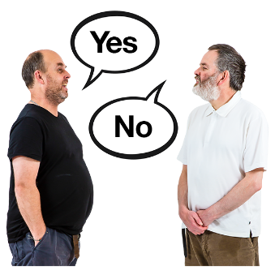
In the new disability support system disabled people and their families / whānau can decide:

- if they want to use the system
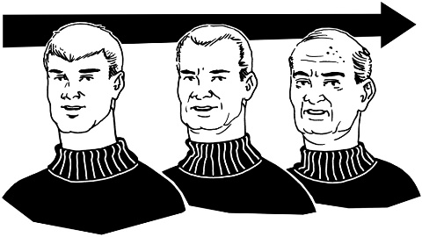
- when is a good time for them to use the system

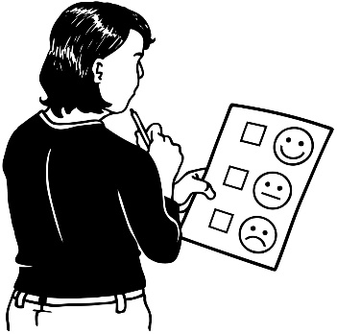
- what parts of the system they want to use.

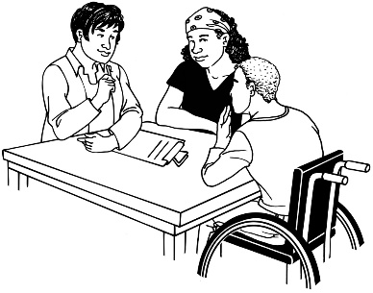
Disabled people and their families / whānau will be able to have an EGL connector / tūhono to work with if that is what they want.

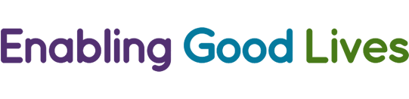
EGL means Enabling Good Lives.

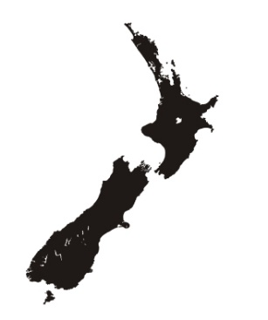
Enabling Good Lives is a way of giving disability support that has been tried in some parts of New Zealand.
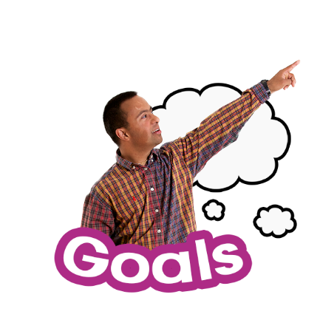

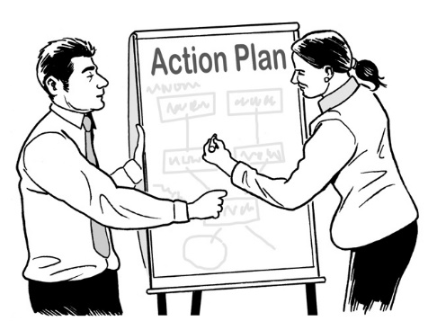
The job of an EGL connector / tūhono is to work with disabled people and their families / whānau to think about:

- what they want for their life

- how to make it happen.
Disabled people will be in control of their own information in the new disability support system.

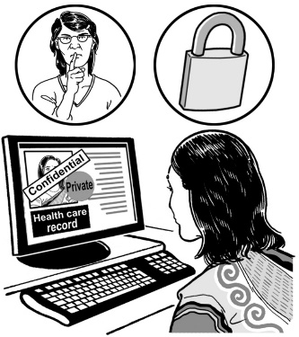
Disabled people will be able to:

- see the information about them

- choose who can see the information about them

- use the files about them to record:

  - their goals

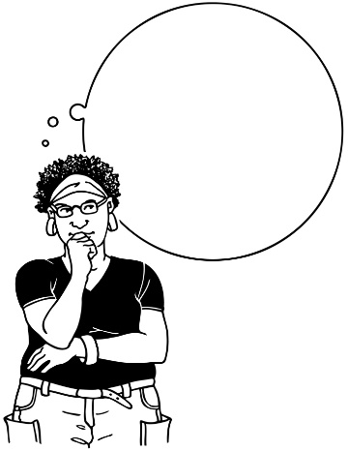
  - what is working and what is not working

  - what tools they found helpful.

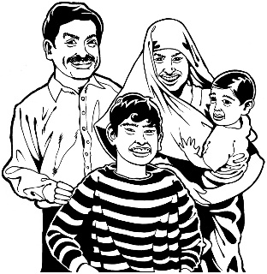
In the new disability support system there will be funding for:

- support for disabled people and their families / whānau

- making sure disabled people and their families / whānau know how to use the system

- doing things that will help people over a long time
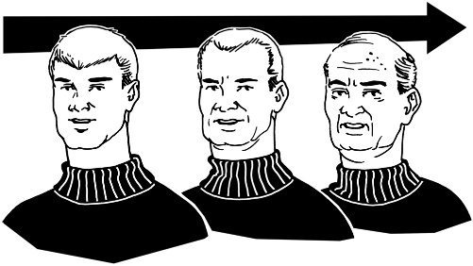
- supporting people in a way that may cost less if you look at it over a long time

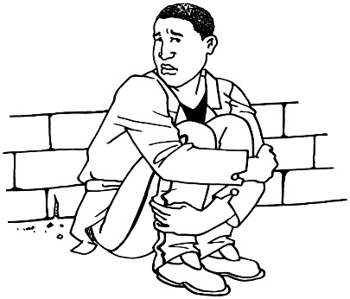
- disabled people and their families / whānau to get help fast if they have a very bad problem.

There will be an Enabling Good Lives’ Team in the new disability support system.

In the Team there will be:
- EGL Connectors / Tūhono – the people who will work with disabled people and their families / whānau
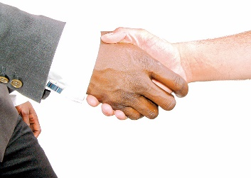
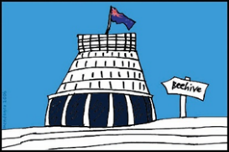
- Government connectors – people who work with government agencies to make sure government services work well together
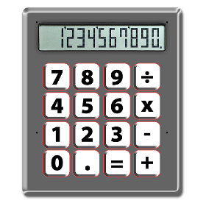
- Regional funding management teams – groups of people who will work to look after the money of the new disability support system

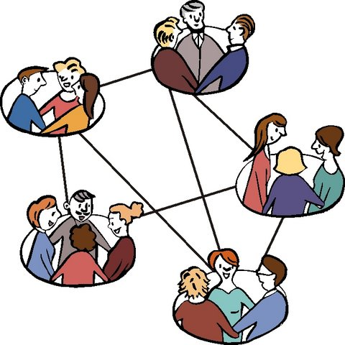
- Network builders – workers who will support Connectors / Tūhono to help disabled people have more people in their lives.
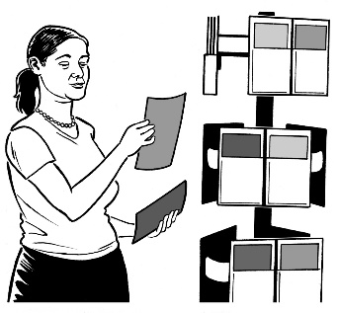
In the new disability support system there will be support to understand the values of Enabling Good Lives for:

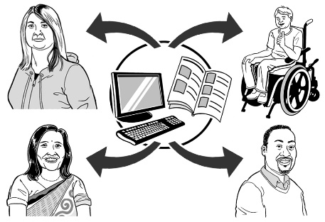
- Disability service providers

- people who work in the disability support system.

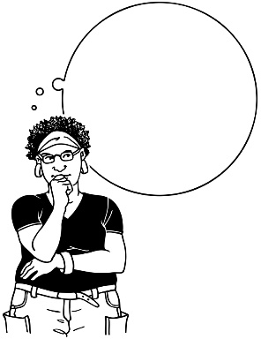
Values are important ideas.

This support will help these places to understand how to work in an Enabling Good Lives way.

Point 3: How to make sure the system works

There are some important things that must be done to make sure the new disability support system works well.
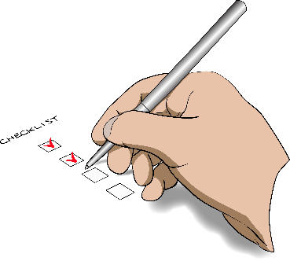

Here is a list of those things.

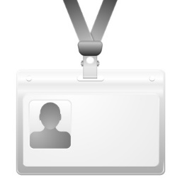
- The new system must have a new brand.
?

What is a brand?

A brand is:
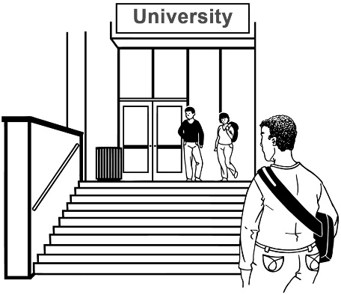
???????
  - a name

  - a logo

  - what people think of when they see it.

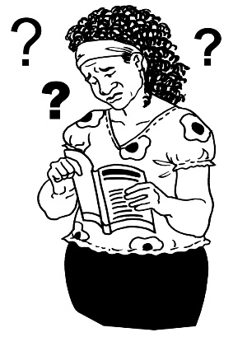
When the new brand is getting made it will be important to think about:

- what the disability community will think of it
- Enabling Good Lives.
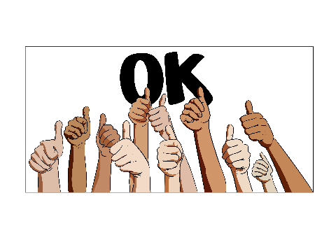
- The new system must be able to change so it works for different cultures.

What is culture?
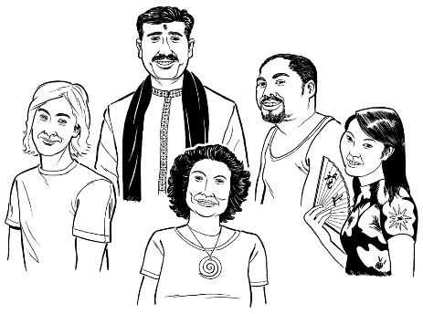
Culture is a way of thinking and doing things as a group.

There are many different cultures in New Zealand.

For example: Māori culture and Deaf culture.

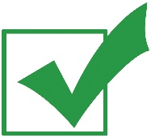
The new system must make real the rights in the Treaty of Waitangi / Te Tiriti o Waitangi.

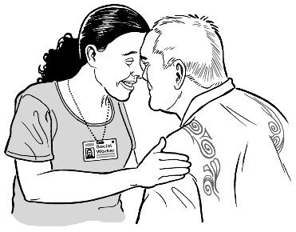
The new system must try to make groups who do not use the disability support system very much feel welcome.
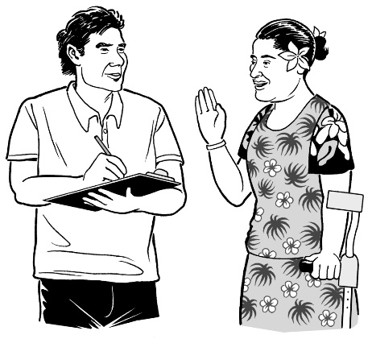

For example:

- people from Pasifika cultures

- people from Asian cultures
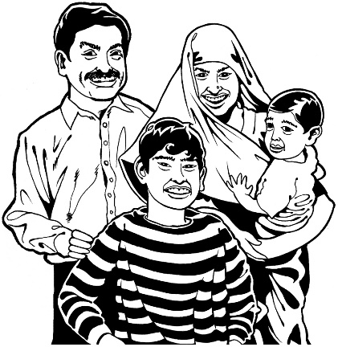
- other groups of people who have moved to New Zealand.

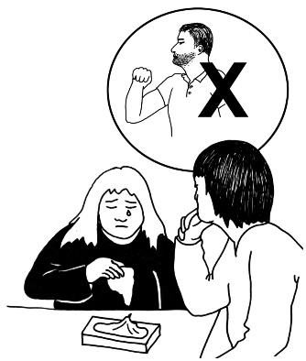
- The new system must make sure disabled people can make their own choices in a way that keeps them safe from abuse.

This is called safeguarding.

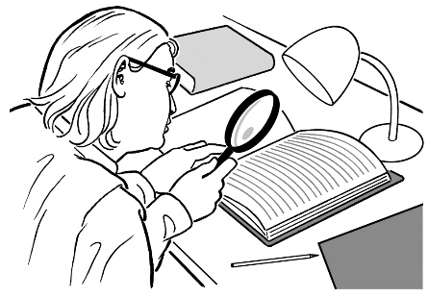
Some of the things that could be done are:

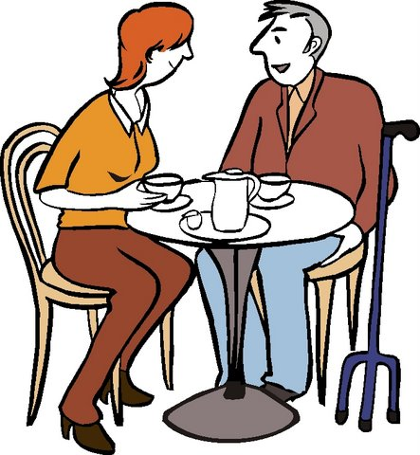
- Checking what is happening to people in the system

- Supporting disabled people to have good relationships

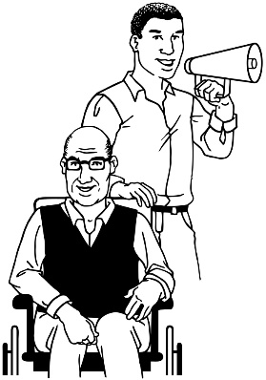
- Teaching people about keeping safe

- Advocacy services

- Having rules for services.
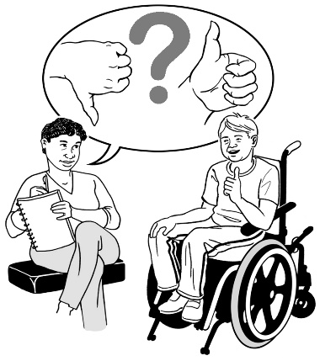
- It is important that we find out if the new system is working.

We will get this information from:

- disabled people and their families / whānau

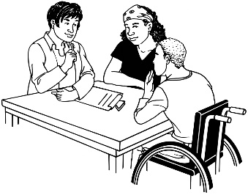
- government agencies

- other people working in the new system.

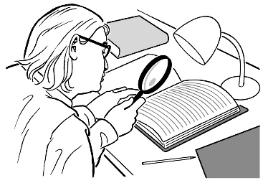
We must look at this information.

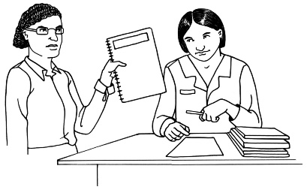
We must keep this information.

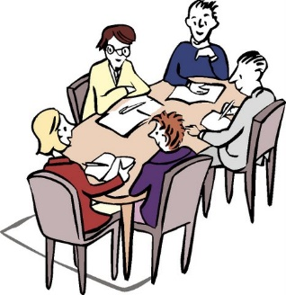
- We must make groups to look at the information we get about the new system.
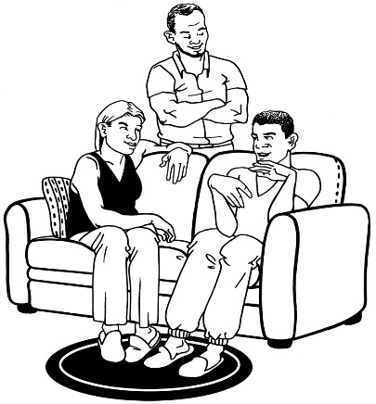

These groups must have disabled people and family / whānau in them.

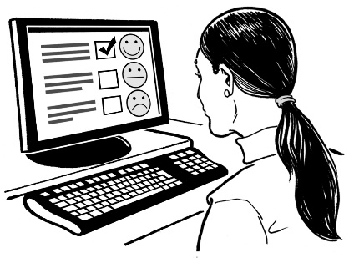
These groups will tell us:

- what is working in the new system

- what is not working in the new system

- what things in the new system need to change.

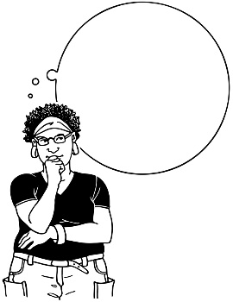
- The new system must work in a way that:

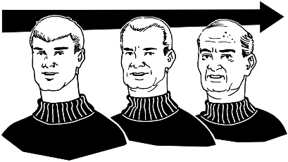
- thinks about how funding and support now can make a person’s life better later on

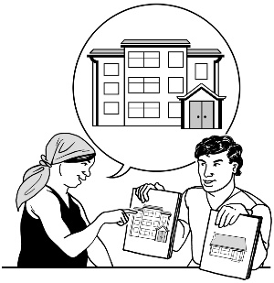
- makes sure disabled people and their families / whānau are the ones making most of the decisions.

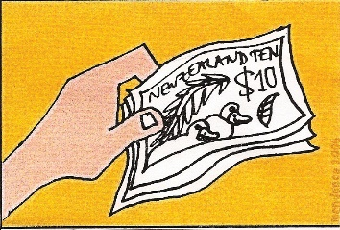
- There must be good plans in place for looking after the money in the new system.

It is important that the money is being used in the best way for disabled people and their families / whānau.
Point 4: Checking the new system

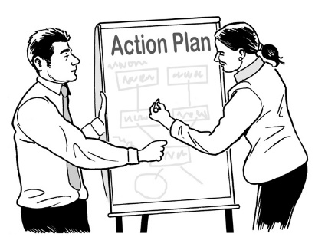
There will be a plan for how to check the new disability support system is working well.

The system will be checked many times while we move from the system we have now to the new system.

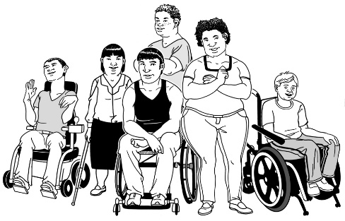
Groups that will be part of the checking:

- the disability community
- government agencies, like the Ministry of Health.

Point 5: What the changes mean for agencies

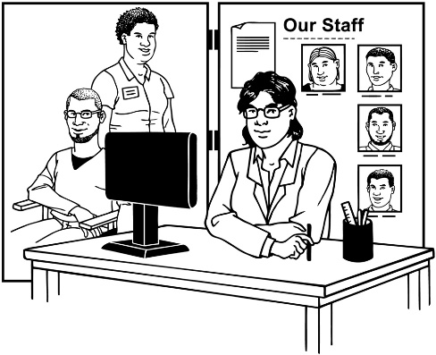
Having a new disability support system will mean big changes for:

- places that decide how much funding and support people can get
- Disability support providers

- government agencies.

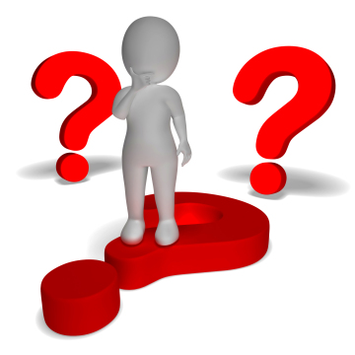
All of these places will have to learn new ways of working.

Point 6: Future work

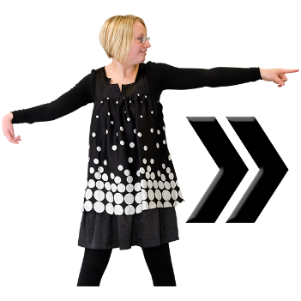
Next we need to work on:

- planning every little part of the new system
- testing the plan for the new system.

We will test the new system by:

- trying it in the MidCentral region
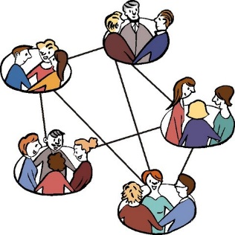
- doing background work to make sure the system works for different groups

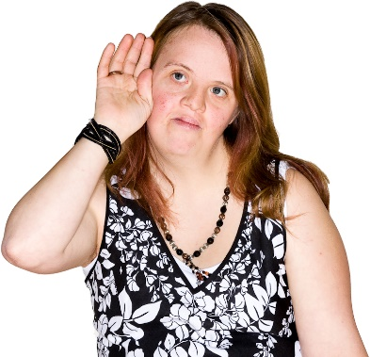
- getting information on what is working and what is not

- the work of the National Enabling Good Lives Leadership Group

- the work of the MidCentral Leadership Group

- making sure everyone that is part of the new system knows what to do and how to do it

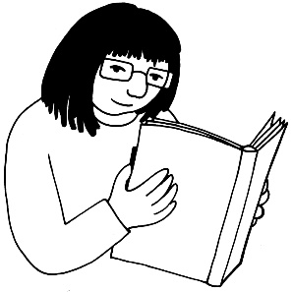
- getting information out to the disability community quickly through the media, like Facebook and the newspapers.
Point 7: Working with the disability community

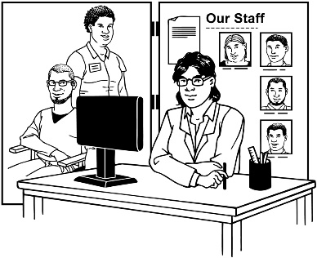
Staff from government agencies will do much of the work to get the new system up and running.
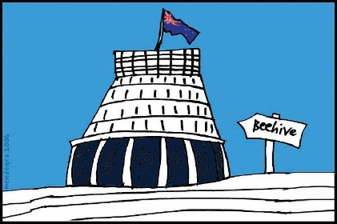

The disability community will also help to get the new system up and running.

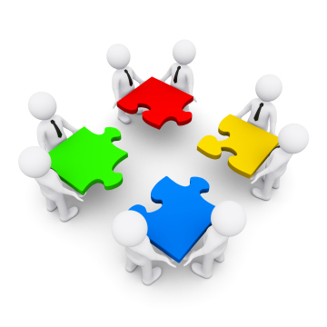
The 2 groups will keep working in a co-design way.

Co-design is where the Government works together with:
- disabled people

- family / whānau
- disability support services.

Co-design will still happen through the work of the:
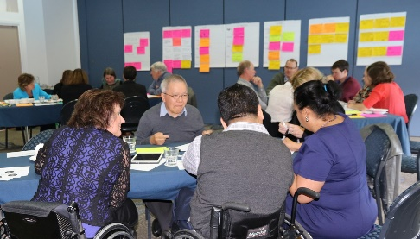
- Co-design group that worked on the plan for the new disability support system
- National Enabling Good Lives Leadership Group

- MidCentral Leadership Group.

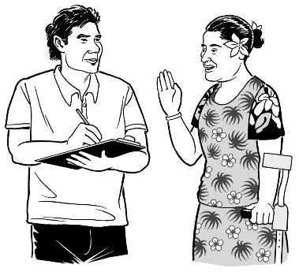
Other groups from the disability community will also be working with staff from government agencies.

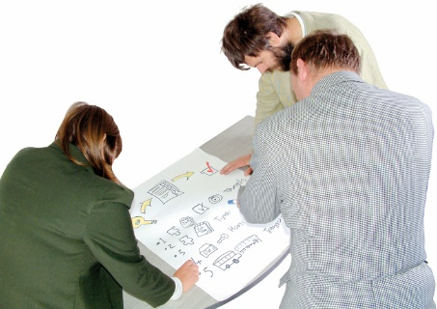
They will be working on the plan and testing the system.

Point 8: A note from the co-design group

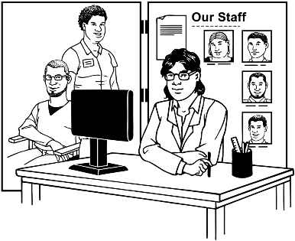
The Disability service providers who are on the co-design group want to say a few things:
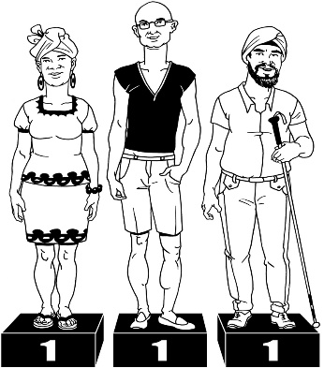
- being on the group worked really well for us

- we always felt like we were an equal part of the group

- it took a little while to get used to the way that the design company ThinkPlace worked

- we think we have all made a good plan for a new disability support system for New Zealand

- we think it is very important to have disability service providers as part of any more work that is done
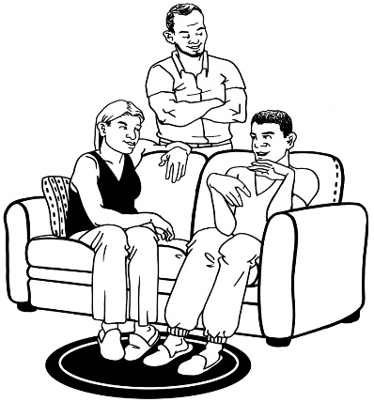
- we think it is also very important that any future work on the new system keeps working with:

  - disabled people

  - families / whānau.

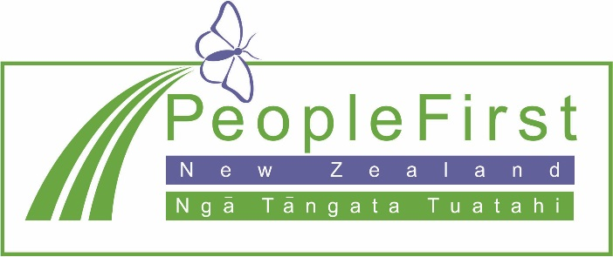

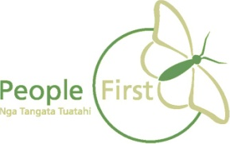
This information has been translated into Easy Read
by People First New Zealand Inc. Ngā Tāngata Tuatahi
