APPENDIX ONE: CO-DESIGN PACKAGE

Table One: Diversity Factors within the disability community
 | Not willing to engage, share or disclose (reasons include privacy, savviness of system, distrust, tikanga, resisting another label, hoha, whakamā, discomfort of assessment process, embarrassment, to protect a dysfunctional family) |  | Willingness to engage, share or disclose (trust/comfort with the system + people)
 | Captured or limited by prolonged struggle and focus on what is not possible - leading to lack of dreams and confidence |  | Strength-based with a focus on what is possible — can dream, feels confident to search for creative solutions
 | Dysfunctional, potentially abusive, isolating family environment with low or detrimental family capability |  | Resilient, upbeat family with strong communication skills and problem-solving capabilities
 | Supported by paid people who provide service-centred services, and have deficit mindset |  | Supported by paid people who are well trained and a person-centred, strengths-based view of the person they are supporting
 | Needs support or interpretation to process information |  | Can process information independently
 | No access or confidence with technology |  | Confidence, ease and access to technology
 | Needing help to provide/authorise consent |  | Can authorise consent independently
 | Needs time and support to make decisions |  | Can make decisions without assistance
 | Always coming up against a  non-inclusive context, community and system |  | Immediate social, environmental, employment, education context is authentically inclusive
 | Impairment fluctuates or is progressing to a greater impairment |  | Impairment is stable; needs are predictable and stable
 | Emerging sense of identity, not knowing where you belong yet |  | Strong sense of identity, and a feeling of belonging/whakawhnaungatanga
 | Person lacks diagnosis and therefore has not clear funding/medical pathway |  | Person has a clear diagnosis and a funding/medical pathway
 | Little or no access to service and support, or only access to low quality services |  | Good access to quality service and support
 | Little options and opportunities for contribution and purpose |  | Options and opportunities for contribution and purpose
 | Does not have a means of having voice heard |  | Has a means of having voice heard
 | Under developed and under resourced peer networks creating an isolated environment |  | High functioning, well-resourced peer networks that enable participation and contribution to society
 | Tikanga is paramount |  | Tikanga is not paramount
 | Experiencing anger, guilt and grief |  | In a position of moving on with life
 | Impairment developed/not an accident |  | Impairment caused by injury
 | Impairment is less apparent, visible and/or recognised |  | Impairment is apparent, visible and/or others see need for support
 | Compounding factors (impairment, family and other contexts) are create a downward spiral |  | Environmental, family and impairment factors allow for personal growth
 | Only engages with universal services, but not Disability Services |  | Engages in a multitude of government services
 | Only engages with disability services |  | Interfaces with a multitude of government services and agencies
 | Parents are loving and protective but not tapped into the system and therefore not informed |  | Parents are loving and protective
 | Parents/carers are risk adverse and protective |  | Parents/carers support the individual to be self-actualising adult
 | Parent experience, and therefore lack of options related to being a parent of able-bodied children |  | Is not a parent and therefore no need for care and consideration of children
 | Attitudes and actions that support independence of children and welcomes calculated risks |  | Attitudes and actions of parenting style are risk adverse
 | Options to lead a quality life limited by poverty |  | Options to lead a quality life available by financial position, and financially stable
 | Housing is inadequate |  | Housing is fit for purpose and feels like a ‘home’

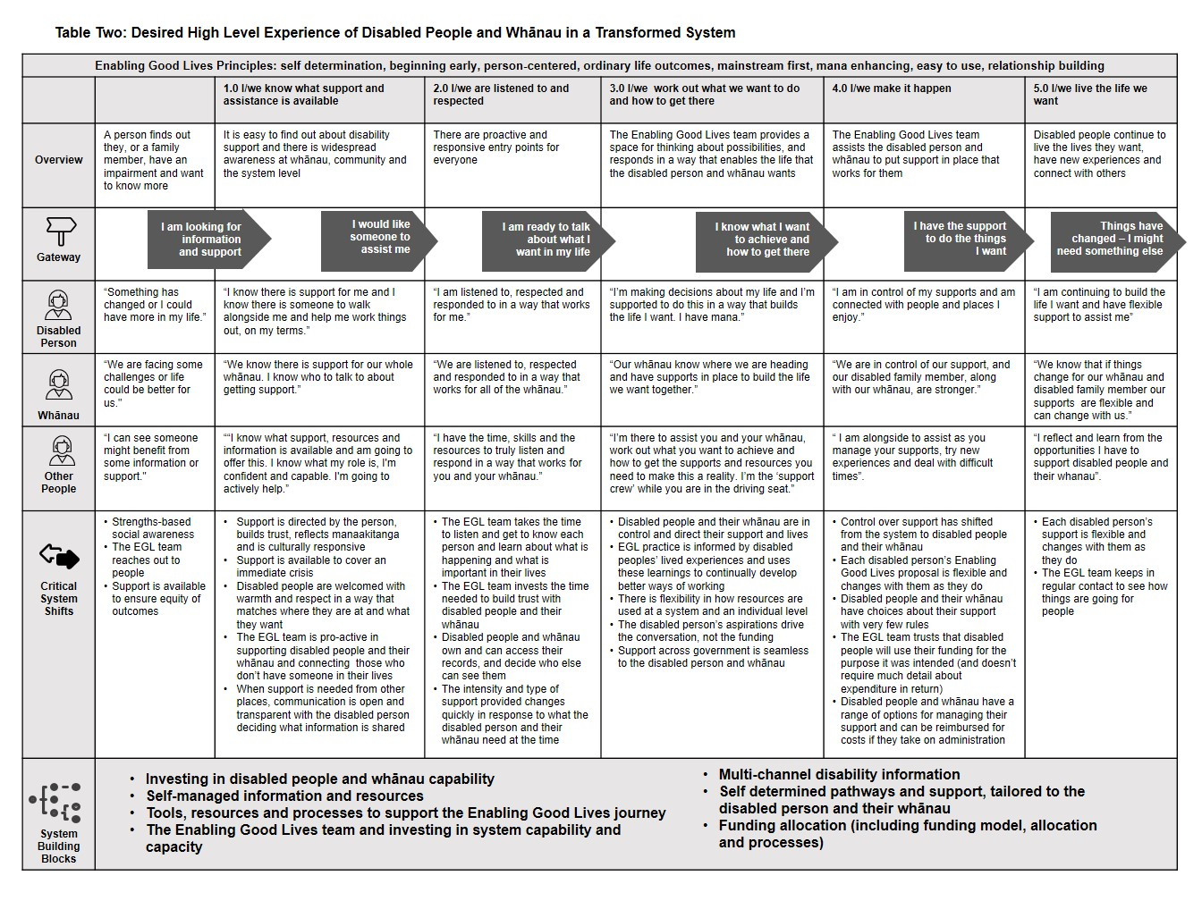

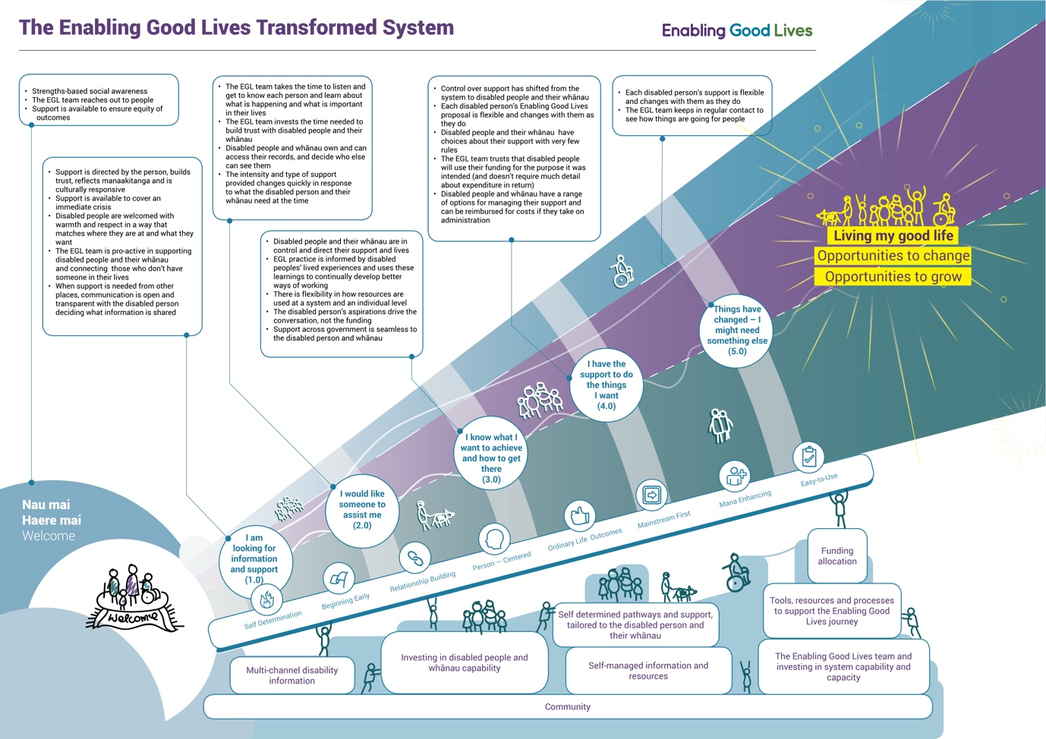

Table Four: Building Blocks and Underpinning Elements of the Transformed Disability Support
System Building Blocks | Underpinning System Elements
A responsive and accessible multi-channel disability information system which provides information about disability and the range of support available. This includes mainstream services and support in the community, as well as specialised disability support. It includes:  - outreach to disabled people and whānau who do not currently access disability support or are unaware of the possibilities (eg vulnerable families who are not engaged with services);  - follow up and proactive contacts when someone first receives advice that they, or their child, has a long-term impairment;  - peer and whānau networks;  - face to face local options, communication by phone or email; and  - an accessible digital hub that is available on a range of devices. | A distinctive identity (i.e. a ‘brand’) that the disability community identifies with, feels ownership of, and will contribute to its success. The brand - which is likely to reflect the strong ownership of EGL within the disability community - will build awareness of the system and of the disability community, and provide a platform for messages, news and information, as well as helping to create connections within the disability community and across government systems.
Investment in the capability of disabled people and whānau at a national and regional level to expand the range of options and possibilities they are able to envision, and how effectively they are able to put them into practice. This includes building the capability and leadership of people within their cultural networks. Experience with the Waikato demonstration has shown how essential building the capacity and capability of disabled people and whānau is to transforming their lives. | Cultural responsiveness, which is about ensuring that the system engages with, understands, and responds effectively to valuing to each disabled person and their whānau. Particularly significant elements will include a recognition that the Treaty relationship underpins the relationship with Māori, the strong cultural identities of some disabled people, particularly the Deaf community, and groups such as Pasifika peoples, migrants and refugees, and the Asian community, who use the current system less than other groups.
Disabled people and whānau determine when and how they engage with the range of pathways that are responsive to their particular situation – how much thinking they have done about their lives, the pace they want to progress through the system, the strength of their networks, the support required for decision making and their cultural values and context | Safeguarding arrangements, which is about disabled people making life choices while being able to experience same level of risk as other people. This approach, which is considerably broader than the focus on regulating for provider safety under the current Health and Disability Services (Safety) Act 2001, is described further in Appendix Two.
Self-managed information and resources in a range of formats that disabled people and whānau are able to create, manage and control access to. The resources include tools for: for creating their vision and how they want to get there; finding out what community support is available; recording outcomes; and managing the resources they use. | Outcomes monitoring, which involves gathering and analysing qualitative (rich and in-depth about individual disabled people and whānau) and quantitative (summary information across population groups) information about the system’s impacts on the lives of disabled people and whānau. This would be complemented by the collection and analysis of information on how well the system reflects the EGL vision and principles, and how other government agencies are engaging with the transformed system.
Funding model and allocation process: This includes the funding model and processes to access disability support funding. Funding will be available for:  - disabled people and whānau capability and capacity building;  - ongoing support for disabled people and whānau; and  - investing to improve longer-term outcomes or reduce longer-term costs;  - to support a disabled person and whānau to move out of a crisis | A responsive system where national and local governance groups with disabled people and whānau representation use data analytics and system insights to monitor outcomes for disabled people and whānau and to identify and continually improve the system
An EGL Team, which includes:  - EGL Connectors or Tūhono, who, when invited, walk alongside disabled people and their whānau when responding to crises and on their journey of planning and building the life they are seeking using the full range of available resources, including family, community, mainstream services and specialist disability support.  - Government connectors, who are back-office workers who work with EGL Connectors and other government agencies, and the services and support they offer, to assist disabled people and whānau to access the full range of government services and support in a seamless way.  - A regional funding management team, which includes disabled people, which gathers the information needed for, and make, decisions on funding allocations with disabled people and whānau (including social investment funding), and monitoring individual and system level expenditure; and  - Network builders who work with EGL Connectors by provider tools and guidance for growing and developing networks, supporting EGL Connectors to find advocates and provide support to rebuild connections with whānau. | Social investment arrangements, which are about encouraging decisions that:  - better meet immediate needs and achieve benefits across a person’s life course (e.g. early investments may lead to better outcomes and lower costs and risks in the future); and  - reflect the cross-government impacts of disability (e.g. better support might lead to a person getting a job and moving off benefit, while a lack of support might contribute to poor life outcomes generally).  The transformed system will devolve most commissioning decisions to individual disabled people or their whānau. Some capacity will be maintained for regional funding managers to suggest or further invest in services that will intervene early where data analytics suggest there would be significant future benefits. The details of the social investment approach will be further developed in tandem with the precise funding allocation and outcomes monitoring arrangements.  There is potential for a social investment approach in the transformed system to deliver significant returns over time. Initially, these are likely to come from:  - fewer people entering residential care avoidably; and  - improved employment outcomes for disabled people and their whānau.
Investment in provider, workforce, NASCs and system capability and capacity so they can work in ways that are consistent with the EGL vision and principles. | Financial management arrangements, which provide assurance that the system is being managed in a financially sound and sustainable way, and that resources are being used cost-effectively to improve outcomes for disabled people and their whānau.

Appendix Two: Safeguarding Framework
- The safeguarding framework was co-developed by a Working Group of officials and representatives from the disability community which was reviewing the current regulatory regime under the Health and Disability Services Safety Act (2001). The Working Group envisaged that the safeguarding framework would become integral to a transformed disability support system. That approach was supported by the system transformation co-design group and the EGL National Leadership Group.
- The Safeguarding Framework is summarised in the following diagram.

Diagram One: The Spectrum of Safeguards
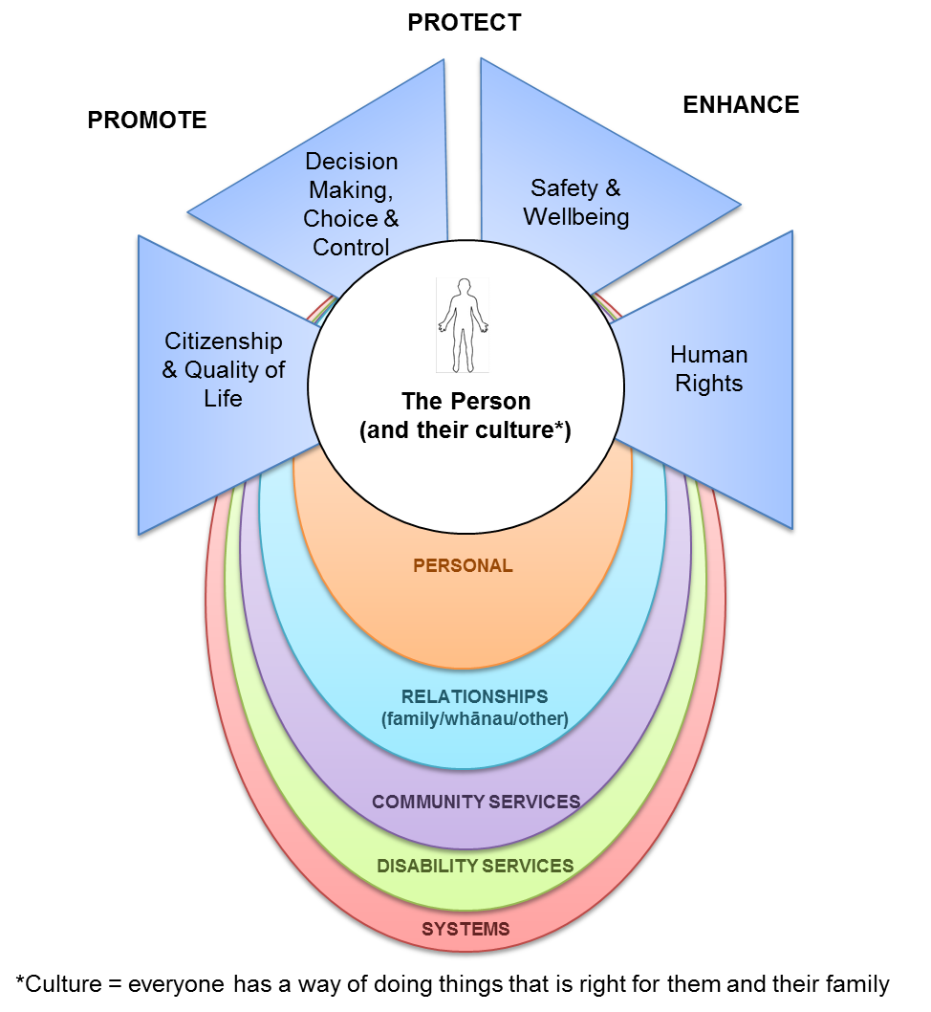

Levels of Safeguarding
- There are several levels of safeguarding in the framework:
  - Personal safeguards focus on a person building up their skills, knowledge, opportunities for learning through living life, communication, self-advocacy and decision-making, physical independence, financial security, personal worth and identity and security of home.
  - Relationship-based safeguards focus on strengthening current, and building up new, relationships with people that the disabled person and their family and whānau have regular personal contact with, who care about their wellbeing, and who can (when necessary) support them to communicate with others and have their voice and self-determination respected.
  - Community-based safeguards are the mechanisms or services available to all citizens to respond to the risks that they may face, for example the Police, or the Citizen’s Advice Bureau.
  - Disability services safeguards focus on building up people’s ability to live an everyday life and putting in place mechanisms to protect them against the risks that arise within the disability support system. Possible mechanisms include legislation, regulations, funding and purchasing arrangements, independent facilitators and monitoring arrangements.
  - Broader system safeguards include the many things that focus on promoting the person’s ability to participate in the community generally, and protecting them from the risks of harm that arise in the wider community through legislation, regulations, policy and other mechanisms that have a broader focus than disability support.
- The Spectrum of Safeguards places the person at the centre with systems of support and safeguarding around them. Responses will vary depending on the level of safeguarding needed in a particular situation. Some safeguards may happen at the personal or family level, for example, ensuring a person has an understanding of their human rights so they can safeguard themselves. Other safeguards may happen at the disability support service level, for example, making sure there is appropriate and effective staff training.
- There were three themes to implementing the framework:
  - Being aware – ensuring everyone has an understanding and awareness of the abuse and neglect of disabled people, including changes attitudes in society about the value of disabled people and the unacceptability of ill-treatment. This can be achieved through:
  - Being heard –disabled people continue to have difficulty in protecting themselves from harm and abuse; speaking up about abuse; having their voices and choices heard, being respected and value; and being supported to make decisions about their own lives, the Group recommended that:
  - Being inclusive and responsive – many disabled people face barriers in their access to services, and services are often less responsive to the needs of disabled people than to people in the broader community. In order to make informed choices, disabled people need to know where to go for help, and this help must be responsive to their needs.
- A key element of safeguarding is the relationships disabled people have with family/whānau, friends, carers/providers. The more positive relationships a person has in their life the more enabled they are to make decisions (whether through supported decision making or not), access supports, advocate for themselves, seek help if needed, leading to a life in an environment with less risk of abuse or neglect. These relationships with the wishes and particular circumstances of a person will affect where that person sits on the spectrum of choice and control over the supports they receive and the lives they lead.

