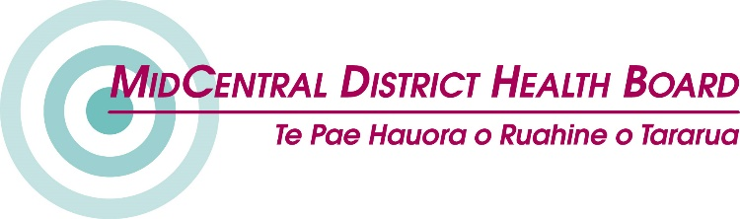
A better disability support system

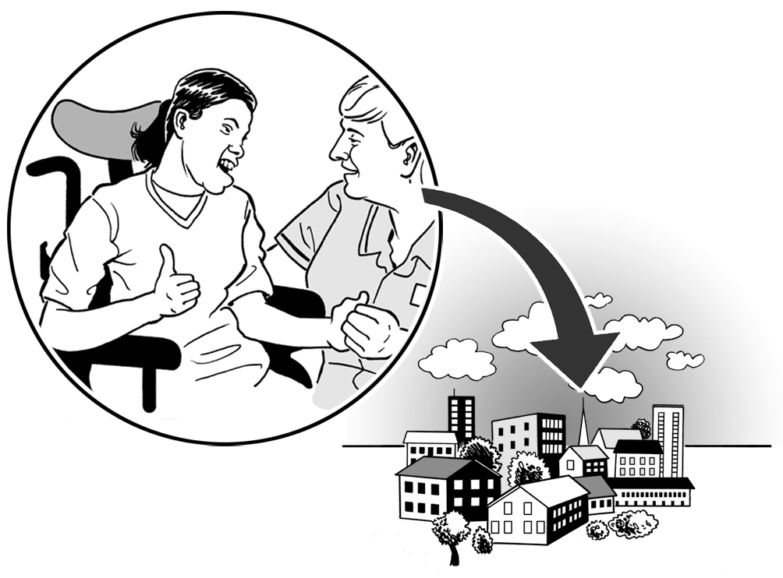

Making sure the new disability support system works well

September 2017
Easy Read

A better disability support system

This information is about work that is being done to make the disability support system better for disabled people.

System transformation is new work being done to design a new disability support system.

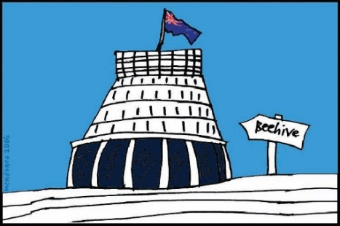
On the 20th July the New Zealand Government Ministers in Parliament released the new disability support system design.

Some more work still needs to be done to make the new design better.

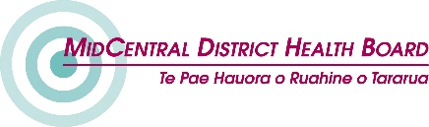
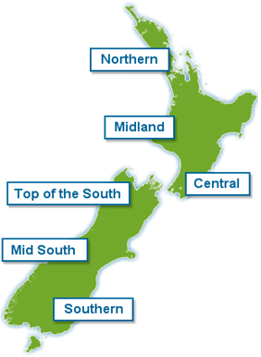
On the 1st of July 2018 the new disability support system design will be ready to use in MidCentral New Zealand.

There will be more information at this website about the work being done:
http://www.enablinggoodlives.co.nz/system-transformation/

Making a better disability support system design

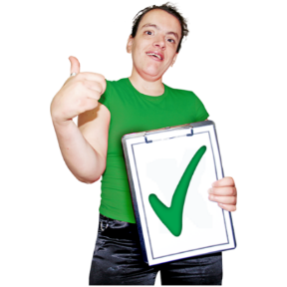
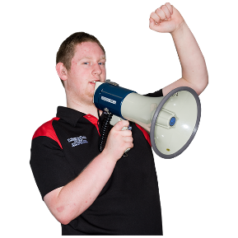
We need people to say how to make the disability support system design better.
To have your say about how to make the design better, you can join a:

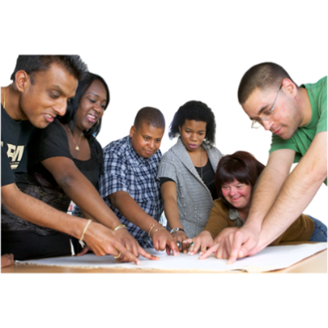
- working group

- virtual testing group.

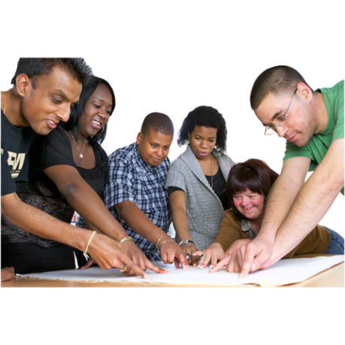
About working groups

Working groups will meet to make sure the new disability support system design will work well.

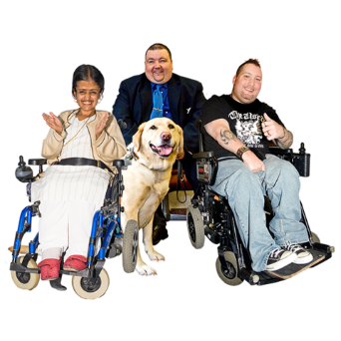
On the working groups there will be:

- disabled people

- people who work for Government

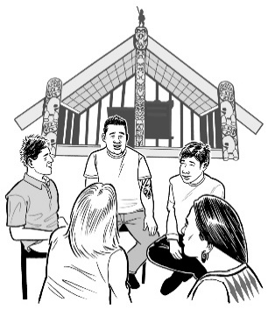
- family / whānau

- service providers
- people who know a lot about disabled people.

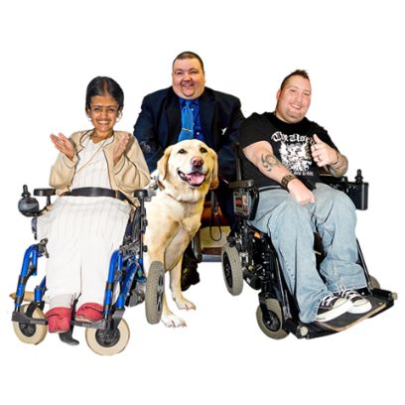
On every working group:

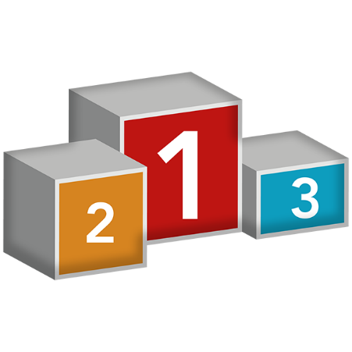
- one third of the members will be disabled people

- one third of the members will work for the Government.

A person can go on 3 working groups.

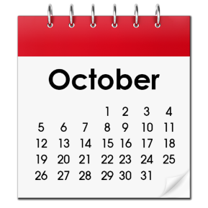
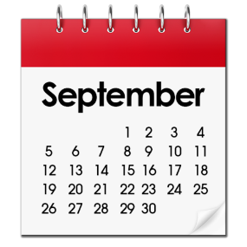

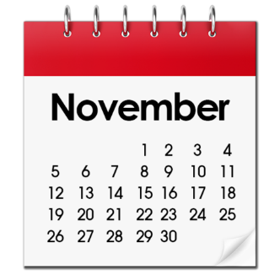
Working groups will meet for 3 to 5 days over 3 months.

About virtual testing groups

A virtual testing group is a group of people who will use social media tools to have their say.

The virtual testing group will tell us what they think will make the new disability support system design work well.

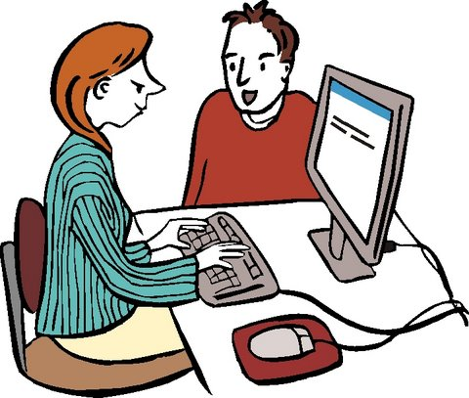
Virtual testing uses social media tools on computers and mobile phones.
Social media tools can be used to:
- have your say
- hear about what other people have to say.

Email, Facebook and Loomio are examples of social media tools.

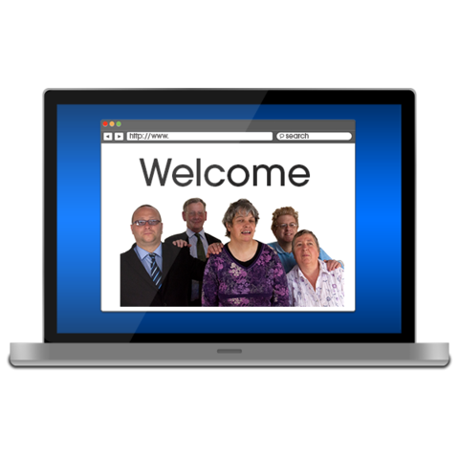

Anybody can join a virtual testing group.

1 person can join as many virtual testing groups as they want to.

Social media tools will be used by everyone who joins a virtual testing group.

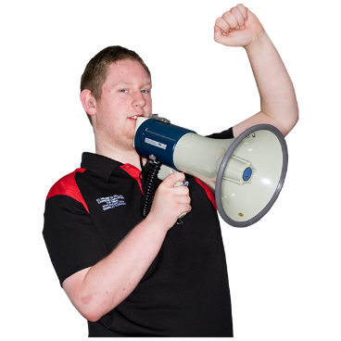
How to join a group

It is important that disabled people say how to make the new disability support system design work well.
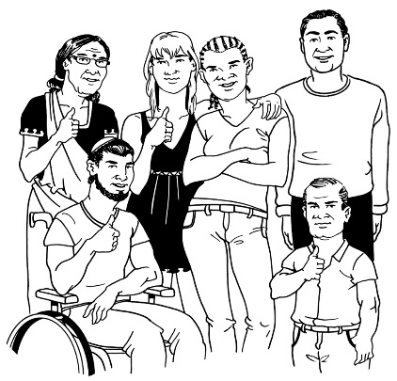
We hope disabled people want to join the:

- working groups

- virtual testing groups.

Look at this website to find out what groups you can join:
http://www.enablinggoodlives.co.nz/system-transformation/transformation-papers/system-transformation-updates/work-streams/

To join a group, email us to say what groups you want to join:
STfeedback@moh.govt.nz

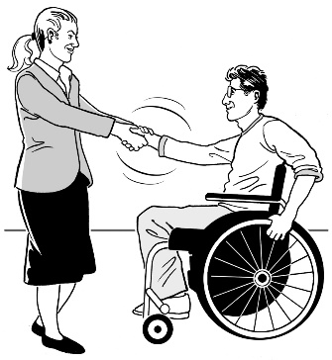
We look forward to working with you to make the new disability support system design work well.

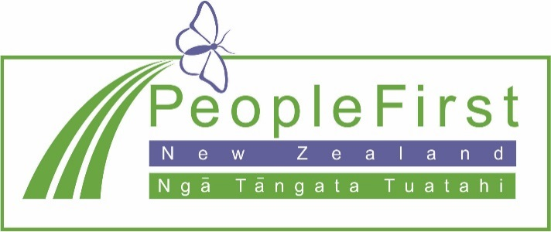

This information has been translated into Easy Read
by People First New Zealand Inc. Ngā Tāngata Tuatahi
