A new disability support system for New Zealand
October 2017 update

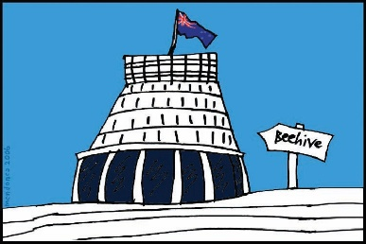
The Government of New Zealand is making big changes to the disability support system.

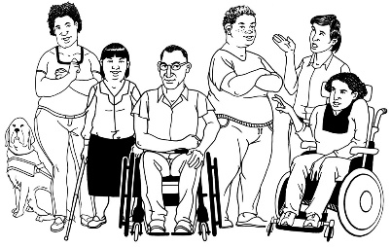
The Government has been planning the changes to the disability support system together with:
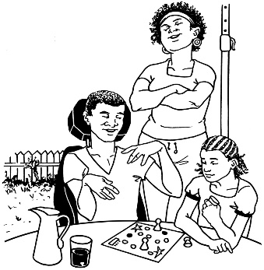
- disabled people

- family / whānau
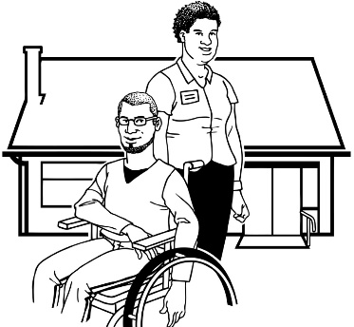
- disability support services.

This is an update to let you know what:

- has been happening

- is going to happen next.

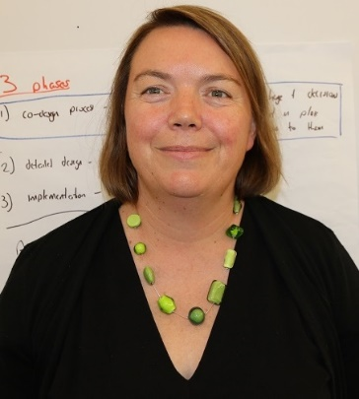

This update is from Sacha O’Dea from the Ministry of Health.

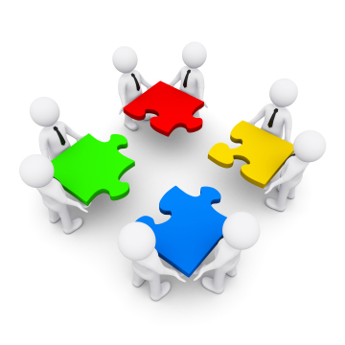
Sacha is working with the disability community on this work.

Working groups and virtual testing groups

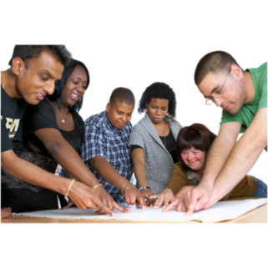
In September we told you about the chance to be part of our:

- working groups

People on working groups will get together in meetings to see if the new disability support system will work well.

- virtual testing groups.

People on virtual testing groups will use online tools to see if the new disability support system will work well.

Online tools are things like email and Facebook.

Thank you to all of the people who have said they want to be part of these groups.

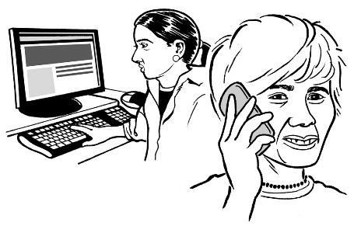
If you have told us you want to be on a group we will be in touch with you soon.

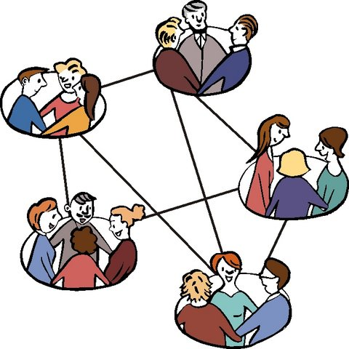
There are still some spaces for more people to be on these groups.

We also need more disabled people on these groups.
If you want to take part in these groups you can email us on:
STfeedback@moh.govt.nz

These are some of the groups that still need more people:
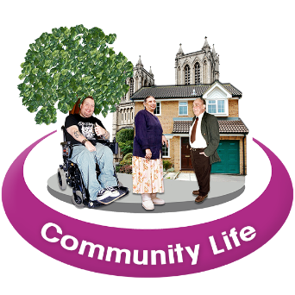
- A group that will work on how the new disability support system works together with other groups in the community

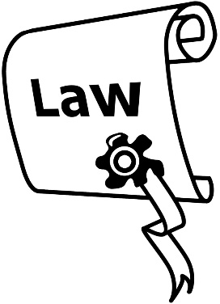
- A group that will look to see if any changes need to be made to laws and the way things work at the moment so the new disability support system will be able to work well

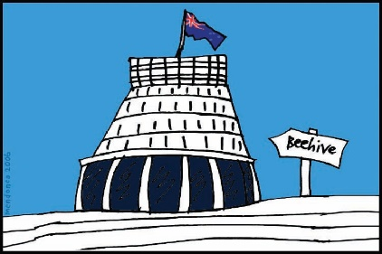
- A group that will work on how the new disability support system works together with other parts of the Government, like:
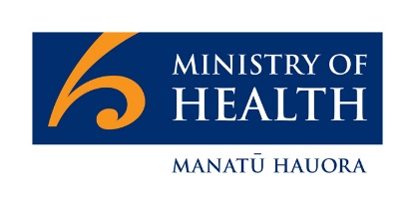
  - the rest of the Ministry of Health
  - the Ministry of Education
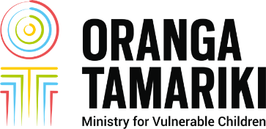
  - Oranga Tamariki, the Ministry for vulnerable children
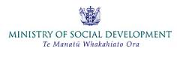
  - the Ministry of Social Development
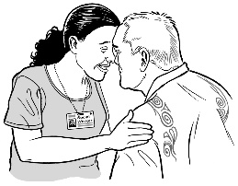
  - Whānau Ora – a Māori health project
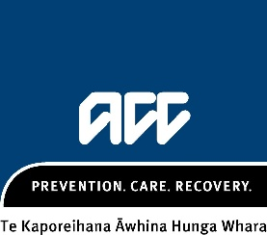
  - ACC.

What has been happening?

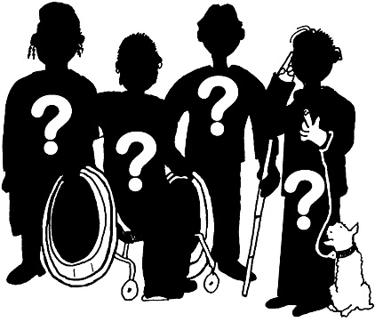
- There is now a group in the MidCentral region called the:

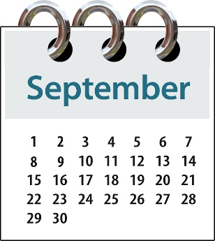
MidCentral regional leadership group

This group had its first meeting at the start of September.

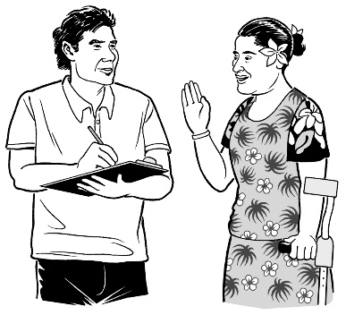
- We have got feedback on the work we did about all of the different ways that disabled people may start to use the disability support system.

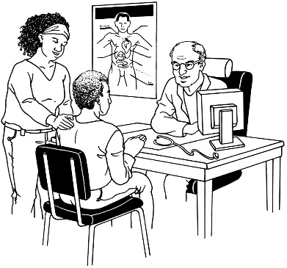
Like:
- some people might come into the disability support system through their doctor

or
- some people might hear about the disability support system from another disabled person.

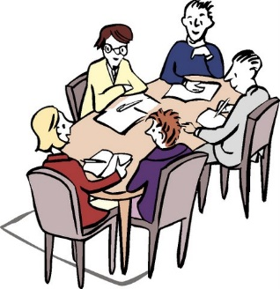
- A working group about funding has met a few times.

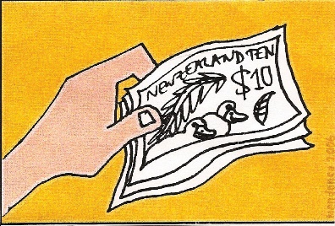
Funding means the money the Government gives for disabled people to be able to get the support and the things they need for their disability.

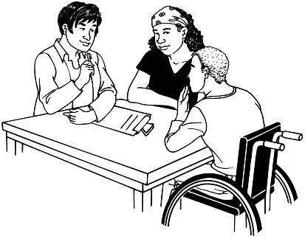
This group is ready to start talking about the work they have done with people outside this group.

- Some of the other working groups have also started to meet.

What is going to happen next?

Over the next month we are going to:
- Let everyone know if they are on a:

- working group

- virtual testing group.

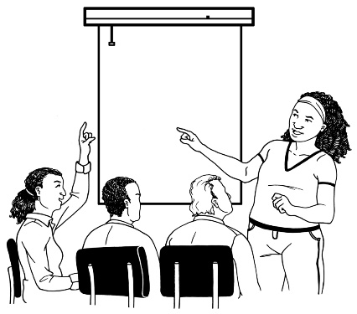

- Make sure all of the working groups have started to meet up

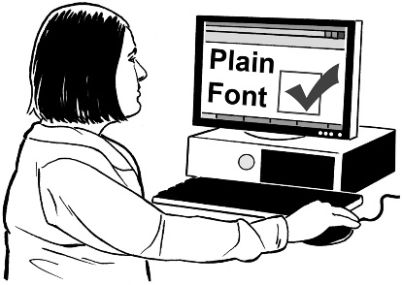
- Set up the virtual testing groups so that they are easy for everyone to use
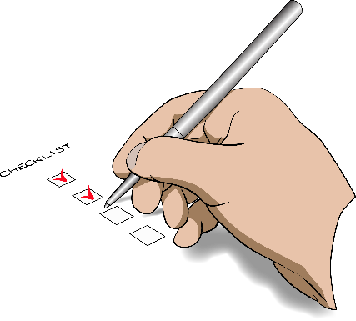
- Meet with all of the groups that are helping us to plan this work, like the:

- National Enabling Good Lives leadership group
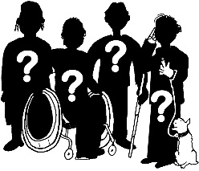
- MidCentral regional leadership group
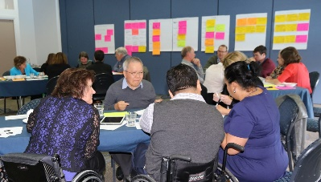
- Co-Design group.

We are looking forward to working with you as part of the working groups and the virtual testing groups.

Thank you.

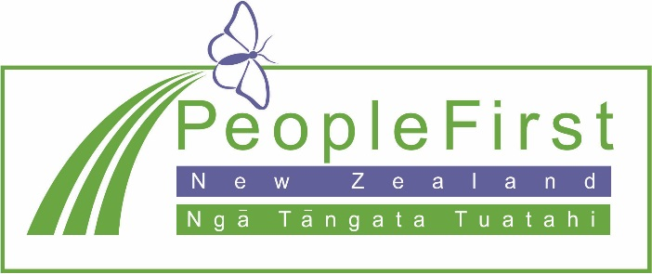

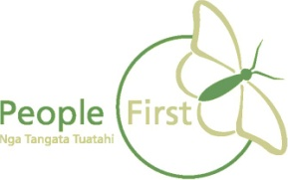
This information has been translated into Easy Read
by People First New Zealand Inc. Ngā Tāngata Tuatahi
