A new disability support system for New Zealand
December 2017 update

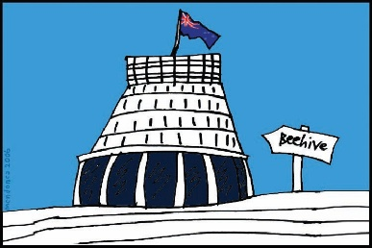
The Government of New Zealand is making big changes to the disability support system.

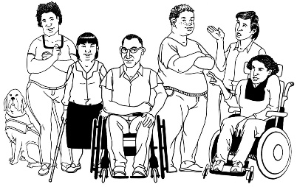
The Government has been planning the changes to the disability support system together with:
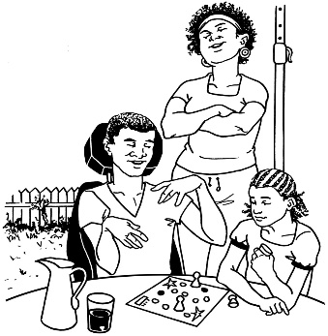
- disabled people

- family / whānau
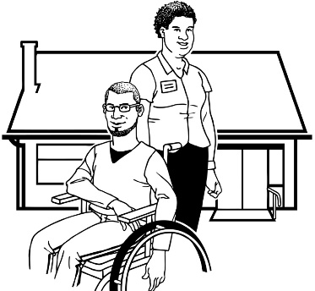
- disability support services.

Working together like this is called co-design.

This is an update to let you know what:

- has been happening

- is going to happen next.

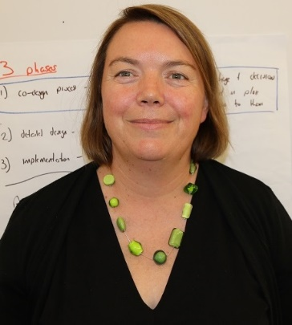

This update is from Sacha O’Dea from the Ministry of Health.

Sacha is working with the disability community on this work.

Looking back
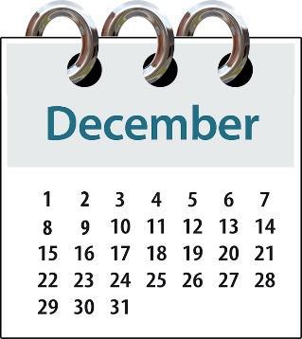
It is the end of the year so we are looking back at what has been done.

Over the last 9 months:
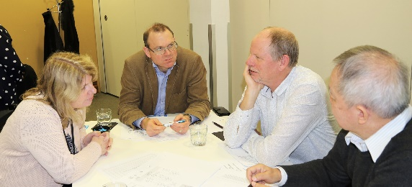
- we spent 3 months working with a co-design group on a plan for the new disability support system
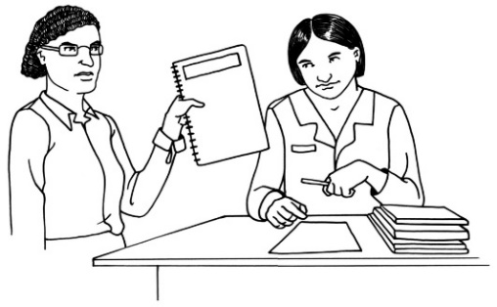

- we showed the new plan to Cabinet.

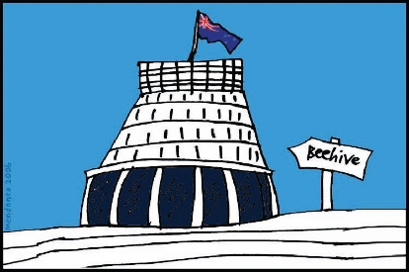
Cabinet is a group of senior Government Ministers.

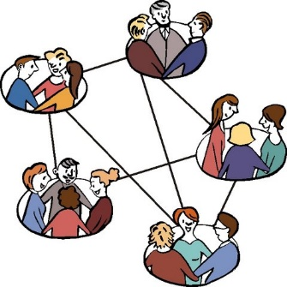
We have also been working with more than 20 working groups.

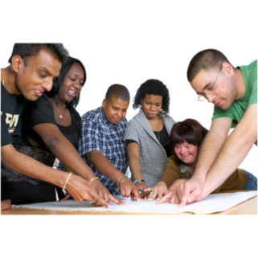
People on working groups get together in meetings to see if the new disability support system will work well.

What are we working on now?
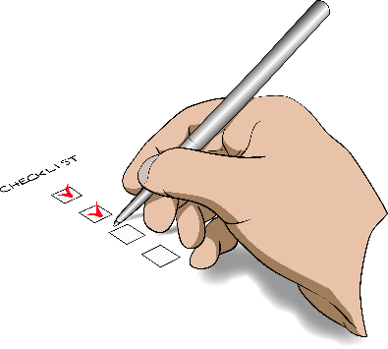
At the moment we are trying to get all of the work done by the working groups ready to be tested by virtual testing groups.

People on virtual testing groups will use online tools to see if the new disability support system will work well.

Online tools are things like email and Facebook.

If you want to take part in the virtual testing groups you can email us on:
STfeedback@moh.govt.nz
What is coming up?
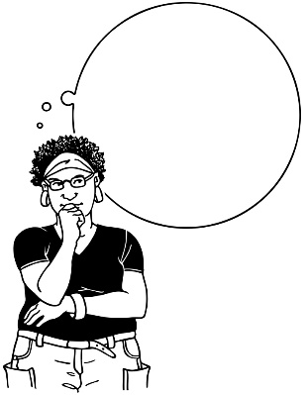
I am already thinking about what we need to work on in 2018.

We are going to start 6 new working groups.

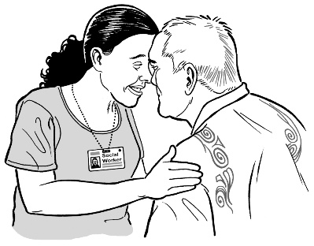
1 of the new working groups is the Whānau Ora group.

We have been doing some other work on getting things right for Māori in MidCentral.

We wanted to do this work first before this working group started.
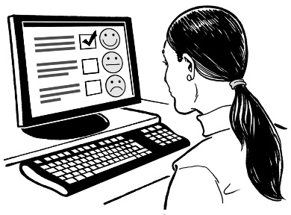
We will be getting lots of feedback from the virtual testing groups until the end of March 2018.

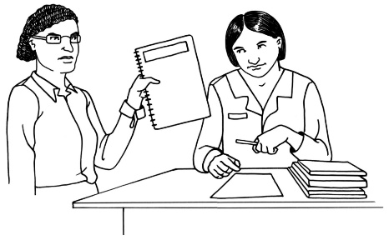
We will also be getting another paper ready to go to Cabinet.

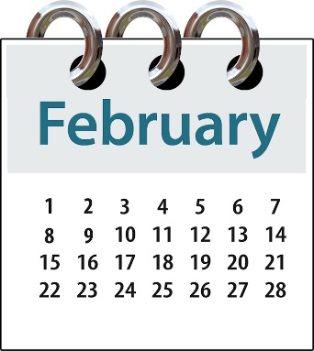
If you are on a virtual testing group and you get your feedback to us by 9th February 2018 your feedback will help us to write the Cabinet paper.

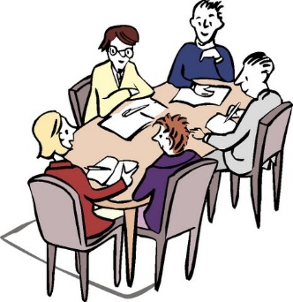
Cabinet will give us some advice on how to make sure the new disability support system does well.

Cabinet will also read our paper and say yes or no to:
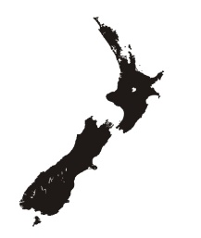
- moving ahead with the plan to have a new disability support system in MidCentral

- using money for the new disability support system in MidCentral
- using money from other parts of the government for the new disability support system.

Future updates from us
The updates we are going to send out in 2018 are going to tell you:
- what the new disability support system is going to look like

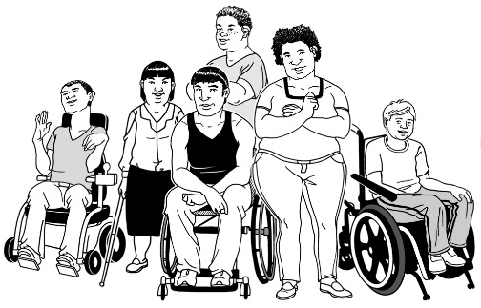
- what having a new system will mean for:
  - disabled people

  - families/ whānau
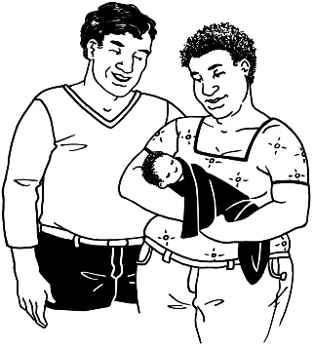
  - people who work in disability services

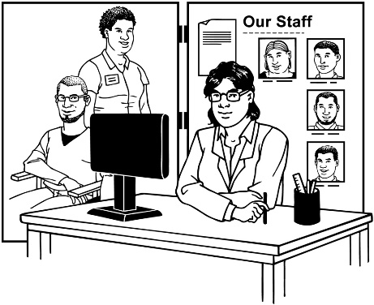
  - people who work in Needs Assessment and Service Coordination services (NASCs)

  - people who work in the Government.
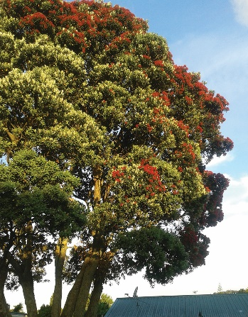
I hope you all have a good summer.

I am looking forward to working with you in 2018.

From Sacha O’Dea

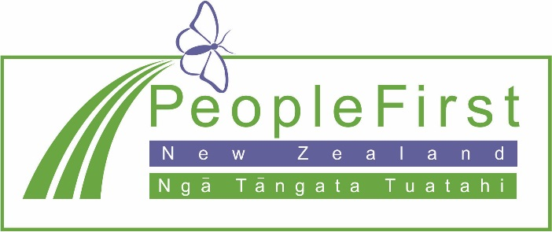

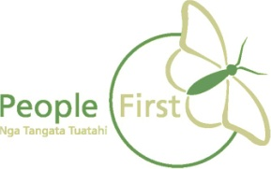
This information has been translated into Easy Read
by People First New Zealand Inc. Ngā Tāngata Tuatahi
