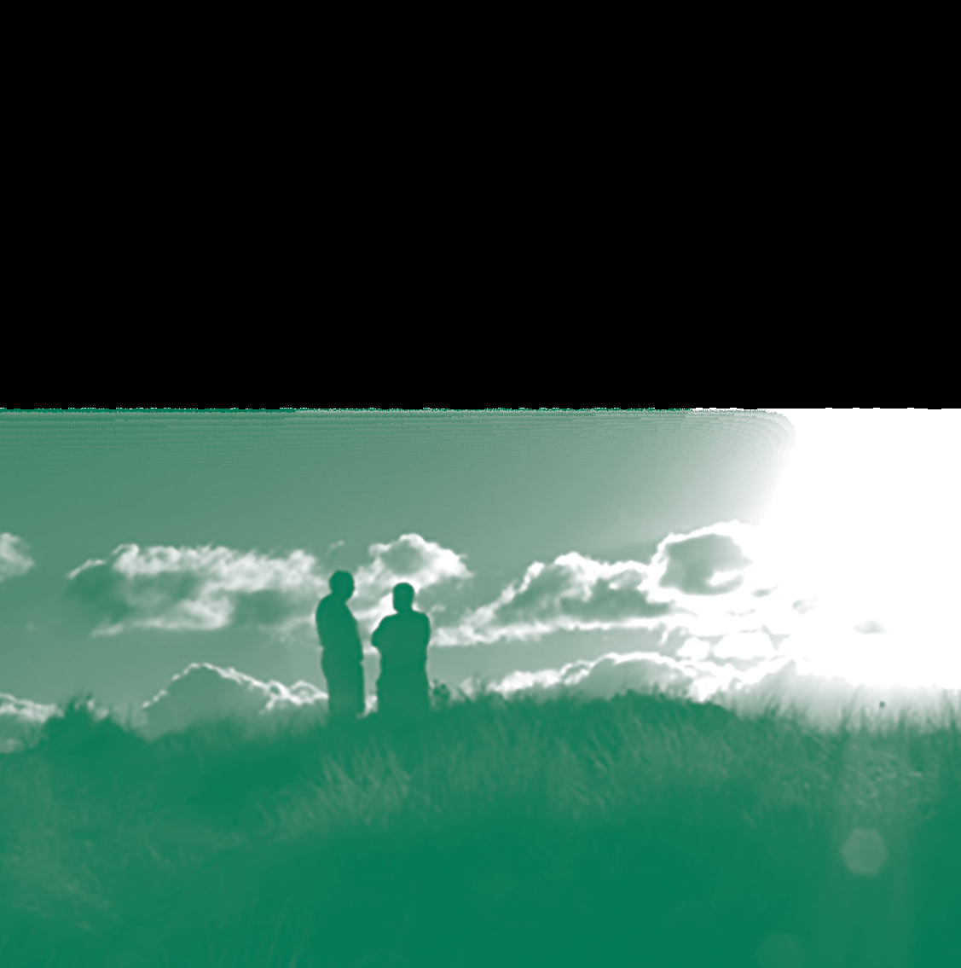

The Principles in Action ….

A “how to” focus resource
With Enabling Good Lives (EGL), and other new initiatives, individuals and families have more flexibility to create the supports that they want.

This resource is intended to help plan using the EGL Principles;
to think about what you want ....... at home, at school and when interacting with services.

Enabling Good Lives - The Principles
These concepts are the basis for all decisions and actions
Self-determination | - disabled people are in control of their lives
Beginning early | - invest early in families and whānau to support them to be ambitious for their disabled child  - to build community and natural supports  - to support disabled children to become independent.
Person-centred | - disabled people have supports that are custom-made to their individual needs and goals  - a whole life approach rather than being split across programmes.
Ordinary life outcomes | - disabled people are supported to live an everyday life in everyday places  - disabled people are regarded as citizens with opportunities for learning, employment, having a home and family, and social participation - like others at similar stages of life.
Mainstream first | - disabled people are supported to access mainstream services before specialist disability services.
Mana enhancing | - the abilities and contribution of disabled people and their families are recognised and respected.
Easy to use | - disabled people have supports that are simple to use and flexible
Relationship building | - supports build and strengthen relationships between disabled people, their whānau and community.

Main Changes and their Impact
Supports and Services used to be | The new way will see | What this means for Disabled Persons and Families – knowledge and skills to have
Separate from mainstream services in the community | Increased use of mainstream community supports | Know the possibilities in the community.  Able to create personal safeguards
Focussed on building good disability organisations | Focus on making it easier for individuals, families and other community services | Know what you want in your life.  Have thoughts about how you can achieve what you want  Ideas about how supports can best assist you.
Focussed on providing set ‘programmes’, services and activities | Supports based on individual preferences and aspiration | Be clear about what you like, what you need and what you want
Standardised | Flexibility | Have good communication and negotiation skills
Access through assessment | Things built around an aspirational personal plan | Have a clear “plan”
Limited number of organisations to choose from | Increased choice regarding how funding is used and who/what you want as supports | Know the options
Families sometimes seen as barriers | Families seen as important allies | Have ‘partnership’ skills

What is a “Good Life”?

Participants in consultation around the Enabling Good Lives project identified and agreed experiencing a “good life” was related to the following Figure 1.

Figure 1 – What is a Good Life
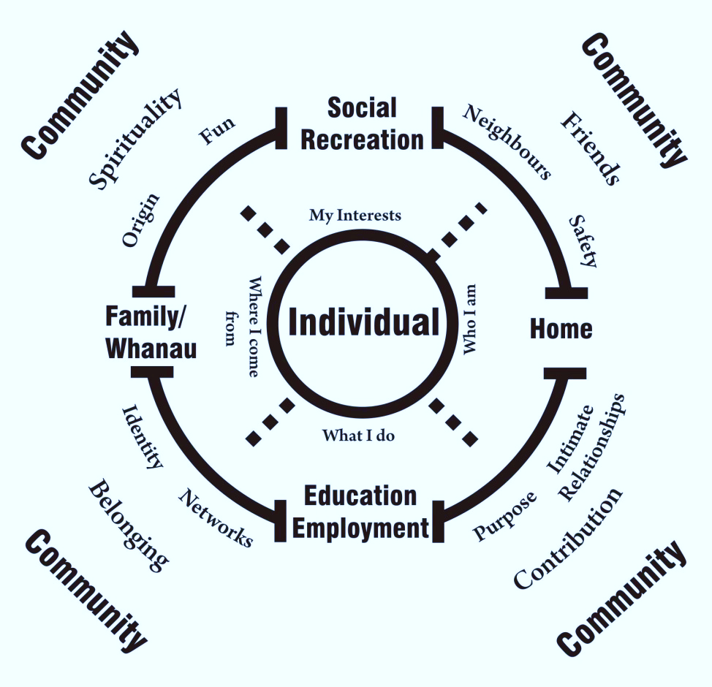

A good life is associated with a variety of opportunities that may have different meaning to different people. Creating a vision may include thinking about some of the areas included below.

Being connected with family/whanau  - Loving and caring relationships and belonging | Having friendships | Employment  - Enough money so I can have some choices
Living where I want with whom I want  - A home / a place where I can be myself | Education | Contributing to the community  - Opportunities to make a meaningful contribution and respect within my community
Having fun | Being valued | Being able to get around

The Enabling Good Lives (EGL) Principles are intended to be the basis for how things are done.
The Principles in Action….
Self-determination:
- disabled people are in control of their lives.

Self Determination  Clues that this is happening: | What I can expect to experience
People make informed choices, e.g. where they live, who they live with, involvement with employment and/or education | I am the person who has the “say so”. Nothing happens without me giving my opinion first
Supports and/or services are tailored to the expressed preferences and aspirations of the individual/families | I am asked what I like doing, what I have achieved in the past and what I want in my life
Resources and supports are allocated and designed on the basis of individual circumstance and aspiration | What funding I might have access to and what supports do are directly linked to what I want to achieve
Disabled persons and their families have a leadership role in service and or sector development | I have places where I can express how well I think supports are doing and what changes could happen to the systems to make things easier

What might this look like for you?
Self
Determination
I choose my flatmates, not someone else who does not live here (example)

Beginning Early:
- invest early in families and whānau to support them to be ambitious for their disabled child
- to build community and natural supports
- to support disabled children to become independent.

Beginning Early
Clues that this is happening | What I can expect to experience
Families/whanau/disabled persons have the right information at the right time and support structures in place to plan for the future | I am given information in a way I understand so I can plan for my future. I have access to support when I choose.
Families/whanau/disabled persons have the knowledge and skills to make informed decisions | I have opportunities to get information and develop skills to make decisions.
Families/whanau/disabled persons have access to natural and universally available supports | I can easily access the supports I need at different times.
There is a planned approach to services and supports which assists the individual to achieve the life they want and is regularly reviewed/ updated | I am able to review and change the services and supports I use.

What might this look like for you?
Information is in plain language (example)
Beginning Early
Person-Centred:
- disabled people have supports that are custom-made to their individual needs and goals
- a whole life approach rather than being split across programmes.

Person-Centred  Clues that this is happening: | What I can expect to experience
Supports and services are tailored to individuals needs and goals | My needs and goals are the starting point, then I can choose supports and services.
Peoples’ lives are not split into day, night, home, community, etc | My life is not divided into sections; the focus is on me as a person.
Individuals personal preferences and aspirations drive services and supports | My “likes” and goals are known and respected by the services and supports I choose.
Supports are co-ordinated and assist the individual with achieving their aspirations | A co-ordinated approach is in place to meet my goals.
Supports are customised to the individual | I am able to change what is offered so it is in line with my choices and needs.

What might this look like for you?
I can do things
spontaneously.
(example)

Person
Centred
Ordinary Life Outcomes:
• disabled people are supported to live an everyday life in everyday places
• disabled people are regarded as citizens with opportunities for learning, employment, having a home and family, and social participation - like others at similar stages of life.

Ordinary Life Outcomes  Clues that this is happening: | What I can expect to experience
Individuals contribute to the community through a range of activities (ie, educational, social, recreational, employment and/or personal activities) | I am able to participate and am accepted by my community.
Individuals have a range of roles that are socially valued | I have opportunities to be a part of my community.
As citizens, disabled persons have the same rights and responsibility as other members of the community | I have the same rights and responsibilities as other New Zealanders.
Supports assist people to be ‘part of’ their community through social participation and relationship building | As part of my community I can meet new people and make friends.

What might this look like for you?
I belong to the local ukulele group.
(example)
Ordinary Life Outcomes
Mainstream First:
- disabled people are supported to live an everyday life in everyday places
- disabled people are regarded as citizens with opportunities for learning, employment, having a home and family, and social participation - like others at similar stages of life.

Mainstream First  Clues that this is happening: | What I can expect to experience
Disabled persons have access to mainstream services | I am given everyday opportunities alongside other New Zealanders.
Disabled persons have information to make informed decisions about supports | I have information about opportunities so I can make informed decisions.

What might this look like for you?

I attend Polytech alongside my peers.
(example)
Mainstream
First
Mana Enhancing:
- the abilities and contribution of disabled people and their families are recognised and respected.

Mana Enhancing  Clues that this is happening: | What I can expect to experience
Individuals abilities and contributions are valued | I am valued and what I have to say is listened to.
Disabled persons and their families are given opportunities to contribute | I have a clear pathway to feed into making change in my community.
Individuals and families have a range of opportunities to influence policies and practice | I am asked to contribute and am respected as an equal partner in organisations.
A partnership approach is central to how services are provided | I am listened to before and during being supported.
Individuals experience of supports is valuing | I am respected and treated with dignity.

What might this look like for you?

I attend council meetings and contribute to consultation
(example)

mana enhancing

Easy to Use:
- disabled people have supports that are simple to use and flexible.

Easy to Use  Clues that this is happening: | What I can expect to experience
Disabled persons and their families have a clear understanding of what supports are available and how to use them | I am given information that is clear and have opportunities to say if I do not understand. This happens in a safe environment.
Accessing multiple supports is easy to co-ordinate and the process is transparent | With the clear and precise knowledge I am able to have a good life using supports that I choose.
Supports can meet the changing needs of the disabled person and their families | I am able to change my supports when I need.

What might this look like for you?

I understand the paperwork.
(example)
easy to
use

Relationship Building:
- supports build and strengthen relationships between disabled people, their whānau and community.

Relationship Building  Clues that this is happening: | What I can expect to experience
Services are involved in developing relationships and actioning practices that result in increased opportunities for people with a disability in the community | I am having a better life and have services that I have a positive relationship with.
Services operate in a manner that develops, strengthens and maintains relationships | I can expect to be respected and to be seen as an essential partner.
The individual is encouraged to explore their culture and identity | If I choose, I can explore more about who I am and my culture.

What might this look like for you?

I am seeking information and knowledge about who I am so I can truly build a good life.
(example)
relationship
building

What might you expect to see from a service provider (including schools)?
And, what would this look like for your family?

Principle | The service provider viewpoint might include: | I should experience
Self-determination  Disabled people are in control of their lives. | Able to listen to what people want, and then figure out how to make that happen.  There are staff who are:  - skilled in different ways to communicate  - aware of personal development strategies  - able to assist people to experience new options that reflect the person’s interests  - knowledgeable about the impact of ‘power imbalance’ and how to shift authority  - welcoming the lead of disabled persons and families  - skilled in partnership methods | - being asked about what I want in a way I understand  - I am a part of designing my supports  - I am regularly asked to participate in reviews in a meaningful way  - a shared understanding of what my good life is
Beginning early  Invest early in families and whānau to support them to be aspirational for their disabled child, to build community and natural supports and to support disabled children to become independent, rather than waiting for a crisis before support is available. | Services create strong trusting relationships with families.  Planning and trusting relationships support a ‘proactive’ approach.  Staff have a strong sense of optimistic hopes and potential. | - together we plan for the future  - thinking about what is possible, rather than focussing on available options only
Person-centred  Disabled people have supports that are tailored to their individual needs and goals, and that take a whole life approach rather than being split across programmes. | Services create support around the individual, rather than expecting the person to fit into the programmes they have on offer.  Approaches are timely, responsive, creative and holistic. | - it’s is not a “one size fits all”  - I do not need to change to meet what someone else expects  - I can expect flexibility and have opportunities to feedback when things are not going well
Ordinary life outcomes  Disabled people are supported to live an everyday life in everyday places; and are regarded as citizens with opportunities for learning, employment, having a home and family, and social participation - like others at similar stages of life. | Services and supports are not limited to keeping people fed, housed and occupied.  People are supported to develop friendships, careers, live more independently – whatever a good life looks like for the individual.  Staff have:  - a ‘whatever it takes’ approach  - flexibility to support people in a range of environments and situations. | - I have opportunities to live alongside others in my community with an open approach to meeting my idea of a good life  - I am able to connect with people outside my family
Mainstream first  Disabled people are supported to access mainstream services before specialist disability services. | Services support the individual to get to know and connect to the community in which they live.  Connections are made with local people on an individual basis, rather than in a group.  The service has diverse, strong and mutual connections with community resources and networks.  The service encourages their staff to do the same for themselves and the people they support. | - I am part of my local community  - I am able to enjoy spending time with other people in my community in an open environment
Mana enhancing  The abilities and contribution of disabled people and their families are recognised and respected. | Support provided will increase the respect others in the community have for the person.  There are multiple ways for people to express their views.  There is a direct link between service practice and ways for people to contribute.  People report that they feel valued and respected – and they have mana or authority over what they do and who they are. | - I have rights and am a contributor to my community  - I design the things in my life, not someone else  - I am empowered to sort things out myself
Easy to use  Disabled people have supports that are simple to use and flexible | Supports and services are simple to access and easy to change. It is expected that individuals will change their plans and services will respond accordingly.  Communication is accessible and easy to understand. | - Things make sense to me  - I measure the success of what is happening
Relationship building  Supports build and strengthen relationships between disabled people, their whānau and community. | Supports and services focus on connecting the individual to other people rather than to an activity.  The importance of natural supports is recognised and actively developed.  There are multiple forums/ways for relationships to be recognised and respected. | - I am not alone in holding onto the vision of a good life  - The input of my family and friends is valued

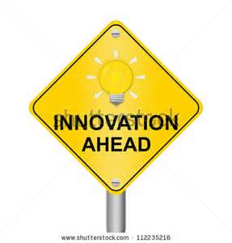
And, what about at home?
How can you see the Principles applying for you and
your family?

Principle | At home I can…
Self-determination

Disabled people are in control of their lives.

Beginning early

Invest early in families and whānau to support them to be aspirational for their disabled child, to build community and natural supports and to support disabled children to become independent, rather than waiting for a crisis before support is available.

Person-centred

Disabled people have supports that are tailored to their individual needs and goals, and that take a whole life approach rather than being split across programmes.

Ordinary life outcomes

Disabled people are supported to live an everyday life in everyday places; and are regarded as citizens with opportunities for learning, employment, having a home and family, and social participation - like others at similar stages of life.

Mainstream first

Disabled people are supported to access mainstream services before specialist disability services.

Mana enhancing

The abilities and contribution of disabled people and their families are recognised and respected.

Easy to use

Disabled people have supports that are simple to use and flexible.

Relationship building

Supports build and strengthen relationships between disabled people, their whānau and community.

