Enabling Good Lives Waikato
Evaluation
Part Two

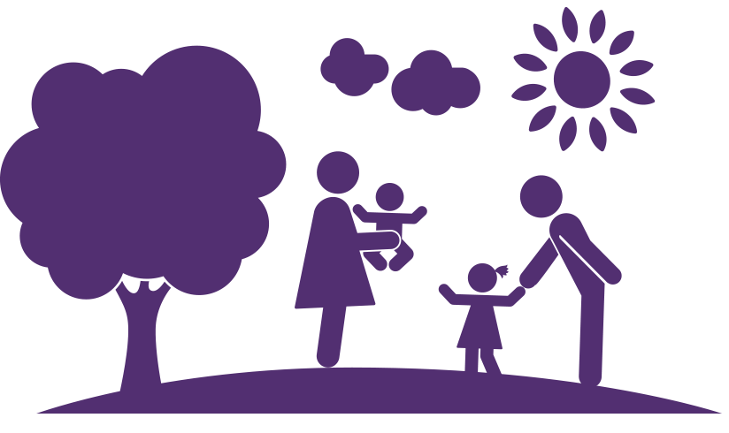

Easy read version: Readable by Glen

The EGL Waikato Demonstration:
- Is giving disabled people, family and whanau more choice and control in their own life
- 32 people were asked what they thought before they started on EGL. All felt EGL would be a really good thing
- Most said that the things they have achieved is only because of EGL Waikato
- 30 people enjoyed working with their Tuhono/Connector
- 81% (n=26 felt that planning part of their EGL was really good
- 94% (n=30) feel that the EGL Demonstration is making a difference in their lives and it has been a positive change.
- Is changing how things are done
- Is changing the way people think about support.
- Is making sure there is clear communication and good relationship between provides, EGL family and the person
- Is making sure the supports are what the person needs
- Is trying their best to work with people to make changes happen when they are ready.
- Knows how important relationships are
- Having some issues meeting targets but have some ideas to fix this

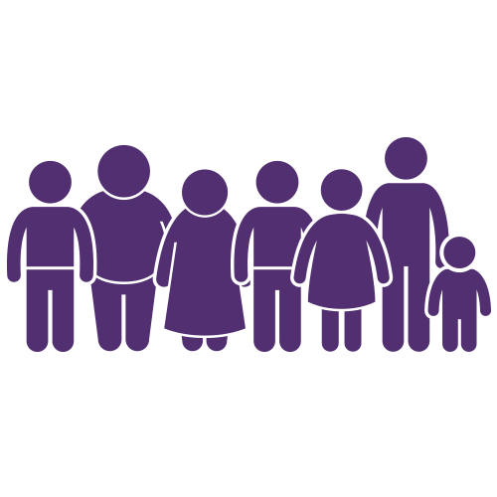
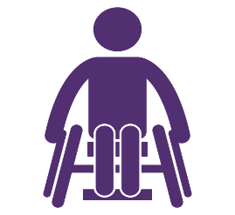
People said EGL Waikato is …

Freedom | Loving it
Hope | Flexible
Exciting | Challenging
Independence | A process
A Good life | Awesome
Easy | Opportunity
Connections | A life changer
One cool programme | Enabling
A better future | Person centred
Fantastic | Community
Learning | Less Frustrating
Glad they’ve got this out there … Don’t stop it, keep it going

What people want for EGL…
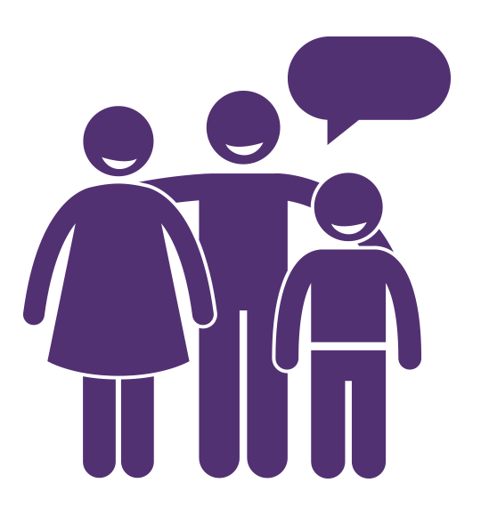

They should roll it out across the country | Keep this funding going – first positive experience | Would highly recommend it and it should be available for everyone
It would be nice if all agencies worked under the same philosophy | This has given us the opportunity to be independent | Don’t stop it. It’s making a difference.
Glad they’ve got this out there… don’t stop it, keep it going | Please consider opening for longer to give other people the opportunities | Please consider other people the opportunities
If it was increased, it would change the nation | Without services like this, families like ours would fall down | It would be crazy to stop it. Has made everyone’s lives better.

Important things we learnt so far in the EGL demonstration;
- Self-determination
- EGL supports disabled people to have control over their lives
- Teaches disabled people and their family/whanau how to make choices about their lives
- Having disabled people play a key part in all areas
- Having people know, understand, and live the EGL principles
- Helping disabled people to make changes that will give them a good, happy life
- Making sure people who live in small towns or who have high needs are able to choose who supports them.

- Person-centred
- Supports are chosen by the person and they have control over how they are supported
- Helping families/whanau best support their disabled person to have a good life and work together on dreams and goals
- Helping families understand and deal with changes in the way a disabled person is supported

- Beginning Early
- Making sure that all parts of EGL are easy for disabled people to use
- Make sure it is easy for families to understand and use EGL
- Tuhono believe in EGL and in families
- Tuhono help disabled people choose how their EGL money is used
- EGL always looks at what is going well or not going well so that EGL can learn from it
- EGL doing what works for people and all areas of the demonstration run well

- Mana Enhancing
- EGL gives people power over their lives
- EGL knows that family is a big part of a person’s EGL story
- EGL listens to disabled people and their families/whanau
- Tuhono help people make choices about their support
- Knows that the amount of support a disabled person needs can change.
- Knows that the way a disabled person wants to be supported can change

- Ordinary Life Outcomes
- EGL families meeting up and talking to each other
- Helps disabled people and their family/whanau learn how to budget and choose support
- Makes sure things are easy to use

- Mainstream First
- Helps people look at their community for support first, before looking at disability services
- Share EGL ideas with the community to help them understand.
- Helps disabled people to be part of their community.

- Relationship Building
- EGL principles being in every part of a disabled person’s EGL story
- Communities and government working together to support people better
- EGL ideas are import at all times
- Everyone being open, honest, and taking to each other
- Everyone knowing what their job is and what they are meant to do
- EGL making sure that people are getting the support they pay for
- Supports change in the way things are done
- Everyone working together on the same goal

Main Point 1
Who is in the Demonstration

In June 2016
- 193 people asked to be part of the EGL demonstration
- 11 people could not take part.
- 29 people were waiting to take part.
- 103 disabled people, families/whanau were talking to Tuhono about planning their lives
- 79 people decided not to go ahead with their EGL story
- 30 people were asked to talk about their EGL story and what was going well
- 3 people who had decided not to go ahead were also asked to talk about EGL
Of the 30 people planning their EGL stories;
- Choice is the focus
- All of the people live in the Waikato
- 45% live in Hamilton
- The youngest person is 3 and the oldest person is 64
- 87% had started working on their EGL budget
- 68% wanted to sign up to EGL
- There were more men than women
- 54% were European
- There were 11 more Maori people than in Part 1 of the demonstration

How do people join the Demonstration?
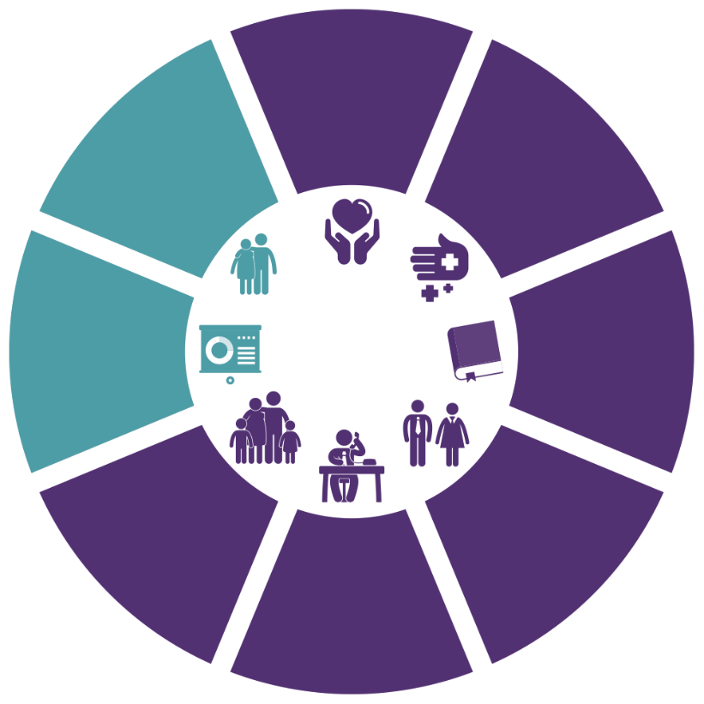
1 from MSD

33 from families or self-referred

2 from health providers
21 from EGL workshops
2 from schools
14 from disability support services
12 from other agencies
5 referred by friends
Main Point 2
Who is not taking part in EGL and why?
What are they doing instead?
- 79 disabled people did not want to join EGL
- EGL wanted to find out why they didn’t want to join so they asked 10 people, but only 5 people told them why
- The youngest was 2 and the oldest was 64
- Most were men over 20
- Nearly half were European
- Half lived in Hamilton

Reasons for not using EGL
- 8 People wanted to stay with the provider they had or were given more support from DSL
- 10 people chose to go with something different, some moved in with family.
- 9 people wanted to wait and see how EGL worked out

10 of the people that decided not to go with EGL still got something good out of it;
- They saw the good in EGL and how it could work for them, but felt it was too hard
- Some people felt it was helpful being given information, items they needed, learning, job options etc.
- Some people still think they are part of EGL even if they did not go ahead with their EGL budget
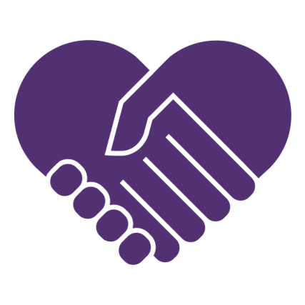
Main Point 3
What makes a good Tuhono/Connector?
What support do they need to do a good job?
What does a Tuhono/Connector do?
- Gives support and information to help people plan their good life
- Helps disabled people look at support in their community
- Helps disabled people join new groups and meet new people
- Helps people get what they need
- Helps people find the support they want
- Help people plan their good life
- Make things happen at the speed the disabled person is happy with

How do they work?
- They get to know the person and their family
- Support people to make choices about their life
- Connect people to others and to groups
- Help with planning and budgets
- They have the skills to see how much support a person really needs
- They make sure the person is happy

What did people think about Tuhono?
- 94% of people in EGL liked working with their Tuhono
- Some of the 94% said there were some problems working with their Tuhono
- 6% did not like working with a Tuhono
- Some people were worried that the Tuhono would not always be there
Some people thought that the Tuhono had great ideas, that they knew how to find things in the community to help, and would always asked what the person wanted.

What makes the Tuhono job work well?
- Tuhono have the skills to see how much support people need
- They work at the speed the person and their family is happy with
- Having disabled people lead in all areas of EGL
- The Tuhono work with the EGL principles
- They get training and help each other
- They know what their job is and how to do it
- They think about what is going well and what needs fixing

What makes the Tuhono job not work well?
- Not understanding where people and families are at
- Working too fast or too slow for the person or their family
- Not knowing the community
- Not understanding how things work in the disability world
- Not knowing EGL system’s
- Not getting or giving clear information
- Things taking too long to happen
- Providers not working together with EGL
Some people thought that the Tuhono wanted things to happen too quickly and didn’t give enough guidance. Some thought that the Tuhono did not have enough training and didn’t know the community well.

What can be done to fix this?
- Have clear roles when working with providers and people
- Being able to slow things down when a person needs it but still working towards their good life
- Having lots of ideas and information to share
- Knowing the community
- EGL talking to people more and giving clear information
- Training for the Tuhono job
- Everyone in a person’s EGL story working together
- Make sure everyone knows what is happening and what they need to do.
Main Point 4
How are people’s budgets decided?
How are the budgets being used?

- EGL looks at the person’s whole life and what they need and want
- The person and their family help by saying what they want
- The Tuhono and the disabled person plan the person’s good life together
- The Tuhono works out how much money is needed and talks about it with other EGL people.
They talk about
- Being fair
- Good life goals and achievements
- Is it an EGL way of doing things?
- Will this make the person’s life better?

- They all agree on the amount of money the disabled person will have in their budget
- The budgets are checked every three months
What people thought about this
- 81% liked this way of working
People said…..
“It’s about my life”
“Could express what I wanted”
“Focused on opportunities”
“Holistic, inclusive”
“Perfect amount of support from the Tuhono”
“An easy, good process”
- 19% did not like the self-assessment.
People said…
“It was rocky”
“Left feeling like they didn’t get all the information or guidance needed”
“Not reflective of what was required to manage complex health needs”
“Left feeling unsure or unclear about the outcomes”

Managing personal budgets
- 20 people manage their own budget.
- These 20 people feel more confident now about managing their EGL budget
- They know where their EGL money was going
- They have made good decisions
- They have learnt how to manage their money
- 9 people have a provider who manages their budget for them.
- These 9 people chose to have a provider manage their EGL money because they knew they would not be able to do it alone, or didn’t want to do it.
- Some thought it was working well
- Some did not think it was working well
- 2 people have a provider who helps them manage their EGL budget
- 1 person didn’t know who looked after their EGL budget
What are people buying with their EGL budgets?
- Staff who provide help and support
- Specialist support and training
- Activities, things to do
- Equipment, things the person needs that will help them live a good life

What other options are people thinking about?
- Technology
- How to be more a part of their community
- More training and learning

Natural (unpaid) supports are family, friends, and people in the community
- Disabled people are able to use their natural supports differently
- People can hire the support they need whenever they need it, this means there is less pressure on families to support the person
- Family relationships are better
- Families can do ordinary things together
- Families have more choices
Being part of the community
- People feel that they are more part of their communities
- Volunteering and sharing skills
- Starting their own businesses
- Studying
- Taking part in more sporting events
- Talking with neighbours more
How has EGL helped make a difference?
- People are being supported to be part of their communities in a way that works for them
- Disabled people are able to choose their own support staff, so they know the person they are working with
- EGL helps people with transport
- Ideas and help from the Tuhono
- Everything is more flexible and easier
- People and families decide what is best for them

Main Point 5
Are disabled people reaching their goals?
Before EGL…
- 78% felt they did not have the support they needed
- 22% felt they did have good supports but wanted to try new things
- People said….
“It was a disaster.”
“EGL is a lot more flexible than [NASC] ever was, and I wasn’t really utilising the hours”
“I wasn't going out much…I was basically a prisoner before”
Why people chose EGL…
- Everyone thought EGL would be better
- They wanted more choice and control
- Different people had different reasons and goals
- Some wanted to try new things
- People said…
“The freedom to do things for ourselves. The power is with us”.
“Before, deficit based, but EGL is aspirational.”
“Flexibility is an absolute imperative to get the aid and help we need.”
- People felt they could not do the things they wanted before EGL
“No guarantee.”
“Too much red tape.”
“Didn’t work.”
“Harder”.
“Impossible”.
“No not at all. It wouldn’t even come close”.

What did people want with EGL?
- Control of their lives and what happens to them
- To say what they want and make choices
- Get the support they need, when they need it
- Choose supports that work for them
- Choose where and how they live
- Have more options in life
- Hope for the future
- Having goals and dreams to work on
- Meet with others and make friends
- Feel like part of their community
- Freedom to do their best
- Less stress
- Disability services that are easier to use and understand
- Better family relationships
- Celebrate their culture

People said…
“Can take control of my life, and Mum doesn’t feel like I’m missing out”.
“The best is that every day can look different.”
“In residential you don’t make your own goals, they make them for you.”
“My outlook is a bit better now. Makes me keep healthy, looking forward to the day. I look a bit higher, further out at what's around.”
“It [the equipment] has made a huge difference because he is now safe at night … so its gives us piece of mind, and we can relax about it now”
“It’s made it a lot easier knowing we’ve got funding to use for what [she] needs. Especially things she wants to do … [she] is getting older, there will be more opportunities opening up to her. We see EGL funds will support this.”
“I have a lot to contend with so just having the freedom to see my friends; I really look forward to that. Without EGL playing that important role, I wouldn’t have that time. I’ve felt like I’ve been entombed in my house for three years. People take seeing their friends for granted. It means the world to me.”
“If I didn’t have this funding I would be in my room 20 hours a day.”
“I kind of liked creating the plan. I think having another person’s perspective was good as well. I also think it kind of gave me the opportunity to think quite big ... and to be aspirational with the things that you wanted in the plan.”
“It was a broad plan, included getting set up, getting staff involved, training and up-skilling to be more independent and get [my] drivers licence back.”
“Being able to control what you do. Like having a shower when I want.”

Things that stopped EGL working for some people;

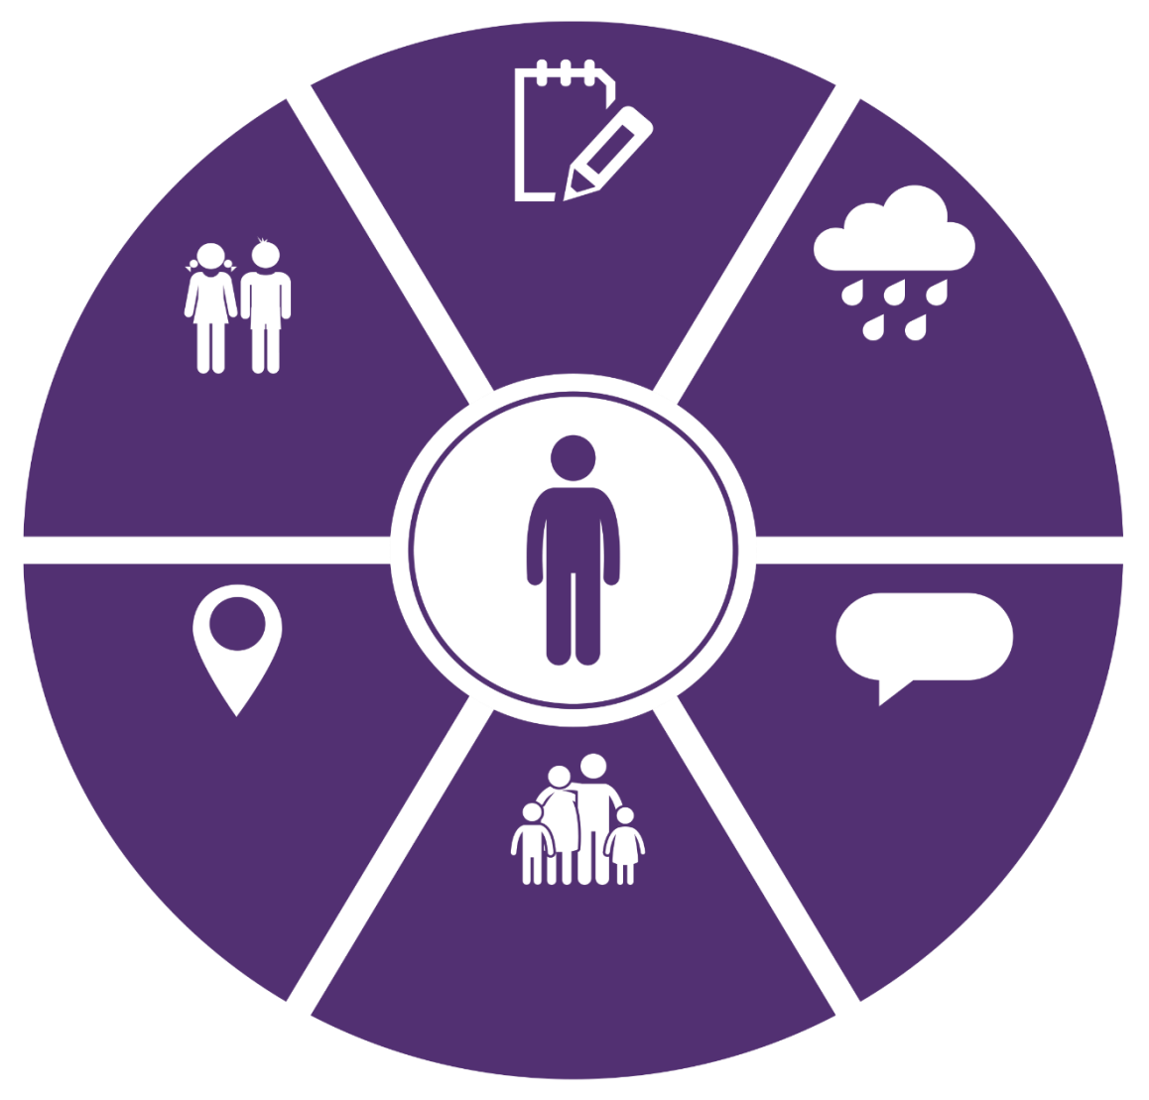
.
.
Not enough information. No clear plan

Not many young people in small towns
How far away people live. Not much family to help

Hard to get EGL and supports in small towns
Not able to find the support they want
Disabled people and family still learning how to make choices and control EGL budgets

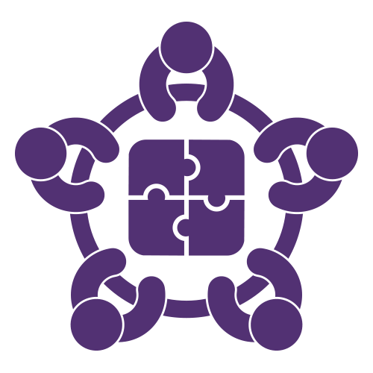
Main Point 6
How are Providers working with disabled people
and their families?

How are Providers changing?
- Lots of providers are working with EGL
- EGL asked 6 providers some questions
- Some providers are working with disabled people and their Tuhono to make sure they have the right supports.
- Some providers are helping people manage their EGL budgets and support

What do the providers think of EGL?
- EGL is seen as a fresh new idea that gives power to disabled people and families
- 4 Providers said they believe in the EGL principles
- They want disabled people and their families to lead the way
- Providers are using the principles and trying to work with them
- Providers are working with people to make sure disabled people have choice and control
- Providers are taking part in the Waikato Leadership Group
Providers said….
“There are very limited choices in small towns. EGL has had a huge impact and there is potential for EGL to make a significant difference.
“Participants are beginning to see the benefit of the connections between community and participants”
“The power of giving someone the chance to know there are options is great”

Things that have been hard to do or understand;
- Providers can get confused about their role in a person’s EGL story. EGL is working to make the provider role clearer
- Providers want to be part of a person’s EGL budget planning.
- Providers talking to each other and working together.

How are Providers changing what they do/how they do it?
- Four providers are changing things to work with the EGL principles
- Two providers are training staff to do things in an EGL way
- Two providers are sharing ideas with each other
- The Community of Practice (COP) talk and share ideas
- Understanding that people need support from lots of different services, working together to help disabled people live a good life

What is stopping Providers from changing?
- The EGL way takes time
- The EGL ideas have been around for a long time, some Providers are not using the EGL ideas in the right way

How are Providers making things better for participants?
- Two providers are working to help people change the way they think and make plans for their good life
- They help people think about being part of their community
- Providers are helping disabled people look at who already supports them
- One provider is doing workshops about EGL

What Providers think about the changes to support services;
- EGL makes the supports given to people better
- Everyone needs to think about the EGL way and how to use it
- Providers need to tell the government what they want and need
- Disability supports need to be better
- Providers need to learn how to support in different ways to fit what a person wants and needs
- Providers need to talk to each other share ideas
- Give staff training on the EGL principles

Providers said…
“People are now making decisions for themselves, now can be creative, and decide how to send their budget,
as there is no or limited respite or carer support options, they are employing whanau members to provide vital supports that is working really well.

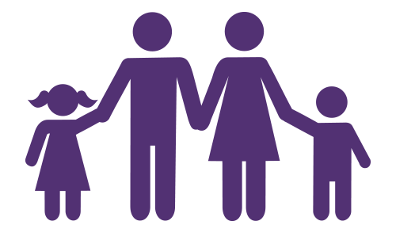
Main Point 7
What makes it work?

- 94% of people think EGL is working well
- 2 people think EGL is not going well but think it will get better
- EGL looks at what a person can do, not what they can’t do
- EGL looks at what a person wants
- Tuhono who know and understand the EGL principles
- A budget that covers all parts of a person’s life
- Having choices about who supports you and when they support
- Having choices about what, when and how things are done
- Being able to buy things that help
- Trying new things

People said
“Happy, I’m living in a flat”
“We are individualised now, not part of an agency. The best thing has been getting him out of the system, he’s an individual”
“EGL helped me with my outlook for the future, others say I’m not so down all the time”
“We wouldn’t be able to do this without EGL. It benefits our child getting out in the community”
“EGL provides a lot of opportunities for parents. Parents are really vulnerable”
“I need someone to look after me, so I can look after my children”

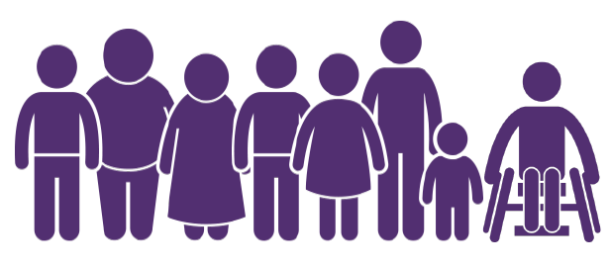
Main Point 8
What has been learnt from the
evaluation so far?

What will keep EGL working in the future?
- Choosing Tuhono who are creative, from different cultures, and are different ages
- Training for Tuhono and helping them do their job well
- Looking at the disabled person’s community first
- Tuhono talking and sharing with each other
- Tuhono who are able to understand what a person wants and needs
- Tuhono telling people that they won’t be part of their lives forever
- Tuhono not telling people what to do with their EGL budget
- Helping the community support disabled people
- Using systems that are already there and working well

