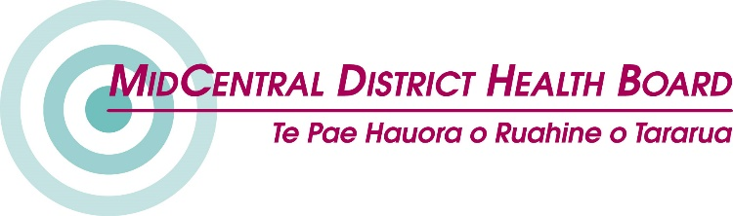
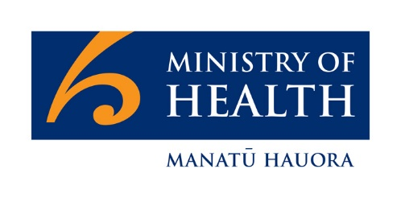

Capability Funding:

Grants for groups of
disabled people and whānau

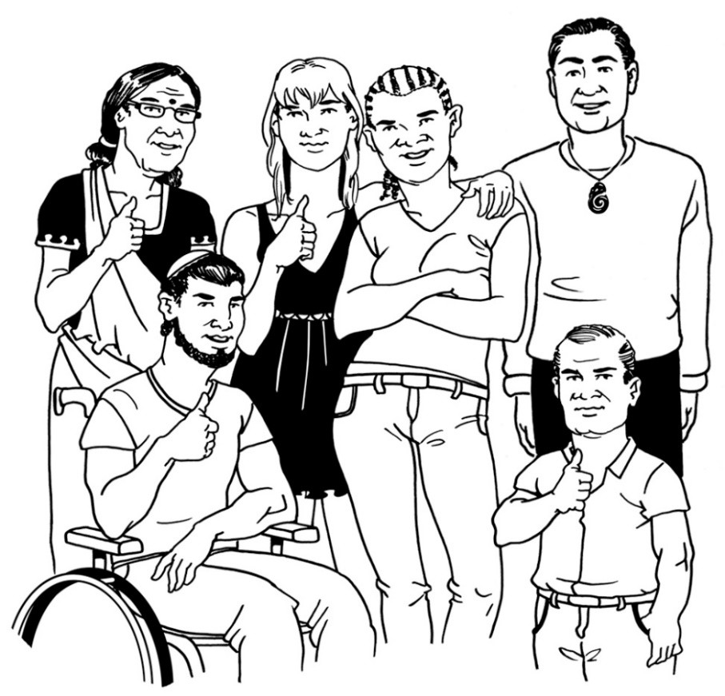

Easy Read

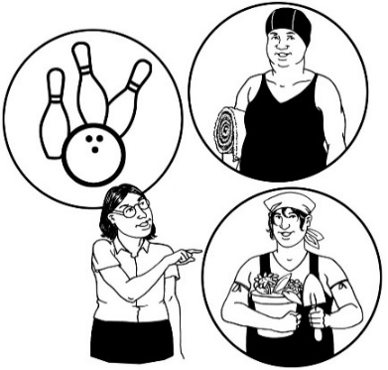
What is the capability fund for?
The fund in this document is called the capability fund.
A fund is money that we can give to people to do things with.

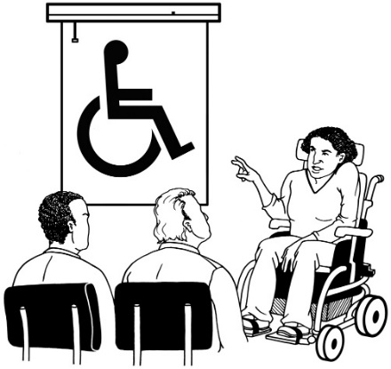
Capability means that a person or group of people is able to do something they:
- want to do
- need to do.

Who can get the capability funding?

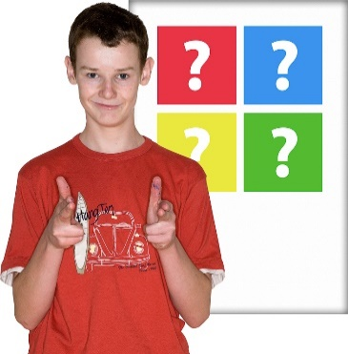
The capability fund is to help support groups of disabled people to be able to do more things.
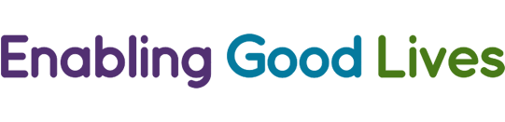
The capability fund promotes the Enabling Good Lives approach.
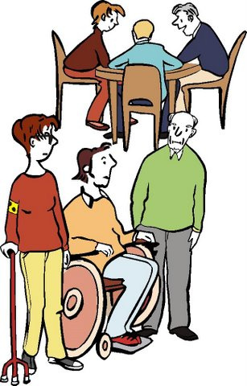
You can apply to get funding if you are:
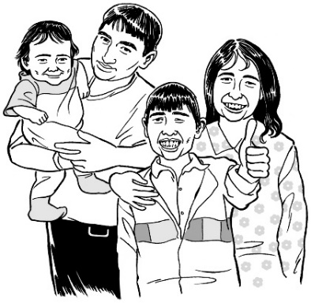
- a group of disabled people
- a group of families with disabled people in the families.
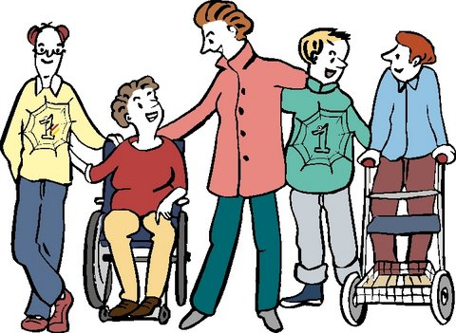
The capability fund must be used to make things better for the:
- group of people you are applying for
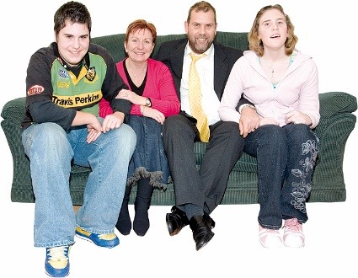
or
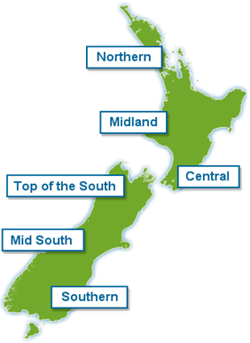
- the group of families / whānau/ aiga you are applying for.
The capability fund is only for people who live in the MidCentral DHB region.

What sort of things can get funding?

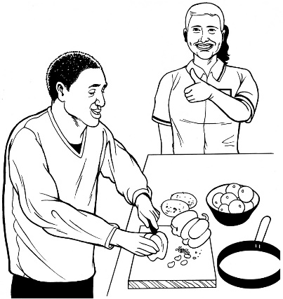
The capability fund can support groups to do more than they are doing already.

Here are some examples of the things the capability fund can support.
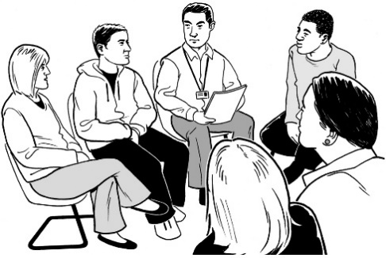
- Families coming together to:
- share ideas
- plan for the future for their disabled teenagers.

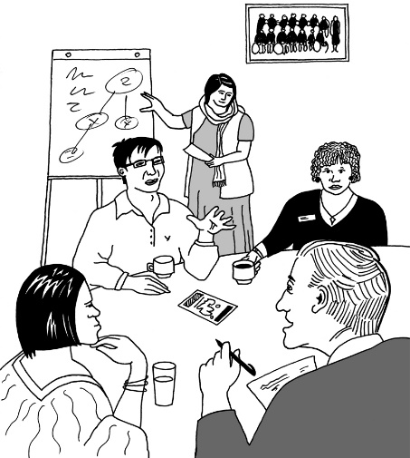
Funding can support families to come together at:
- workshops
- wānanga.

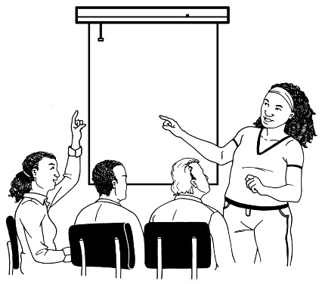
- A talk with information about how to choose a disability support service.

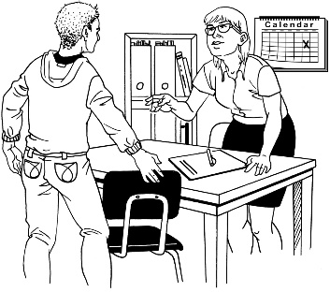
- Support young disabled people who are leaving school to find mentors.

A mentor is a person who:
- gives someone advice
- tells someone how to do things the mentor has already done.

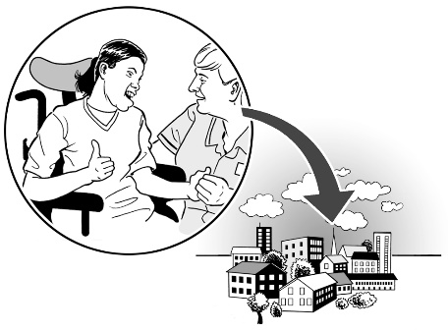
Having a mentor would make it easier for young disabled people to:
- meet people who live near them
- do things with other people.
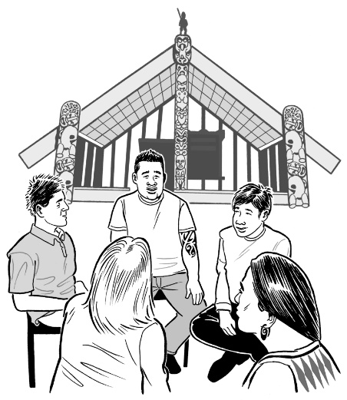
- Making support for disabled people in their:
- whānau
- hapū
- iwi.
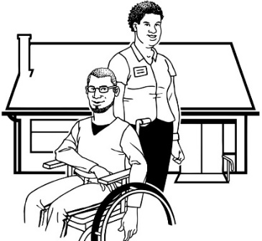
- Workshops about:
- working with your support people
- how to use the money you have to pay support people.

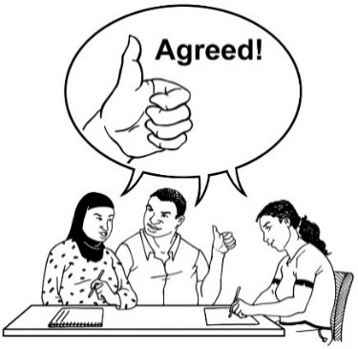
Who chooses which groups
get funding?

The Funding Panel chooses who gets funding from the capability fund.
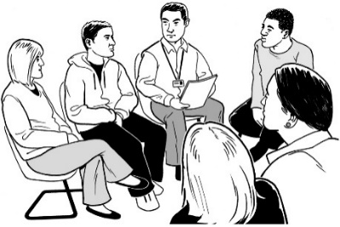
A panel is a group of people who are chosen to help make decisions about something.
The Funding Panel is part of the MidCentral Regional Leadership Group.

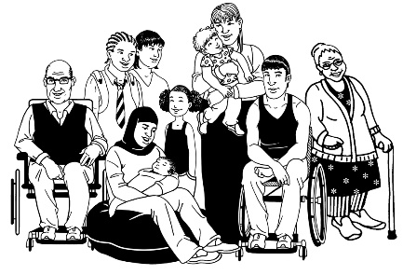
The Funding Panel is made up of:
- disabled people
- family / whānau / aiga of disabled people.

It will take the Funding Panel from 1 week to 1 month to let you know:
- if your group will get the funding you have asked for.

How do I apply for funding?

You can apply in a way that works best for you.

You can apply for capability funding by:
- making a short video
- a face to face presentation

- sending an email to:
apply@manawhaikaha.co.nz
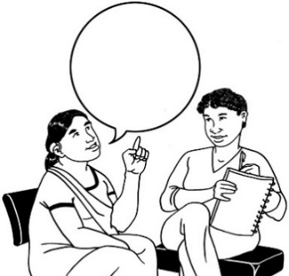
A good way to start is by talking to the Fund Advisor.

The Fund Advisor can:
- tell you more about the funding
- help you apply for funding.

The Fund Advisor is Chris Potts.
Contact her by:
- texting:
027 620 3036
- calling:
027 620 3036
- emailing:
apply@manawhaikaha.co.nz

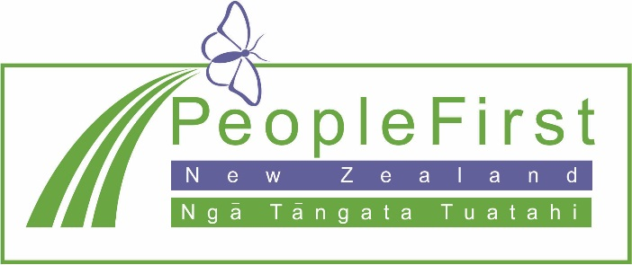

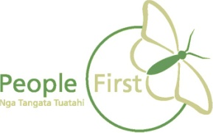
This information has been translated into Easy Read
by People First New Zealand Inc. Ngā Tāngata Tuatahi
