A new disability support system for New Zealand
August 2018 update

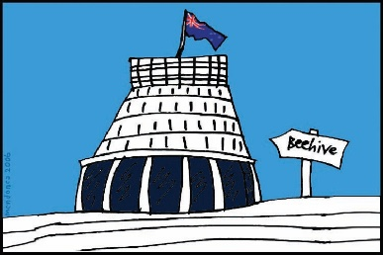
The Government of New Zealand is making changes to the disability support system.

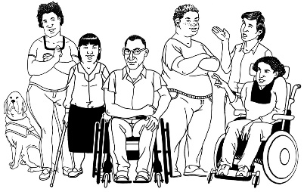
The Government has been planning the changes to the disability support system together with:
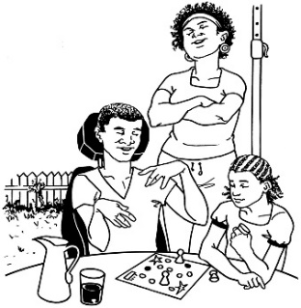
- disabled people

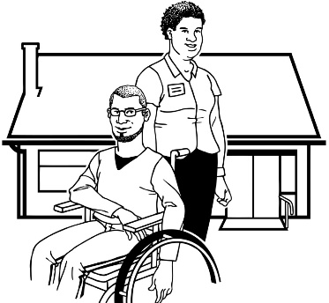
- family / whānau

- disability support services.

Working together like this is called
co-design.

This is an update to let you know what:

- has been happening

- is going to happen next.

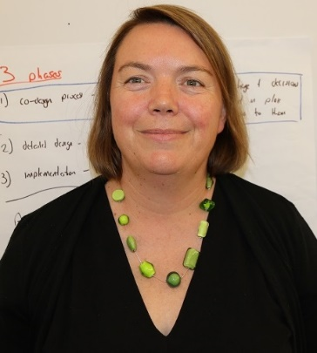

This update is from Sacha O’Dea from the Ministry of Health.

Sacha is working with the disability community on this work.

What have we been doing?

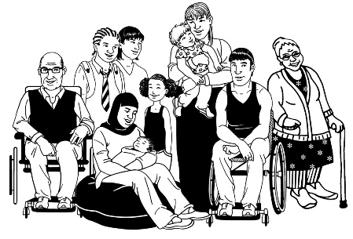
- Disabled People and Whānau Capability Fund

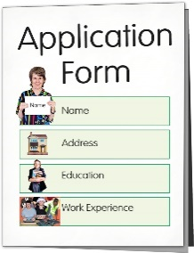
The Disabled People and Whānau Capability Fund is now open.

A fund is money that we can give to groups of people to do things with.

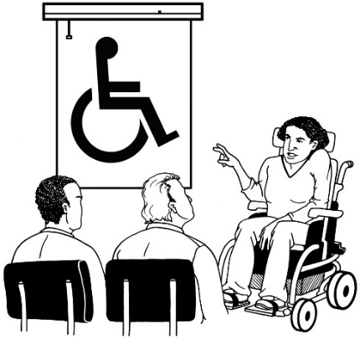
Capability means that a person or group of people learn new skills so they are able to do something they have not been able to do before.
For example, when a group of young people learn how to move out of home to go and live in their first flat.
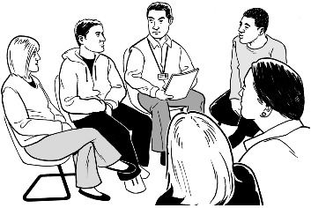
We would like to see groups of people think about what sorts of things they would like to learn together.

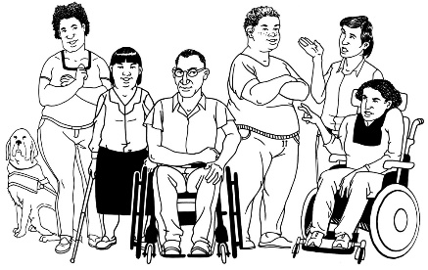
You can ask to get funding if you are:

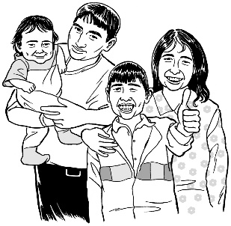
- a group of disabled people
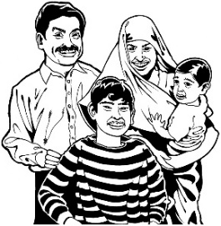
- a group of families with disabled people in the families.

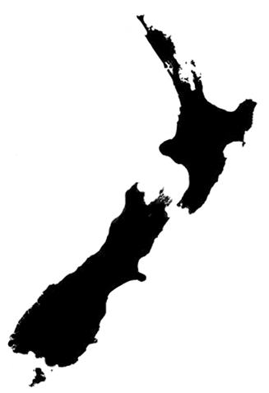
Your group needs to be living in the MidCentral DHB region which includes:

- Palmerston North
- Horowhenua
- Manawatu
- Ōtaki
- Tararua districts.

There is an Easy Read booklet called Capability Funding: Grants to groups of disabled people and whānau.

It will give you information about:

- what this funding can be used for

- how you can apply for this funding

- ideas of the sorts of things your group might like do.

You can find this booklet on the Enabling Good Lives website:
www.enablinggoodlives.co.nz

- Baseline study
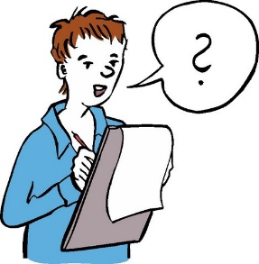

We have started our baseline study.

A baseline study:
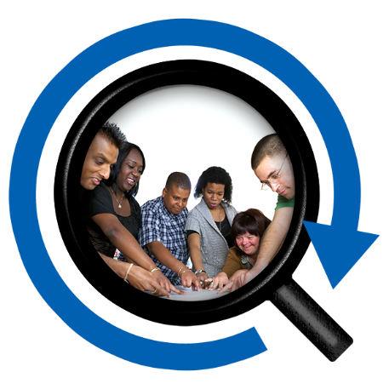
- gets information from a wide range of people about their lives at the start of a project

- keeps this information so it can be used to see if what we are doing is making a difference.

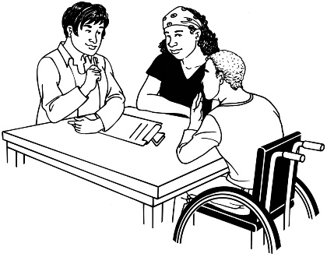
For this baseline study we are meeting with 165 disabled people and family / whānau.

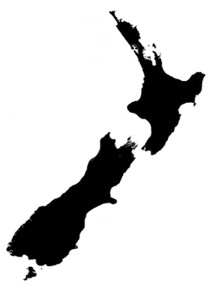
These people use disability support services in MidCentral.

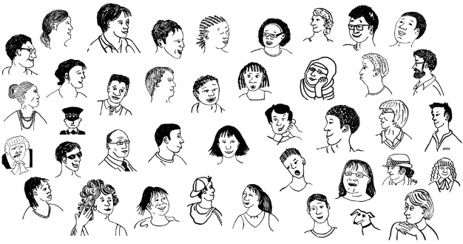
The 165 disabled people have been randomly selected.

Randomly selected means picking some people out from a large group.

This will mean everyone has the same chance of being picked.

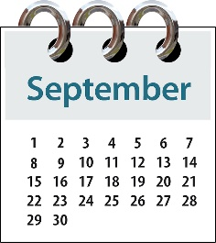
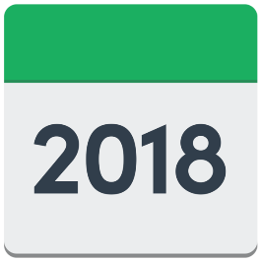
We will be meeting with these people over the next month or so.

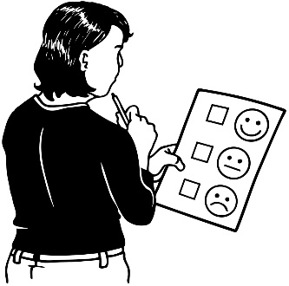
We will use this baseline study to find out about:

- how they feel about the disability support services they use now

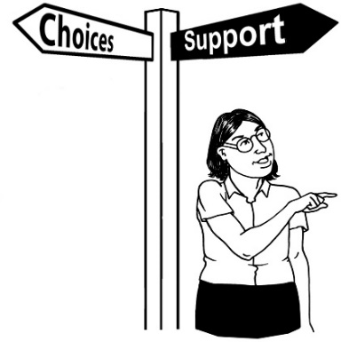
- what this means for how they live their life

- what things they think need to change.
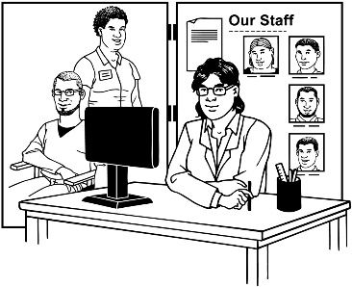
We will also be getting information from providers as part of this baseline study.

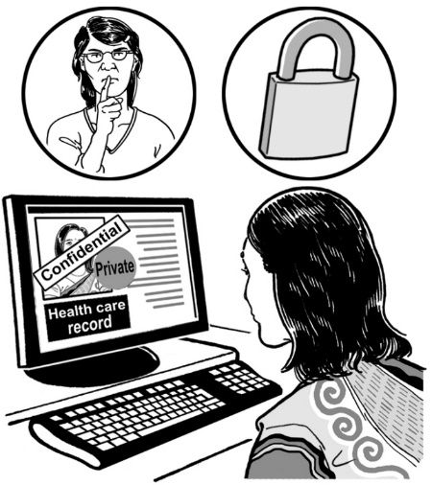
All of the information collected is confidential.

Confidential means to keep information very private.

When we write our report we will not include the names of the people who have shared their stories.

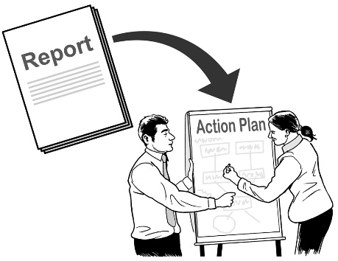
We will write a report about what we find out from the baseline study.

The information in the report will help change the way we give to disability support services.

When the report is finished we will put it on the Enabling Good Lives website for people to have a read.
www.enablinggoodlives.co.nz

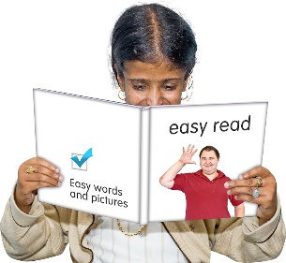
The report will also be in Easy Read.

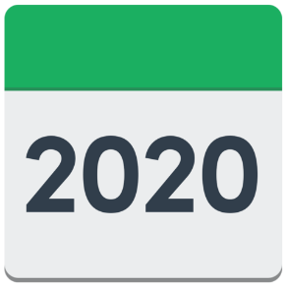
In 2020 we will talk to the same people again to see if disablity services are better for disabled people.
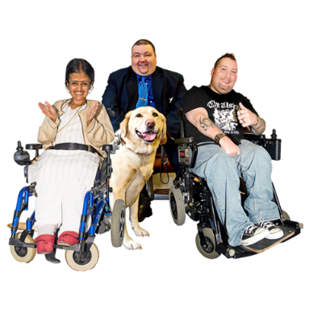
By doing this we will be able to tell if the new disability support system has made a difference to people’s lives.

- Two teams

We have set up two teams to support disabled people and their whānau.

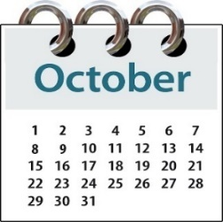
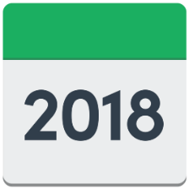
These teams will be starting their support from 1 October 2018.

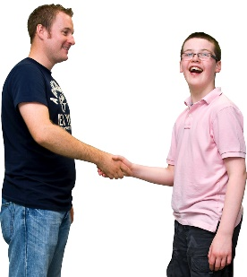
There will be Connectors / Kaitūhono in the teams who will work alongside:

- disabled people

- family / whānau.

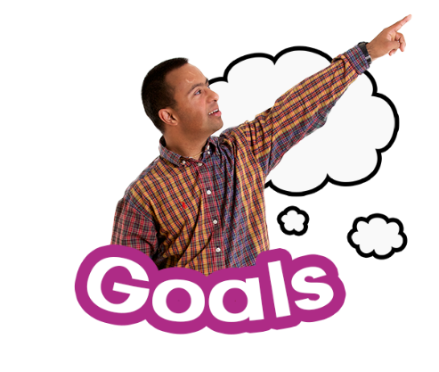
The Connectors will help disabled people think about what they want in their lives.

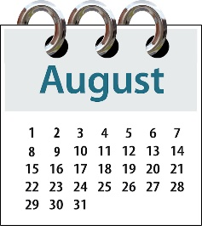
Most of these new Connectors have started and they are on an induction program.

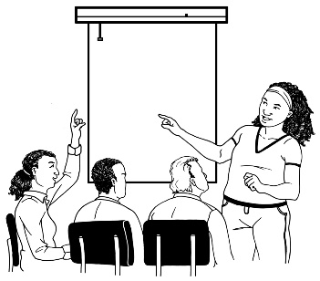
An induction program tells Connectors the things they need to know to be able to do their job.

It is important to have the right people on the teams so that the new disability support system will work the best it can for disabled people and their families / whānau.

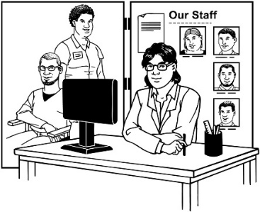
- Working with providers

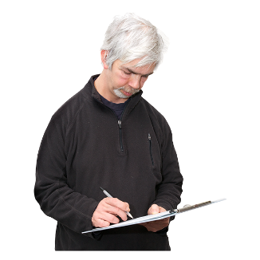
We have asked providers to tell us about what support they can give to disabled people in this new system.

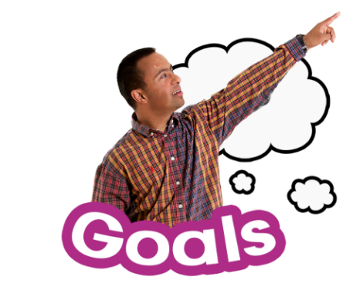
Disabled people and whānau will be able to use this information when:

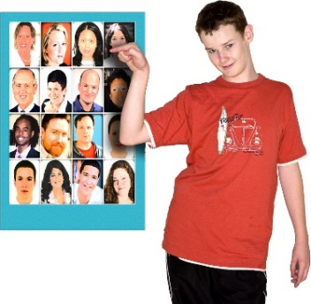
- they are thinking about what they are wanting to do in their lives

- which provider can best meet their needs.

This information will be put on the
Mana Whaikaha website:
www.manawhaikaha.co.nz

- Website

We are busy working on the website.

We are gettting it ready so that people can have the information they need from 1 October 2018.

- Cabinet papers

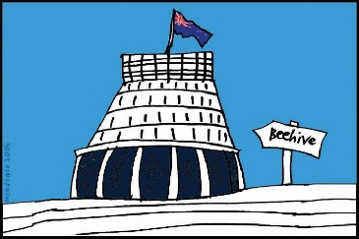
Cabinet is a group of Government Ministers.

We write Cabinet papers to let them know about what we need to set up this new disability support system.

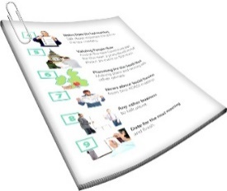
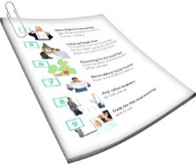
Cabinet has read 2 of our papers.

Some of this information will be made available in Easy Read.

They will be on our website before 1 October 2018.

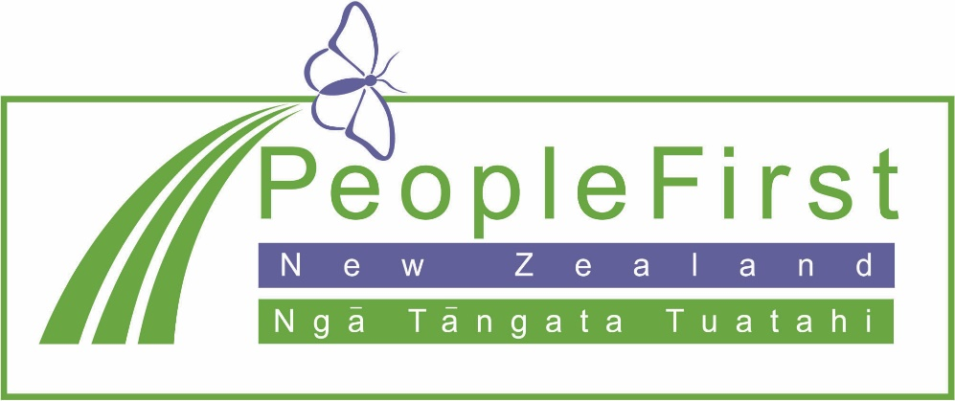

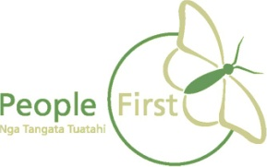
This information has been translated into Easy Read
by People First New Zealand Inc. Ngā Tāngata Tuatahi
