What is an Independent Facilitator and how do I make the most out of them?
Enabling Good Lives Independent Facilitation

An Independent Facilitator (previously known as an Enabling Good Lives Navigator) is an ally who assists a disabled person and their family to dream big, make a plan for the future and connect with their local community.
When can I work with an Independent Facilitator?
From July 1, 2016, as a 2016/2017 school leaver you are entitled to six hours of free independent facilitation, with the ability to purchase more hours with your EGL personal budget if you choose to … although it is likely that for many families the connections and skills you have developed will be sufficient to 'self-navigate'.

What will they do?
Some things an Independent Facilitator can do with you and your family include:
- Build a trusting relationship; with you and with your family
- Connect with others who are involved; wider family and friends, school, LifeLinks …
- Help you (and your family) dream and plan about what a good life might look like. Not being restricted to what we might have always thought before, but aiming really high, and then figuring out how to take the first steps towards that
- Helping you access and use your EGL personal budget
- Helping you find out what is in your local community that you might be interested in
- Helping you find out and connect to who else might be able to help. These might be local people in your community, friends and family (perhaps forming a Circle of Support) agencies (e.g. supported employment, Work and Income, Housing NZ …)
- Help you negotiate with disability support services, if you choose to use them
What won't they do?
Things that your Independent Facilitator won’t do (but can help you find the people to do this if you wish) include …
- Make decisions or speak on your behalf
- Refer you to disability support services (but we'll help you make the most out of them, should you choose to use them)
- Introduce you to the community (but we can help you find out how to connect with)
- Another person’s job (e.g. an Independent Facilitator is not a support worker, or a transition teacher or a budget adviser…)

Who will my Independent Facilitator be?
We have a number of accredited Independent Facilitators for you to choose from. Check out the profiles on the next pages, and think about
- Who captured your interest?
- Who has the skills and experiences you think might be helpful?
- Who lives near you so might know what is available in your community?
Please let Joanna Martino (phone: 03 974 2308 or email Joanna@eglives.co.nz) know who you would like to work with so that she can connect you with that person.

Following your six hours free independent facilitation, if you are looking to purchase further assistance the most important thing to ensure is that your Independent Facilitator is
- Independent (they do not benefit from any of the choices you make)
- A facilitator (they might make it EASIER for you to do things, but they don’t do things for you)
- Understands the principles of Enabling Good Lives and works with you in an “Enabling Good Lives” way

Please note Joanna’s details for future reference:
Joanna Martino
Enabling Good Lives Christchurch – Lead
Ministry of Health
Phone: 03 974 2308
Email – Joanna@eglives.co.nz

What is important to me – How do I enable my good life? | Kerri Bonner 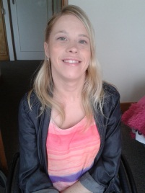 | Background info
The following parts of my life are important to me:  - Exercise and Sport; I am a regular gym member. I have travelled internationally with the New Zealand Boccia team and attended the Beijing Paralympic Games.  - I love the outdoors, especially in the warmer weather. I particularly like going into Hagley Park and rolling around.  - I enjoy travelling. I regularly travel around New Zealand for work with Standards and Monitoring Services.  - I am very much a people person and love spending time with family and friends. I enjoy going out for coffee, wine and food.  - Treating other people with respect is a value of mine.  - I aim to do my best in whatever I am doing.  - I have individualised funding and employ support workers to assist me in living a life that is important to me. |  | I am a disabled person and have experienced the successes and challenges of a well-planned transition from school. After school, I completed a Community Studies course specializing in Youth Work at CPIT. From there, I went to University and studied Psychology. I also volunteered at Youthline as a text counsellor for a number of years. When I graduated I worked at Youthline Central South Island as the Volunteer Coordinator. Currently, alongside being an Independent Facilitator, I work for Standards and Monitoring Services, where I evaluate and develop services that work with disabled people. Enabling Good Lives excites me because it’s all about disabled people having a good life and at the end of the day that’s what we all want.
 | Contact details | What people appreciate about me
 | Lives in the Mairehau/Shirley area | My colleagues have told me that they appreciate:  - My people focused approach  - My very high expectations of what people’s lives can be like  - My warm and friendly manner with others  - That I start with where the person is at  - That I keep people on task  - That I use my personal experience of disability in an appropriate manner  - A colleague said to me recently, “There’s a good positive energy when Kerri is around”

What is important to me – How do I enable my good life? | Sue van der Byl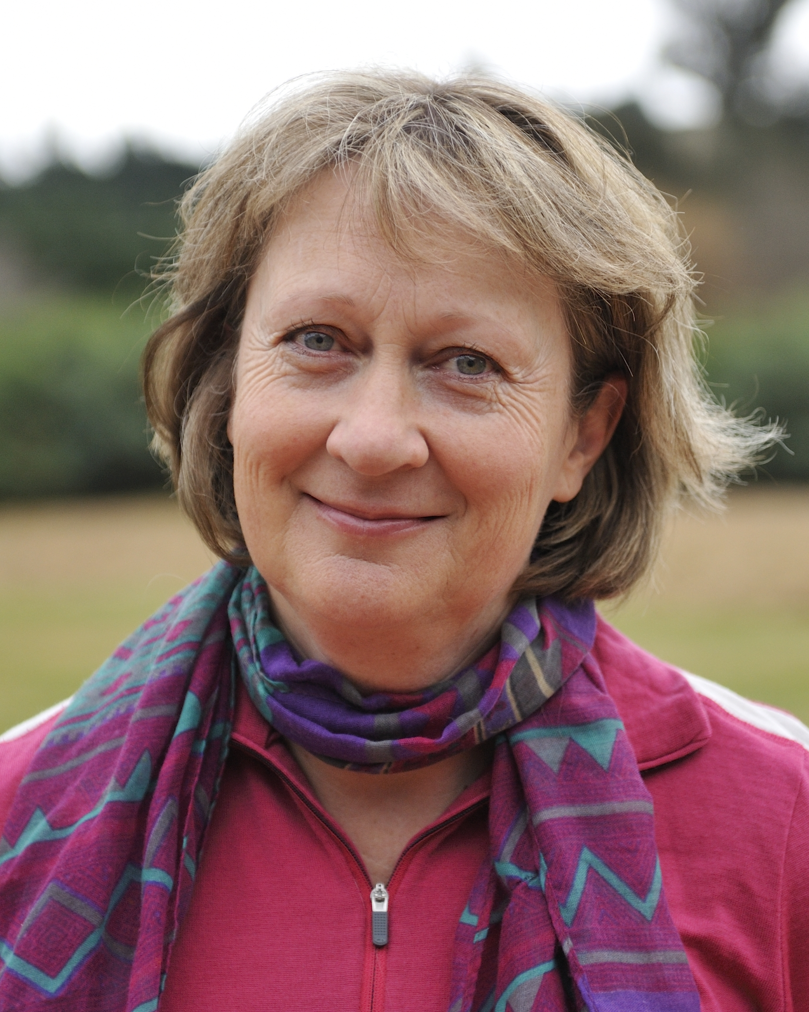 | Background info
The following parts of my life are important to me:  - My Family are the most important thing to me. My husband and I have two sons aged 18 and 22 years - both are studying.  - I love living in the country and have a few sheep and chickens on our lifestyle block.  - I have a large vegetable garden and really enjoy growing our own food.  - We have a little caravan and like to visit wild places to explore and go fishing.  - I have weekly walks with my friends and love to get together to share good food and wine.  - I love to spend time with my Mum who lives nearby. |  | I have spent 25 years working in the disability sector in a variety of positions in New Zealand, Britain and Australia. Soon after graduating with a Master’s Degree in psychology (Canterbury University) I set off on a working holiday travelling in Asia, Africa and Europe. I enjoyed meeting a lot of wonderful people and eating great food along the way. Our youngest son was diagnosed with dyspraxia at the age of three - I have personally experienced the journey of finding the best for our son and bring that experience to my position. I am well connected in the North Canterbury community.
 | Contact details | What people appreciate about me
 | I live in North Canterbury. | My colleagues have told me that they appreciate:  - I have great rapport with all types of people.  - I don’t make judgements and am open minded.  - I am dedicated to improving people’s lives.  - I can help people identify their dreams and put plans in place to achieve them.  - I have a lot of energy and the ability to motivate people.  - I am relaxed and reliable.  - This is not just a job to me – enabling good lives is a passion.

What is important to me – How do I enable my good life? | Julie Bacon  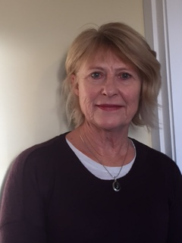 | Background info
My family and friends are very important to me. I am married and have two adult children and two grandchildren who I spend a lot of time with. I am involved in their lives and I am very useful as an after school carer and I love playing with them. I have an elderly mother who lives in Dunedin and I am increasingly spending time supporting her. That is an important role in my life at the moment.  I have a group of good friends with whom I go for long walks in the hills and solve the world’s problems or so we think at the time. I play golf regularly but with no skill and am currently starting to play bridge with friends. I enjoy my time at the gym and at regular Pilates sessions. I have been with my book club for many years and I enjoy reading, knitting, sewing at home.  I have enjoyed continuing to work with Deaf students in the new navigator role and it is important to me to give them support to reach their goals.  I believe that I have a good balance in my life and I endeavour to assist clients to achieve this also. |  | I have worked in Deaf education for 40 years and have worked with all ages of students but my passion is the transition area where I have worked with students who are finishing school. This is where my new role as a navigator can draw on my past skills and experiences. I have also worked as an ORS teacher with autistic students at schools in the Christchurch area.  I have always been involved with the families of the students and have a good relationship with the teachers also. I am familiar with the opportunities open to the students in the Christchurch area and am committed to helping the students fulfil their dreams in the future and to enable them to have a good life.
 | Contact details | What people appreciate about me
 | I live in Clifton | My colleagues in education have always told me that they admire the energy and professionalism I have brought to the job. They have told me that I am hard working and always do the best I can for the students. They have talked about the way I am always positive and good humoured but persevere to achieve results.

