‘System Transformation co-design process’
Easy Read key points from the
26th April 2017 workshop:

What is this about?

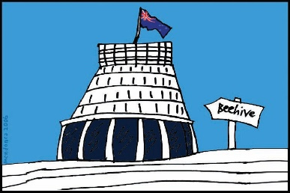
The Government of New Zealand is looking at making big changes to the disability support system.

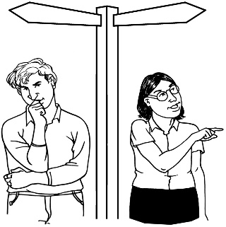
The long name for this is system transformation.

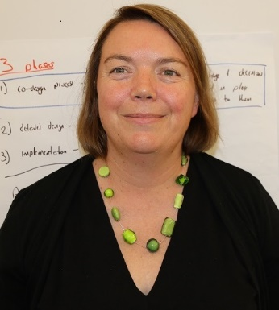
Sacha O’Dea from the Ministry of Health is leading this work.

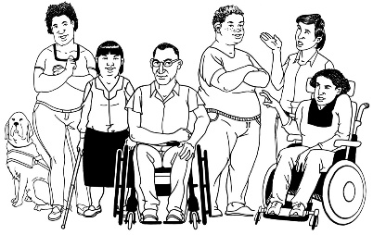
The Government has said it will plan the changes to the disability support system together with:
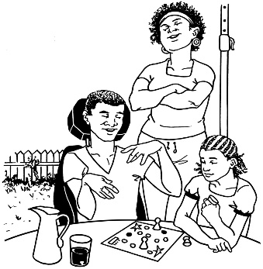
- disabled people

- family / whanau
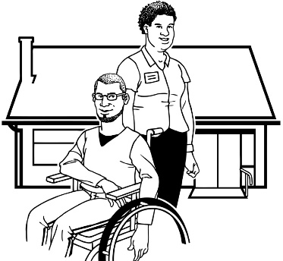
- disability support services.

Working together like this is called co-design.
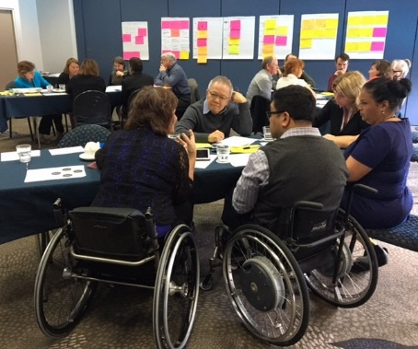

A co-design group has been put together.

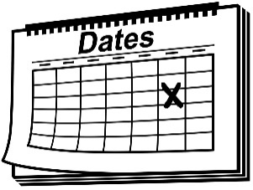
The co-design group will work together over 9 workshops.
9

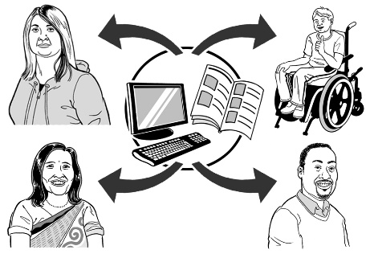
The key points of every workshop will be sent out so the rest of New Zealand can see what is being talked about.

26 April 2017
The second co-design workshop was on 26 April 2017.

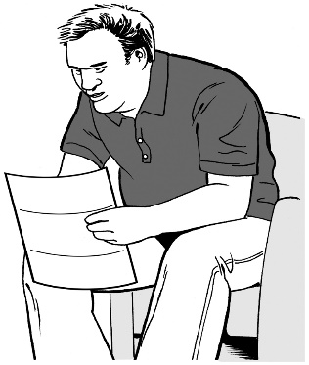
Keep reading to find the key points from that workshop.

Key point 1

The co-design group talked about:
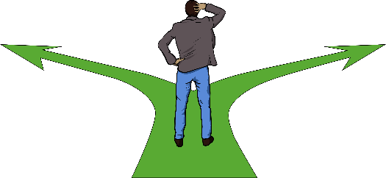
- what parts of the disability support system the group will be looking at making changes to

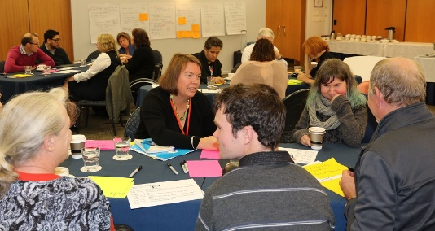
- what the job of the co-design group is

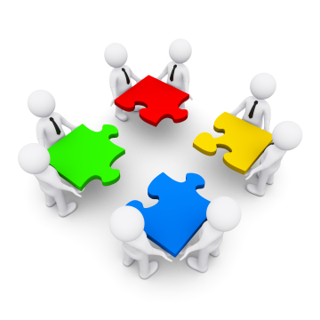
- how decisions in the group will be made.

What parts of the disability support system will the group be looking at making changes to?

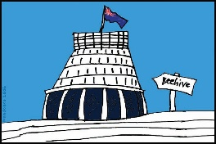
The co-design group will be looking at making changes to:
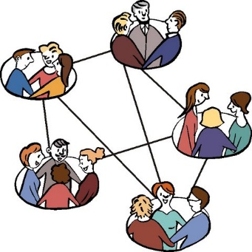
- disability support from all government departments, like Work and Income
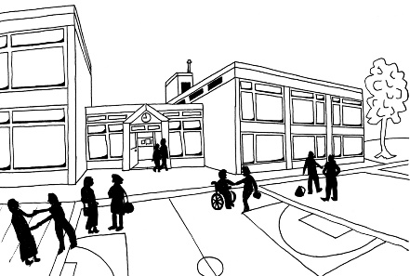
- how this support works together with services, such as education in schools.

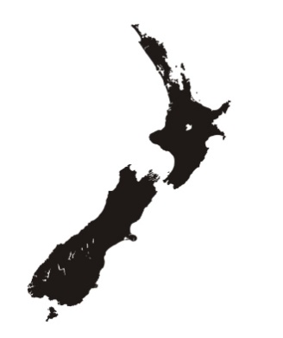
At the start the changes will not happen all over New Zealand.

The changes will be done in 1 place first – to see if it works well.

The people who will get to try the changes first are:
- people who live in the Mid Central region
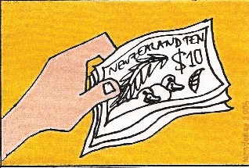
- people who get funding from Disability Support Services.

The co-design group will need to make a plan for:
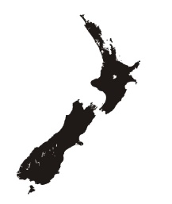
- when the changes will happen in the Mid Central region

- when the changes will happen in the rest of New Zealand.

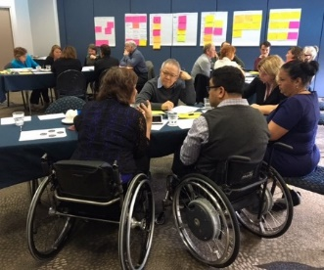
The co-design group has 2 jobs.

1 job is to plan a new disability support system for New Zealand.

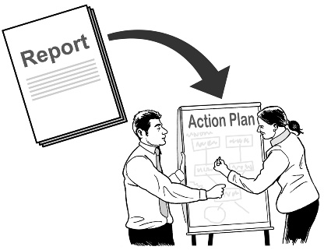
The other job is to make a plan for how to get from the system we have now to a new system.

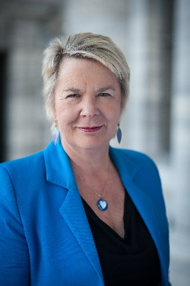
The co-design group will show their plans to Nicky Wagner, the Minister for Disability Issues.

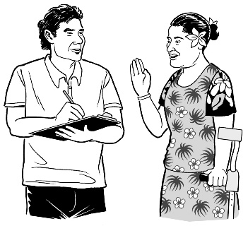
The people on the group will also be able to share what they think about other disability issues they know about.
The plans made by the co-design group will also be given to Cabinet in late June 2017.

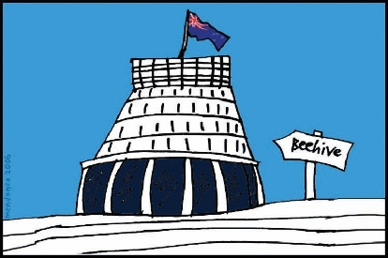
Cabinet is a group of senior Government Ministers.

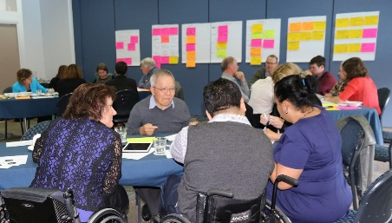
The co-design group will also come together later on to do more work around making the real changes in the Mid Central region.

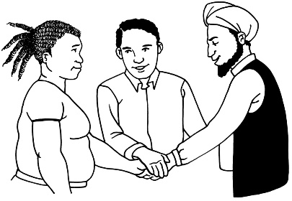
The co-design group wanted to know how they will work together with other groups who are part of this work.

A document will be made that will help the co-design group to work:
- together

- with other groups.

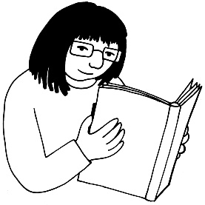
This document is called a Terms of Reference.

The co-design group will look at this document at the next workshop.
Key point 2

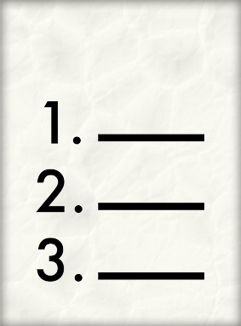
The co-design group talked about some of the things they will need to work on, like:

- Why are we making changes to the disability support system?

- What parts of the disability support system are we going to make changes to?
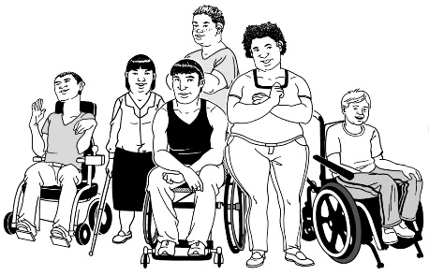

- Who are we making these changes for?

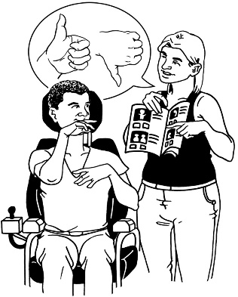
- What is the disability support system like now for disabled people and everyone else?
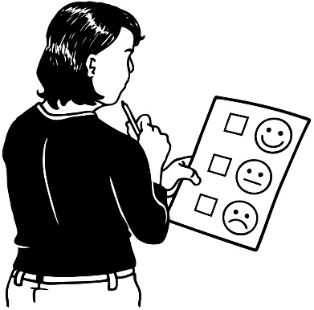
- What have we learned about:

          - what we should do?

          - what we should not do?

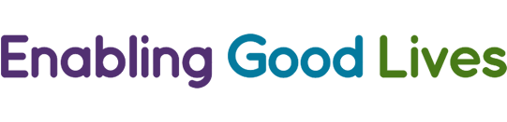
- Thinking about Enabling Good Lives, what should life be like for disabled people in the new disability support system?
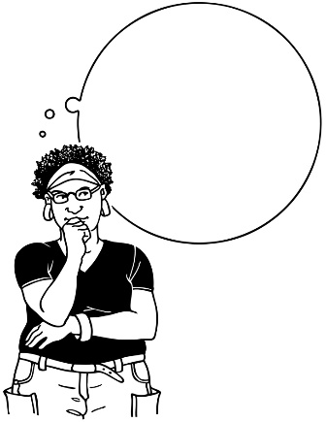

- If we want good lives for disabled people in the future, what changes need to happen?

- When the changes happen what will it:

- feel like for the people it will make a difference to?

- do to the system?
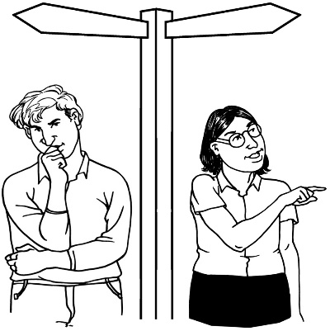
- What is the best way to make these changes in the Mid Central region and across New Zealand?

3 people from the co-design group will also work together with ThinkPlace – a design company.

These people will plan future workshops.

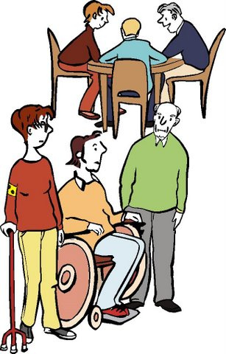
The people from the co-design group who will do this work are:
- Sacha O’Dea – Ministry of Health
- Dr Esther Woodbury – a disabled person
- Gerri Pomeroy – a disabled person.
Key point 3
The co-design group talked about Enabling Good Lives.

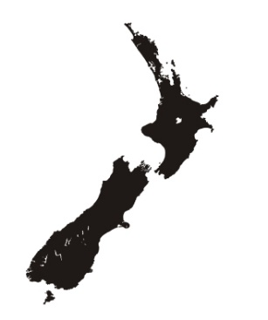
Enabling Good Lives is a way of giving disability support that has been tried in some parts of New Zealand.

The co-design group understands the values of Enabling Good Lives.

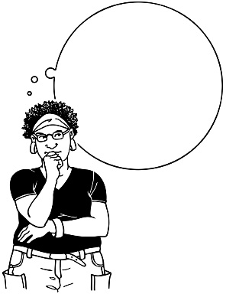
Values are important ideas.

Values are sometimes called principles.

The people doing this work will try to follow the values of Enabling Good Lives.
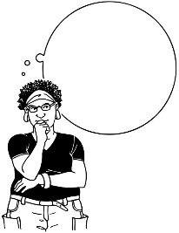
1

Many people have been talking about the Enabling Good lives idea of Mainstream First:
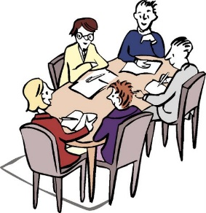
- at the first co-design group workshop

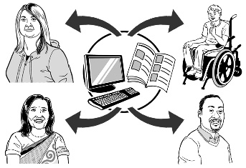
- at the Disability Forum

- in between meetings.

The co-design group says Mainstream First means:

“Everybody experiences full participation and inclusion within their community (people, places, assets, infrastructure and supports) as of right and can choose funded supports to enhance and facilitate this.”
This is not Easy Read

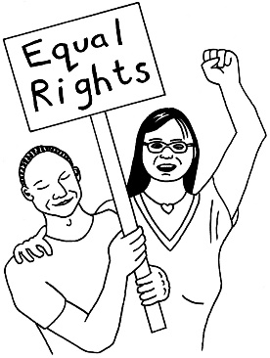
An easy way to understand this is:

It is your right to:
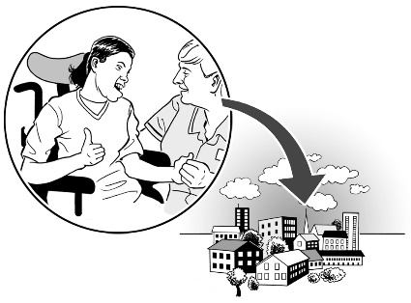
- be part of your community

- use the things, places and services in your community like everyone else.

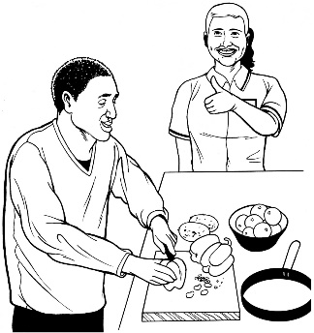
You can also choose how you use disability support services to get the most from your community.

The co-design group may change how they explain what Mainstream First means in the future.

Key point 4

The co-design group made a long list of things they will need to think about when they are doing the work, like:
- what we have learned in the past
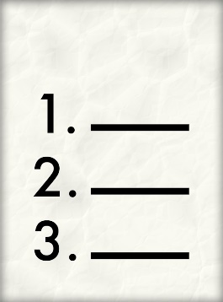
- the things we know

- research that has been done.

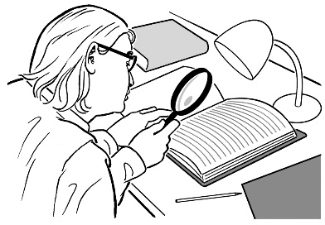
Research is:
- looking to find an answer to a question you have

- trying to find out how to do things better.
The co-design group will also think about:

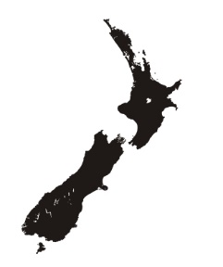
- what the people of New Zealand have said

- the work that is being done on:

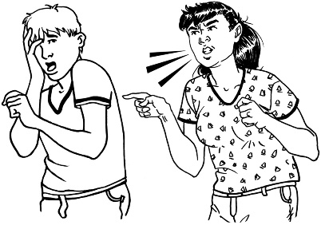
  - safeguarding – making sure that disabled people can make their own choices in a way that keeps them safe from abuse
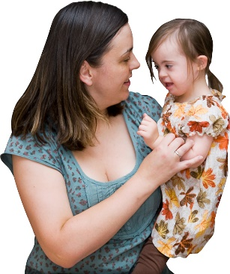
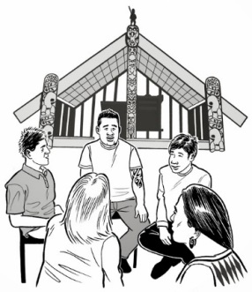
  - A good start in life – this is a Government project that is looking at making better supports for parents, family / whānau of disabled children between the ages of 0-8.

Key point 5

The first stage of work for the co-design group needs to be done by June 2017.

The co-design group talked about:
- how they are going to get all of the work done in this time

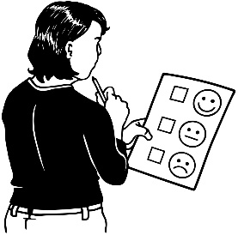
- if there is time to get it all done

- the need to hold more workshops

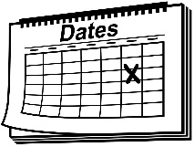
- work will need to be done between workshops
- some of the dates of the workshops have changed.

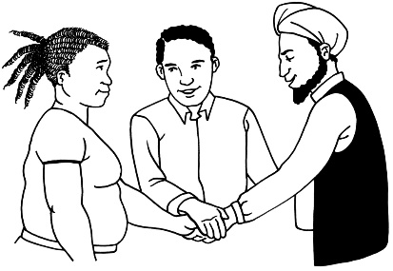
The people in the group need to trust each other to be able to work together.

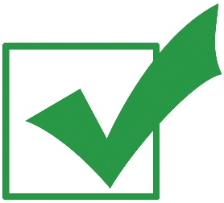
The people in the co-design group said they feel like they are:
- getting to know each other

- now building trust.

Everyone is keen to start the work.

What now?

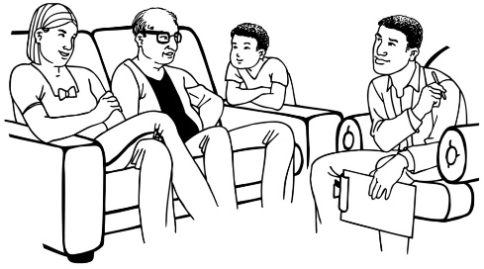
Before the next workshop we will get the stories of 7 of the people in the co-design group.

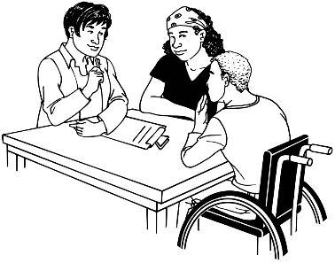
We will ask 5 disabled people and 2 people from family / whanau groups about:
- their lives
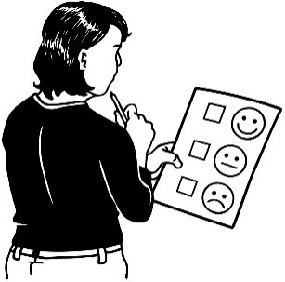
- what has happened to them in the disability support system we have now – both good and bad things.

Hearing these real stories will help us when we are doing the work.

The next workshop will be on 4th May 2017.

Talk to us
?

You can talk to us if you:
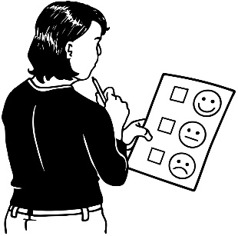
- have any questions

- want to tell us what you think about the work that is being done
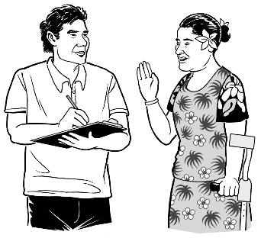
- want to tell us an idea.

Our email address is:
STfeedback@moh.govt.nz

Thank you,
Sacha O’Dea

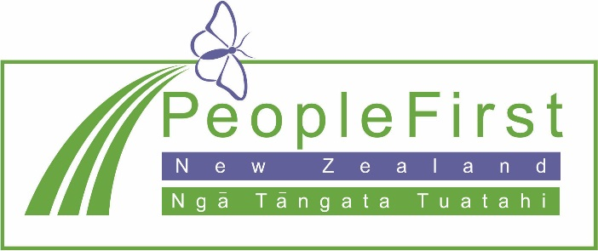

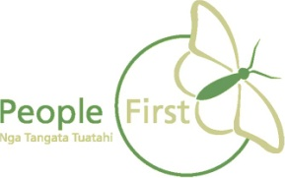
This information has been translated into Easy Read
by People First New Zealand Inc. Ngā Tāngata Tuatahi
