

Independent Facilitation

What is an Independent Facilitator and how do I make the most out of them?
An Independent Facilitator (previously known as an Enabling Good Lives Navigator) is an ally who assists a disabled person and their family to dream big, make a plan for the future and connect with their local community.
When can I work with an Independent Facilitator?
2017 and 2018 school leavers are entitled to six hours of free independent facilitation, with the ability to purchase more hours with your EGL personal budget if you choose to.

What will they do?
Some of the things Independent Facilitators can do with you and your family include:
- Build a trusting relationship; with you and with your family
- Connect with others who are involved; wider family and friends, school, LifeLinks …
- Help you (and your family) dream and plan about what a good life might look like. Not being restricted to what we might have always thought before, but aiming really high, and then figuring out how to take the first steps towards that
- Helping you access and use your EGL personal budget
- Helping you find out what is in your local community that you might be interested in
- Helping you find out and connect to who else might be able to help. These might be local people in your community, friends and family (perhaps forming a Circle of Support) agencies (e.g. supported employment, Work and Income, Housing NZ …)
- Help you negotiate with disability support services, if you choose to use them
What won't they do?
Things that your Independent Facilitator won’t do (but can help you find the people to do this if you wish) include …
- Make decisions or speak on your behalf
- Refer you to disability support services (but we'll help you make the most out of them, should you choose to use them)
- Introduce you to the community (but we can help you find out who to connect with)
- Another person’s job (e.g. an Independent Facilitator is not a support worker, or a transition teacher or a budget adviser…)

Who will my Independent Facilitator be?
We have a number of Independent Facilitators for you to choose from. Check out the profiles on the next pages, and think about
- Who captured your interest?
- Who has the skills and experiences you think might be helpful?
- Who lives near you so might know what is available in your community?
Please let Hannah Perry know who you would like to work with so that she can connect you with that person. See below.
Following your six hours free independent facilitation, if you are looking to purchase further assistance the most important thing to ensure is that your Independent Facilitator is
- Independent (they do not benefit from any of the choices you make)
- A facilitator (they might make it EASIER for you to do things, but they don’t do things for you)
- Understands the principles of Enabling Good Lives and works with you in an “Enabling Good Lives” way

Although it is likely that for some families the connections and skills you have developed will be sufficient to 'self-navigate'.

Hannah Perry
Enabling Good Lives Christchurch
Phone / Text : 021 035 4134
Email – Hannah@eglives.co.nz

What is important to me – How do I enable my good life? | Kerri Bonner 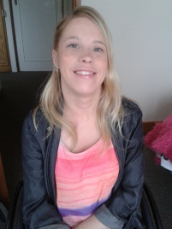 | Background info
The following parts of my life are important to me:  - Exercise and Sport; I am a regular gym member. I have travelled internationally with the New Zealand Boccia team and attended the Beijing Paralympic Games.  - I love the outdoors, especially in the warmer weather. I particularly like going into Hagley Park and rolling around.  - I enjoy travelling. I regularly travel around New Zealand for work with Standards and Monitoring Services.  - I am very much a people person and love spending time with family and friends. I enjoy going out for coffee, wine and food.  - Treating other people with respect is a value of mine.  - I aim to do my best in whatever I am doing.  - I have individualised funding and employ support workers to assist me in living a life that is important to me. |  | I am a disabled person and have experienced the successes and challenges of a well-planned transition from school. After school, I completed a Community Studies course specializing in Youth Work at CPIT. From there, I went to University and studied Psychology. I also volunteered at Youthline as a text counsellor for a number of years. When I graduated I worked at Youthline Central South Island as the Volunteer Coordinator. Currently, alongside being an Independent Facilitator, I work for Standards and Monitoring Services, where I evaluate and develop services that work with disabled people. Enabling Good Lives excites me because it’s all about disabled people having a good life and at the end of the day that’s what we all want.
 | Contact via hannah@eglives.co.nz | What people appreciate about me
 | Lives in the Mairehau/Shirley area | My colleagues have told me that they appreciate:  - My people focused approach  - My very high expectations of what people’s lives can be like  - My warm and friendly manner with others  - That I start with where the person is at  - That I keep people on task  - That I use my personal experience of disability in an appropriate manner  - A colleague said to me recently, “There’s a good positive energy when Kerri is around”

What is important to me – How do I enable my good life? | Sue van der Byl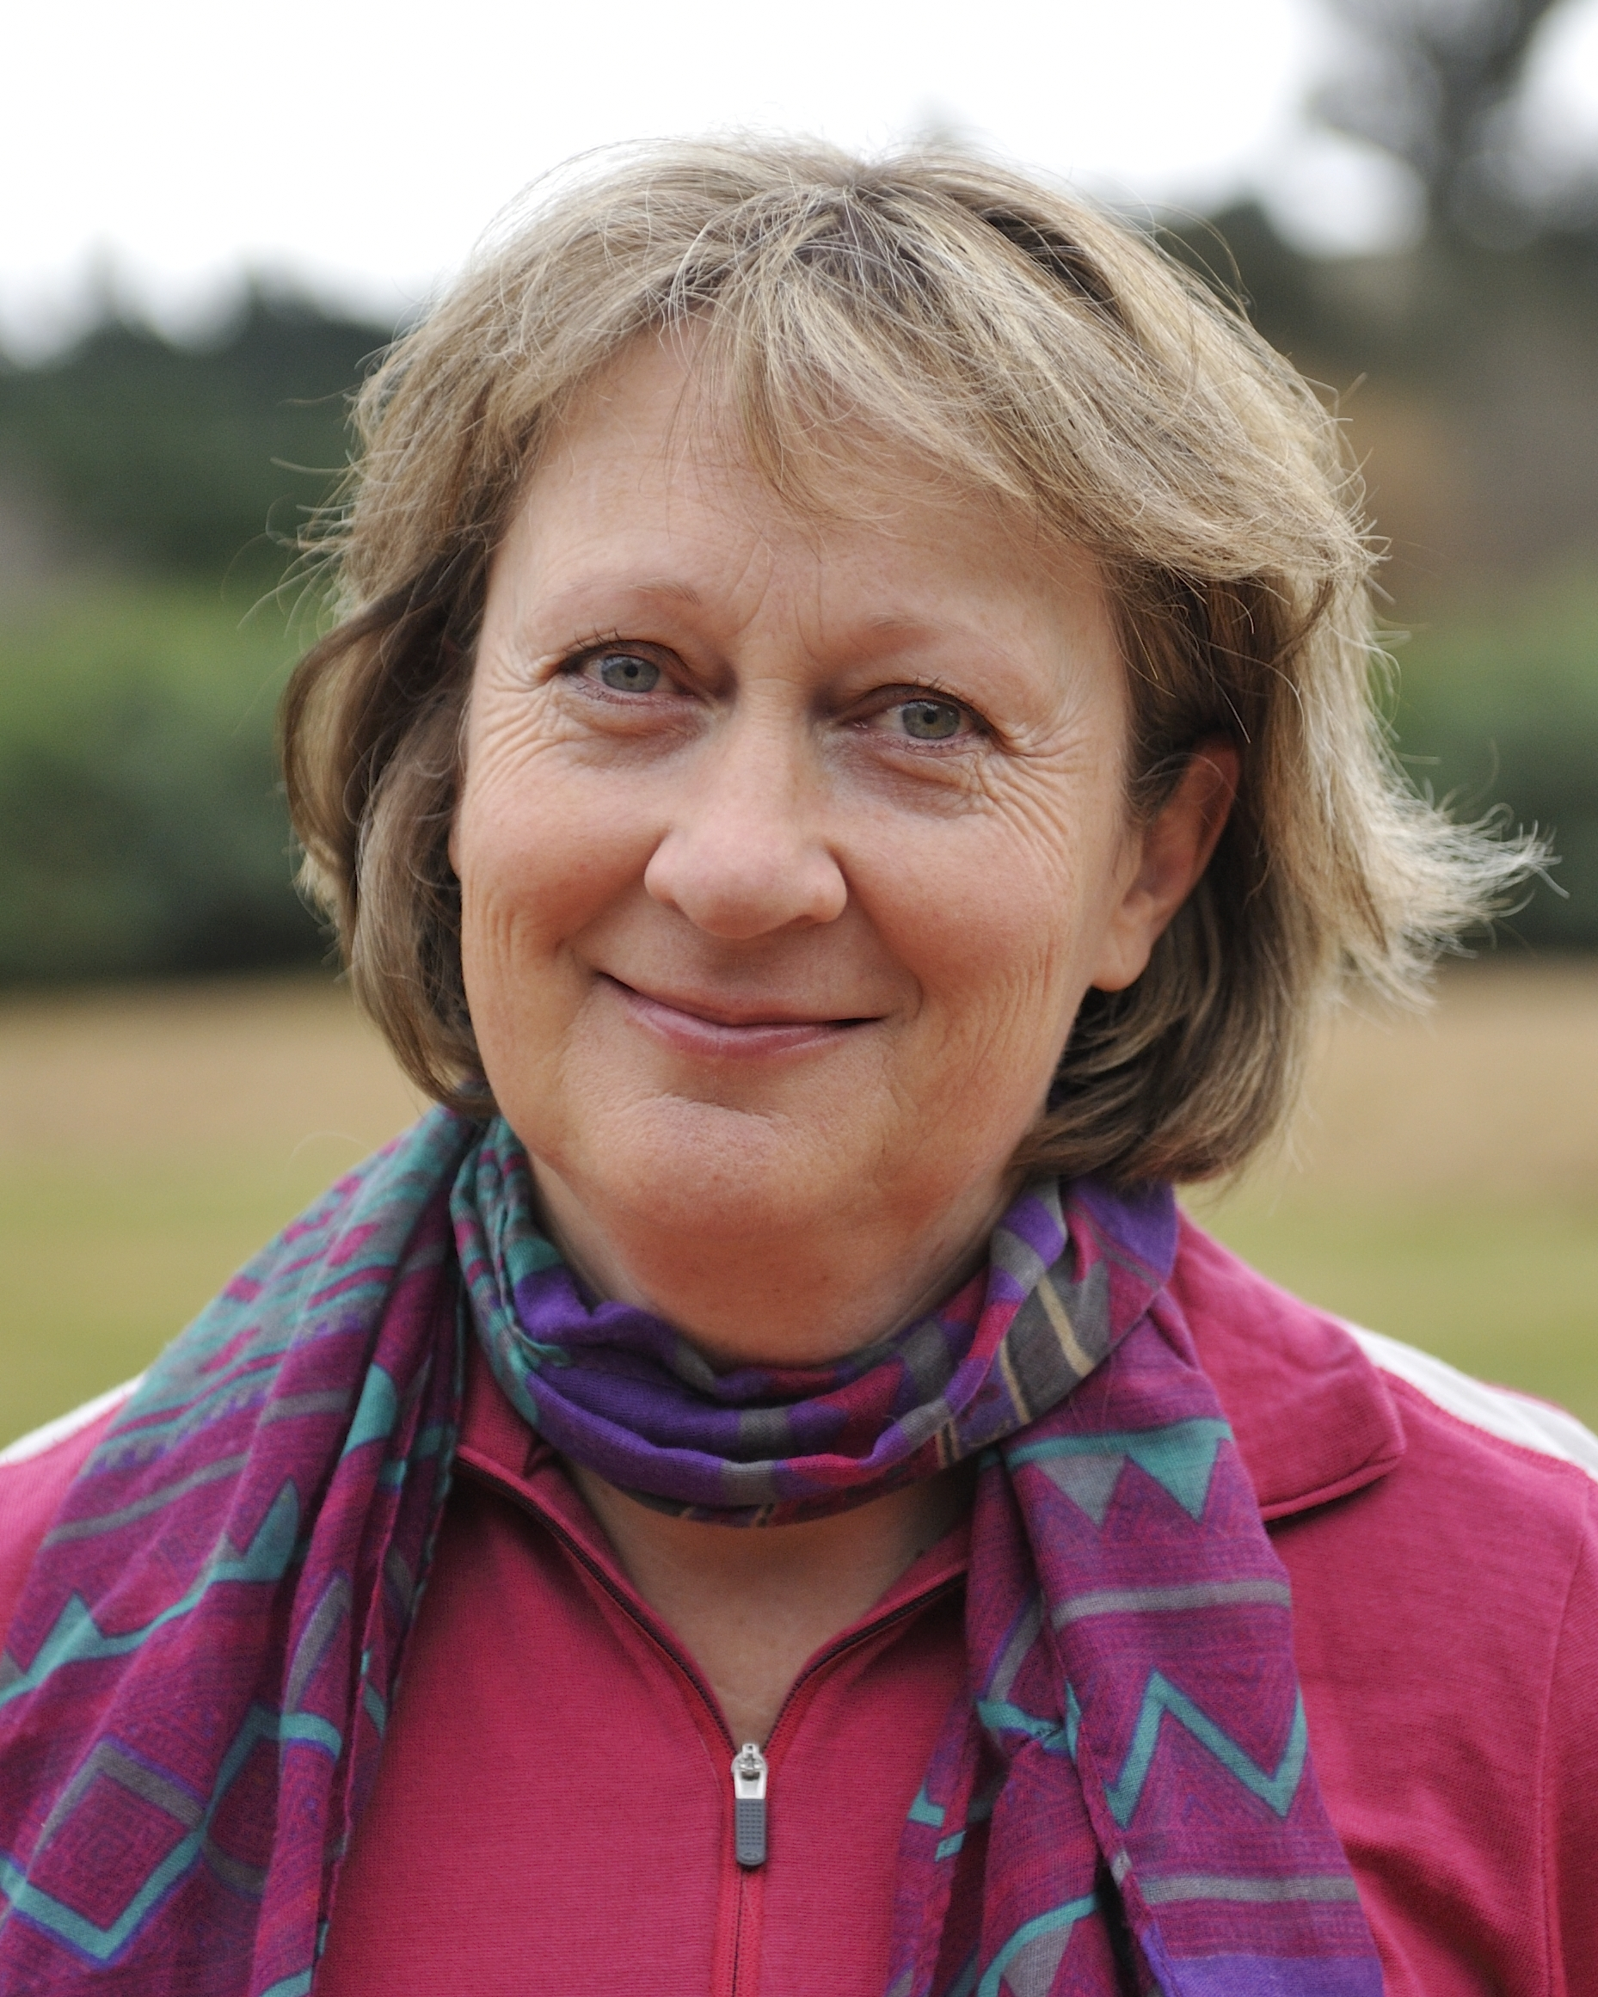 | Background info
The following parts of my life are important to me:  - My Family are the most important thing to me. My husband and I have two sons aged 18 and 22 years - both are studying.  - I love living in the country and have a few sheep and chickens on our lifestyle block.  - I have a large vegetable garden and really enjoy growing our own food.  - We have a little caravan and like to visit wild places to explore and go fishing.  - I have weekly walks with my friends and love to get together to share good food and wine.  - I love to spend time with my Mum who lives nearby. |  | I have spent 25 years working in the disability sector in a variety of positions in New Zealand, Britain and Australia. Soon after graduating with a Master’s Degree in psychology (Canterbury University) I set off on a working holiday travelling in Asia, Africa and Europe. I enjoyed meeting a lot of wonderful people and eating great food along the way. Our youngest son was diagnosed with dyspraxia at the age of three - I have personally experienced the journey of finding the best for our son and bring that experience to my position. I am well connected in the North Canterbury community.
 | Contact via hannah@eglives.co.nz | What people appreciate about me
 | I live in North Canterbury. | My colleagues have told me that they appreciate:  - I have great rapport with all types of people.  - I don’t make judgements and am open minded.  - I am dedicated to improving people’s lives.  - I can help people identify their dreams and put plans in place to achieve them.  - I have a lot of energy and the ability to motivate people.  - I am relaxed and reliable.  - This is not just a job to me – enabling good lives is a passion.

What is important to me – How do I enable my good life? | Julie Bacon  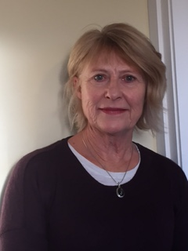 | Background info
My family and friends are very important to me. I am married and have two adult children and two grandchildren who I spend a lot of time with. I am involved in their lives and I am very useful as an after school carer and I love playing with them. I have an elderly mother who lives in Dunedin and I am increasingly spending time supporting her. That is an important role in my life at the moment.  I have a group of good friends with whom I go for long walks in the hills and solve the world’s problems or so we think at the time. I play golf regularly but with no skill and am currently starting to play bridge with friends. I enjoy my time at the gym and at regular Pilates sessions. I have been with my book club for many years and I enjoy reading, knitting, sewing at home.  I have enjoyed continuing to work with Deaf students in the new navigator role and it is important to me to give them support to reach their goals.  I believe that I have a good balance in my life and I endeavour to assist clients to achieve this also. |  | I have worked in Deaf education for 40 years and have worked with all ages of students but my passion is the transition area where I have worked with students who are finishing school. This is where my new role as a navigator can draw on my past skills and experiences. I have also worked as an ORS teacher with autistic students at schools in the Christchurch area.  I have always been involved with the families of the students and have a good relationship with the teachers also. I am familiar with the opportunities open to the students in the Christchurch area and am committed to helping the students fulfil their dreams in the future and to enable them to have a good life.
 | Contact via hannah@eglives.co.nz | What people appreciate about me
 | I live in Clifton | My colleagues in education have always told me that they admire the energy and professionalism I have brought to the job. They have told me that I am hard working and always do the best I can for the students. They have talked about the way I am always positive and good humoured but persevere to achieve results.

What is important to me – How do I enable my good life? | Caroline Dunn  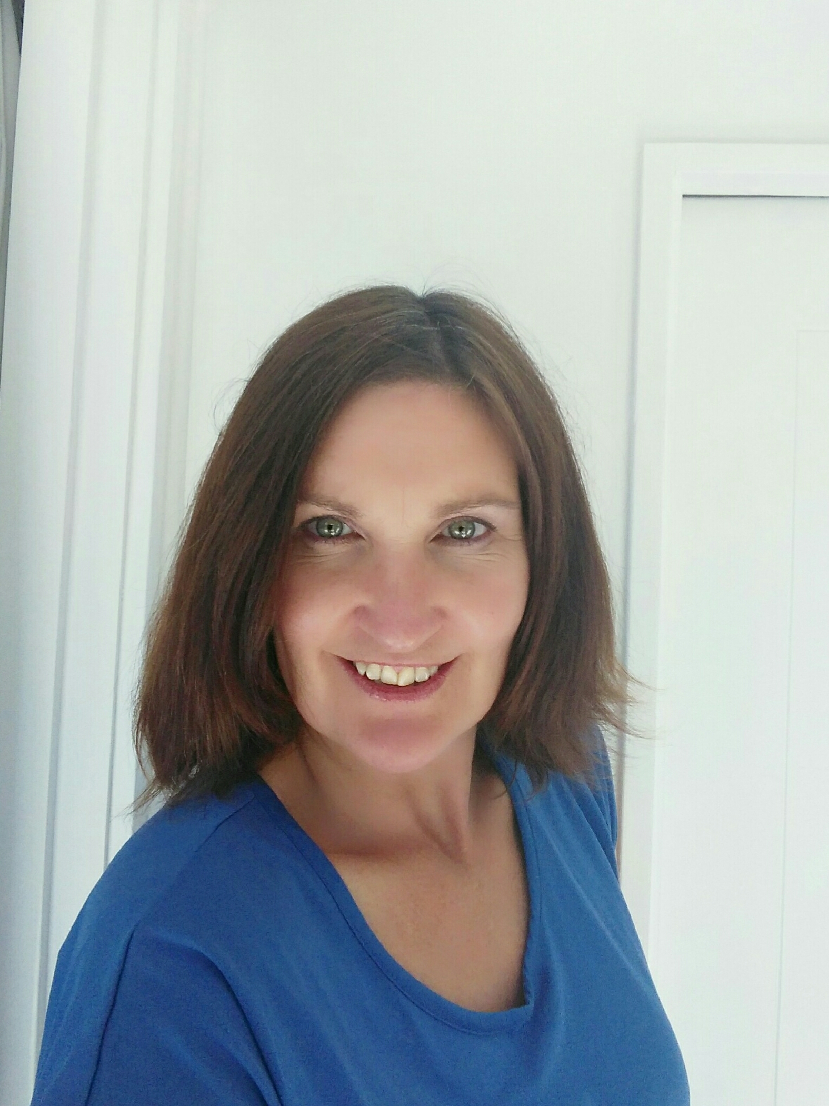 | Background info
I enable my good life by striving for balance between work, play, social, community and my interest activities.  - I love exploring our outdoors and new places particularly the bush and mountain environment. Mountain biking, trail running and tramping are my means to do so.  - Other interests include yoga and pilates, swimming, reading, home renovation, landscape gardening, dancing to music, art appreciation and occasional baking to satisfy a sweet tooth.  - My family is my top priority. I am married with two young sons aged 6 and 8 years so I volunteer at school assisting in the reading recovery programme.  - Catching up with my friends through telephone calls, visits, regular beach walks;  I also enjoy shared lunch dates.  - I like to follow what’s currently on in Christchurch and enjoy taking my children to diverse local community events.  - I’ve always enjoyed learning new things, setting, and achieving bigger and differing goals (currently off road half marathon).  - Being helpful, considerate, kind and respectful to others in my approach to life is huge value for me and I believe in ‘paying it forward’. |  | After graduating from University with a Bachelor of Arts (Education), I travelled extensively overseas for three years. Following a life changing accident in 1993, I received assistance from a variety of rehabilitation services. Whilst these were delivered with good intentions, I found some of the services restrictive and limiting resulting in frustration for me. What would have helped is for someone to encourage me to follow my dreams not simply take the easier option.  This is why the principles of EGL really excite me, being what I firmly believe in and fully committed to helping participants realise and achieve their goals.  Having worked in a variety of roles; ski patroller, veterinary nurse, art framer, outdoor guide, tutor, and currently rehab coach, I am adaptable and can easily develop rapport with a wide range of people. These opportunities have strengthened my skills in motivating, encouraging, assisting, and supporting the people I work alongside with compassion and empathy.
 | Contact via hannah@eglives.co.nz | What people appreciate about me
 | I live in South New Brighton. | My friends, family and colleagues tell me I’m:  - Relaxed, friendly, and easy going yet focused and determined to achieve great results.  - I work with integrity in a patient, helpful, non-judgemental manner by building relationships based on trust and respect.  - I am proactive, thorough and reliable, being true to my word I endeavour to give 110%.
What is important to me – How do I enable my good life? | Lisa Hortin  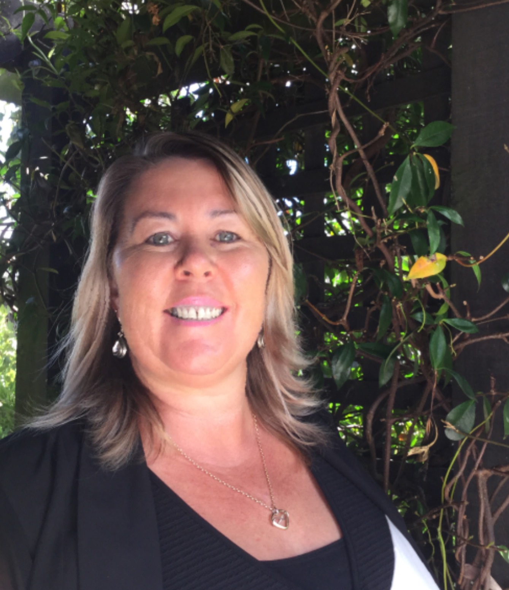 | Background info
My family is very important to me, I have been married for 20 years. I have four children, two girls and twin boys, about to be a Nana for the first time - very exciting.  - I enjoy riding my 55 year old bike around the city and surrounding areas as Christchurch is always changing.  - My children and I enjoy walking around the beautiful walking tracks we have here in Christchurch. Also camping out by the river.  - I love catching up with friends over coffee, movies, walks, darts or a lunch date.  - Enjoy the warmer months so I can get out into our vegetable garden/garden with a nice BBQ for tea.  - I really enjoy learning new things, at the moment I am learning NZ sign language.  - Working alongside great colleagues and challenging myself in my work environment.  - I am very professional in my work. Confidentiality, integrity and being efficient are really important. |  | I was self-employed for ten years delivering Metro bus timetables over the Christchurch area, this job was perfect while bringing up a young family.  I went on to study, achieving a Diploma in Social Work as well as a Diploma in Social Services. This was really exciting, learning new skills and making a decision that I wanted to make a difference in people's lives.  I worked in a day service for young people with intellectual disabilities and getting them involved in their own community was very satisfying.  One of my twin boys Te Ramanui caught an air born virus when he was three weeks of age, the damage has left him with an intellectual disability. I have been a very strong advocate for him.  Te Ramanui left school last year 2016 so I have first-hand experience in the EGL process.  I believe in EGL as Te Ramanui has control over his own life, he does not need to fit into somebody else's square box, his future is tailored around him.
 | Contact via hannah@eglives.co.nz | What people appreciate about me
 | I live in Linwood/Avonside | - The way I can think outside the square to get the best outcomes for people.  - My great sense of humour. I have been told that, I am very uplifting and engaging.  - I can help people see the big picture of what their dreams are, make a plan so they can implement it.  - My passion for making a difference in people's lives.

What is important to me – How do I enable my good life? | Bridget Carter  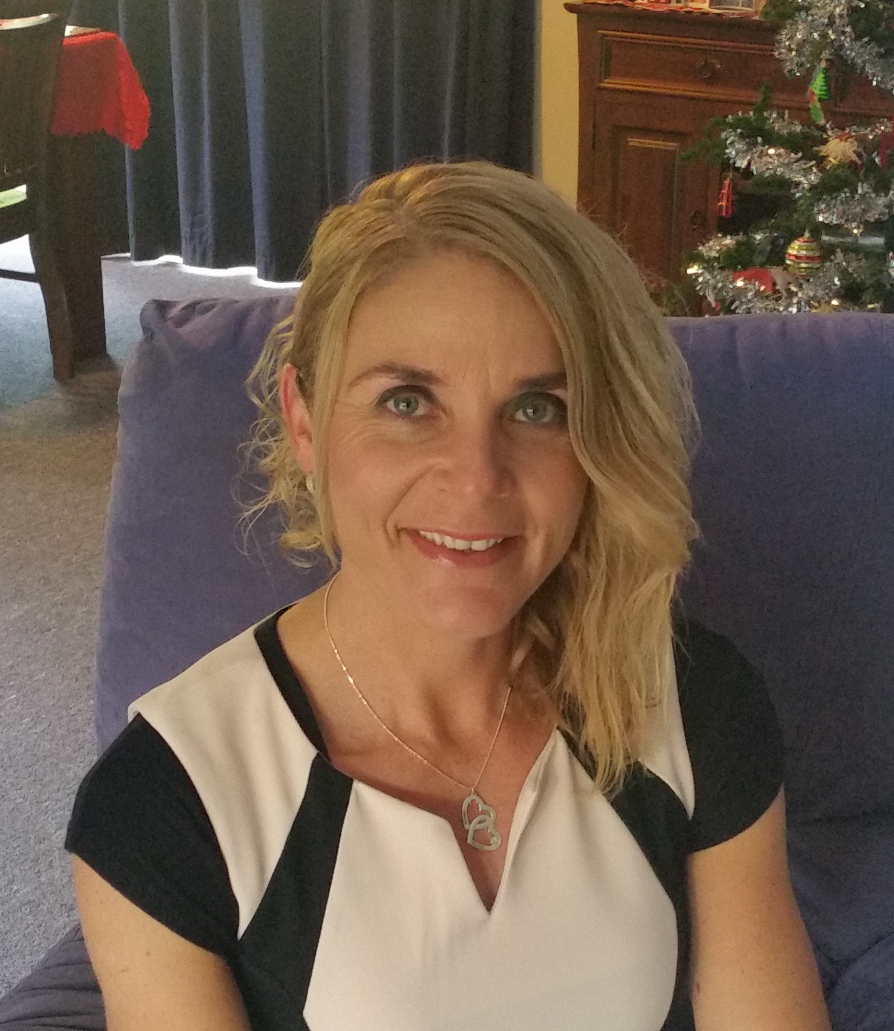 | Background info
The following parts of my life are important to me:  My Family are a huge part of my life and they are most important to me. My husband and I have been married for 22 years, we have 2 beautiful boys on the Autism spectrum.  I enable a good life by doing things I am passionate about, including trying new things and setting life goals.  I enjoy supporting and following my sons’ passions, interests and strengths.  I am passionate about running and have competed in many places in New Zealand and around the world.  I enjoy being part of others success/life goals and see it is a huge privilege.  I love and enjoy outdoor activities.  I enjoy coaching my youngest son with running, and volunteering with Mainline Steam with my oldest son. |  | After completing my Playcentre diploma my desire to learn more about inclusion has led me onto the path of facilitating roles and presenting about inclusive education. I have been an advisor and writer for narrative assessment and have presented to Ministry of Education staff about successful learning outcome for students with learning needs.  I am currently a facilitator for the Tips for Autism course which focus on strength base, positive behaviour support / learning outcomes.  I also work with a local girl with cerebral palsy with a focus on her strengths, interests and goals.  My most important role is a parent to my beautiful boys on the autism spectrum, constantly learning alongside them.  I have personal experience with both of my boys with their school education, community involvement.
 | Contact via hannah@eglives.co.nz | What people appreciate about me
 | I live in Darfield which is in the Selwyn district. | People have told me that they appreciate:  - My enthusiasm and energy  - My dedication to supporting others to have a fulfilling life that matches the individuals own ideas.  - My personal experience and ability to see and value everyone as an individual.

