

Independent Facilitation

What is an Independent Facilitator and how do I make the most out of them?
An Independent Facilitator (previously known as an Enabling Good Lives Navigator) is an ally who assists a disabled person and their family to dream big, make a plan for the future and connect with their local community.
When can I work with an Independent Facilitator?
2018 and 2019 school leavers are entitled to ten hours of free independent facilitation, with the ability to purchase more hours with your EGL personal budget if you choose to.

What will they do?
Some of the things Independent Facilitators can do with you and your family include:
- Build a trusting relationship; with you and with your family
- Connect with others who are involved; wider family and friends, school, LifeLinks …
- Help you (and your family) dream and plan about what a good life might look like. Not being restricted to what we might have always thought before, but aiming really high, and then figuring out how to take the first steps towards that
- Helping you access and use your EGL personal budget
- Helping you find out what is in your local community that you might be interested in
- Helping you find out and connect to who else might be able to help. These might be local people in your community, friends and family (perhaps forming a Circle of Support) agencies (e.g. supported employment, Work and Income, Housing NZ …)
- Help you negotiate with disability support services, if you choose to use them
What won't they do?
Things that your Independent Facilitator won’t do (but can help you find the people to do this if you wish) include …
- Make decisions or speak on your behalf
- Refer you to disability support services (but we'll help you make the most out of them, should you choose to use them)
- Introduce you to the community (but we can help you find out who to connect with)
- Another person’s job (e.g. an Independent Facilitator is not a support worker, or a transition teacher or a budget adviser…)

Who will my Independent Facilitator be?
We have a number of Independent Facilitators for you to choose from. Check out the profiles on the next pages, and think about
- Who captured your interest?
- Who has the skills and experiences you think might be helpful?
- Who lives near you so might know what is available in your community?
Please let Hannah Perry know who you would like to work with so that she can connect you with that person. See below.
The intention is for an independent facilitator to be someone who is “just there for me, with no other loyalties”. In Christchurch, because we do a limited amount of work with a small group of young people, the independent facilitators have other roles and do other work. We want to be upfront where there are any potential “conflicts of interest” and have listed other roles and work on each person’s profile.
Regardless of any other roles they hold, EGL Independent Facilitators will not influence a person’s choice, they will help young people and their families to explore all options, and they do not benefit from any of the decisions that are made.

Following your ten hours free independent facilitation, if you are looking to purchase further assistance the most important thing to ensure is that your Independent Facilitator is
- Independent (they do not benefit from any of the choices you make)
- A facilitator (they might make it EASIER for you to do things, but they don’t do things for you)
- Understands the principles of Enabling Good Lives and works with you in an “Enabling Good Lives” way
Although it is likely that for many families the connections and skills you have developed will be sufficient to 'self-navigate'.

Hannah Perry
Enabling Good Lives Christchurch
Phone / Text : 021 035 4134
Email – Hannah@eglives.co.nz

What is important to me – How do I enable my good life? | Bridget Carter  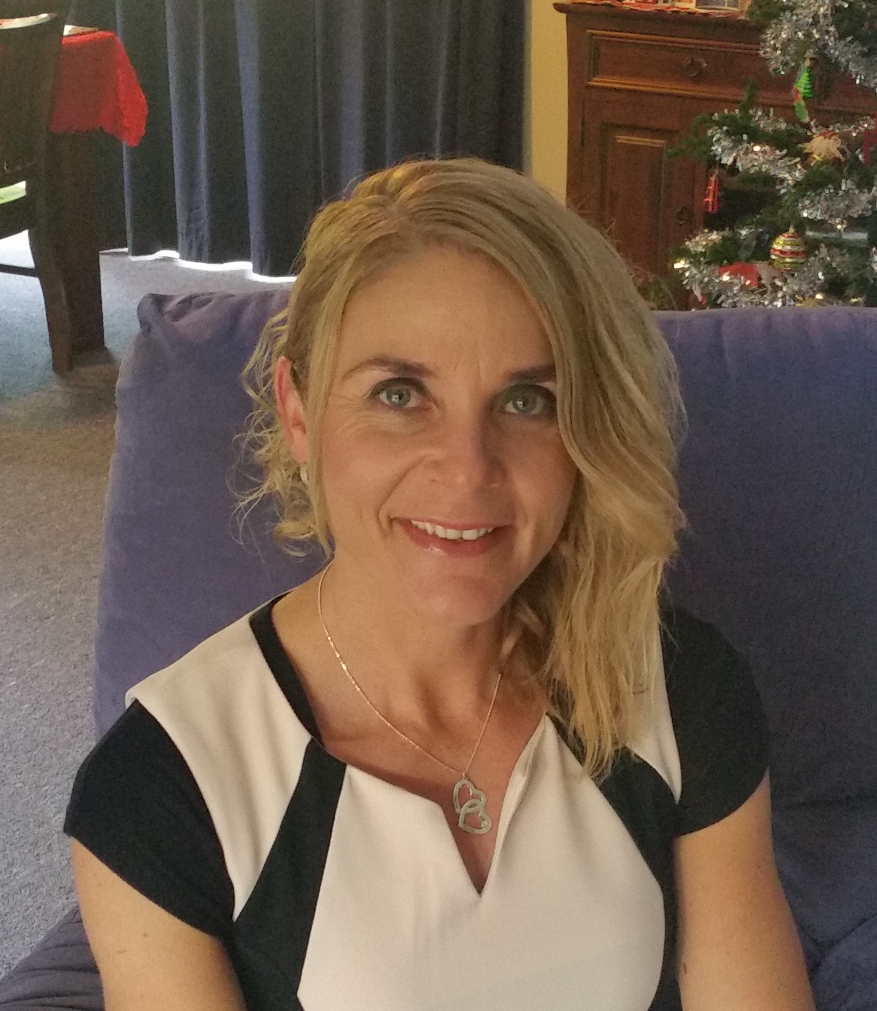 | Background info
The following parts of my life are important to me:  My Family are a huge part of my life and they are most important to me. My husband and I have been married for 22 years, we have 2 beautiful boys on the Autism spectrum.  I enable a good life by doing things I am passionate about, including trying new things and setting life goals.  I enjoy supporting and following my sons’ passions, interests and strengths.  I am passionate about running and have competed in many places in New Zealand and around the world.  I enjoy being part of others success/life goals and see it is a huge privilege.  I love and enjoy outdoor activities.  I enjoy coaching my youngest son with running, and volunteering with Mainline Steam with my oldest son. |  | After completing my Playcentre diploma my desire to learn more about inclusion has led me onto the path of facilitating roles and presenting about inclusive education. I have been an advisor and writer for narrative assessment and have presented to Ministry of Education staff about successful learning outcome for students with learning needs.  I am currently a facilitator for the Tips for Autism course which focus on strength base, positive behaviour support / learning outcomes.  I also work with a local girl with cerebral palsy with a focus on her strengths, interests and goals.  My most important role is a parent to my beautiful boys on the autism spectrum, constantly learning alongside them.  I have personal experience with both of my boys with their school education, community involvement.
 | Contact via hannah@eglives.co.nz | What people appreciate about me
 | I live in Darfield which is in the Selwyn district.  My other roles / work :  - Tips for autism facilitator  - FANZ autism course Autism NZ  - Support worker (private)  - Supporting my sons to live a good life | People have told me that they appreciate:  - My enthusiasm and energy  - My dedication to supporting others to have a fulfilling life that matches the individuals own ideas.  - My personal experience and ability to see and value everyone as an individual.
What is important to me – How do I enable my good life? | Caroline Dunn  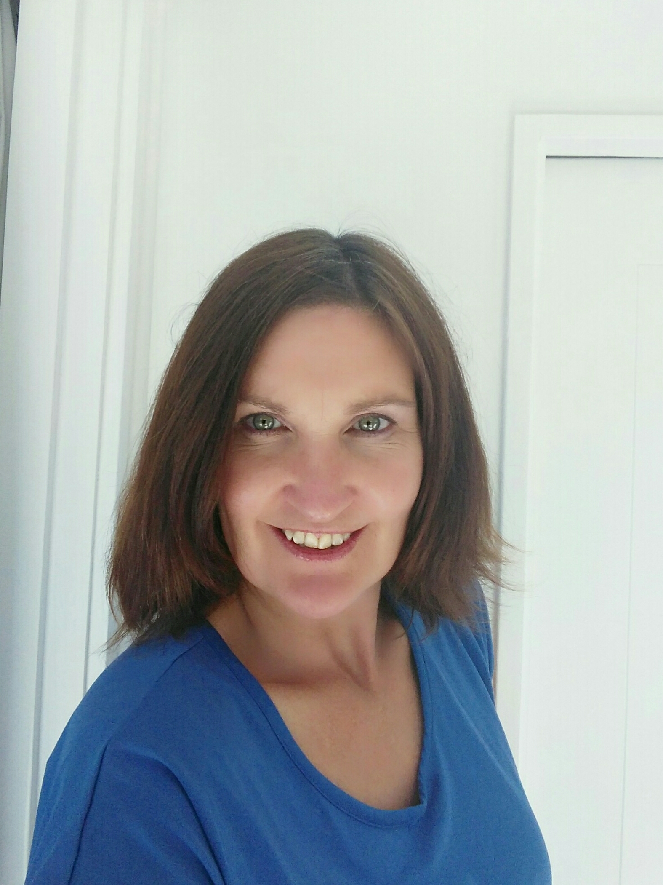 | Background info
I enable my good life by striving for balance between work, play, social, community and my interest activities.  - I love exploring our outdoors and new places particularly the bush and mountain environment. Mountain biking, trail running and tramping are my means to do so.  - Other interests include yoga and pilates, swimming, reading, home renovation, landscape gardening, dancing to music, art appreciation and occasional baking to satisfy a sweet tooth.  - My family is my top priority. I am married with two young sons aged 6 and 8 years so I volunteer at school assisting in the reading recovery programme.  - Catching up with my friends through telephone calls, visits, regular beach walks;  I also enjoy shared lunch dates.  - I like to follow what’s currently on in Christchurch and enjoy taking my children to diverse local community events.  - I’ve always enjoyed learning new things, setting, and achieving bigger and differing goals (currently off road half marathon).  - Being helpful, considerate, kind and respectful to others in my approach to life is huge value for me and I believe in ‘paying it forward’. |  | After graduating from University with a Bachelor of Arts (Education), I travelled extensively overseas for three years. Following a life changing accident in 1993, I received assistance from a variety of rehabilitation services. Whilst these were delivered with good intentions, I found some of the services restrictive and limiting resulting in frustration for me. What would have helped is for someone to encourage me to follow my dreams not simply take the easier option.  This is why the principles of EGL really excite me, being what I firmly believe in and fully committed to helping participants realise and achieve their goals.  Having worked in a variety of roles; ski patroller, veterinary nurse, art framer, outdoor guide, tutor, and currently rehab coach, I am adaptable and can easily develop rapport with a wide range of people. These opportunities have strengthened my skills in motivating, encouraging, assisting, and supporting the people I work alongside with compassion and empathy.
 | Contact via hannah@eglives.co.nz | What people appreciate about me
 | I live in South New Brighton.  My other roles / work :  I am employed as a Community Support Worker at Emerge Aotearoa working in Supported Living Services- a contract with Accident Compensation Corporation. | My friends, family and colleagues tell me I’m:  - Relaxed, friendly, and easy going yet focused and determined to achieve great results.  - I work with integrity in a patient, helpful, non-judgemental manner by building relationships based on trust and respect.  - I am proactive, thorough and reliable, being true to my word I endeavour to give 110%.
What is important to me - How do I enable my good life? | 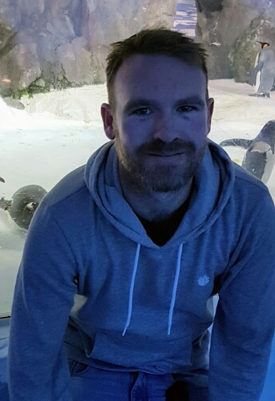  Jonny Cameron | My other roles / work :
My family/whanau play a huge role in my life.  I have two teenage daughters that provide me with constant challengers on a daily basis. I love watching them grow and experiencing life whilst they are maturing into lovely young ladies.  My choice of work and recreation enables me to have a good life as it fulfils the passions I enjoy i.e. bringing smiles to the faces of my children and those I work with. To watch a young person, achieve what they thought was impossible to achieve and to show them how to have fun while doing it.  This may be in the form of indoor or outdoor activities from surfing to tramping, movies, cooking or play station games, appropriate social skills, work or study. |  | For the past 10 years I have worked as a Support Professional with Emerge Aotearoa The service I have been working in is the ‘Regional Intellectual Disability Support Service’. This service is a direct response to the IDCC & R Act (Intellectual Disability Compulsory Care and Rehabilitation Act) this act was set up to prevent those with an intellectual disability who have committed an imprisonable offence from going to prison. These clients therefore had a range of high and complex needs.  Also, during this time I have been providing support to a young man under Individualised Funding who has high disability and mental health needs. In this role the young man designs his own programme together with the family and I provide the flexibility and support to achieve it.
 | Contact via hannah@eglives.co.nz | What people appreciate about me
 | I live in Central Christchurch | I am reliable, person centred and extremely focussed on the wishes of the young person and their family/whanau. I am honest, flexible, outgoing and creative and meet challenges head on.  I learn by listening and observing and this enables me to successfully resolve conflicts whilst maintaining trust with those concerned.
What is important to me – How do I enable my good life? | Julie Bacon  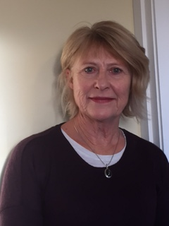 | Background info
My family and friends are very important to me. I am married and have two adult children and three grandchildren who I spend a lot of time with. I am involved in their lives and I am very useful as an after school carer and I love playing with them.  I have a group of good friends with whom I go for long walks in the hills and solve the world’s problems or so we think at the time. I play golf regularly but with no skill and am currently starting to play bridge with friends. I enjoy my time at the gym and at regular Pilates sessions. I have been with my book club for many years and I enjoy reading, knitting, sewing at home.  I have enjoyed continuing to work with Deaf students in the new navigator role and it is important to me to give them support to reach their goals.  I believe that I have a good balance in my life and I endeavour to assist clients to achieve this also. |  | I have worked in Deaf education for 40 years and have worked with all ages of students but my passion is the transition area where I have worked with students who are finishing school. This is where my new role as a navigator can draw on my past skills and experiences. I have also worked as an ORS teacher with autistic students at schools in the Christchurch area.  I have always been involved with the families of the students and have a good relationship with the teachers also. I am familiar with the opportunities open to the students in the Christchurch area and am committed to helping the students fulfil their dreams in the future and to enable them to have a good life.
 | Contact via hannah@eglives.co.nz | What people appreciate about me
 | I live in Clifton  My other roles / work :  I am a relief teacher with Deaf students at van Asch Deaf Education Centre. | My colleagues in education have always told me that they admire the energy and professionalism I have brought to the job. They have told me that I am hard working and always do the best I can for the students. They have talked about the way I am always positive and good humoured but persevere to achieve results.

What is important to me – How do I enable my good life? | 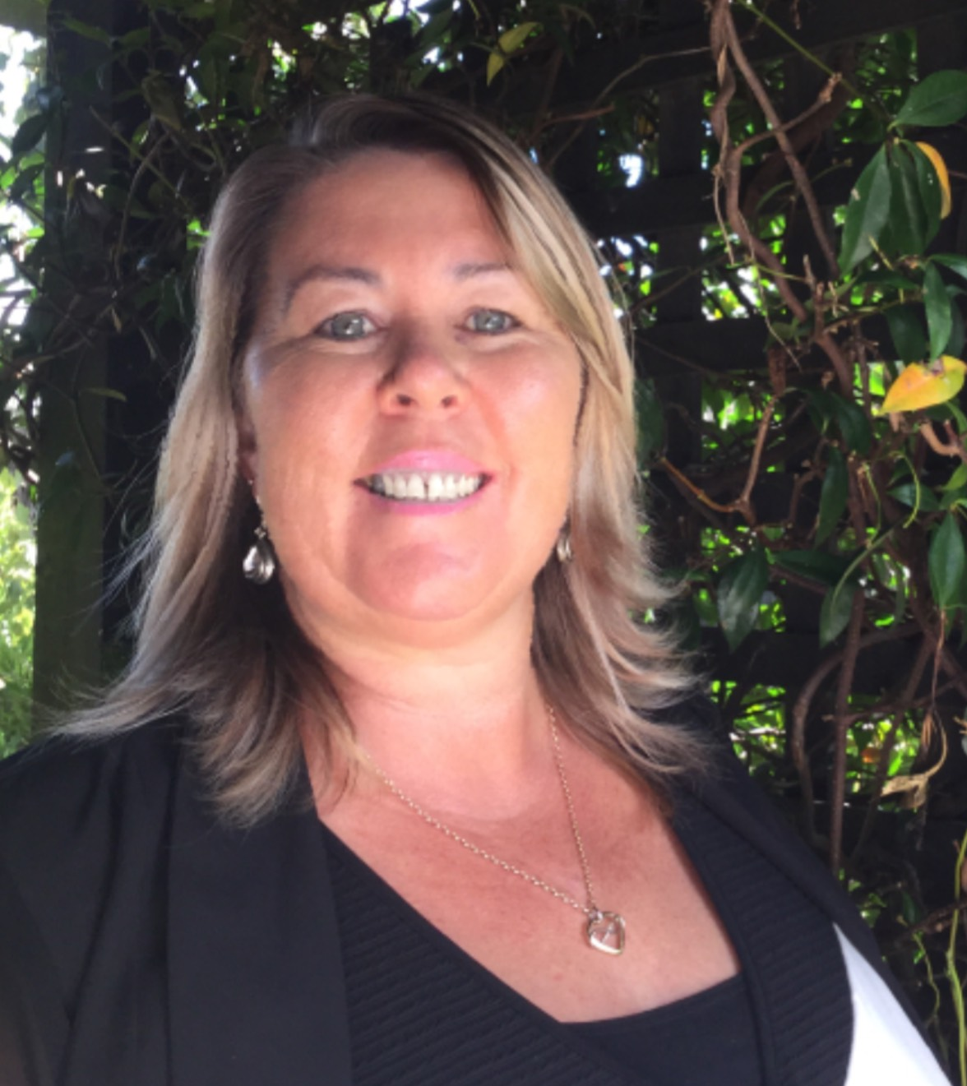  Lisa Hortin | Background info
My family is very important to me, I have been married for 20 years. I have four children, two girls and twin boys, about to be a Nana for the first time - very exciting.  - I enjoy riding my 55 year old bike around the city and surrounding areas as Christchurch is always changing.  - My children and I enjoy walking around the beautiful walking tracks we have here in Christchurch. Also camping out by the river.  - I love catching up with friends over coffee, movies, walks, darts or a lunch date.  - Enjoy the warmer months so I can get out into our vegetable garden/garden with a nice BBQ for tea.  - I really enjoy learning new things, at the moment I am learning NZ sign language.  - Working alongside great colleagues and challenging myself in my work environment.  - I am very professional in my work. Confidentiality, integrity and being efficient are really important. |  | I was self-employed for ten years delivering Metro bus timetables over the Christchurch area, this job was perfect while bringing up a young family.  I went on to study, achieving a Diploma in Social Work as well as a Diploma in Social Services. This was really exciting, learning new skills and making a decision that I wanted to make a difference in people's lives.  I worked in a day service for young people with intellectual disabilities and getting them involved in their own community was very satisfying.  One of my twin boys Te Ramanui caught an air born virus when he was three weeks of age, the damage has left him with an intellectual disability. I have been a very strong advocate for him.  Te Ramanui left school in 2016 so I have first-hand experience in the EGL process.  I believe in EGL as Te Ramanui has control over his own life, he does not need to fit into somebody else's square box, his future is tailored around him.
 | Contact via hannah@eglives.co.nz | What people appreciate about me
 | I live in Linwood/Avonside | - The way I can think outside the square to get the best outcomes for people.  - My great sense of humour. I have been told that I am very uplifting and engaging.  - I can help people see the big picture of what their dreams are, make a plan so they can implement it.  - My passion for making a difference in people's lives.
What is important to me – How do I enable my good life? | Sue van der Byl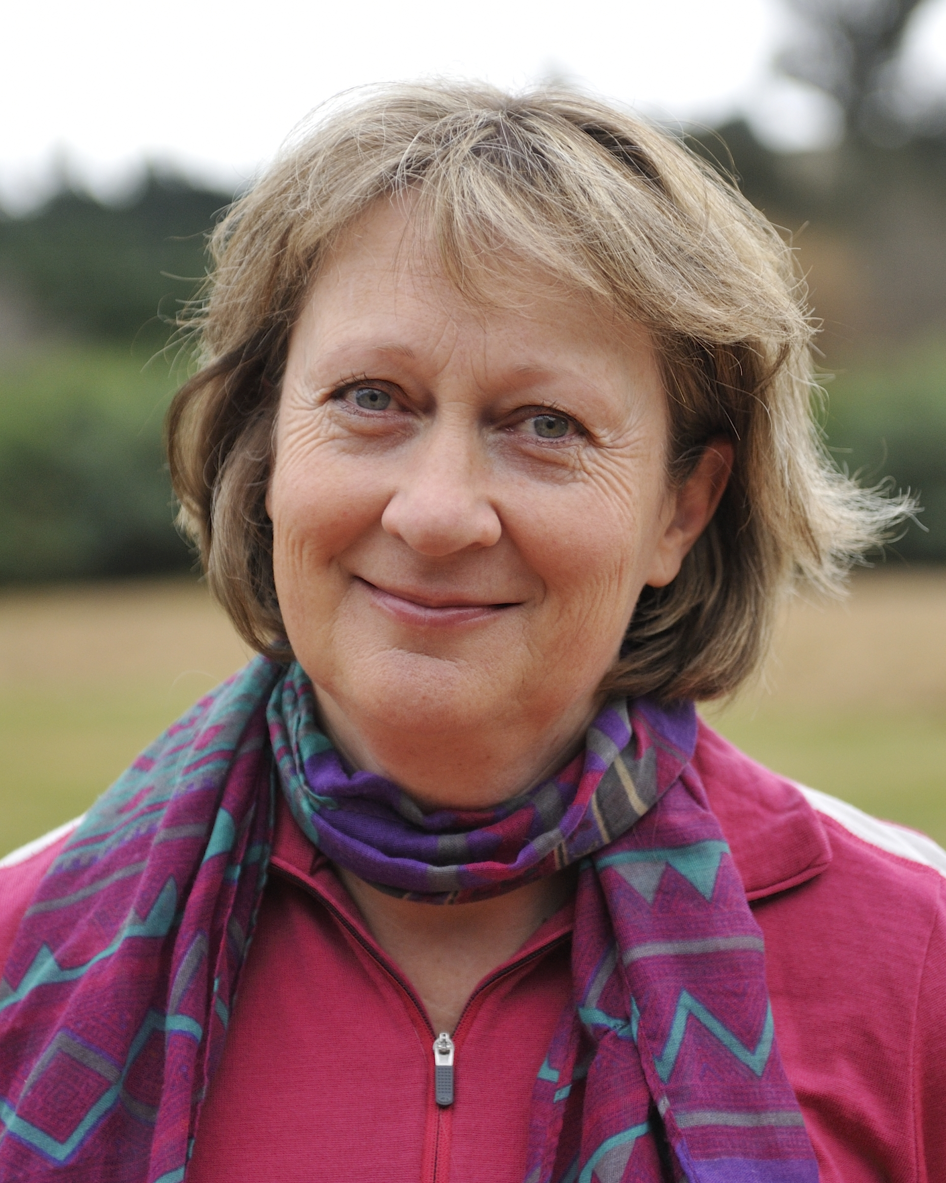 | Background info
The following parts of my life are important to me:  - My Family are the most important thing to me. My husband and I have two sons aged 18 and 22 years - both are studying.  - I love living in the country and have a few sheep and chickens on our lifestyle block.  - I have a large vegetable garden and really enjoy growing our own food.  - We have a little caravan and like to visit wild places to explore and go fishing.  - I have weekly walks with my friends and love to get together to share good food and wine.  - I love to spend time with my Mum who lives nearby. |  | I have spent 25 years working in the disability sector in a variety of positions in New Zealand, Britain and Australia. Soon after graduating with a Master’s Degree in psychology (Canterbury University) I set off on a working holiday travelling in Asia, Africa and Europe. I enjoyed meeting a lot of wonderful people and eating great food along the way. Our youngest son was diagnosed with dyspraxia at the age of three - I have personally experienced the journey of finding the best for our son and bring that experience to my position. I am well connected in the North Canterbury community.
 | Contact via hannah@eglives.co.nz | What people appreciate about me
 | I live in North Canterbury.  My other roles / work :  - Manager of Delta Friendship Link | My colleagues have told me that they appreciate:  - I have great rapport with all types of people.  - I don’t make judgements and am open minded.  - I am dedicated to improving people’s lives.  - I can help people identify their dreams and put plans in place to achieve them.  - I have a lot of energy and the ability to motivate people.  - I am relaxed and reliable.  - This is not just a job to me – enabling good lives is a passion.

