What is the UN Convention on
the Rights of Persons with Disabilities?

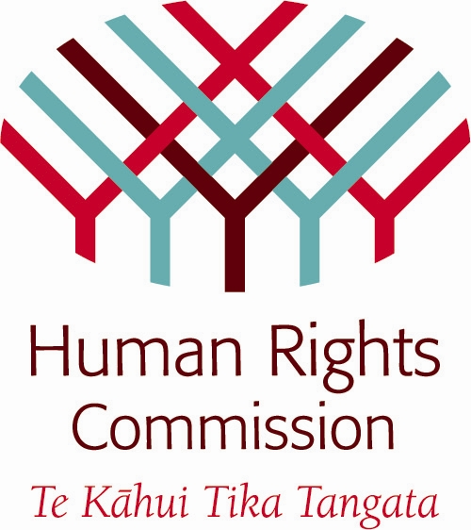
Easy Read version
produced for the
Human Rights Commission 2011
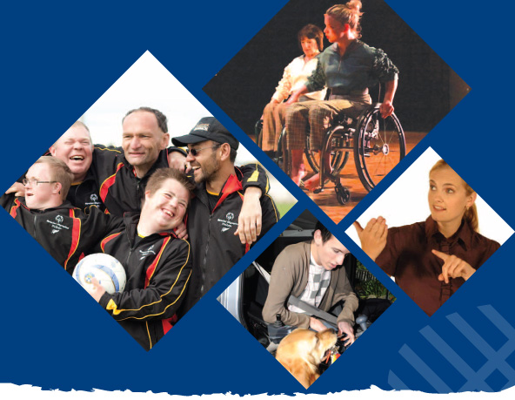
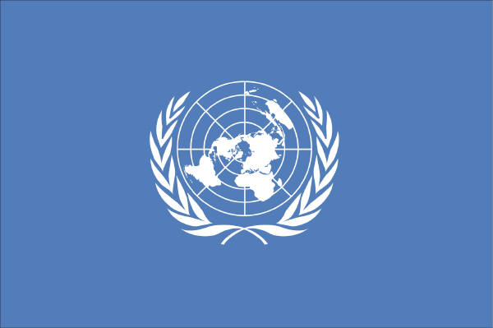

What is the United Nations Convention on the Rights of Persons with Disabilities?
The Disability Convention
This Convention is about the human rights of Disabled people.

What are Human Rights?


Everyone has human rights.

Human rights mean you must be treated:
- Fairly
- Equally
- And with respect.

The government must make sure that all people can:
- Be safe
- Make their own decisions
- Have a good life
- Be part of community and society.

What is the Disability Convention?
Disabled people all over the world get treated differently because of their disability.


The Disability Convention is a worldwide human rights agreement.

The Disability Conventions full name is the United Nations Convention on the Rights of Persons with Disability.
The Disability Convention says that Disabled people have the same human rights as everyone else.
The Disability Convention tells government what to do to make sure Disabled people know about and get their rights met.

The United Nations accepted the Disability Convention in December 2006.


The aims of the Disability Convention are:
- Promote human rights
- Protect human rights
- Make sure all people have equal human rights
- Respect for Disabled people.

The New Zealand government has signed the Disability Convention to say they agree with the Disability Convention.
Who are Disabled people?
The Disability Convention says that Disabled people are those with long term:

- Physical disability
- Intellectual disability
- Experience of mental illness
- Sensory disability like deaf or blind.

Sometimes it can be hard for Disabled people to do the same things as non disabled people because of their disability.

Other people’s attitudes also make it hard for Disabled people.


Everyone is different.

The Disability Convention says it is important to respect people’s differences.

When Disabled people are included in their communities, they can lead full and happy lives.

What does the Disability Convention mean for New Zealand?

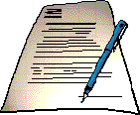
The New Zealand Government signed to say they agree with the Disability Convention in September 2008.
This means that the Government must make sure that the things in the Disability Convention are happening in New Zealand.

This is to make sure Disabled people enjoy the same human rights as everyone else.
17% of New Zealanders are Disabled people.

In New Zealand Disabled people say it is hard to:
- Get good education
- Get good jobs
- Take part in their communities
- Have a chance to have their say.

The Disability Convention will help to make things better for Disabled people.

What does the Disability Convention say?
The Convention protects the Human Rights of Disabled people.
The Disability Convention gives the government advice on how to make sure Disabled people get their rights met.
The Disability Convention has information on making services accessible. Services like:

- Health services
- Education
- Other services like providing mobility aids, and easy read information.

General Rights are about:
- The Right to life
- Emergencies
- Being treated equally by the law
- Getting justice
- Being free and safe
- Not being tortured or treated cruelly
- Not being used or abused
- Treating Disabled people as people first
- Moving around
- Independent living and being part of the community
- Getting about
- Saying what you want and access to information
- Privacy
- Respect for the home and the family
- Being involved in politics.

Financial, Social and Cultural Rights:
- Education
- Health
- Services to help you recover
- Support to keep you healthy
- Work
- Standards of living
- Social protection such as: having good police, having Work and Income benefits and having Disability Support Services
- Being able to take part in cultural life, recreation, leisure and sport.

How does the New Zealand government make the things in the convention happen?

The New Zealand Ministerial Committee on Disability Issues will look after the work of the Disability Convention.

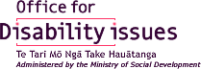
The Office for Disability Issues will support the Ministerial Committee.
Government must report on their work on the Disability Convention.

The first report was due 2 years after signing agreement to the Convention.

Every 4 years a report must be written to the United Nations.

What is the Human Rights Commission’s Role?
The United Nations sees the Human Rights Commission as New Zealand’s independent human rights organisation.
The Commission promotes, protects and checks the human rights of all New Zealanders.
The Commission says that Disabled people don’t always get their human rights met.
The Commission is working hard to change this.
The Government must have independent organisations involved to check how the rights in the convention are being put in place in New Zealand.

In New Zealand these independent organisations are:
- The Human Rights Commission
- The Office of the Ombudsman

- The Disability Coalition - people representing Disabled Peoples’ Organisations.

The Commission will write its own report to the United Nations.
Disabled Peoples’ Organisations can also write a report.

How can you be involved?
The Disability Convention says that Disabled people and their organisations must be involved in how the work is done.

You can do this by:

- Telling everyone about the Disability Convention and what it means

- Sharing your ideas with government

- Talking to the Commission about your experiences of getting, or not getting your human rights

- Making complaints if things go wrong

- Becoming involved in the reports to the United Nations.

How can you get a copy of the Disability Convention?


You can find different versions of the Disability Convention on the Human Rights Commission’s website:

- The full convention
- Summaries
- Audio tape
- Braille
- Full English
- Plain English
- Easy Read
- Te reo Maori
- Maori Easy Read
- New Zealand Sign Language
- A range of Pacific languages
- A children’s summary

Here is the link to get the Disability Convention
http://www.hrc.co.nz/disabilityconvention

or you can contact the Human Rights Commission.

Human Rights Commission contact details

InfoLine: 0800 496 877 (toll free)


Fax: 09 377 3593

Email: infoline@hrc.co.nz (for general enquiries)

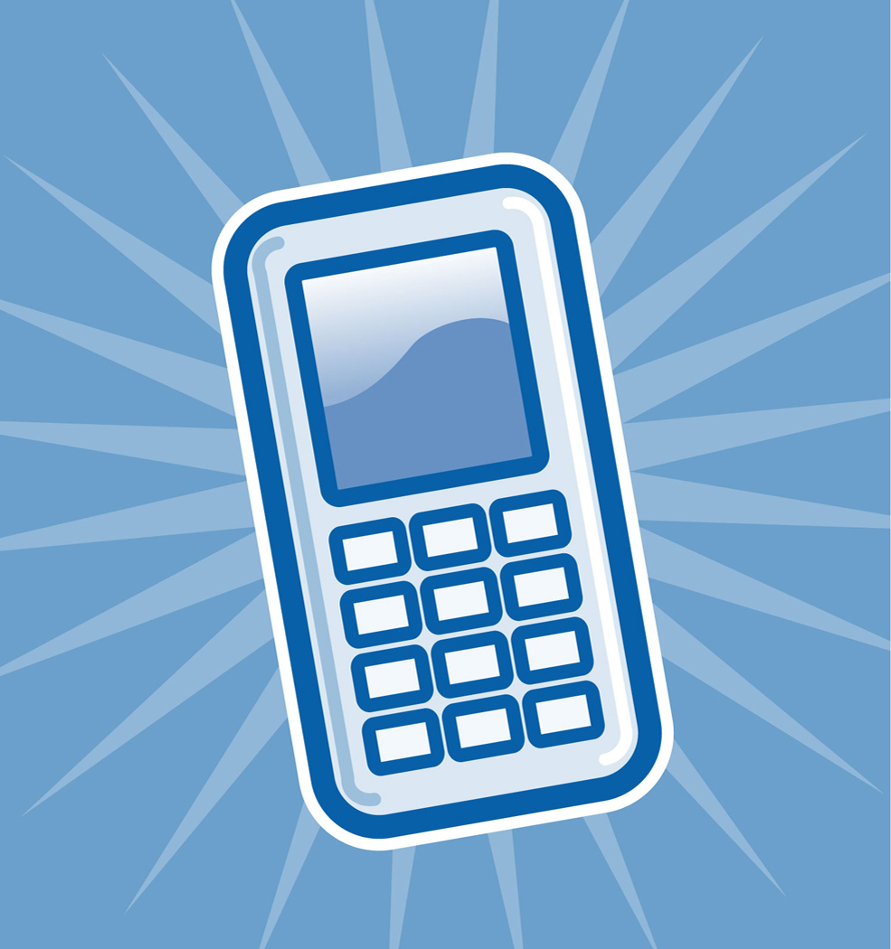
TXT: 0210 236 4253

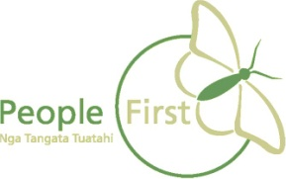
This information has been translated into Easy read
by People First New Zealand Inc.

