Enabling Good Lives Waikato

Evaluation

Part Three

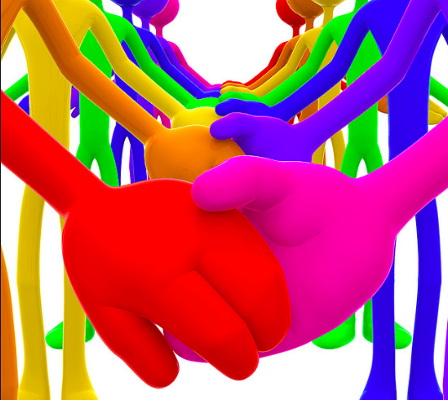

EasyRead Version by: Readable by Glen

Who is ‘The Demonstration’?

- 55 disabled people and their families

What is ‘The Demonstration’?

- It is done to look at how disabled people and their families achieve their goals.

The EGL Demonstration:

- This report explains what we learnt about the EGL Waikato Demonstration from the Phase Three evaluation.

- The evaluation looks at If people have been able to reach the goals they had when they started with EGL, and how much EGL helped with this.

- The phase 3 evaluation was done from April 2018 to November 2018. 55 disabled people, families and whānau talked about how they felt about their EGL journey.

What EGL do:

- Helped 91% of participants complete half or more of their goals.
- Offer Flexibility and Freedom
- Support people to look after their own money
- Help make personal budgets
- Build Tuhono/Connector Relationships
- Provide support.

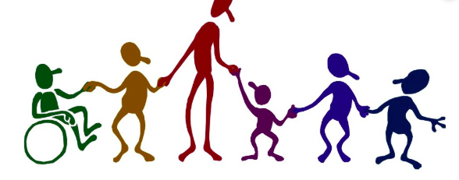

What the people of EGL have said:

EGL has built their  confidence | They have made Friends
Are able to participate in more things | They have a sense of independence
They have more opportunities | Having a say in their support workers

Enabling Good Lives:

- EGL is a group that forms partnerships between the disability sector
- The ‘disability sector’ is, disabled people, families, whanau and providers of disability support.

EGL Vision:

- In future disabled children, adults and their families will have more of a choice and control over their supports and lives.

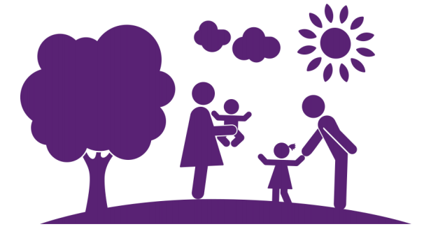
Question:
- How are disabled people, families and Whanau effectively achieving their goals?

Answer:
- 91% percent. This is 31 out of 41 people in the demonstration had completed at least half or more of the goals they had set for the past year.
- Some people said it was a slow process but they were still completing things.

EGL participants said:

- They felt they had much more independence in their lives.
- Had a chance to grow up and be independent
- Were able to be a contributor not a consumer
- Get on with life knowing that their home and personal care are looked after.

Some things families said:

- EGL has changed their lives
- They do not know where they would be without EGL
- Being able to do more activities at home and out of home has been great.

Tāngata Whaikaha and their Whānau

- Tāngata Whaikaha and Maori disabled people make up 36% of total people in EGL.
- Tāngata Whaikaha and Maori participants and families were happy with EGL and felt as if they were well supported.
- Families felt safe and that they could rely on EGL compared to other systems they had worked with.
- They stated they had positive relationships with their Tūhono/Connectors and they loved and appreciated that they were Māori. Stating that it makes a big difference
- Everyone loved the ongoing communication they had with everyone as well.
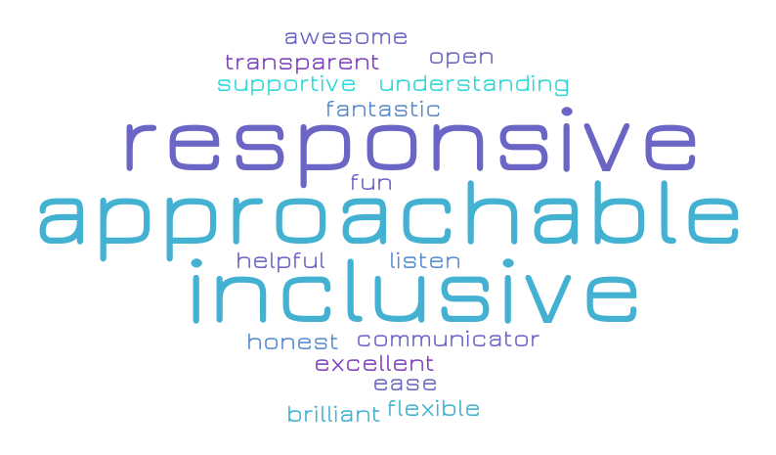

Tagata Pasifika and their Families:

- Tagata Pasifka make up 7% of total participants across EGL.
- Families said EGL creates a real difference to their lives.
- A big thing that helps them is the opportunities, choice and freedom the disabled people get.
- Most people achieved what they had set out to do.
- They said EGL was family focussed.
- EGL helped them find places where they belong and feel accepted.
- EGL helped them feel ‘normal’

Tuhono/Connector Relationships

- Each participant has a Tuhono/Connector that they work with.

- Participants have said that their Tuhono/Connector is someone that they trust and respect.

- People have said they feel supported and are able to ask for help when they need it from their Tuhono/Connector.

- People said they liked that their Tuhono/Connector helped them come up with new ideas and new ways to think about what they needed to live a good life.
Things that can Improve

- Having back up Tuhono/Connectors.

- Some people do not know what they can do with their funding.

- Some people are not having enough contact with Tuhono/Connector.

- People do not know of all their options that they have

This is what some of the family members have said about EGL:

- EGL is transformational … Power needs to be given back to the individuals with disabilities
- I thought how could it possibly change. I couldn’t see the light at the end of the tunnel, but now there is light all around me
- He is out in the community now. Before he was reliant on me, and if I was tired it wouldn’t happen…. I kind of have a life too

