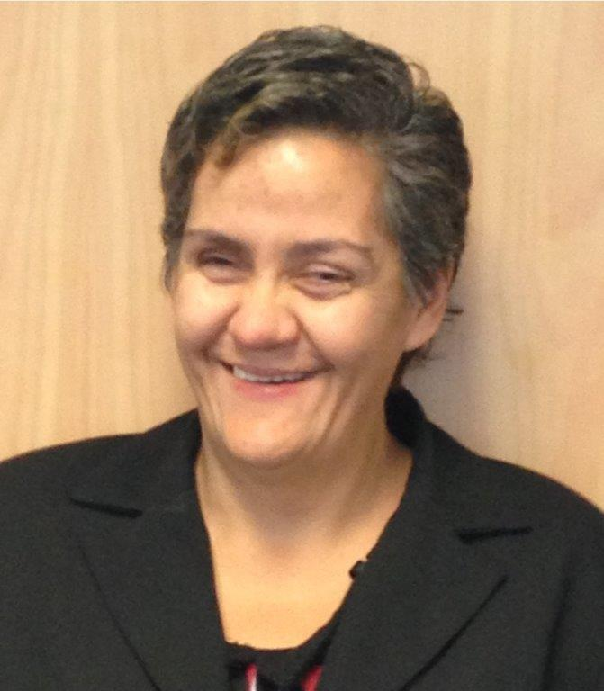
Helena Tuteao –

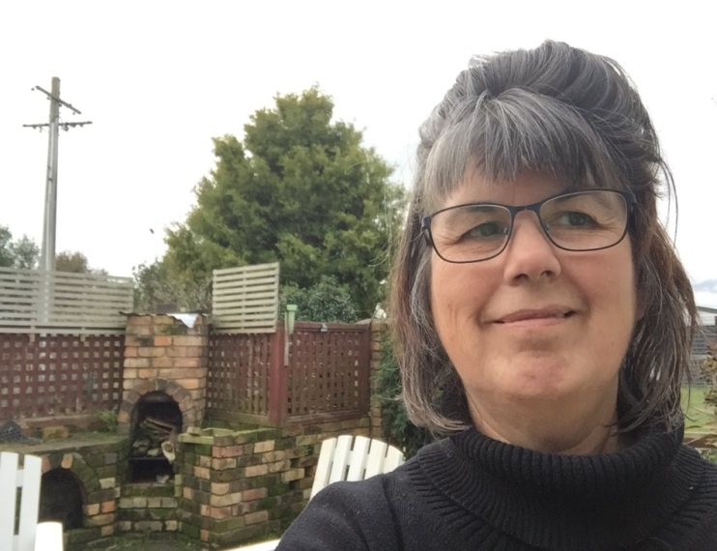
Jean Masters –

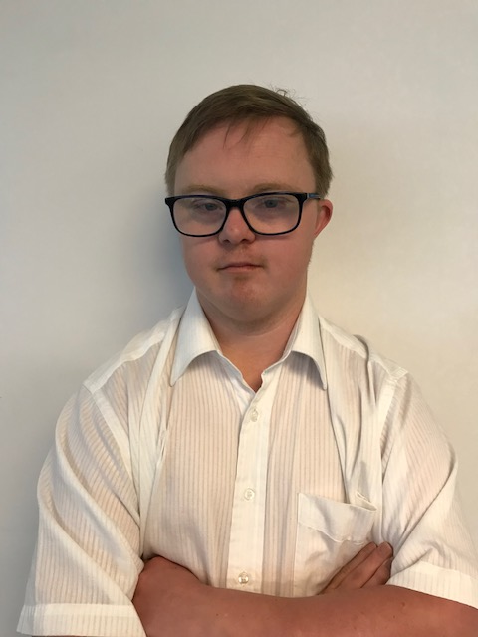
Glen Terry

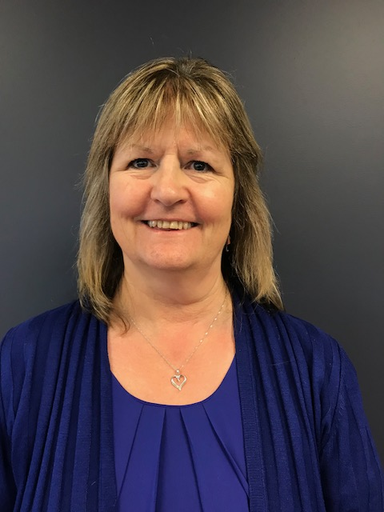
Karina Johnson

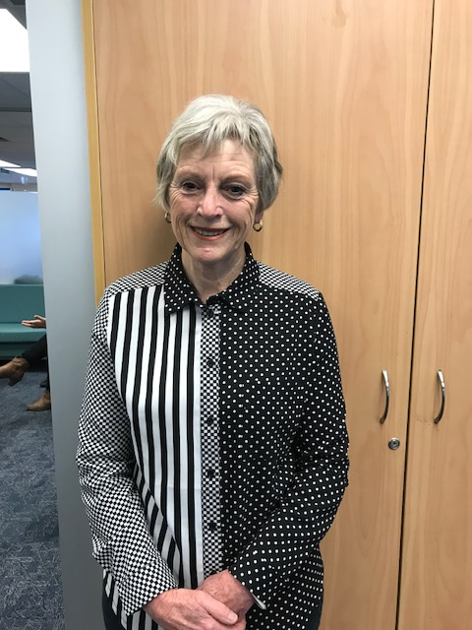
Linda Terry –

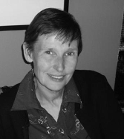
Anne Wilkinson

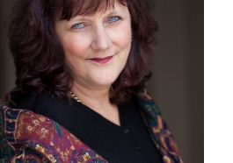
Gerri Pomeroy

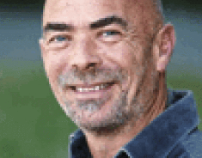
External Facilitator
Mark Benjamin

Murray Penman

Government Agency Representatives

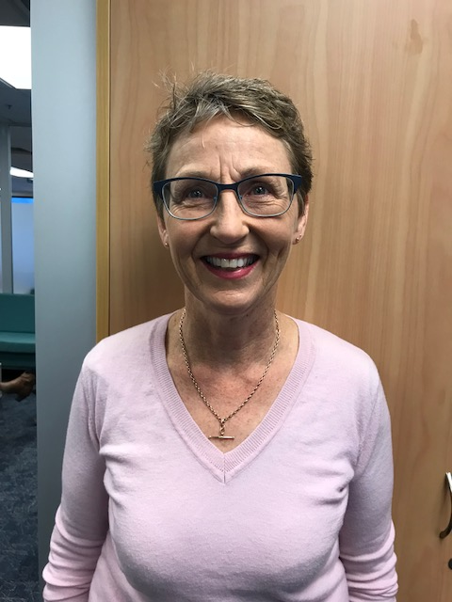
Bev Hoskins – Ministry of Education

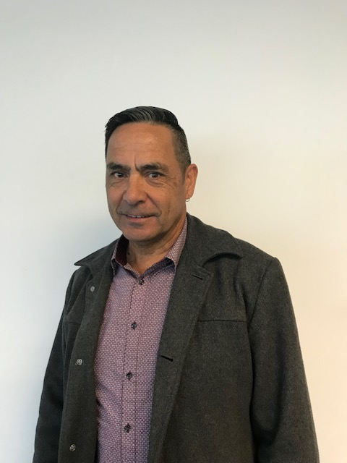
Lyall Wilson – Ministry of Social Development

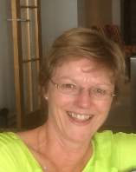
Jaqui Williams – Accident Compensation Corporation

Provider representatives


Kate Shaw – ConneXu Executive Leader, Services & Development

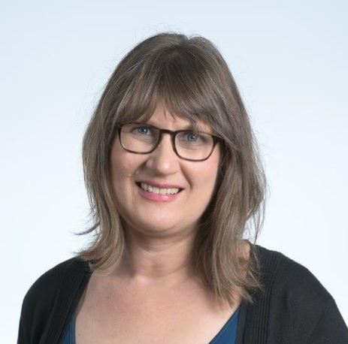
Janelle Fisher - Quality Practice Leader, Interactionz (provider representative for Inclusive NZ)

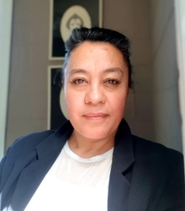
Sam Lee - Chief Executive, The Supported Life Style Hauraki Trust.

Michael White

Kathryn Numa

