What is Enabling Good Lives Waikato?

 | Enabling Good Lives gives disabled people and their families/whanau more choice and control over their support.
 | Enabling Good Lives asks disabled people and their family and whanau to think about what a good life means for them.
 | Enabling Good Lives can help you decide what information and support could help you work towards your good life.
 | In year one funding will be pooled from the Ministries of Health and Social Development into one pot of money that the disabled person and their family/whanau will have control over.

Who can use Enabling Good Lives Waikato?

Enabling Good Lives will work with 105 people in the first year.
There are four action areas.

  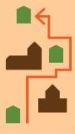 | Disabled people who want to have more choice about where you live, who you live with and what you do during the day
 | Families who have a child with disability that is 0-17 years old
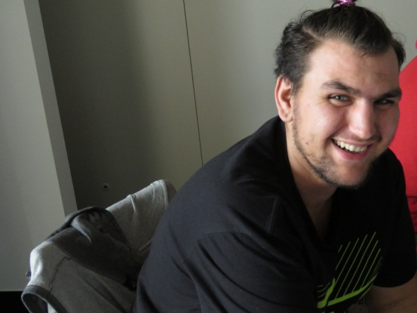 | Maori disabled people
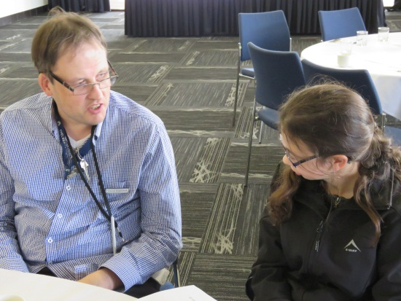 | Disabled people who could get into work with a small amount of assistance

You also need to be:

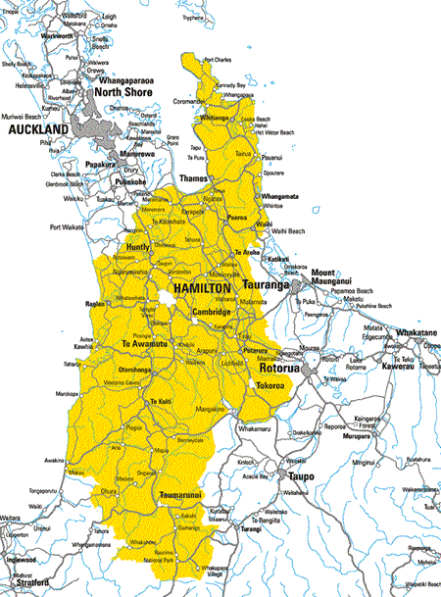 | Living in the Waikato
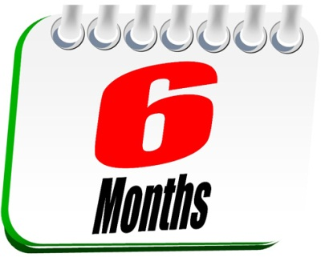 | Living with a disability that is  Likely to continue for at least six months, and  Limits your ability to function independently, to the extent that on-going support is required.
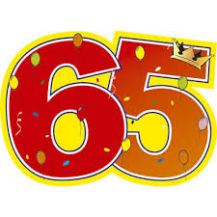 | Under 65 years of age when you start with Enabling Good Lives
 | A New Zealand citizen.

What Enabling Good Lives can do for you.

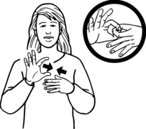 | You will work with a Connector/Tuhono during the time you are using Enabling Good Lives.
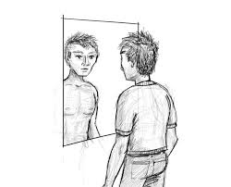 | Some people will do a supported self-assessment.  This is about you telling us what support and equipment you need.
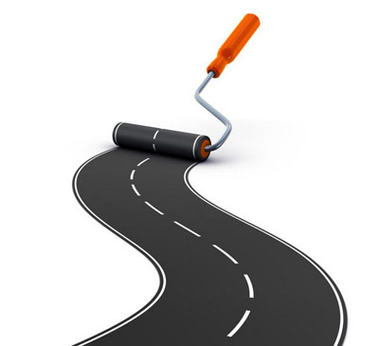 | You can make a plan that says what a good life means to you.
 | Your Connector/Tuhono will help you understand your budget.  This means they will  - Tell you how much money you can spend on your support  - Show you the different ways that you could manage your support
 | Your Connector/Tuhono will talk with you about what information you need to work towards your good life and link you with places and people that have that information.
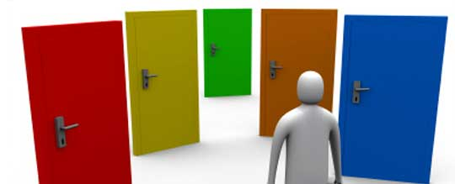   | Your Connector/Tuhono will talk with you about what support you need to work towards your good life.  You and your Connector/Tuhono can think about the best way for you to get this support, whether that is with your family or friends, a mainstream service, employing your own staff, or using a disability service.

