TERMS OF REFERENCE

Enabling Good Lives Leadership Group

Table of Contents

Purpose and role 3
Scope of interest 3
Members 4
Approach 4
Reporting and relationships 5
Conflicts of interest 6
Appendix: Overview of Enabling Good Lives 7

Purpose and role
- The purpose of the Enabling Good Lives Leadership Group is to provide disability community and sector input to and advice on current and future initiatives involving changes to the disability support system.
- The role of the Enabling Good Lives Leadership Group is to:
- provide advice on the alignment of changes to the disability support system with the Enabling Good Lives vision and principles
- provide advice and support to initiatives progressing the Enabling Good Lives approach in, for example, Waikato and Christchurch, including about any emerging issues and lessons learned from the initiatives
- build understanding of the Enabling Good Lives approach among communities, disabled person’s organisations, the disability community and sector, and government agencies.
- Three factors distinguish the Enabling Good Lives Leadership Group from other reference groups:
- a focus on change to the disability support system across multiple agencies, rather than a single agency’s part of that system
- a focus on Enabling Good Lives as an approach to system transformation, rather than being about an individual initiative
- working with government agencies and other major stakeholders to progress change of the system, rather than parallel to them.
- In keeping with Article 4.3 of the UN Convention on the Rights of People with Disabilities, the Group will provide advice and support during the design and implementation phases of initiatives, rather than after decisions have been made.

Scope of interest
- Although Enabling Good Lives is an overarching framework for change, the initial scope of interest for the Group will be existing and new initiatives to redesign the disability support system. The scope of interest of the Enabling Good Lives Leadership Group may evolve over time. Accordingly, the ongoing role and purpose of the Group will be reconsidered after two years.
- Although there may be other initiatives underway or existing service issues that will impact on the design of the disability support system, initially the Enabling Good Lives Group will focus on the following initiatives:
- Disability Action Plan: A Good Start in Life (Ministry of Education lead)
- Disability Action Plan: Proposal for an Enabling Good Lives demonstration
- Proposed day service reform initiative in Waikato ( Ministries of Social Development and Health)
- Ministries of Social Development and Education: Going Places

Members
- The Enabling Good Lives Group will have six to eight members in total. The Convention Coalition will be asked to nominate up to five people for the Group. The New Zealand Disability Support Network, the Standards and Monitoring Service and the Canterbury Enabling Good Lives Steering Group will be asked to jointly nominate up to five people.
- The Ministries of Education, Health and Social Development will collectively select between six and eight of the nominees as group members, and will take account of the need to ensure disabled people, families, providers and Enabling Good Lives leaders are involved. Māori and Pasifika perspectives will also be represented. If any of these perspectives are not represented in the nominations, further nominations may be sought from other disability community and sector groups.
- Members participate in the Group in their own right as leaders and do not represent any one perspective. Knowledge and understanding of the Enabling Good Lives approach and journey will be important. Knowledge and experience of the current disability support system, and being widely trusted and respected among the disability community and sector will also be important.
- The active involvement of disability community and sector leaders in the Group will be demanding on their time. To avoid overdrawing on limited capacity in the community and sector, the Ministry of Social Development will contract members of the Enabling Good Lives Leadership Group for their leadership, input and advice on Enabling Good Lives initiatives.
- Members will be initially appointed for two years. The three Ministries can collectively agree to end any member’s term. Casual vacancies will be filled from nomination/s from the organisation/s that nominated the retiring member.

Approach
- One of the core aspects of the Enabling Good Lives approach is a constructive partnership approach between disabled people and their organisations, families, and providers. Therefore, the Group will operate as a collective that is focused on progressing Enabling Good Lives, rather than operating as a committee of members representing various constituencies.
- The work of the Enabling Good Lives Leadership Group will be self-directed within the scope of its role. That is, the Group will have some autonomy in determining how best to fulfil its role within the contracted time.
- The Group will meet up to four times a year. In addition, each member of the Enabling Good Lives Leadership Group may be paid for up to four days additional work per annum to progress the purpose of the Group. The number of days will be reviewed if the demands of membership in the Group are higher than anticipated.
- Fees will be aligned with the Cabinet Office Circular Fees framework for members appointed to bodies in which the Crown has an interest CO (12) 6.
- The Ministry of Social Development will provide administrative support to the Enabling Good Lives Leadership Group, including making meeting and travel arrangements to support the Group to fulfil its role. Direct meeting costs will be met by the Ministry of Social Development.

Reporting and relationships
- The Group has both a leadership and a support/advisory role in respect of the Enabling Good Lives approach. Reflecting this ‘work with us’ approach, the Group will not have a formal reporting line to the Minister for Disability Issues, the Ministerial Committee on Disability Issues, or the Chief Executives’ Group on Disability Issues.
- In their support/advisory role, Group members will work directly with officials, project teams and local governance groups on specific initiatives. The Group will also report periodically on its activities as contracted. If an individual member is drawn directly into working more intensively on a specific project, that person may be contracted separately for the work, providing that any conflicts of interest are resolved prior to them taking on the additional work.
- In keeping with its broader purpose, the Group could also provide advice to the Senior Officials Group on Disability Issues on the overall alignment of the disability support system with the Enabling Good Lives approach.

Figure 1. Enabling Good Lives Leadership Group Roles and Relationships
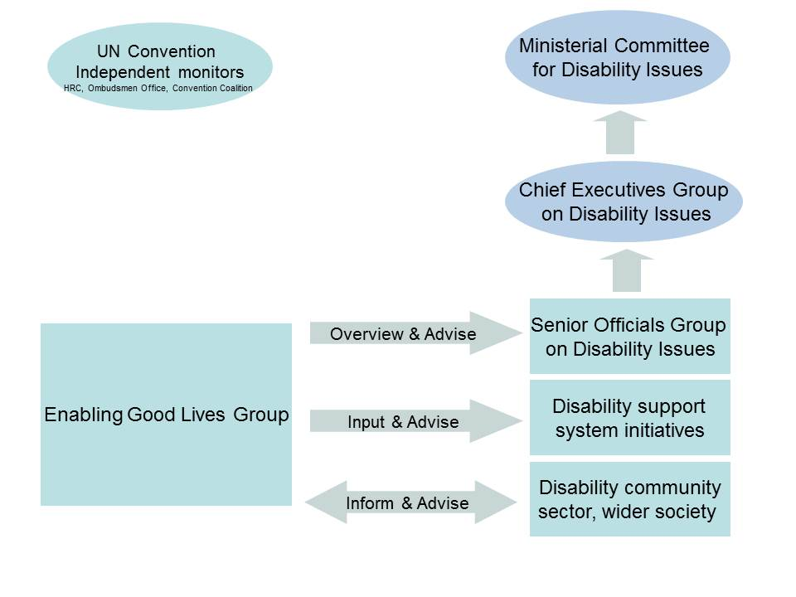
- The Ministry of Health New Model for Supporting Disabled People is currently being demonstrated in the Bay of Plenty. The disability community and sector provide advice and support to the New Model in a number of ways, including a National Reference Group, Local Working Group and Framework Redesign group. Each of these involves sector leaders with an interest in the development of the New Model work. The Enabling Good Lives Leadership Group will complement rather than replace or duplicate the role of these three groups.
- The Office for Disability Issues will engage with the Enabling Good Lives Leadership Group as part of its role in monitoring and reporting progress on implementation of the Disability Action Plan to the Ministerial Committee on Disability Issues.
Conflicts of interest
- Members of the Group or the organisations they are employed by may have existing roles in governance groups or hold contracts for government funded services. Care will need to be taken to ensure that members can fulfill their current obligations to their organisation or employer, and meet any contractual requirements, without conflicts of interest arising because of their role on the Enabling Good Lives Leadership Group. The way to handle this is openly, transparently and pragmatically.
- Individual members and the Group as a whole will need to be mindful of any potential conflict of interest, and undertake to raise it at the earliest possible time. Any actual or potential conflicts of interest will be discussed with the parties concerned and steps taken to manage these conflicts on a case by case basis.
Appendix: Overview of Enabling Good Lives
- On 1 August 2011, an Independent Working Group on Day Options presented the Minister for Disability Issues with a report entitled Enabling Good Lives.
- The Minister had commissioned a group of trusted disability community leaders to come up with a new approach for day services for disabled people. Rather than just focusing on day services, the group came back to the Minister with a proposal for a new approach to the disability support and services system as a whole.
- The Enabling Good Lives approach is a blueprint to transform the disability support system from segregated centre-based services to facilitated support, integrated within communities, that offers disabled people and their families greater choice and control over their supports and a greater range of activities – doing ordinary things, in ordinary places.
- The main characteristics of the Enabling Good Lives approach are:
- self-directed planning and facilitation
- cross-government individualised and portable funding
- considering the person in their wider context, not in the context of ‘funded support services’
- strengthening families or whānau
- community building to develop natural supports.
- Enabling Good Lives has five elements for system change. These are interdependent but can be implemented incrementally, either concurrently or separately in phases. The five elements are:
- building knowledge and skills of disabled people: to ensure disabled people understand the direction for change, and can take up opportunities to have more choice and control over their supports
- investment in families: to assist families/whānau to best support their disabled family member to have a “good life” and help them develop a vision and aspirations about what can be achieved
- changes in communities: to ensure communities, including businesses, workplaces, schools, and religious, cultural, sport and recreational activities, are accessible , welcoming and recognise the contribution that disabled people can make to enhance community cohesion and well-being
- changes to service provision: to align organisational roles and functions, delivery models, workforce capability, accountability measures, monitoring and evaluation with the vision and principles of the transformed system
- changes to government systems and processes: to support the system redesign e.g., integrated contracting, individualised funding, flexible outcomes-focussed contracting, funding pooled from across Votes (may include Vote structure changes) and involving disabled people and families in governance.
- Across government there are multiple initiatives already underway to drive better results for disabled people, including a number of initiatives that aim to make the changes to the system as described by the Enabling Good Lives report.
- The Ministry of Health work on the New Model for supporting disabled people in the Bay of Plenty is a phased introduction of individualised planning, facilitation and funding and is the most comprehensive current initiative of its type. Enabling Good Lives provides the overarching framework for the New Model – the vision it aims to progress for the disability support system, the long term direction for change and the principles on which change will be based.
- The Ministries of Education and Social Development have a system level project underway called Going Places. This is focused on integrated planning and facilitation to achieve better outcomes for disabled school leavers with high needs.
- The Ministerial Committee for Disability Issues has requested that the Ministries of Health, Social Development and Education produce a Cabinet proposal for a demonstration of the Enabling Good Lives approach in Christchurch. Work is now underway to develop this proposal. Input from the disability community and Enabling Good Lives leaders will be crucial to the development of the proposal and any subsequent demonstration of the Enabling Good Lives approach.

