‘System Transformation co-design process’
Easy Read key points from the
11th May 2017 workshop:

What is this about?

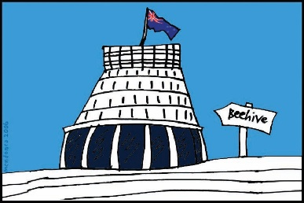
The Government of New Zealand is looking at making big changes to the disability support system.

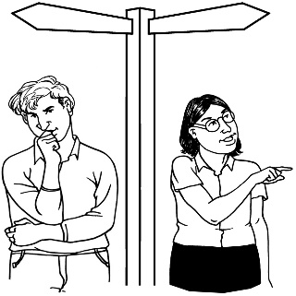
The long name for this is system transformation.

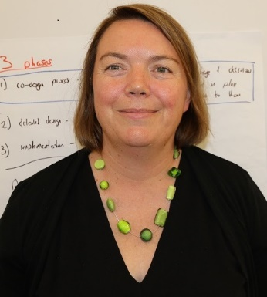
Sacha O’Dea from the Ministry of Health is leading this work.

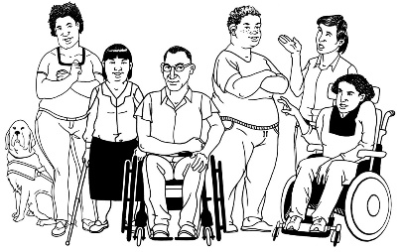
The Government has said it will plan the changes to the disability support system together with:
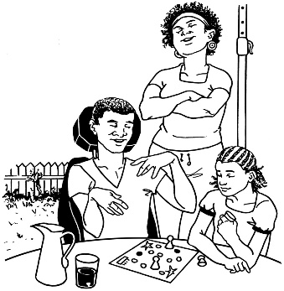
- disabled people

- family / whānau
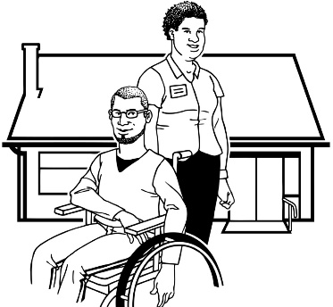
- disability support services.

Working together like this is called co-design.
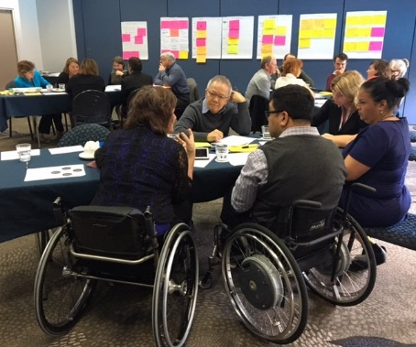

A co-design group has been put together.

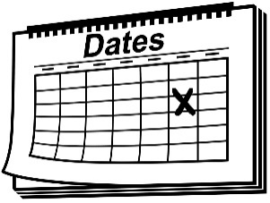
The co-design group will work together over 9 workshops.
9

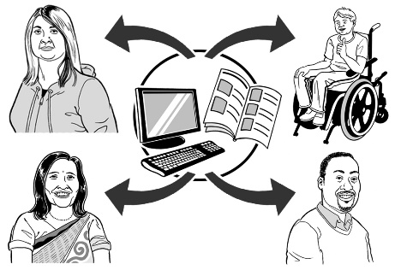
The key points of every workshop will be sent out so the rest of New Zealand can see what is being talked about.

11 May 2017
The fourth co-design workshop was on 11 May 2017.

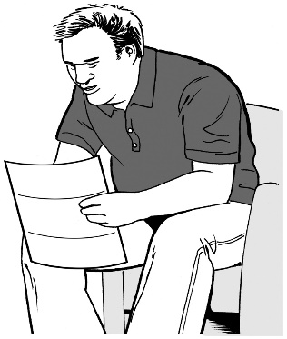
Keep reading to find the key points from that workshop.

Key point 1

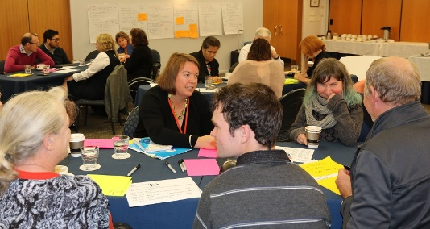
Since the last workshop the co-design group has been thinking about:
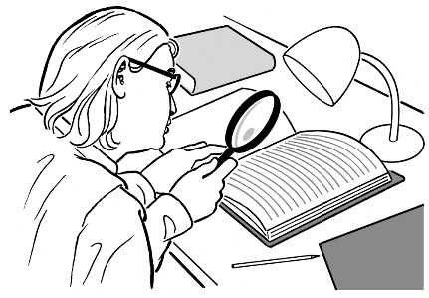
- what we have learned in the past

- the things we know

- research that has been done.

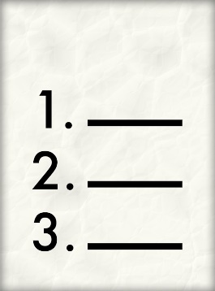
Here are some of the things the co-design group has learned.

- To do a good job of making the new disability system it is important that:

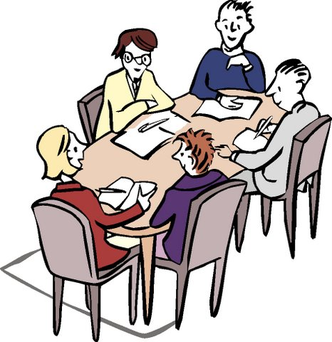
- the whole group has a clear idea of what they are trying to do

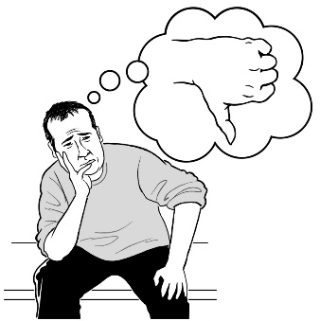
- everyone can speak up about:
  - how people are working in the disability system we have now
  - what needs to change

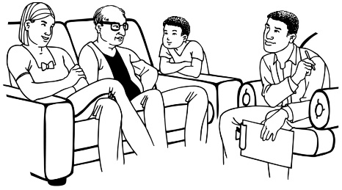
- more work is put into helping disabled people and their family / whānau to have choice and control over their own lives

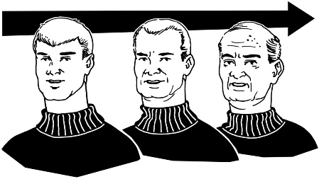
- the new system can change to meet the needs of people as they get older
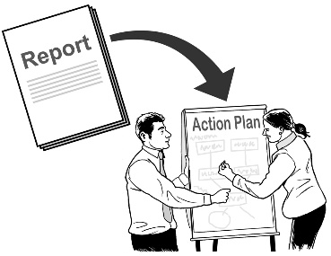
- the new disability system is made with the help of:

  - disabled people

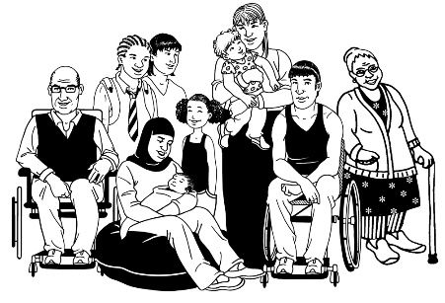
  - family / whānau of disabled people

  - people who work in the disability system.

- Identity is very important.

Identity is a hard idea to explain.

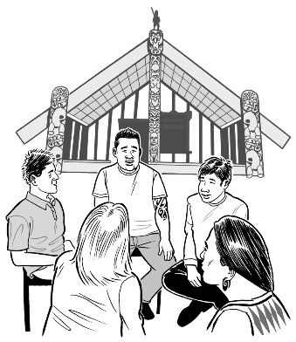
It is about who you are and where you come from.

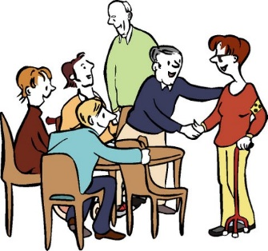
It is also about where you feel like you belong.

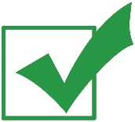
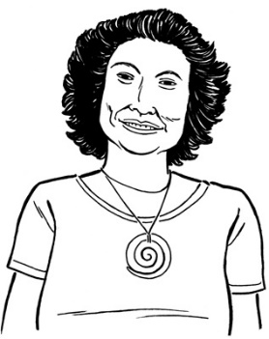
For some Māori disabled people their identity as Māori is the most important part of who they are.

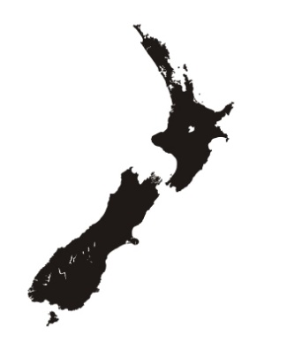
In Māori culture knowing who you are and where you come from is an important part of being healthy and well.

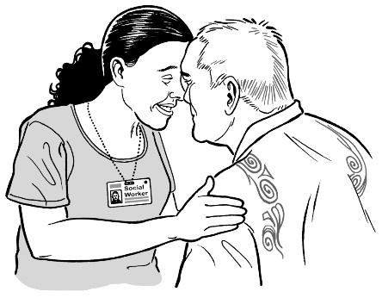
In Māori culture being healthy and well also means having a healthy:

- mind / hinengaro
- spirit / wairua
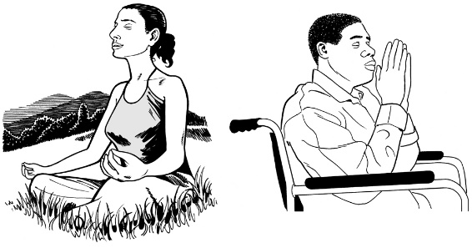
- body / tinana
- connection with family / whānau / community.

The 4 things link with each other.
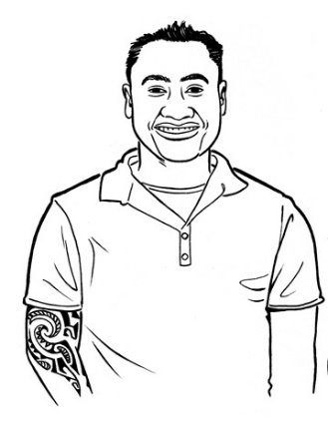

The same things are important for Māori disabled people to be healthy and well.
- It is important that the new disability support system is easy to use and understand.

The co-design group knows that even if we make the new system easy to use:
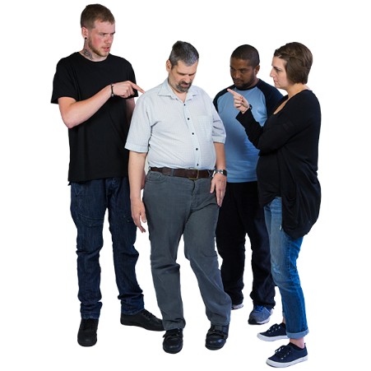
- disabled people and families / whānau sometimes need support for different things at the same time

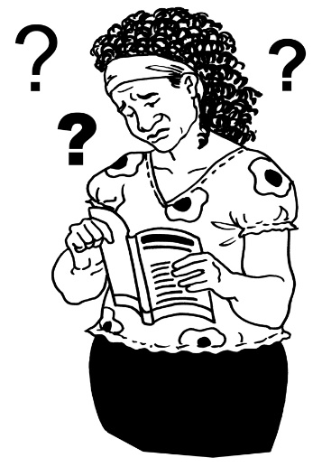
- what is happening in people’s lives may mean that using the new disability system will still:

  - not be very easy for some people

  - take more time for some people to use.

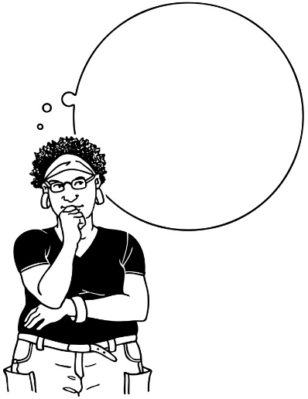
- When we are planning the new disability support system we must:

- be careful not to just put new ways of working on top of old ways of working
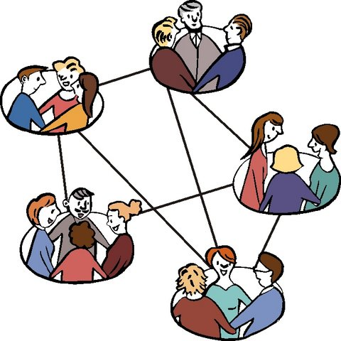
- make sure that services are working together so disabled people and their families / whānau get better services

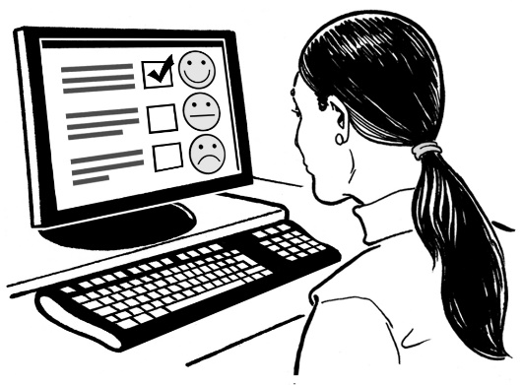
- make sure that it is easy to see what each service provider is supposed to be doing

- be able to tell if the lives of disabled people are getting better or not.

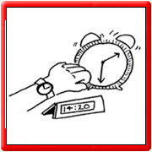
- It can take time for people and organisations to make big changes.

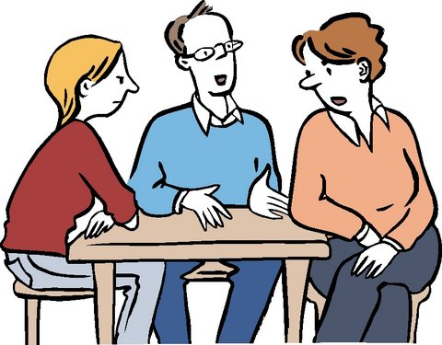
People and organisations may be stuck on the idea that making big changes will be hard.

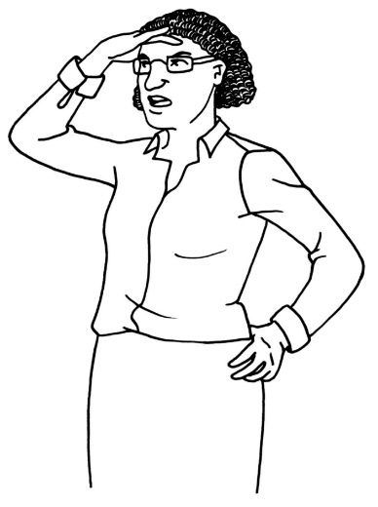
Sometimes it can be hard for people and organisations to see how things could be better with a new system.

Key point 2
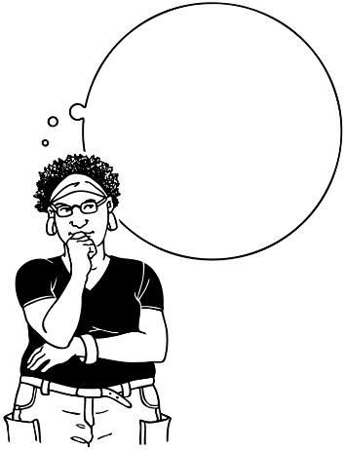

The co-design group talked about 2 different ways of thinking that they can use in their work.

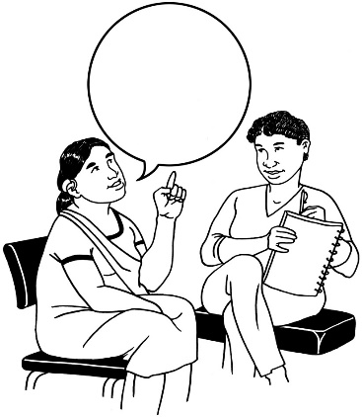
1 way is to think about what a brand new, good disability support system could look like.

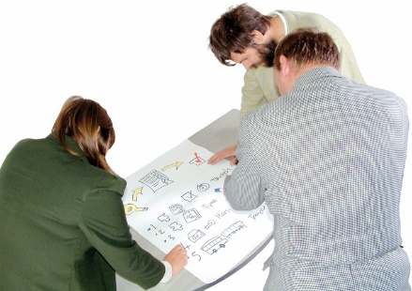
The other way of thinking is to think about what steps we need to take to get to that brand new system.

Key point 3

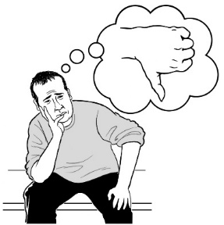
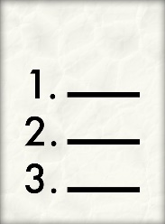
The co-design group knows that some parts of making a new disability support system will be harder to do than others.

These things needs to be thought about very carefully.

The parts that may be harder to do are:

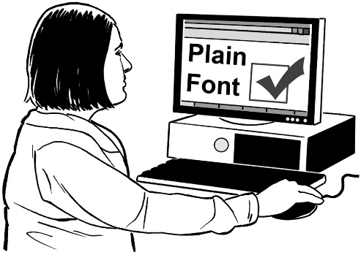
- making sure that disabled people and their family / whānau can get the information they need:

  - quickly

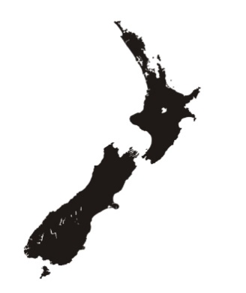
  - in a way that works for them

  - anywhere in New Zealand

  - any time in their lives.

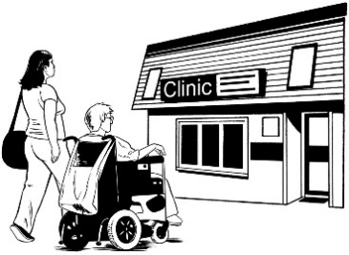
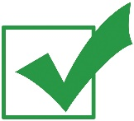
- making sure people can always get the support they need, even if everything has not been put into a plan
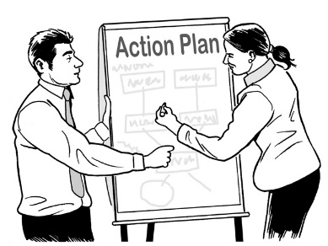

The other parts of making a new disability support system that may be hard to do are:

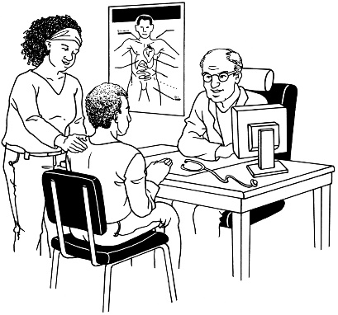
- making sure that disabled people and their families / whānau do not have to explain their lives every time they meet a new person who will be working with them

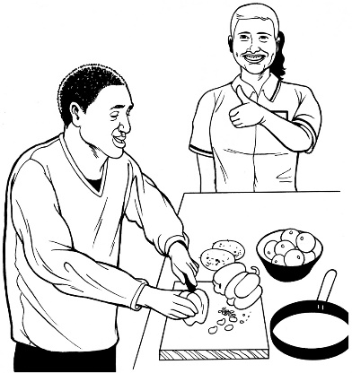
- making sure the organisations which decide how much funding disabled people get are thinking about what people can do, not what they cannot do.

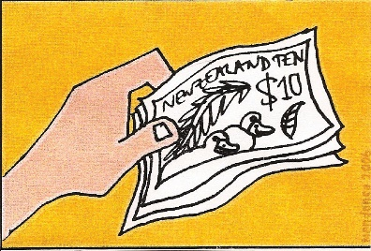
Funding means:
The money the Government gives for disabled people to be able to get the support and the things they need for their disability.
The other parts of making a new disability support system that may be hard to do are:

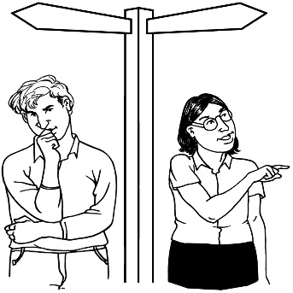
- how to make sure that disabled people are in control of their funding and their support

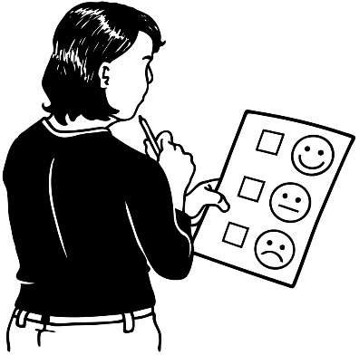
- making sure that disabled people and families / whānau are able to:

  - tell people when things are not working for them

  - ask for things to be changed

  - get the changes they need, when they ask for them.

Key point 4

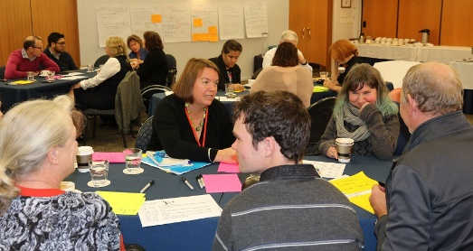
The co-design group is working really well together.
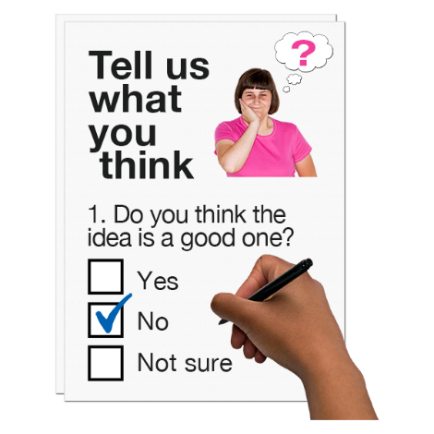

People in the group are feeling ok to ask each other hard questions.

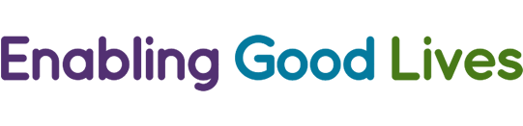
Everybody in the group is keeping the ideas of Enabling Good Lives in their minds while they work.

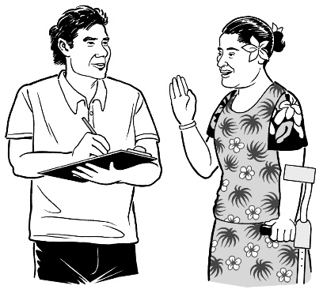
The people in the co-design group are working hard to bring in the advice they are getting from other people in the community.
The co-design group is also learning more about:

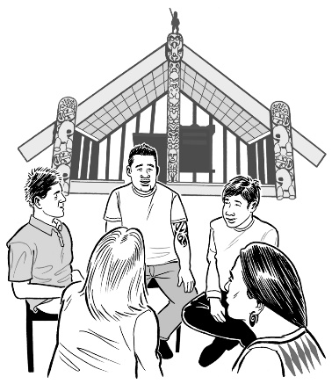
- Māori disabled people

- how not every Maori disabled person is the same or needs the same things.

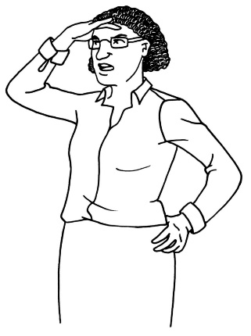
We do not know what the new disability support system is going to look like yet.

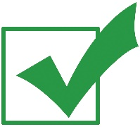
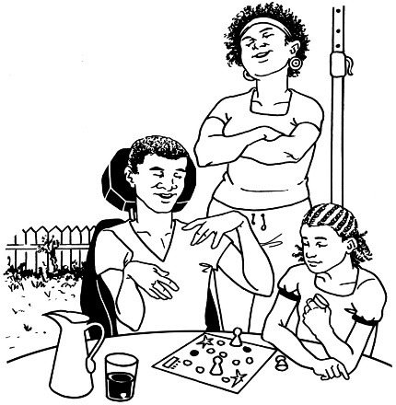
What we do know is that the new disability support system must work well for all disabled people and their family / whānau.

What now?

The next workshop will go for 2 days.

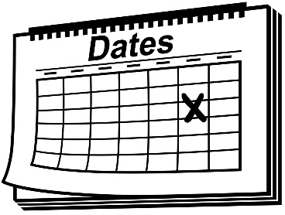
The workshop will be on 16 and 17 May 2017.

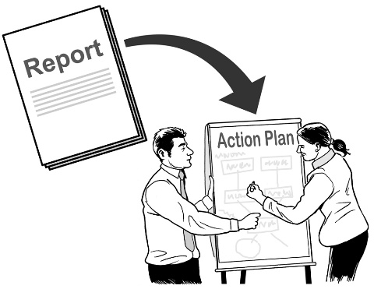
At this workshop the co-design group will be working on what the new disability support system will look like.

Talk to us
?

You can talk to us if you:
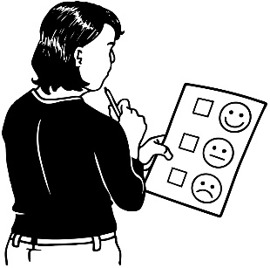
- have any questions

- want to tell us what you think about the work that is being done
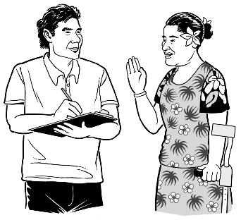
- want to tell us an idea.

Our email address is:
STfeedback@moh.govt.nz

Thank you,
Sacha O’Dea

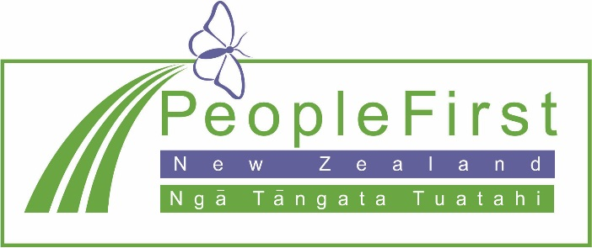

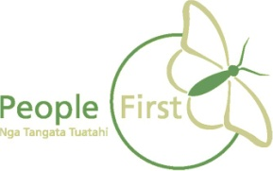
This information has been translated into Easy Read
by People First New Zealand Inc. Ngā Tāngata Tuatahi
