‘System Transformation co-design process’
Answers to the big questions

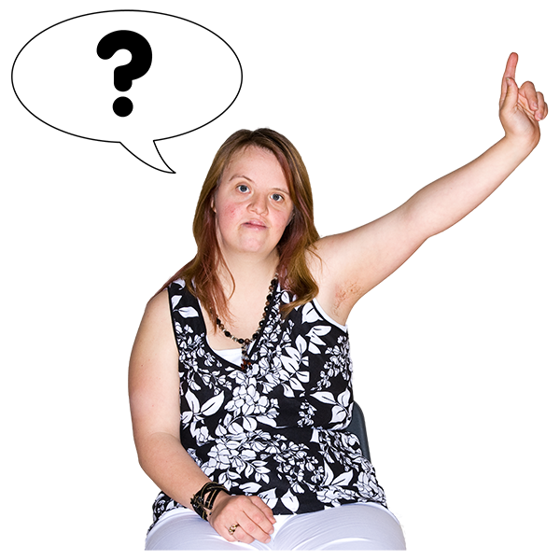
Before you start
Easy Read
information

This is a long document.

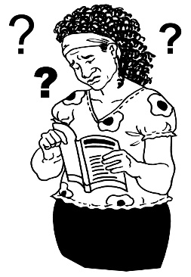
While it is in Easy Read it can be hard for some people to read a document this long.

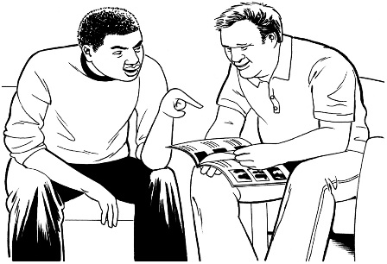
Some things you can do to make it easier are:
- read it a few pages at a time
- have someone to assist you to understand it.

What is in this booklet?

Page

What is this about? 8

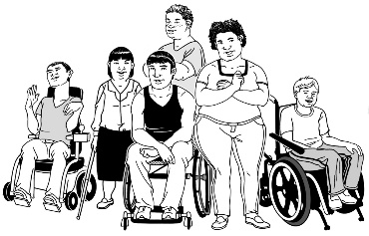
Question 1:
What will the new disability support
system mean for disabled people? 10

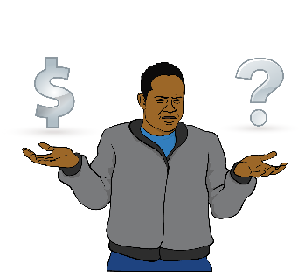

Question 2:
Will there be more funding for disability
support? 18

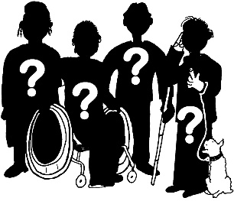
Question 3:
Who will be able to use the new
disability support system? 20
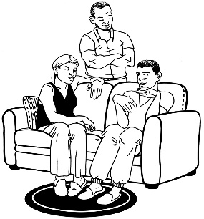
Page

Question 4:
What does it mean for families? 21
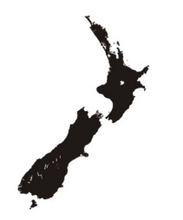
Question 5:
When will this start in MidCentral? 23

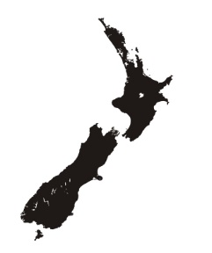

Question 6:
When will the new disability support
system be all over New Zealand? 24

Question 7:
Will anything change for me before
1 July 2018? 26

Page
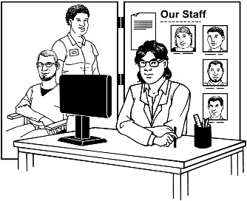
Question 8:
What will this mean for disability
service providers? 27

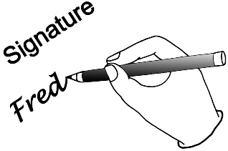
Question 9:
What about the services that already
have contracts to give services and
support? 30

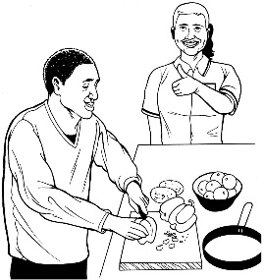
Question 10:
If I am happy with the services and
support I have now do I have to
change? 31

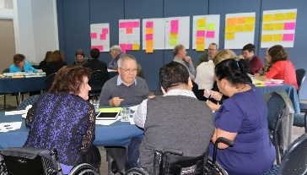
Question 11:
Who worked on the plan for the new
disability support system? 32
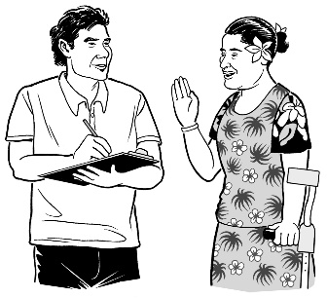
Page

Question 12:
How can the disability community
take part in the next part of the work? 34

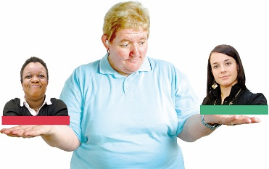
Question 13:
How will you choose the people for
the MidCentral Regional
Leadership Group? 37

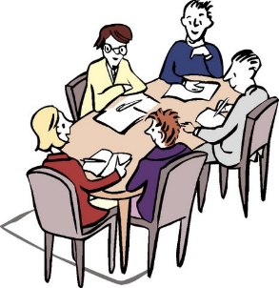
Question 14:
Who will be on the MidCentral
Regional Leadership Group? 38

Question 15:
What work still needs to be done? 39

Page
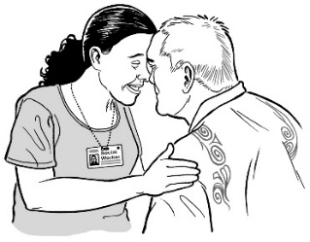
Question 16:
Is there more work to be done on
some parts of the new system? 40

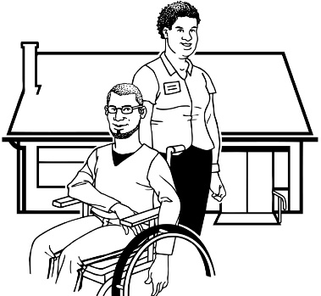
Question 17:
What will the new disability support
system mean for support workers? 43

Question 18:
What will the new disability support
system look like? 45

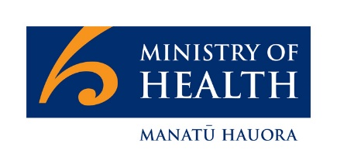
Question 19:
What will this mean for DSS – Disability
Support Services? 47

Page
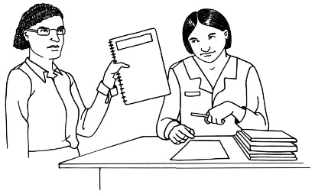
Question 20:
What will this mean for NASCs –
Needs Assessment and Service
Coordination organisations? 49

Question 21:
Who do I contact if I have more
questions? 51

What is this about?

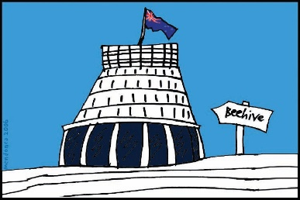
The Government of New Zealand is looking at making big changes to the disability support system.

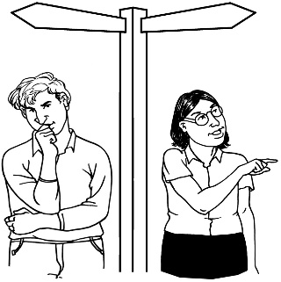
The long name for this is system transformation.

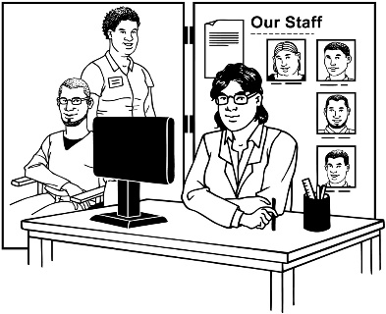
A disability support system is the way the Government gives funding and support to disabled people and their families / whānau.

Funding means the money the Government gives for disabled people to be able to get the support and the things they need for their disability.

Many people have questions about the new changes.

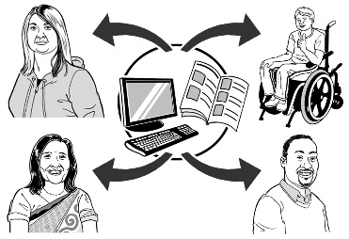
Here are some answers to the questions that have been asked the most.

Question 1: What will the new disability support system mean for disabled people?

The new disability support system will be very different from the system we have now.

In the new disability support system there will be funding for making sure disabled people and their families / whānau:
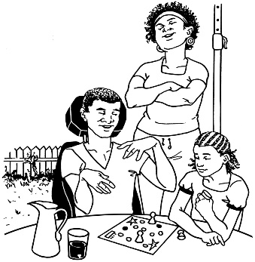
- are strong

- can get the support and things they need.

The ways that people use the new disability support system will be different for everyone.

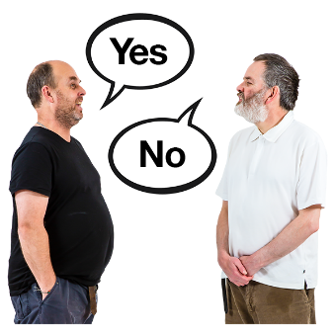
In the new disability support system disabled people and their families / whānau can decide:

- if they want to use the system
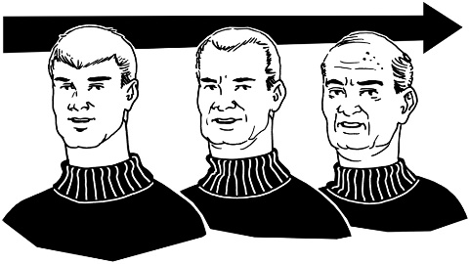
- when is a good time for them to use the system

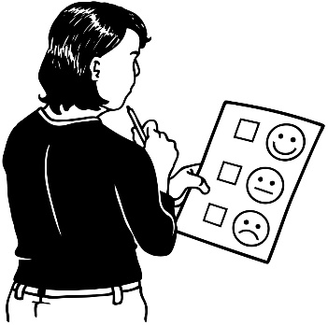
- what parts of the system they want to use.

There will be a new way of funding disability support that will mean:
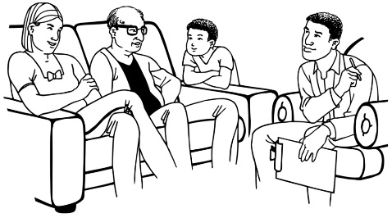
- people will not have to get assessed as much as they are now to get funding and support
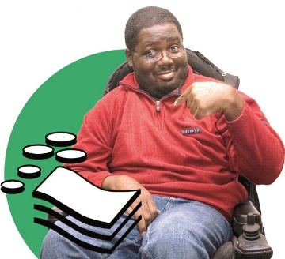
- there will be new ways of giving funding and support to disabled people and their families / whānau
- there will be more choice and control for disabled people and their families / whānau.

The new disability support system will:
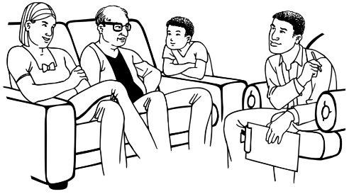
- try to get in contact with all disabled people and their family / whānau to let them know what support they could get
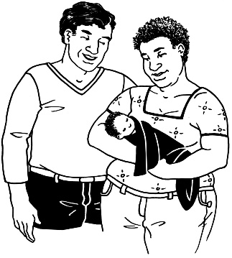

- get in contact with disabled people and their families / whānau when they first find out about the disability
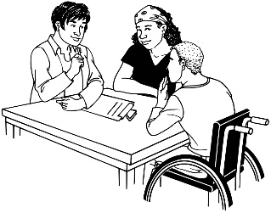
- be easy to get in contact with by:

  - talking to someone face-to-face

  - phone

  - email.

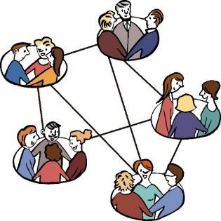
The new disability support system will also:

- have groups of disabled people and family / whānau that can connect with each other
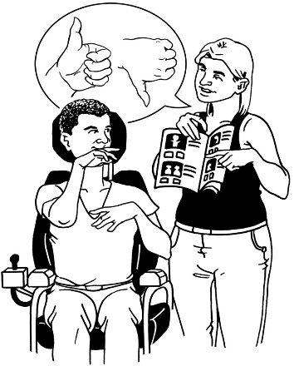

- make it easier for people to make their own choices – with good support

- have a digital hub – this would be online and would be a place where you could get lots of information and support.

Online means on the internet.

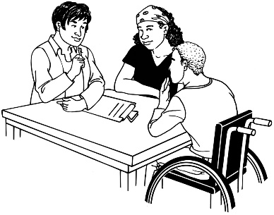
Disabled people and their families / whānau will be able to have an EGL connector / tūhono to work with if that is what they want.

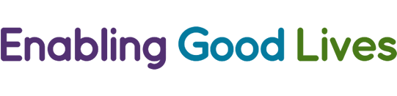
EGL means Enabling Good Lives.

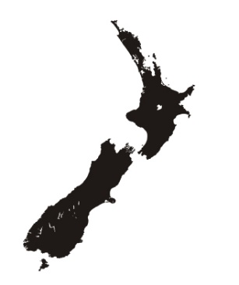
Enabling Good Lives is a way of giving disability support that has been tried in some parts of New Zealand.
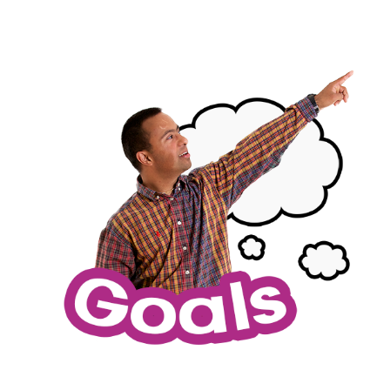

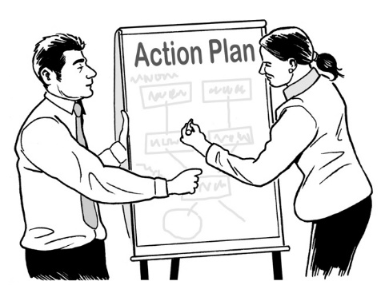
The job of an EGL connector / tūhono is to work with disabled people and their families / whānau to think about:

- what they want for their life

- how to make it happen.
Disabled people will be in control of their own information in the new disability support system.

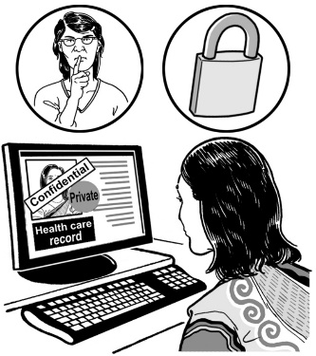
Disabled people will be able to:

- see the information about them

- choose who can see the information about them

- use the files about them to record:

  - their goals

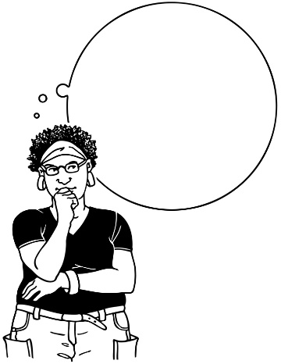
  - what is working and what is not working

  - what tools they found helpful.

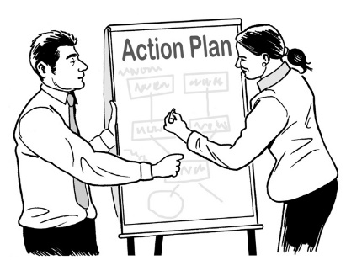
There will be ways to check if the new disability support system is working well.

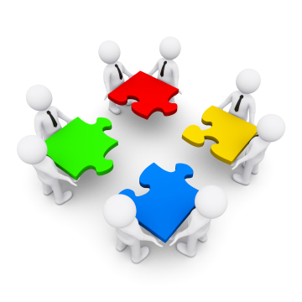
We will check the new system by:

- working together with disabled people and families / whānau

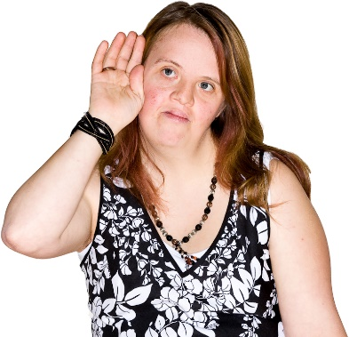
- getting information on what is working and what is not.

Question 2: Will there be more funding for disability support?

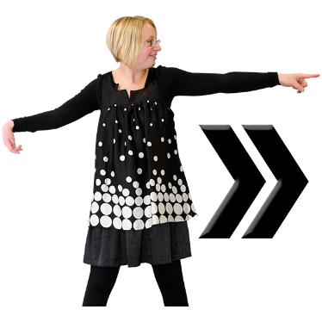
The next part of the work will be looking at:

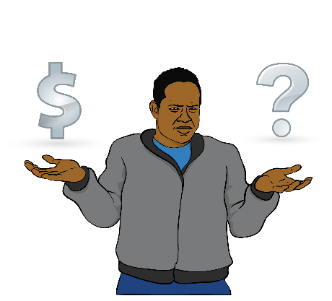
- how much the new disability support system will cost

- where the money for the new system can come from.

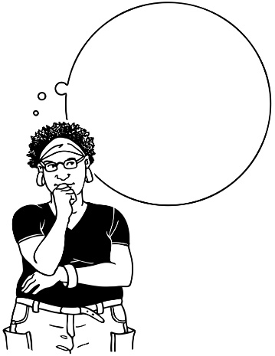
The new disability support system will use what is called a ‘social investment approach’.

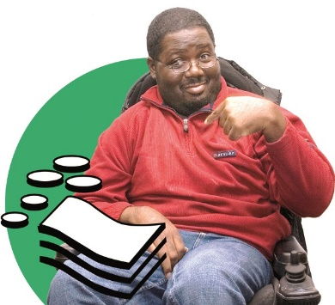
This means:
- thinking about how funding and support now can make a person’s life better later on
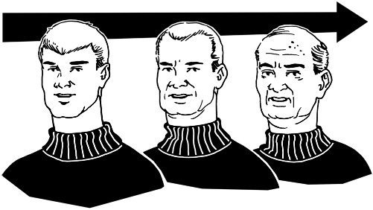
- supporting people in a way that may cost less if you look at it over a long time.

Question 3: Who will be able to use the new disability support system?

The new disability support system is going to be tried and tested in the MidCentral region first.

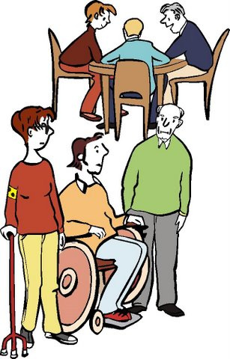
While the system is being tried and tested it will only be able to be used by people who:

- get funding and support now and

- live in the MidCentral region.

After the testing has been done and the new system is ready it will start up in other parts of the country.
Question 4: What does it mean for families?

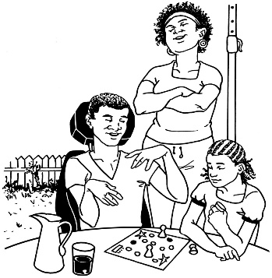
The new disability support system will make things better for disabled people and families / whānau.

In the new disability support system there will be funding for:
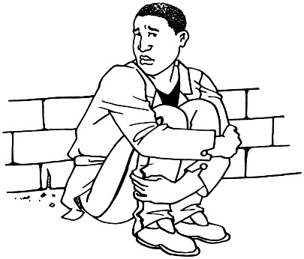
- disabled people and their families / whānau to get help fast if they have a very bad problem

- EGL connectors / tūhono to work with disabled people and their families / whānau will if that is what they want

A new way of funding disability support will also mean:
- people will not have to get assessed as much as they are now to get funding and support
- there will be new ways of giving funding and support to disabled people and their families / whānau
- there will be more choice and control for disabled people and their families / whānau

- a digital hub – an online place where you could get lots of information and support

- funding for making sure disabled people and their families / whānau:
  - are strong
  - can get the support and things they need.
Question 5: When will this start in MidCentral?

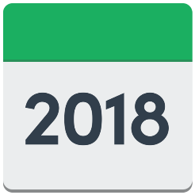
The plan is to start new disability support system in the MidCentral region on 1 July 2018.

This may change.

There is still a lot of work to do.

Question 6: When will the new disability support system be all over New Zealand?

The new disability support system is going to be tried and tested in the MidCentral region first.

The MidCentral region covers:
- Palmerston North
- Horowhenua district
- Manawatu district
- Otaki district
- Tararua district.

For the first year the system will be:
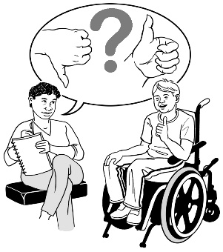
- tested

- changed to make it better.
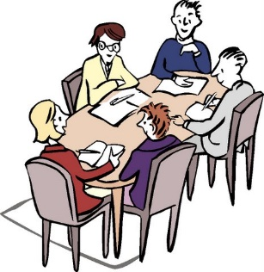
Cabinet will decide when the new disability support system will start up in other parts of New Zealand.

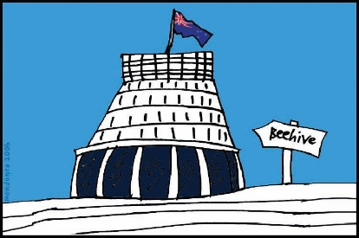
Cabinet is a group of senior Government Ministers.

Question 7: Will anything change for me before 1 July 2018?
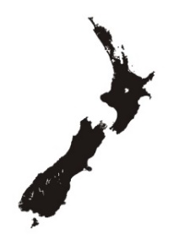

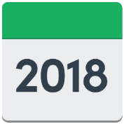
If you live in the MidCentral region there may be changes for you from 1 July 2018.

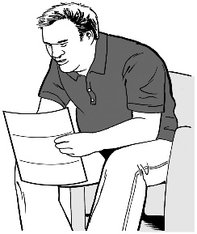
The Ministry of Health will start getting in touch with people about what will change from October 2017.

There will be no changes for people who live in other parts of the country.

Question 8: What will this mean for disability service providers?
How will they find out about the changes?

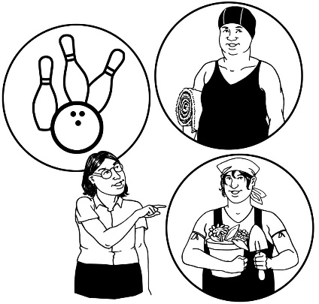
The new disability support system will mean disabled people and their families / whānau have more choice and control over their:

- lives

- support.

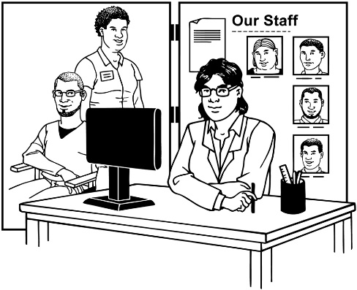
Having a new disability support system will mean big changes for:

- places that decide how much funding and support people can get
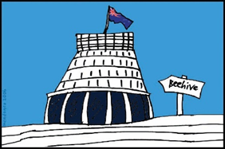
- Disability support providers

- government agencies.

All of these places will have to learn new ways of working.

The team that is working on the new disability support system will be in touch soon with disability service providers.

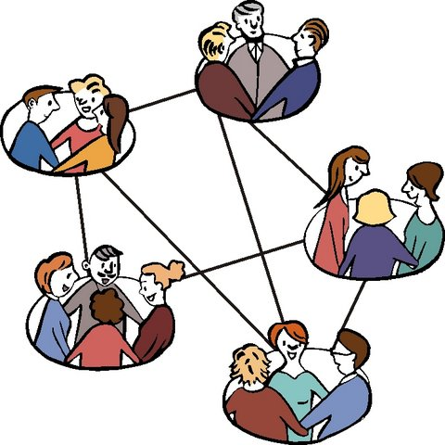
We will tell them what changes are coming by:

- talking to groups of providers
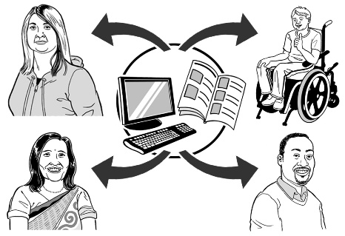
- sending out information every month.

Question 9: What about the services that already have contracts to give services and support?

Will their contracts change?

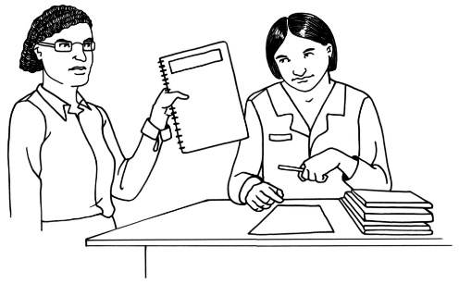
At the moment we are not planning to change any contracts.

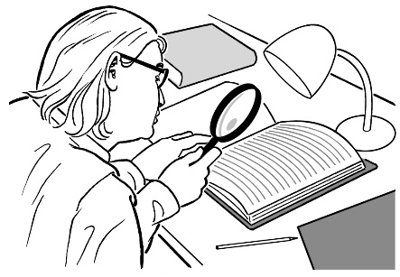
We will be looking at contracts over the next 6 months.

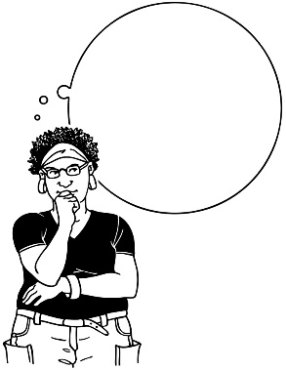
We will be thinking about what changes may need to happen.

Question 10: If I am happy with the services and support I get now, do I have to change?

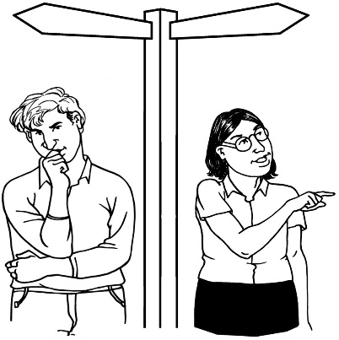
If you are happy with the support you have now we will work with disability service providers to make sure this stays the same.

Question 11: Who worked on the plan for the new disability support system?

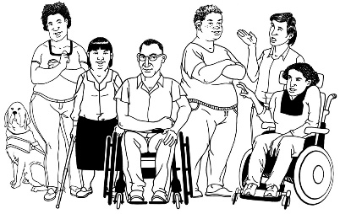
The Government has been planning the changes to the disability support system together with:
- disabled people

- family / whānau
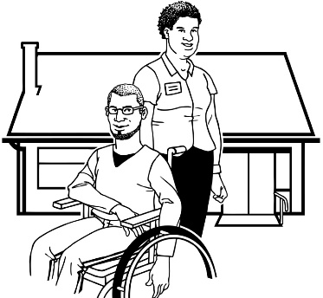
- disability support services.

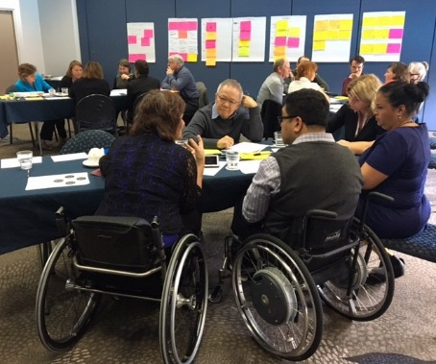
Working together like this is called co-design.

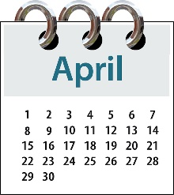
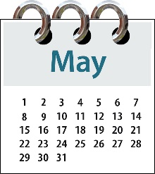
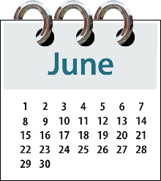
A co-design group has been working on the plan for a new disability support system since April 2017.

You can see more information on the co-design group on this website:

http://www.enablinggoodlives.co.nz/system-
transformation/meet -the-team

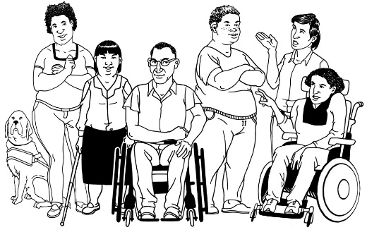
The plan has also been looked at by:
- the National Enabling Good Lives Leadership Group

- Disabled People’s Organisations – groups that are run by and for disabled people.
Question 12: How can the disability community take part in the next part of the work?

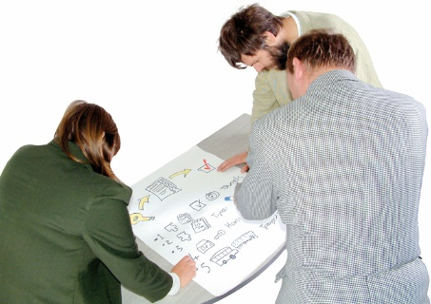
Groups from the disability community will be working on the plan and testing the system.

This will happen through the work of the:
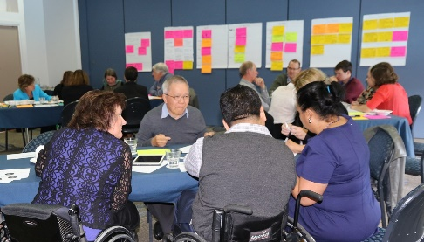
- Co-design group that worked on the plan for the new disability support system
- National Enabling Good Lives Leadership Group

- MidCentral Regional Leadership Group.

This means the Government will keep working with:

- disabled people

- family / whānau

- disability support services.

We will be putting the MidCentral Regional Leadership Group together in the next stage of the work.

We will also be looking for more feedback from the wider disability community in the next stage.

We will be doing this a few different ways, like on Facebook.

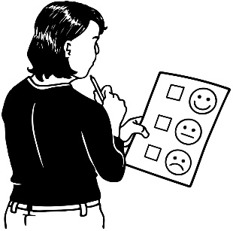
Contact us if you want to tell us:

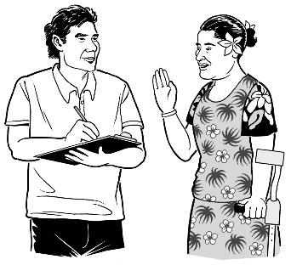
- what you think about the work that is being done

- an idea.

Our email address is:
STfeedback@moh.govt.nz

Question 13: How will you choose the people for the MidCentral Regional Leadership Group?

We will hold meetings for the community in Palmerston North.
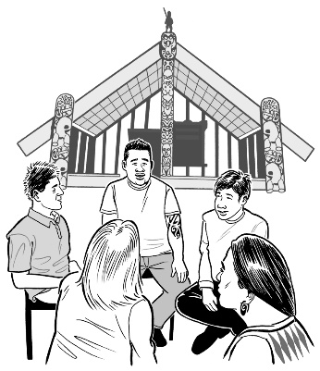

People from the disability community in the MidCentral region will decide:

- how the meetings will be run
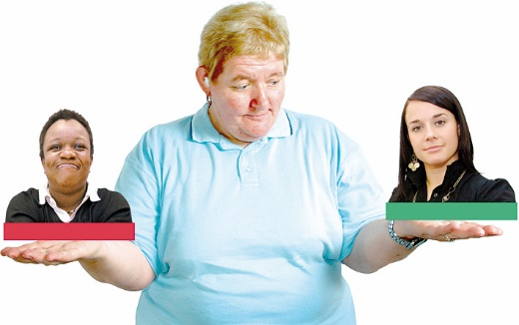
- the best way to pick who will be on the MidCentral Regional Leadership group.

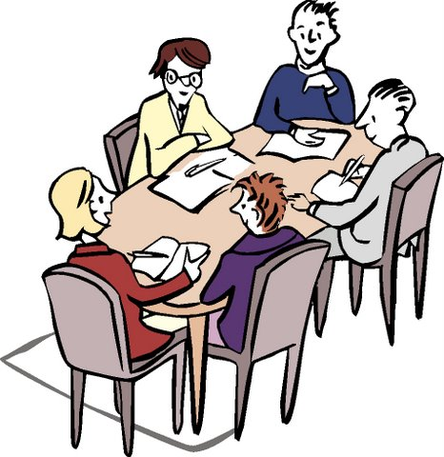

The National Leadership Group will help with this part of the work.

Question 14: Who will be on the MidCentral Regional Leadership Group?

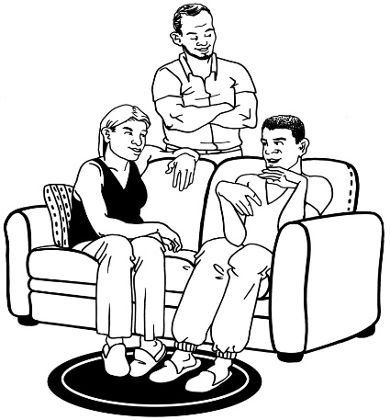
The Regional Leadership Group will most likely have:

- disabled people

- family / whānau
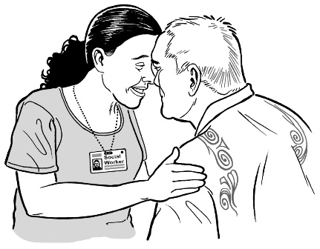
- people who work in disability services

- people from local tribes / iwi.

If you think other people should be on the Group you can email us on:
STfeedback@moh.govt.nz

Question 15: What work still needs to be done?

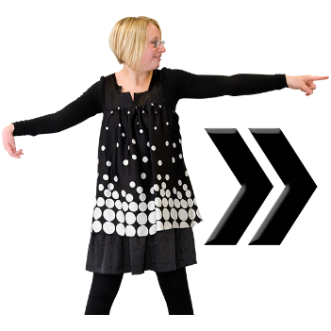
Next we need to work on:

- planning every little part of the new system
- testing the plan for the new system with the disability community

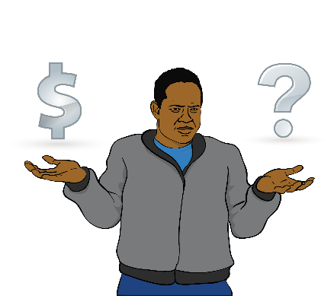
- getting ready to have the new system in the MidCentral region

- working out how the money will work in the new system

- making sure that different groups will do well in the new system

- getting information out to the people of New Zealand about the plan and any changes.

Question 16: Is there more work to be done on some parts of the new system?

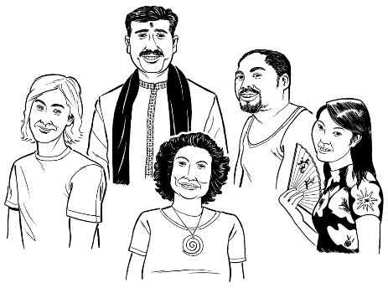
More work needs to be done to make sure the new system works well for different cultures.

What is culture?

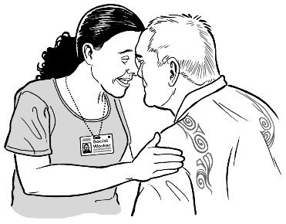
Culture is a way of thinking and doing things as a group.

There are many different cultures in New Zealand.

For example: Māori culture and Deaf culture.

Some groups of people in New Zealand do not use the disability support system very much.

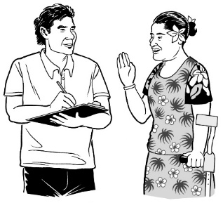
For example:

- Pasifika communities
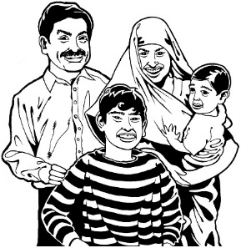
- Asian communities

- other groups of people who have moved to New Zealand.

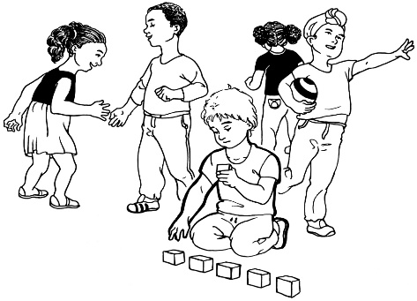
More work also needs to be done to make sure the system works for people who have:

- high support needs

- Autism.
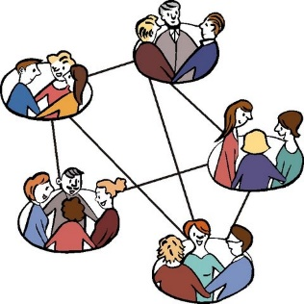
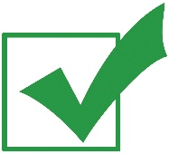
More work needs to be done to make sure the new system works for everyone.

Question 17: I am a support worker.
What will the new disability support system mean for me?

The new disability support system will mean disabled people and their families / whānau have more choice and control over their:

- lives

- support.

Disability service providers and staff:

- will have to learn new ways of working

- may need some new skills.
The team that is working on the new disability support system will be in touch soon with disability service providers and staff.

Question 18: What will the new disability support system look like?

The new system will have a new:
?
- organisation

- brand.

What is a brand?

A brand is:
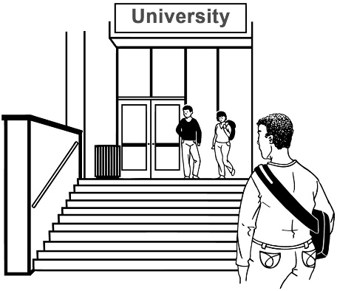
???????
  - a name

  - a logo

  - what people think of when they see it.

We are still working on what the new organisation and brand will look like.

Question 19: What will this mean for DSS – Disability Support Services?

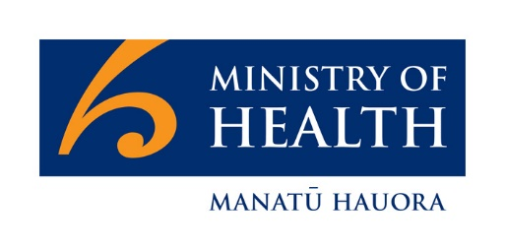
Disability Support Services is part of the Ministry of Health.

Disability Support Services is part of the disability support system we have now.

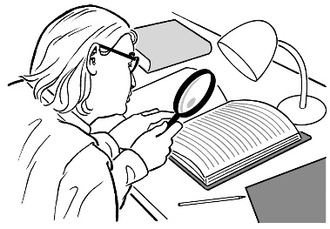
We are still looking at what the change to the new system will mean for Disability Support Services.

The new system must have a new organisation.
?
The new organisation will be different to Disability Support Services.

It will have different:
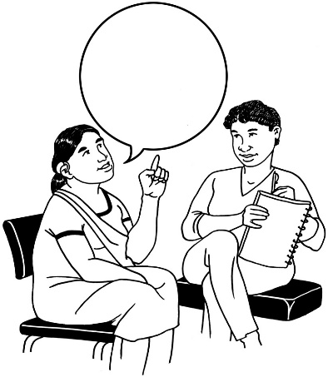
- jobs to do

- funding.

Funding means the money the Government gives for disabled people to be able to get the support and the things they need for their disability.

Question 20: What will this mean for NASCs – Needs Assessment and Service Coordination organisations?

The new disability support system will mean disabled people and their families / whānau have more choice and control over their:

- lives

- support.

This will also mean some changes for the places that decide how much funding people get for their disability needs, like Needs Assessment and Service Coordination organisations.

These places are also called NASCs.

We are still looking at what the change to the new system will mean for Needs Assessment and Service Coordination organisations.

Question 21: Who do I contact if I have more questions?

You can talk to us if you:

- have any questions

- want to tell us what you think about the work that is being done

- want to tell us an idea.

Our email address is:
STfeedback@moh.govt.nz

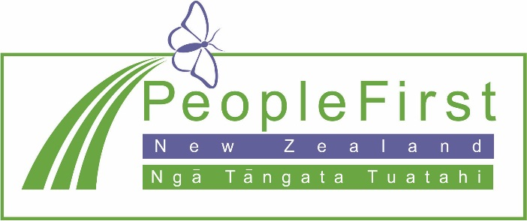

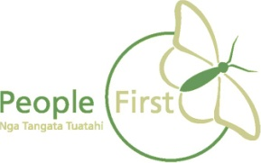
This information has been translated into Easy Read
by People First New Zealand Inc. Ngā Tāngata Tuatahi
