‘New disability system a step closer’
Easy Read statement to the media

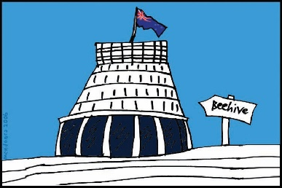
The Government of New Zealand is making big changes to the disability support system.

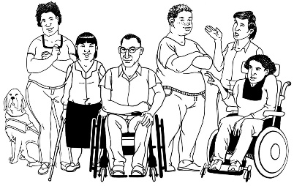
The Government has been planning the changes to the disability support system together with:
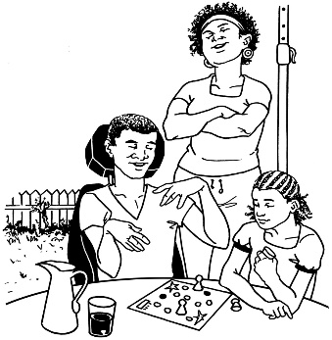
- disabled people

- family / whānau
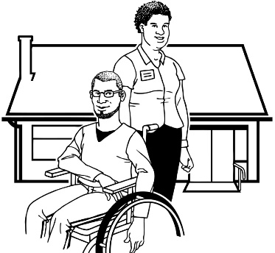
- disability support services.

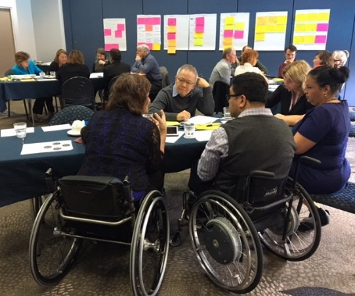
Working together like this is called co-design.

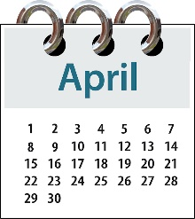
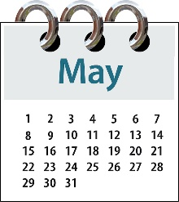
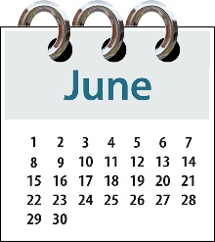
A co-design group has been working on the plan for a new disability support system since April 2017.

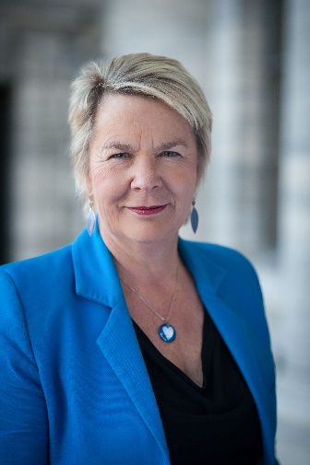
Nicky Wagner is the Minister for Disability Issues.

Ms Wagner says the people on the co-design group:
- have a lot of skill to do this work

- have worked very hard on the plan.

Ms Wagner also says:
- disabled people are experts in their own lives

- the co-design group is a great example of the saying “Nothing about us without us”.

What is in the plan?

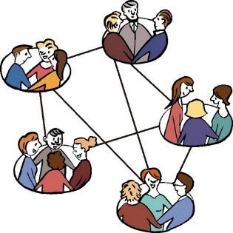
The new disability support system will have:

- groups of disabled people and family / whānau that can connect with each other

- a digital hub – this will be an online place where you can get lots of information and support.

Online means on the internet.

In the new disability support system there will be a new way of funding disability support that will mean:
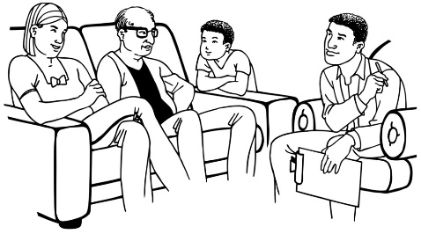
- people will not have to get assessed as much as they are now to get funding and support
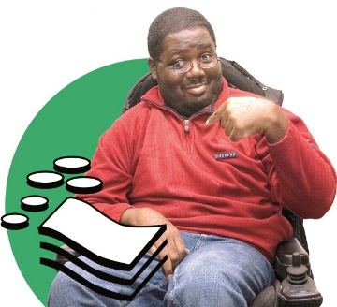
- there will be new ways of giving funding and support to disabled people and their families / whānau
- there will be more choice and control for disabled people and their families / whānau.

In the new disability support system there will be funding for making sure disabled people and their families / whānau:
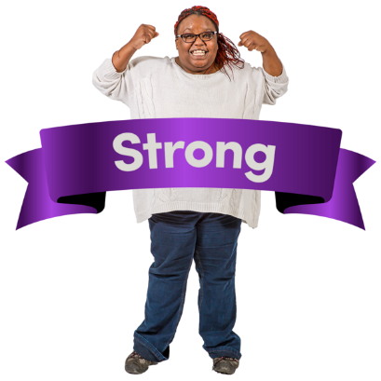
- are strong

- can get the support and things they need.

Disabled people will be in control of their own information in the new disability support system.

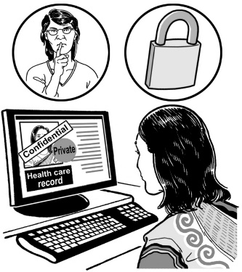
Disabled people will be able to:

- see the information about them

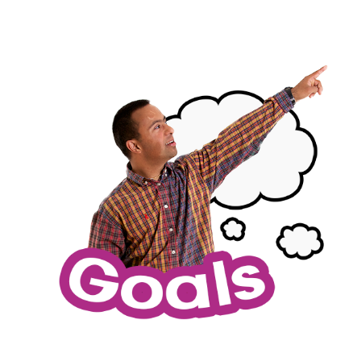
- choose who can see the information about them

- use the files about them to record:

  - their goals

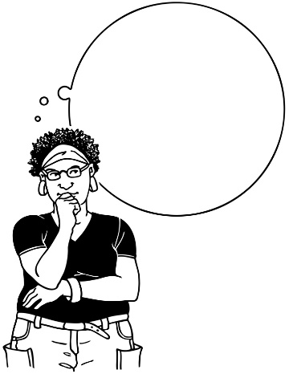
  - what is working and what is not working

  - what tools they found helpful.

Checking the new system

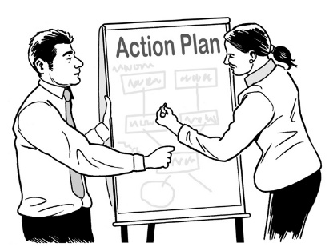
There will be ways to check if the new disability support system is working well.

We will do this by getting information from:
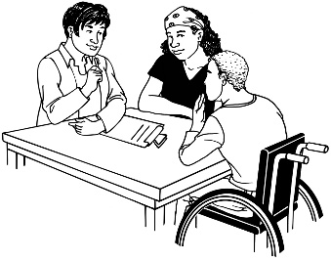
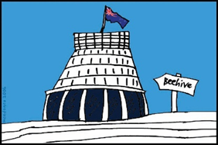
- disabled people and their families / whānau

- government agencies

- other people working in the new system.

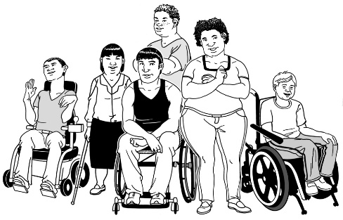

The disability community will take part in the checking.
What next?

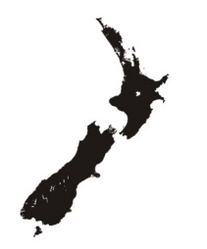
The new disability support system is going to be tried and tested in the MidCentral region first.

The MidCentral region covers:
- Palmerston North
- Horowhenua district
- Manawatu district
- Otaki district
- Tararua district.

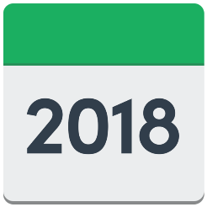
The plan is to start new disability support system in the MidCentral region on 1 July 2018.

Next we need to work on:

- planning every little part of the new system
- testing the plan for the new system.

People from the disability community will be able to help with the next stage.

We will let people know soon how they can do this.

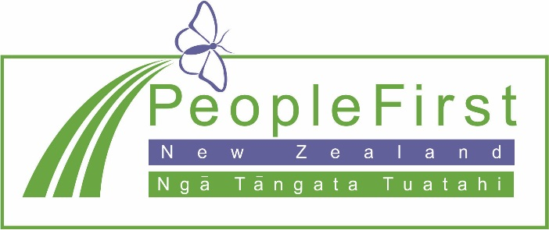

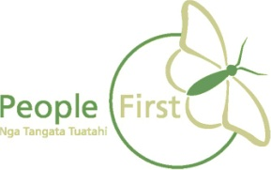
This information has been translated into Easy Read
by People First New Zealand Inc. Ngā Tāngata Tuatahi
