A new disability support system for New Zealand
February 2018 update

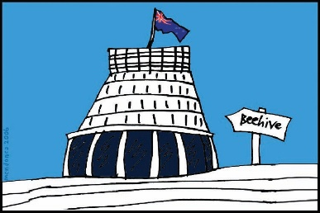
The Government of New Zealand is making big changes to the disability support system.

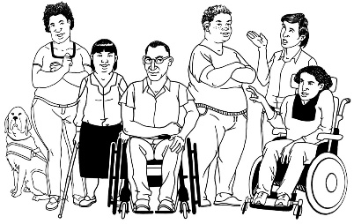
The Government has been planning the changes to the disability support system together with:
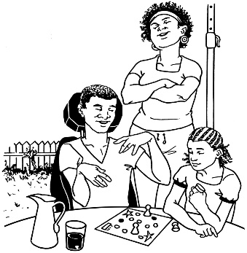
- disabled people

- family / whānau
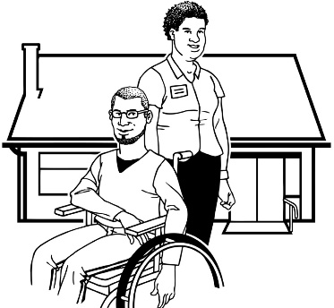
- disability support services.

Working together like this is called co-design.

This is an update to let you know what:

- has been happening

- is going to happen next.

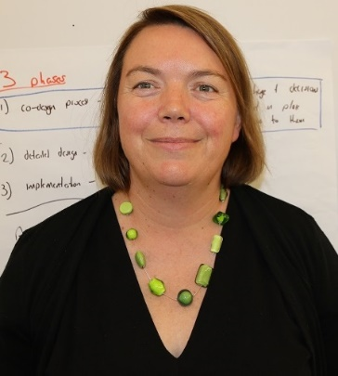

This update is from Sacha O’Dea from the Ministry of Health.

Sacha is working with the disability community on this work.

What are we working on now?

At the moment we are very busy:
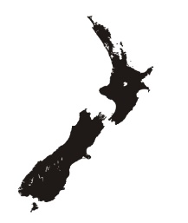
- getting ready to start making changes to the disability support system in the MidCentral area of New Zealand
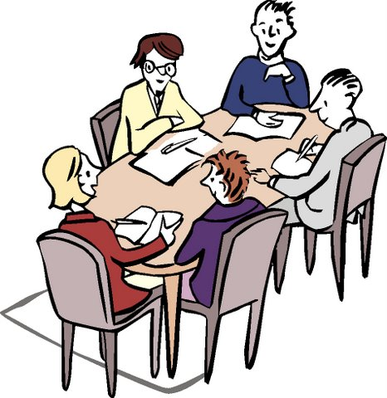
- getting ready to ask Cabinet to make some choices about the plans for the new disability support system.
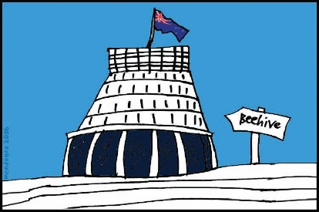

Cabinet is a group of senior Government Ministers.
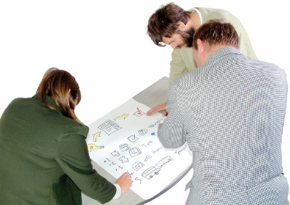

We are going to talk with the Ministers about the plans.
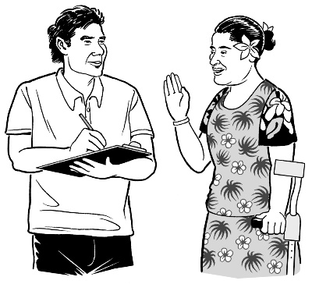
This will be the first time that disabled people have been able to talk to the Ministers of the new Government about:

- how we have been working
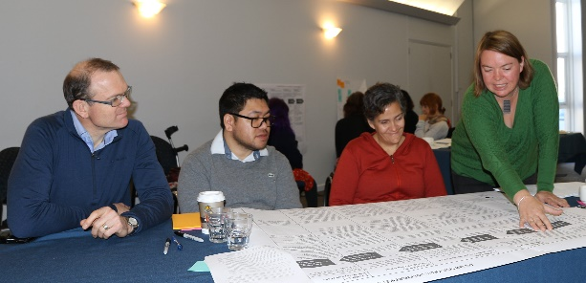
- what the plans look like at the moment

- what the new disability support system may look like in the future.

I am very excited about this.

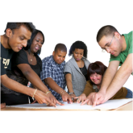
We are also starting to work on some new working groups.

There are 5 new working groups.
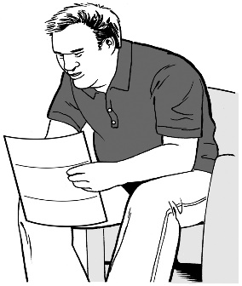
We will send invites to the people who have said they want to be on these working groups in the next 2 weeks.

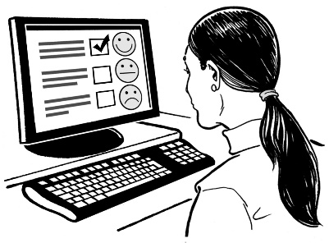
We are still getting lots of feedback from the virtual testing groups.

People on virtual testing groups use online tools to see if the new disability support system will work well.

Online tools are things like email and Facebook.

What next?

2 of the working groups we have had feedback from are:
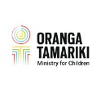
- a working group looking at how the new disability support system should work together with Oranga Tamariki – the Ministry for Children

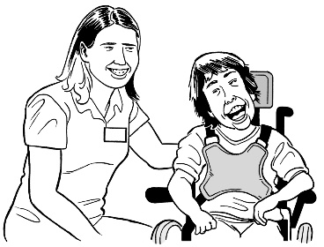
- a working group looking at how the new disability support system should work together with the health system in New Zealand.

The feedback from these working groups will now be tested in virtual testing groups.

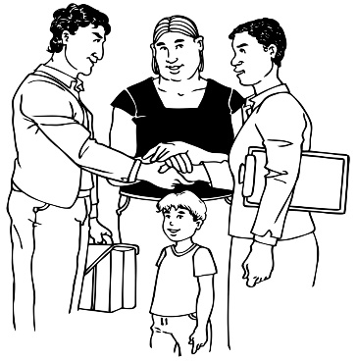
For example – the working group that was looking at how the new disability support system should work together with Oranga Tamariki said:
- it is not ok to just look at how the new disability support system should work together with Oranga Tamariki

- there are other parts of government that also work with children, like the Ministry of Education

- we need to look at how how all the parts of government work together around children.

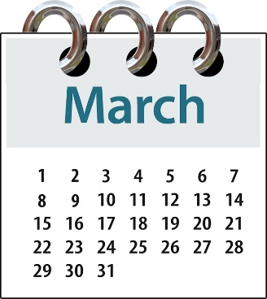
We will be getting feedback from our virtual testing groups until the end of March.

If you want to take part in the virtual testing groups you can still email us on:
STfeedback@moh.govt.nz

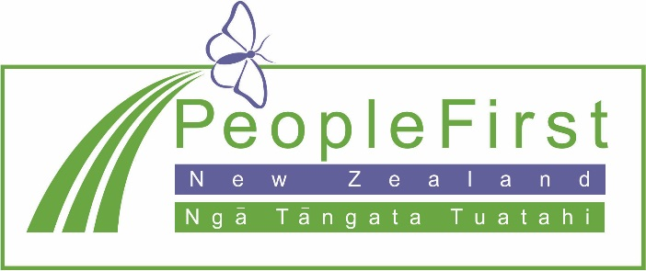

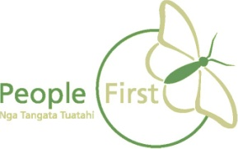
This information has been translated into Easy Read
by People First New Zealand Inc. Ngā Tāngata Tuatahi
