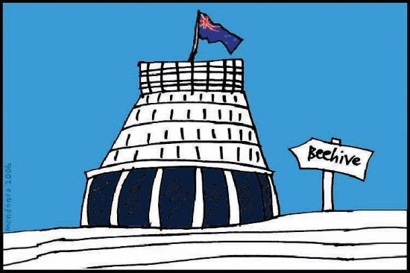
Media Statement
about the new
Disability Support System
26 April 2018
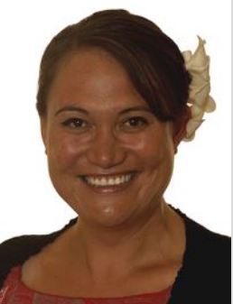
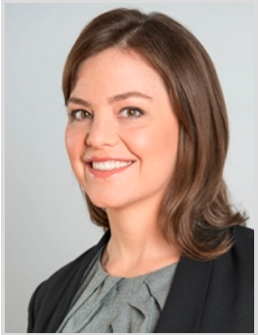

Easy Read
April 2018

Before you start

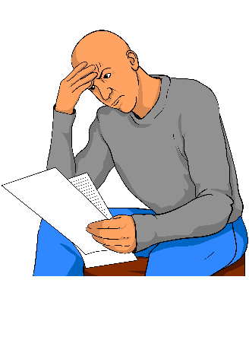
This is a long document.

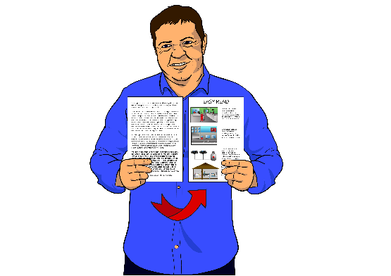
While it is written in Easy Read it can be hard for some people to read a document this long.

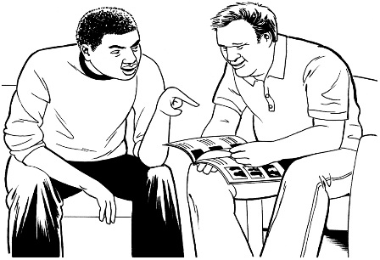
Some things you can do to make it easier are:
- read it a few pages at a time

- have someone help you to understand it.

What is a media statement?
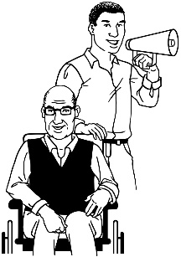
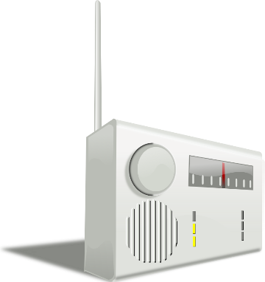
A media statement is a way to get an important message to a lot of people.
A media statement is sent to people and organisations that will be interested in the story.
A media statement is sent to:
- radio stations
- online news organisations
Websites like www.stuff.co.nz and www.nzherald.co.nz
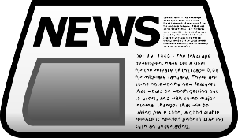
- local newspapers.
These places will put the story:
- on their radio stations
- on their websites
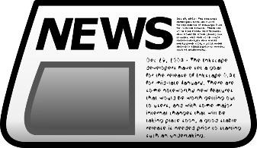
- in their newspapers
- in their newsletters.
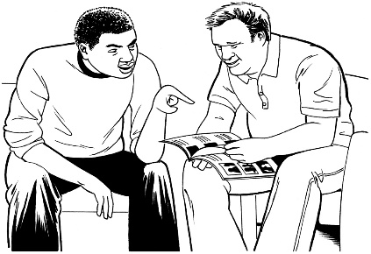
Doing this will mean that lots of people will be able to find out about the important message.

Media Statement – 26 April 2018

MidCentral to try out new
disability support system
This media statement has been made by:
- the Minister for Disability Issues, Honourable Carmel Sepuloni
and
- the Associate Minister of Health, Honourable Julie Anne Genter.
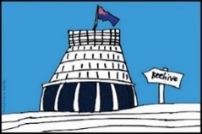
The Government is trying out a new disability support system.
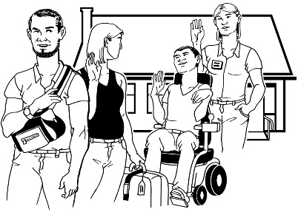
This means disabled people and their whānau will get disability supports in new ways.
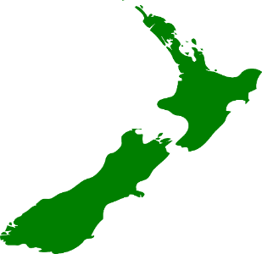
It will start in the MidCentral DHB region on 1 October 2018.
Ms Sepuloni says:
We are excited to be starting a new system.
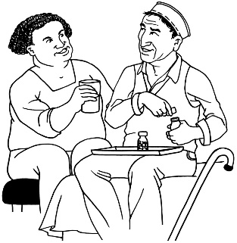
This new system will make it more easy for disabled people to get the disability supports they need.
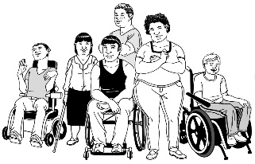
The new system is about disabled people and their whānau.
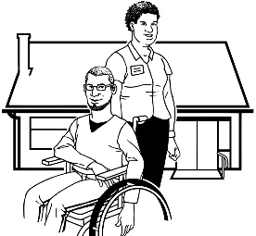
It is about disabled people and their whānau having lots of ways to get the:
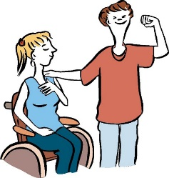
- right disability supports for them
- life they want to have.

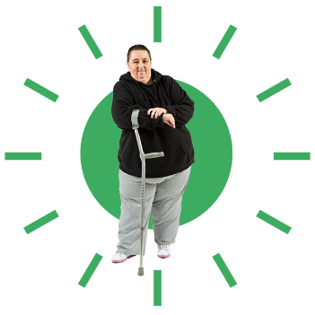
This new disability support system is about disability services fitting around disabled people and their whānau.
Ms Genter says:
The disability community has been asking for change for a long time.

This Government says it is going to do lots of work to make people’s lives better.
1600 disabled people and their whānau living in MidCentral are:
- going to try out the new disability system.

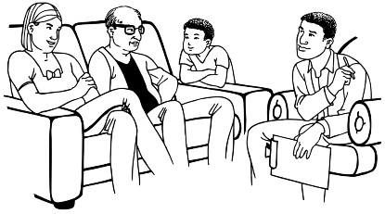
- see if the new system works for them
- see if the new system makes their lives better.
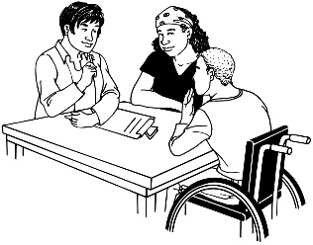
There will be a try, learn and adjust way to start the new disability system in the first year.
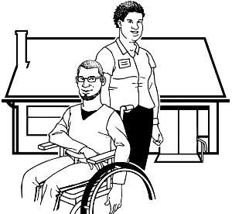
This means that we will:
Try
Try it out to see if it is working.
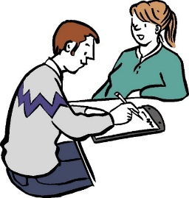
Learn
Learn about what is working and what is not working.
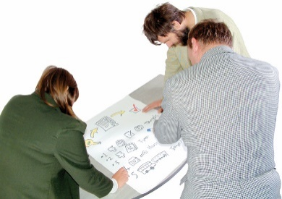
Adjust
Make changes if we think changes are needed to make the system better.
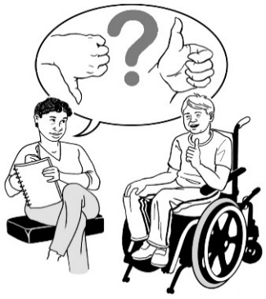
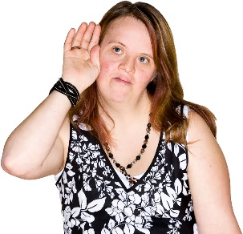
Disabled people and their whānau can tell us about what they think about the new system.
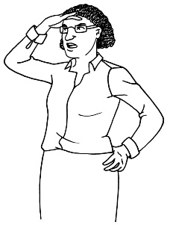
We want to hear from the people taking part in the test to find out if the new system is working for them.
We will make decisions about the future of the new system when we hear back from disabled people and their whānau.

Ms Sepuloni says:
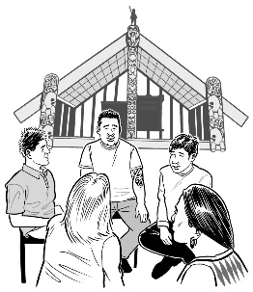
The new system will look closely at the needs of:
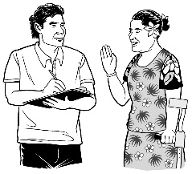
- Māori
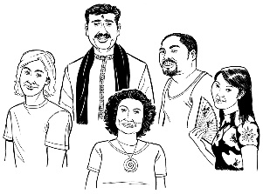
- Pacific people.
- other cultures.
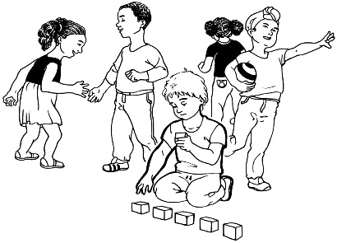
The new system will look closely at the needs of:
- children
- young people.

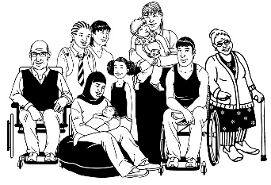
We want everyone using the new system to be able to:
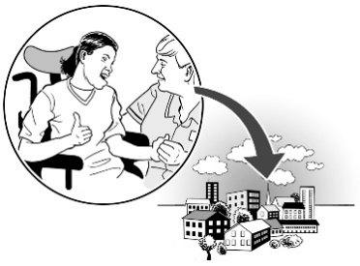
- have good lives
- take part in their community.

Lots of people in the disability community have helped to plan the new disability support system.

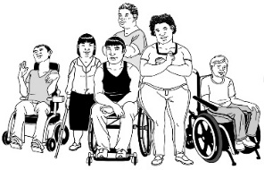
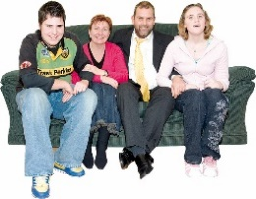
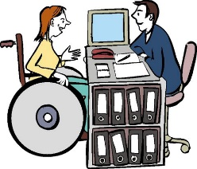
These include:
- disabled people
- whānau
- people in the disability sector.

The Government has said it will give 23.84 million dollars to start the new system in MidCentral.

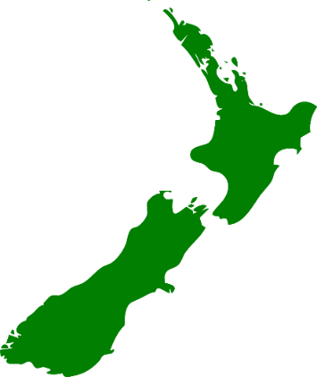
The MidCentral DHB region covers:

- Palmerston North
- Horowhenua
- Manawatu
- Ōtaki
- Tararua districts.
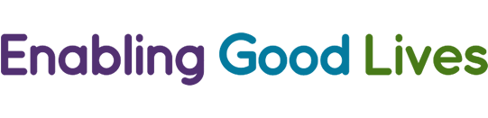
The funding will pay for Enabling Good Lives demonstrations to keep going in Christchurch and Waikato.
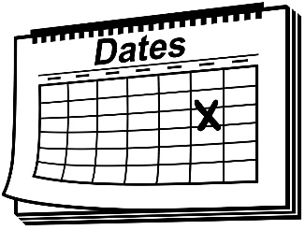
The new system will start on
1 October 2018.

These are the most important things about the disability support system:
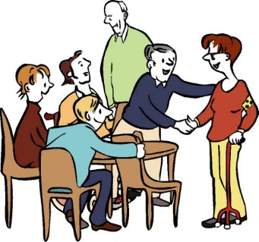
- People will be welcomed into the system

People will be welcomed into the system in lots of different ways.
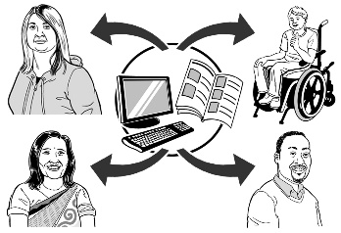
People will be:
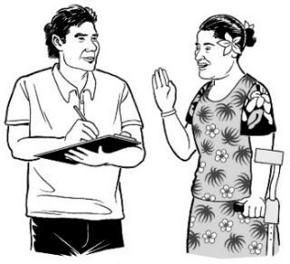
- given information about disability support
- linked with a Connector – a person who knows a lot about the disability support system
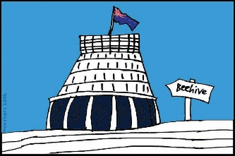
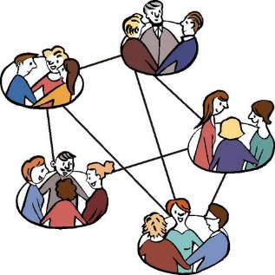
- linked with other people who are using the disability support system
- linked with the right government agency or disability organisation.
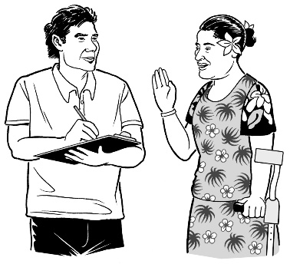
- Access to Connectors
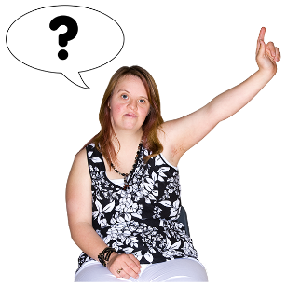
A Connector is a person who knows a lot about disability and the disability support system.
A Connector can help disabled people and their whānau find out:
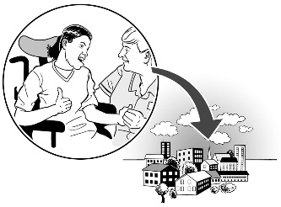
- about the disability support system
- how to use the disability support system.
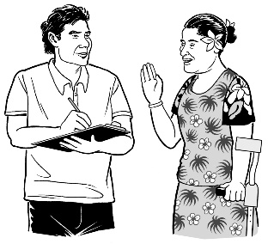
A Connector will find out what a disabled person:
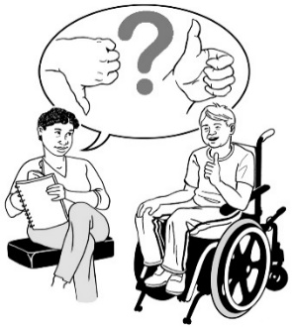
- wants to have a better life
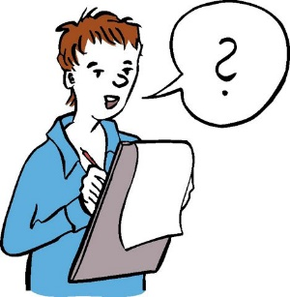
- needs to have a better life.
The Connector will look at how the new system can make people’s lives better.
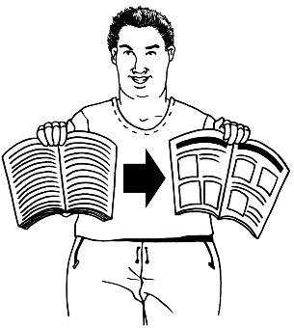
- Easy to use information and processes

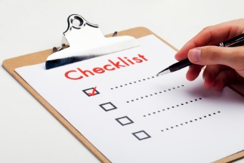
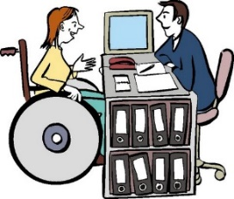
The disability support system will make information easy to understand.
The disability support system processes will be easy to follow.
Processes are the steps needed to do to get something done.
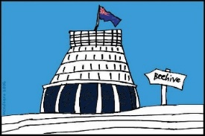
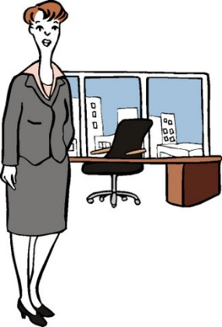
- Connected support across government
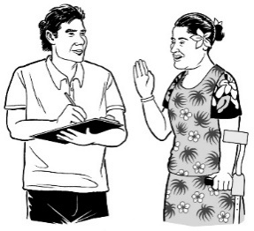
There will be a Government Liaison person working in the disability support system.
This person will help Connectors and disabled people link up to the right government agencies.
This will help to make sure that disabled people and their whānau get the support they need.
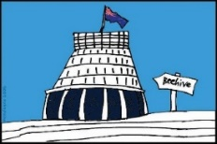
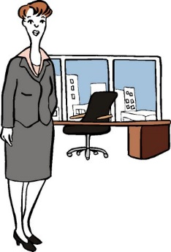
A Government Liaison person will support disabled people:
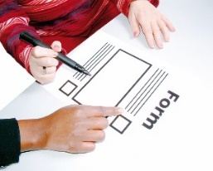
- by helping them how to get government services
For example like asking for the right forms to get a benefit
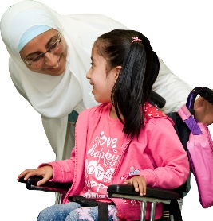
- to make good relationships with other parts of government that can help them.
This includes getting to know about things like learning support services in schools.

- A direct process for getting funding
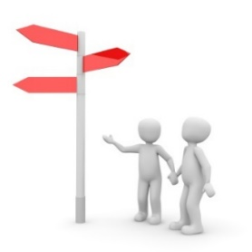
The disability support system will make it easy to ask for the right kind of funding.
Funding means getting money to do something.
There will be more than one way to buy:
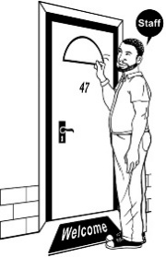
- services
- other things to support disabled people to have better lives.

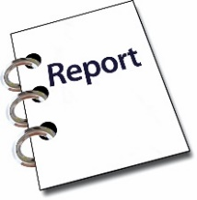
There will also be different ways to make a report about how funding has been used, like:
- write a report

- make a video

- answer some questions.
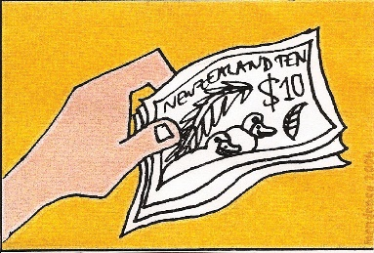
- Capability funding
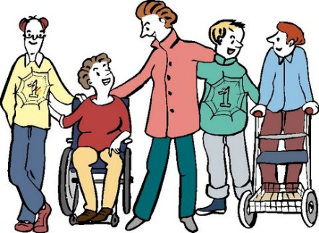
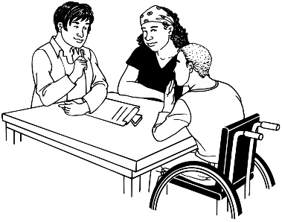
Capability means that someone or something is able to do something.
Capability funding is money that disabled people and their families can get to help make their lives better.
The Regional Governance Group will decide who can get this funding.

- Being more accountable to disabled people and their whānau
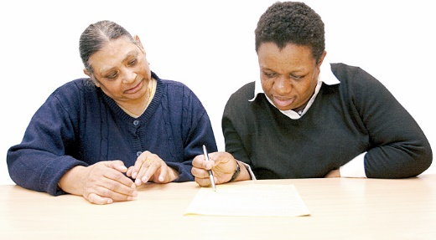
Being accountable means being responsible for something.
Disabled people and their whānau will be able to look at how the disability support system is working.
If they think things can be done better they can tell us:

- what is working well
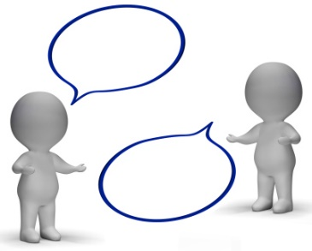
- what is not working

- what changes need to be made.
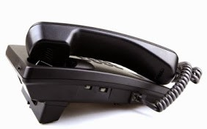
If you want more information contact:
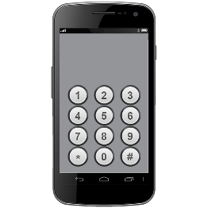
Amanda Snow
Press Secretary for
Honourable Carmel Sepuloni
Call 021 282 0078
Tara Forde
Press Secretary for
Honourable Julie Anne Genter
Call 021 145 9412

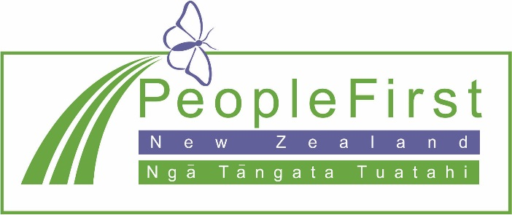

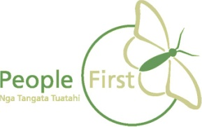
This information has been translated into Easy Read
by People First New Zealand Inc. Ngā Tāngata Tuatahi
