Summary Evaluation Report | Phase One
Enabling Good Lives
Waikato Demonstration
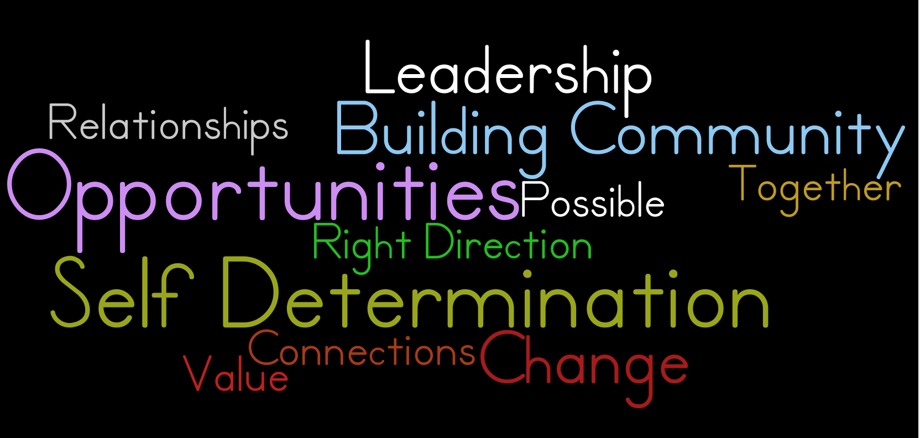

Prepared for
Enabling Good Lives Waikato Leadership Group and Joint Agency Group

Prepared by
Louise Were, Local Evaluator
February 2016

Contacts

Client | Local Evaluator
Enabling Good Lives  Waikato Leadership Group and the  Joint Agency Group  C/- Kate Cosgriff  E: kate.cosgriff001@msd.govt.nz  M: 029 201 4419 | Hikitia Consultants  Member of Tuakana Teina Evaluation Collective  Louise Were  E: louisewere@gmail.com  M: 027 2944385

Acknowledgements

Louise would like to sincerely thank the participants, families and whānau engaged with Enabling Good Lives Waikato, the Waikato Leadership Group, EGL Waikato staff, and Provider Community of Practice members who have shared their whakaaro and their journeys so openly.
Tēnei te mihi atu ki a koutou. Many thanks to you all.

Cover Image

The cover image is a word cloud created from the voices of EGL Waikato partners including participants who took part in the Phase One evaluation.

Accessible and Easy to Read Versions

Accessible and easy to read versions are currently in development with Enabling Good Lives Waikato, and will be available by March 2016.

Disclaimer

The information in this report is presented in good faith using the information available at the time of preparation. It is provided on the basis that the author of the report is not liable to any person or organisation for any damage or loss that may occur in relation to taking or not taking action in respect of any information or advice within this report.

Contents
Contents 3
Summary 4
EGL Waikato is …. 6
The Enabling Good Lives Approach 7
The EGL Approach is principles-based and co-designed 8
Evaluation Approach & Design 9
Demonstrating Enabling Good Lives in the Waikato 12
Disabled people, families and whānau, disability service providers and Government
were consulted on the EGL Approach in the Waikato 12
The Leadership Group, structures and processes were in place from December 2014 12
The core components of EGL Waikato 12
Who EGL Waikato Demonstration aimed to reach 14
What we found 16
Initial application of co-design to the EGL Waikato Demonstration is promising 16
Māori Co-Design Group was established 17
Expected number are participating in EGL Waikato but a wider group are engaging 18
A larger number have engaged with the Demonstration but have not become
participants 21
What EGL Waikato participants aim to achieve 22
EGL Waikato Demonstration Implementation | Participant Perspective 23
EGL Waikato Demonstration Implementation | Organisational Perspective 35
Unintended or unexpected outcomes 44
Early learnings 45
Demonstration success factors 46
Considerations 47
Aspirations for system change 48
Appendix One | Evaluation Approach and Design 50
Appendix Two | Evaluation Pre-Design 53
Appendix Three | The origins of the Enabling Good Lives approach 54
Appendix Four | The structure of EGL Waikato 55
Appendix Five | Evaluative Rubric – Success Criteria 56
Appendix Six | Evaluative Rubric – Performance Criteria 60
References 61

Summary
- Enabling Good Lives Waikato (EGL Waikato) is a three-year demonstration that aims to bring together Government and the disability sector to work together to change the way people with disabilities and their families and whānau get support in the Waikato.

- The Demonstration can be seen in two parts. Firstly the co-design and community building activity in year one. Secondly, years two and three where disabled people, families and whānau can participate in the Demonstration and have more control and choice over their disability supports.

- This summary evaluation report focuses on the six months of the implementation of EGL Waikato (July – December 2015) and has been structured to provide:
  - A commentary on the EGL Approach
  - An overview of the EGL Waikato Demonstration
  - Reflection on the implementation of the Demonstration
  - The emerging learnings and outcomes disabled people, families and whānau, as participants, are creating and experiencing by being part of EGL Waikato.

- While the Demonstration is in a very early stage of implementation, the emerging learnings evidenced in this evaluation reflect that:
  - The Demonstration has been implemented as planned by the Waikato Leadership Group
  - The Demonstration continues to reflect, adapt and respond; consolidating effectiveness against the agreed implementation and outcomes criteria
  - The intent of building EGL Waikato in collaboration, seeking to draw on the strengths and capacity of local leadership, momentum and capacity has been realised
  - Participant experience of the Demonstration to date, as reflected through a small group of 14 participants, shows implementation is being undertaken authentically, in line with the EGL principles, and illustrating system change
  - A number of participants are beginning to create and realise their good lives in positive ways, with some participants requiring additional time, information, connections and support to build the life they want
  - Māori are early and high adopters of EGL Waikato. While tasks within the Māori Action Plan may have played a part, the reasons for this level of uptake will be explored more fully in Phase Two.

- A number of factors have contributed to this early success:
  - The early implementation and on-going embedding of the EGL approach and principles
  - Highly skilled local leadership and capacity; people who model and mirror the EGL principles
  - The commitment to co-design
  - Transparency, trust and clear communication
  - A willingness to learn, adapt and act, leading to responsiveness, high performance and outcomes.

- While these are exciting findings about the success of the Demonstration to date, it is important to see these as early indicators.

- A number of other early learnings were found in the Phase One evaluation, including the complexity of implementing the demonstration, the need to constantly embed EGL principles across the sector, participant’s less than optimal experience of previous systems and supports, and the funding allocation process requiring expertise and time. These early learnings will be further explored in Phase Two.

- In the next phase of the Demonstration consideration should be given to:
  - Continuing to enhance operational processes, practice and performance to strengthen delivery
  - The ways EGL Waikato can use leverage to reduce systemic barriers and issues that impact on disabled people, families and whānau
  - The ways EGL Waikato can continue to support disabled people, families and whānau to enhance motivation and self-advocacy.

- Sustaining the level of performance found in this evaluation will be the focus over the next 18 months, alongside developing a deeper understanding of the value and cost implications of the EGL Waikato Demonstration for disabled people, families and whānau, disability providers, community and Government.

EGL Waikato is ….

Taking a few words to describe what EGL means to them, participants express the impact EGL Waikato has had on their lives.
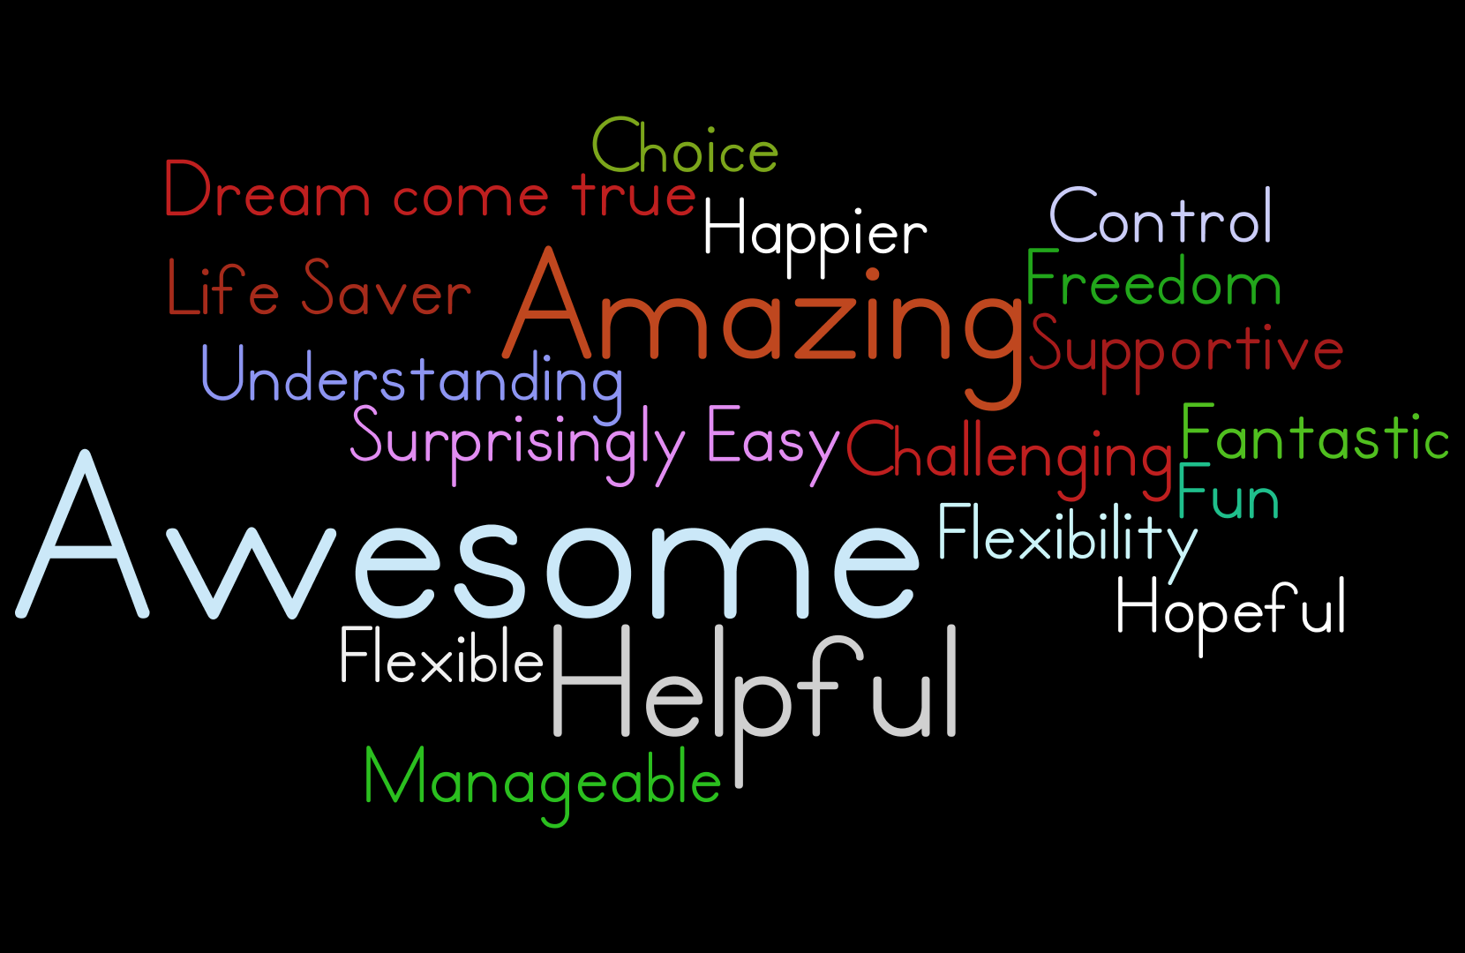
Figure 1: A word cloud reflecting what EGL means to a sample of EGL Waikato participants

The Enabling Good Lives Approach

- Enabling Good Lives (EGL) is a partnership between the disability sector, that is, disabled people, families, whānau, providers of disability support and government agencies.
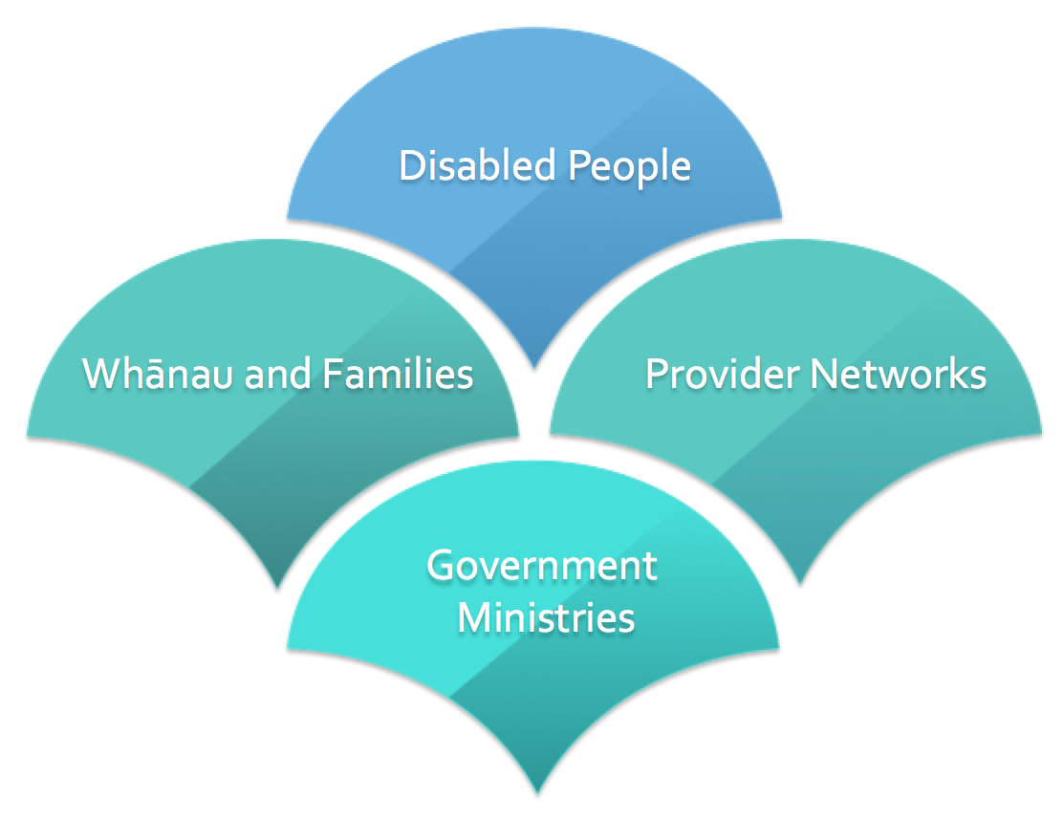
Figure 2: EGL Partners (EGL Waikato, 2015b)

- The vision of Enabling Good Lives is for disabled people, families and whānau to have greater choice and control over their lives and supports. This includes having the ‘say so’ in how resources are used, and making use of more natural and universally available supports; so that people can have the lives they want (Mikkelson & Cosgriff, 2016, p.2).
- The EGL approach provides a clear guiding vision, principles, core components and a description of the intended results for supports and services, instead of prescribed ways of doing things (Mikkelson & Cosgriff, 2016, p.2).
- EGL is an innovative approach; this means it uses new ideas and new ways to do things. For example, bringing together funding from government agencies – the Ministry of Health, Education and Social Development – in a pooled funding package that can be used in different ways, and working together to plan for the life you want.

The EGL Approach is principles-based and co-designed
- EGL is based on eight principles that guide all decisions and actions from the system level to the individual.
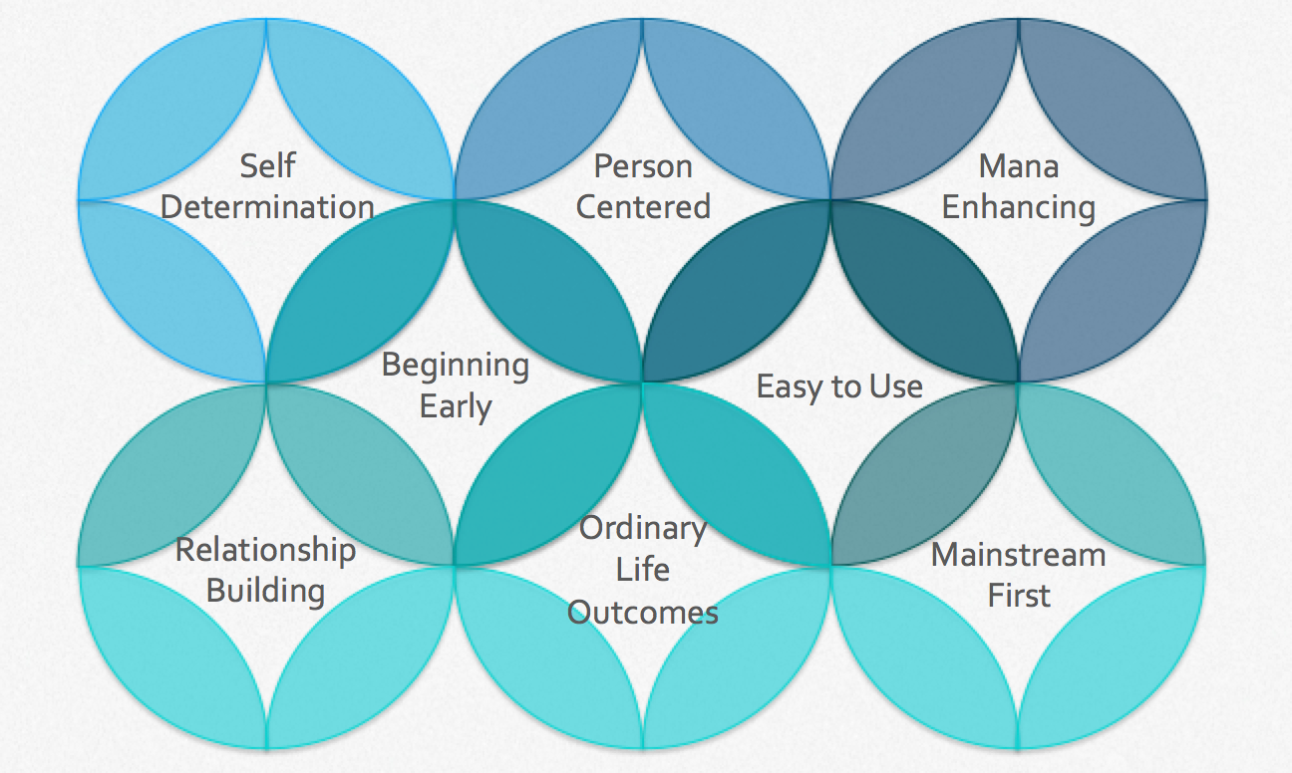

Figure 3: EGL Principles (EGL Waikato, 2015b)

- A key feature of the EGL Approach is co-design. “While there is not an agreed definition of co-design internationally, it usually involves collaborative relationships between public service professionals and citizens or users of the design process. Boyle and Harris (2009) believe these relationships need to demonstrate equality and reciprocity. There is also a focus on delivery of outcomes rather than just the service” (Anderson, Ferguson and Janes, 2014, p. 12).
- EGL is being tried out in two places, Christchurch and Waikato, which are called Demonstration sites. The Christchurch Demonstration began in 2012/2013, and provided a reference point for the Waikato Demonstration.

Evaluation Approach & Design

- The overall purpose and focus of the Enabling Good Lives Waikato Demonstration Evaluation – Phase One, is to understand how the first six months of implementation has gone, and identify some of the emerging outcomes and learnings.
- This summary evaluation report has been structured to provide:
  - A commentary on the EGL Approach
  - An overview of the EGL Waikato Demonstration
  - Reflection on the implementation of the Demonstration to date
  - The emerging learnings and outcomes disabled people, families and whānau, as participants, are creating and experiencing by being a part of EGL Waikato.
- The evaluation approach is unique to EGL Waikato, as it has drawn on and embedded the EGL principles and ways of working to provide an evaluation framework. The evaluation approach also respects a number of important points. EGL Waikato is:
  - A new approach that aims to enable disabled people, families and whānau to have more choice and control so they can plan for and live the lives they want
  - Developing, and involves multiple activities and partners
  - Happening in a complex system; that is, there are many different and connected parts to how disabled people, families and whānau get support (EGL Waikato, 2015b).
- The evaluation is planned to be conducted over four phases between July 2015 and June 2017.
- The overall goal of the EGL Waikato evaluation is to understand how well and in what ways EGL Waikato leads to change for disabled people, families and whānau, organisations and systems.
- An evaluation reference group was established with members of the Waikato Leadership Group, the cross-agency evaluation team, EGL Co-Director and a local evaluator. This group is collaborative and provide the capacity, leadership and oversight of the evaluation.
- The evaluation design process has four key steps:
  - Co-develop the key questions the evaluation aims to answer
  - Co-develop the evaluative framework to share and understand the important parts of the evaluation approach, and to enable open and clear decisions about the quality of delivery and the value or benefit it creates for disabled people, families and whānau
  - Co-develop ways to gather information that meets the needs of people who use and partner with EGL Waikato
  - Collectively review the information to share the journey of disabled people, families and whānau and those who partner with EGL Waikato.
- It is important to note that at each of the four phases of the evaluation, points a. to d. above will be reviewed and refined, as required.
- The first two steps of the evaluation design process will be covered in the following sections, with further information provided in Appendix One and Two.

Evaluation Questions
- The key evaluation questions (KEQs) were developed following discussions with the Waikato Leadership Group and the evaluation reference group, alongside a review of key documents. As part of the evaluation pre-design process, the Waikato Leadership Group, National Leadership Group and the Joint Agency Group endorsed the following KEQs.

KEQ 1 | What is EGL Waikato and how is it being implemented?
KEQ 2 | What are the outcomes that matter to disabled people, families and whānau, community, providers, and government?
KEQ 3 | How and in what ways have disabled people, families and whānau effectively achieved their outcomes? What contribution has the EGL Waikato Demonstration made to those outcomes?
KEQ 4 | How and in what ways have disabled Māori and their whānau been effectively engaged and utilised EGL Waikato?
KEQ 5 | What is the value and cost of investing in EGL Waikato?
For disabled people? For families and whānau? For community? For providers? For funders?
KEQ 6 | How and in what ways has EGL Waikato changed the systems that support disabled people and their families and whānau?
Figure 4: EGL Waikato | Key Evaluation Questions

- The KEQs will span the Demonstration; therefore the timing and priority given to each question will differ depending on the phase the Demonstration is in.
- Phase One of the evaluation reflects the co-design, community building, planning and initial implementation phase of the Demonstration.
- Once the Waikato Leadership Group had clarity about what it wanted to know, work continued to build the evaluation design, process and framework.
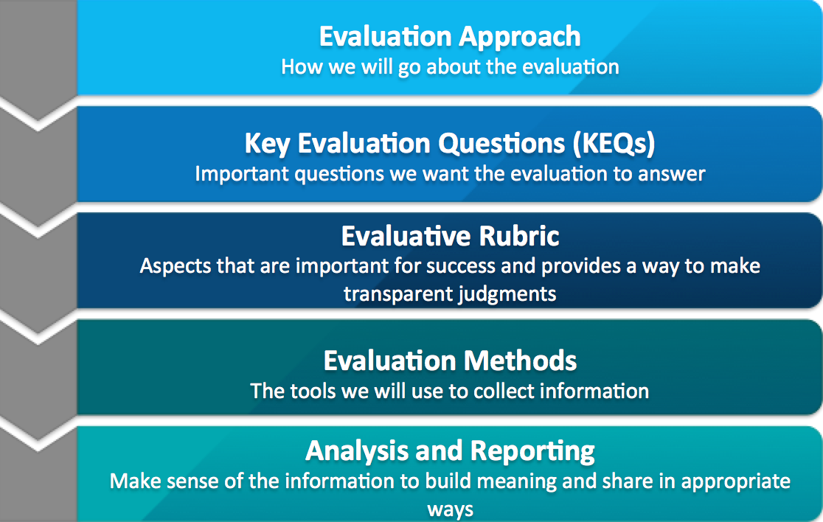
Figure 5: Overview of the Evaluation Process and Framework

- Phase Two of the evaluation of the EGL Waikato Demonstration will span a six-month period from January to July 2016, with the next report due at the end of August 2016.
- The evaluation in Phase Two will focus on the quality of life of EGL Waikato participants through the exploration of the value the Demonstration creates, the experience of participants and their outcomes, and the examination of value for money.

Demonstrating Enabling Good Lives in the Waikato

Disabled people, families and whānau, disability service providers and Government were consulted on the EGL Approach in the Waikato
- In the Waikato, EGL Partners have been in consultation and dialogue about how the EGL approach could be applied in the Waikato since 2012 (Office of Disability Issues, 2016b). In August 2012, the Enabling Good Lives Waikato report was submitted to Cabinet. In this report, disabled people, families and a group of providers described how the existing providers could deliver supports in more flexible ways that enable disabled people to have greater choice and control (Mikkelson & Cosgriff, 2016, p.1). July 2013 saw the establishment of the Waikato Leadership Group. Representatives from three forums, one each for disabled people, families and providers, provided the local capacity and leadership, supported by an investment from the Government’s 2013 budget.
- The aim of the Waikato Leadership Group was to build the skills and confidence of disabled people and families in the Waikato and strengthen local networks and leadership, through creating resources and sharing information via face-to-face meetings.

The Leadership Group, structures and processes were in place from December 2014
- By December 2014, the membership of the Waikato Leadership Group to lead the Demonstration was solidified and agreement from Cabinet was received along with $3.82 million over three years to roll out the EGL Waikato Demonstration (Office of Disability Issues, 2016b). To commence the Demonstration, and to benefit from the skills presented in the candidates, two Co-Directors were initially appointed in October 2014. Now the Demonstration is underway, and the focus of the Co-Directors has changed, this in now reflected in the current structure (Please refer to Appendix Four for more information).
- Between November 2014 and June 2015, the structures and processes for EGL Waikato were developed and recruitment of staff was completed. 1 July 2015 saw the launch of the Demonstration and EGL Waikato staff began working with disabled people, families and whānau. The Demonstration will run until June 2017.

The core components of EGL Waikato
- During the development of the National EGL Approach, five connected elements were identified and were drawn on in the Waikato. These five national elements:
  - Self-directed planning and facilitation
    - All supports and services are led by disabled people, their families and whānau
    - An aspiration-based personal plan is a central document to design and measure paid supports, which continually adapts in ways that assist people to build and maintain a good life
    - An Independent Facilitator can assist people consider existing options and create new possibilities, with the degree of involvement negotiated between the parties.
  - Cross-government individualised and portable funding
    - Disabled people, families and whānau have control over their funding
    - People can choose how they create a good life for themselves
    - All government funders will contribute to one funding pool that is determined through a simple process of self-assessment
    - Disabled people, families and whānau will be able to move their funding as their preferences and needs change.
  - Considering the person in their wider context, not in the context of ‘funded support services’
    - Disabled people, families and whānau are part of networks that are respected as being fundamental to identity, belonging and citizenship.
  - Strengthening families and whānau
    - There is direct investment by EGL in the networks of disabled people and their family/whānau
    - Resources are provided by EGL to assist understanding, educate and promote increased knowledge of options and how to maximise choice and control.
  - Community building to develop natural supports
    - Disabled people are active and valued citizens with an everyday life in everyday places
    - Enabling Good Lives supports people to achieve desirable outcomes such as education and training; employment; being with friends; having relationships and a family; and taking part in community and cultural activities
    - Community (generic, mainstream) opportunities and assets are educated and supported to be inclusive and valuing of diversity
(Enabling Good Lives, 2016).

- Within the EGL Waikato context, these characteristics are embedded and expressed through a process with four core components:
  - Tūhono/Connector engagement
  - Community connections
  - Supported self-assessment and planning
  - Personal budget.

Who EGL Waikato Demonstration aimed to reach
- The Waikato Demonstration has four action areas with associated target groups:
  - Increasing individual choice in all aspects of life including where you live, who you live with, and what you do in the day, which includes building on the Ministry of Health’s “Choices in Community Living approach”
  - Māori disabled and their whānau are fully involved in the design and implementation of the Waikato Demonstration
  - Disabled children and young people have the same life experiences and outcomes as other children and young people
  - Increasing employment outcomes for disabled people
(Office of the Minister of Disability Issues, 2014, p. 6-7).
- For clarity, EGL Waikato works within the Waikato District Health Board (DHB) boundaries (from Coromandel in the north, close to Mt Ruapehu in the south, Raglan in the west to Waihi in the east).
- The following table provides an overview of the scope of participants for each action area:
Action Area | Eligibility | # 2015/2016 | # 2016/2017
Individual Choice | <65 years old, and in or considering residential or aged care, or who are less able to advocate for themselves or be heard | 20-35 individuals | 20-40 Individuals
Māori | Disabled Māori and/or whānau | 20-30 Individuals | 20-30 Individuals
Children and Young people (0-18 years) | Families and whānau of disabled children and young people | 15-20 families | 20-40 families
Employment | Disabled people who can get and retain on-going paid employment | 15-20 Individuals | 25-30 Individuals
Total number of participants (individuals, families and whānau) |  | 70-105 | 85-140
Figure 6: Overview of EGL Waikato participant action areas (Office of the Minister of Disability Issues, 2014, p. 6-7)

- To participate in the Demonstration, people must meet the Ministry of Health Disability Support definition, including people who live with some neurological and developmental disabilities, and where disabilities co-exist with health conditions (Enabling Good Lives, 2015).
- For the Māori action area, there is no age requirement.
- A number of forums and workshops had been happening across the Waikato so the community knew about the EGL principles and the Demonstration.
- Acknowledging the action areas and their respective participant numbers, guidance was also provided by the Waikato Leadership Group outlining their expectations about who could take part in the EGL Waikato Demonstration, and how this would be done.
- In summary, the guidelines confirm that:
  - A wide range of people should take part to show the Demonstration works for everyone
  - At least one rural area was initially identified
  - EGL Waikato wouldn’t let people down who have already engaged through the forums
  - EGL Waikato will build on Choice in Community Living
  - There are clear boundaries so people know why some people are in Enabling Good Lives while others are not
  - EGL Waikato does not let disabled people, families and whānau down by taking on too much or promising things they won’t be able to do
  - Partnerships will be developed with hapū and Iwi so Māori can easily access the Demonstration
  - EGL Waikato is not seen as exclusive to Hamilton.

What we found
- The following sections outline the key findings from Phase One of the evaluation and draws from the interviews and hui with participants, families and whānau, the Waikato Leadership Group, Māori Co-Design Group, Co-Directors, and Tūhono/Connectors, and a focus group and online survey with the Provider Community of Practice.

Initial application of co-design to the EGL Waikato Demonstration is promising
- The intent of building EGL Waikato in collaboration, seeking to draw on the strengths and capacity of local leadership, momentum and capacity has been realised.
- Leadership for EGL Waikato is Iocally driven but is also connected to the national EGL leadership structure.
- The purpose of the Waikato Leadership Group is to:
  - Ensure disabled people, families and whānau, and disability support providers are engaged in an Enabling Good Lives approach in the Waikato
  - Be ‘champions for change’ and to ensure momentum with the introduction of an Enabling Good Lives approach in the Waikato
  - Promote and protect the Enabling Good Lives principles and approaches in the Waikato
(Waikato Leadership Group meeting meetings, September 2014).
- EGL Waikato has a co-designed partnership structure between:
  - Disabled people
  - Families and whānau
  - Disability support providers,
who work together, alongside government agency representatives from the Ministries of Health, Social Development and Education.
- Within the EGL Waikato context, co-design means that all voices are important and everyone works together to come up with something that everyone agrees on to improve outcomes and create change for disabled people, families and whānau (EGL Waikato, 2015).
- The process of co-design is reflected in a number of ways. For example:
  - Drawing on local representation to reflect the diversity of partners in the disability sector who can collectively lead
  - Using the EGL principles as the foundation and a shared vision to inspire and galvanise commitment to and consensus with the aspirations of disabled people, families, whānau and the sector
  - Drawing on the collective to emphasise a thoughtful and aspirational culture within the leadership group, that fosters trust and transparency
  - Open communication between co-design partners and those they represent
  - Continuing to build a recognised disability community to grow identity and give mana to their capacity and leadership.
- Process and operational decisions stay within the Leadership Group, with every effort taken to develop trusting relationships through their agreed way of working:
  - Treat each other with respect
  - Listen to each others’ views carefully
  - Give each other time to speak
  - Use plain language
  - Ask if something needs to be explained
(Waikato Leadership Group meeting minutes, September 2014).
- The Leadership Group has also had the support of an independent and experienced facilitator. This role has supported the creation of an environment that is trusting, voices are heard, and in particular has strengthened the voice of disabled people.
- Overall, the co-design process has been a positive experience for the Waikato Leadership Group, who has brought a high degree of positivity to take the opportunity to unite and mobilise the disability community, and led system change.

Māori Co-Design Group was established

- In late 2014 a Co-Director identified the Leadership Group needed to ensure more Māori were engaged in EGL Waikato. The Group sought to bring more Māori representation to the decision-making table. A local, well-respected kaumātua was approached and provided support and leadership to guide the process of establishing a Māori Co-Design group, of which he became an honorary member. In January 2015, Māori voice and representation was expanded on the Leadership Group, alongside the formation of the Māori Co-Design Group.
- While some Māori Co-Design members are still unclear why Māori co-design wasn’t considered earlier, and an opportunity was missed that could have been capitalised on, they believe they are not behind in the development of pathways that are responsive to Māori.
- A Māori Action Plan was developed by the members of the Māori Co-Design group, to ensure disabled Māori and their whānau access the Demonstration so they can plan for and live the lives they want.
- The Māori Action Plan has clear outcomes and strategies centred around the following goals:
  - Māori disabled and their whānau are fully involved in the design and implementation of Enabling Good Lives Waikato
  - EGL Waikato engages actively with Māori communities and promotes the Enabling Good Lives principles and approach
  - Māori participate in EGL Waikato
  - Disabled Māori leadership is promoted and supported.
- Much of the Action Plan is underway and on-going. It is noted that key tasks associated with the first goal have been completed, including the recruitment of Māori staff. The group is set to monitor the progress and success of their goals and outcomes as part of the Demonstration process. Phase Two of the evaluation will provide insight into how this Māori Action Plan is making a difference.
- Over time, regional relationships will continue to be fostered with hapū, Iwi and Māori communities so opportunities such as marae accessibility, supporting participants to find their whakapapa and developing disabled Māori leadership can be addressed collectively.

Expected number are participating in EGL Waikato but a wider group are engaging

EGL Waikato Participants
- The scope of the action areas referred to point 41 above, acknowledges that EGL Waikato would initially work with people they were already in contact with through the forums, or in contact through the Waikato Leadership Group or Disability Support Link, the Needs Assessment Service Co-ordination service (NASC) (EGL Waikato Guidelines, 2015, pg.2).
- While a large part of the Waikato DHB region is rural, Taumarunui was the initial rural area specifically identified by EGL Waikato Partners, as a rural community where the demonstration could make a significant contribution (EGL Waikato Guidelines, 2015, pg.2-3).
- As at 22 December 2015, there were 64 disabled people, families and whānau who were participants in the EGL Waikato Demonstration. By participants we mean disabled people, families and whānau who are working with Tūhono/Connectors, being connected into their community, planning their life and proceeding towards receiving a personal budget via the Demonstration.
- In summary:
  - The Individual choice action area has had the highest uptake
  - Over two thirds of participants (47) have progressed through the supported self-assessment, with about a quarter of participants (16) having a personal budget in place as at December 2015
  - Participants are spread almost evenly between Hamilton and small town / rural Waikato (33 and 30 respectively)
  - There are slightly more men participating in the Demonstration (35 men and 27 women)
  - There is a good spread of participants across all age ranges, however those aged 20-29 years are the largest group, with 23 participants
  - Māori is the largest ethnicity group, represented by 26 participants, with a similar number identifying as Pākehā (25), and adult Māori men are highly represented (15). Further exploration of reasons behind Māori uptake will be explored in Phase Two.
  - The participants approached for this phase of the evaluation were those people who had a personal budget in place (88%).
  - It is noted that 36 participants as at 28 February 2016 have progressed through to personal budgets.

- The figures below provide an overview of who has participated with EGL Waikato in the first six months of the Demonstration. Only one participant did not consent to being a part of the evaluation, therefore the report will reflect the 63 participants who consented.

Figure 7: EGL Waikato Demonstration participants (July-December 2015) by Action Area

Figure 8: EGL Waikato Demonstration participants (July-December 2015) by Demonstration status

Figure 9: EGL Waikato Demonstration participants (July-December 2015) by age group

Figure 10: EGL Waikato Demonstration participants (July-December 2015) by ethnicity

- Initially, it was signalled that people who had attended the Forums would be the first people the Demonstration would engage with. However, participants are being connected to EGL Waikato through a range of mechanisms. For example, through community contacts, special schools, government agencies, disability service providers and Demonstration promotional material or articles.
- Some participant data, in particular ethnicity, at this stage is ‘not yet known’ due to not being collected and/or verified until the supported self-assessment, which happens later in the Enabling Good Lives Waikato process. However this gap has been identified and work is underway to resolve this.

A larger number have engaged with the Demonstration but have not become participants
- A larger number of participants (approximately 70) have had contact with the Demonstration in different ways, but have not proceeded for a variety of reasons. For example, at least 21 disabled people and families had engaged with Tūhono/Connectors but opted not to continue. Another observation is that at least five participants in the group who did not proceed were from Taumarunui, the initial rural area identified for the EGL Waikato Demonstration.
- The wider engagement group may provide an interesting perspective on why people decide EGL Waikato is not for them or don’t proceed through to a personal budget. These experiences, and the possible value created by short, focused engagement, will be explored further in Phase Two.

What EGL Waikato participants aim to achieve

- EGL Waikato participants are planning to achieve a range of outcomes. The figure below provides a sample of participant goals and aspirations, against the EGL principles:

EGL Principles | Examples of Participant Outcomes
Self-Determination | - I want to be in control of my life  - Living in my own home independently  - Deciding what I do during the day  - Develop my leadership skills
Person-Centred | - Find the right person to work with me  - Get ready to leave home  - Learning how to cook  - Finding my mums marae
Beginning Early | - Have a family holiday  - A break for Mum and Dad  - Literacy course  - Build connections before I leave school
Mana Enhancing | - I want to help develop a better system for support for other people  - Helping people do stuff  - Find / maintain employment  - Build my own business
Ordinary Life Outcomes | - Spending time with people my own age  - Develop my talents  - Build my life skills  - Keep fit and healthy
Easy to Use | - Find flexible service options / opportunities  - Manage my own budget and supports  - Have the information I need to make decisions
Mainstream First | - Find opportunities in the community  - Access sport, education and recreation options safely in the community
Relationship Building | - Be a brother  - Reconnect with my whānau  - Make friends  - Have more relationships  - Connect with others in the disability community
Figure 11: Example of participant outcomes

- In recognition of the very early stage of engagement with the Demonstration, this report will provide an overview of the emerging learnings shared by a small group of 14 participants, through 13 interviews, reflecting on their experience of the Demonstration to date.
- The exploration of participant achievement of their goals and aspirations, and their outcomes, will be a significant focus of the Phase Two evaluation (January to July 2016).

EGL Waikato Demonstration Implementation | Participant Perspective

- The evaluation explored how well the first six months of the Demonstration has gone by looking at criteria or indicators of success (mapped to the EGL Principles), from participant and organisational perspectives.
- A small group of participants were engaged to reflect on their experience of the Demonstration to date through an interview process. Their experiences have been mapped against the outcome criteria developed (refer to Appendix Five). The following sections provide insight into the experiences of participants as they begin their journeys with EGL Waikato.

Self- Determination
Disabled People |
I am in control of my life and what happens to me.
I can say what I want and carry out my choices and decisions.
Families and whānau |
Family and whānau are empowered to express their goals and aspirations.
- Some people are exploring and planning options they didn’t think were possible or had not considered before EGL Waikato. Examples include:
  - Having always dreamed of living independently, a young man is now living in his own home
  - Having just left school, a young woman is now planning to leave home and move to another town
  - Having never been told that shared care was an option for them, a family is now exploring an option with a service provider.

[EGL Waikato] gives a few more options, its very important to have options | Individual choice action area participant

Best thing I ever joined him up to [EGL Waikato]| Māori action area participant

[The Tūhono/Connector] told us about future possibilities and that’s the direction we want to head in | Individual choice action area participant

If you’re with another group [referring to residential services], they have rules and keep you behind, with EGL you don’t have rules | Māori action area participant

- Families are watching their young people have real input into their future through the planning process with Tūhono/Connectors:

[My son] had real input | Individual choice action area participant

Nice to be able to have the choice, its your decision | Individual choice action area participant

The planning conversations are centred around our son | Children & Young People action area participant

- Most people are experiencing more choice and control in their lives, with a few feeling it is possible but are still working to realise their goals.

Sure it works for some people [previous system], but it wasn’t for me … things were super stressful…I have a lot more support to do what I want when I want [now] … no more middleman – they really grind your gears | Individual choice action area participant

I love it, my friends are blown away … I’m the one with the power and control | Individual choice action area participant

[Its my] ticket to independence and freedom | Individual choice action area participant

[Previously] we could only get to the edges of aspirational things … Before funds were tagged to specific things, with specific rules …now I can bridge [to] areas I couldn’t before | Individual choices action area participant

Person-centred
Disabled People |
I control and direct my life, including my disability supports.
I can choose who can assist me with my on-going support.
Supports work for me when and how I want them.
I can do things that are important to me.
Families and whānau |
Supports work for families and whānau when and how they want these.
- It is evident that disabled people, families and whānau feel that they are at the centre of the Demonstration. This is expressed through their acknowledgment of the Tūhono/ Connectors – who listen, are empathetic, supportive, helpful, and deliver.
- Participants also expressed an appreciation of having consistency with one Tūhono/ Connector supporting them.
- The supported self-assessment and planning process is person-centred and explores aspirations, goals and practical needs, with the budget reflecting their reality, and demonstrating the whole of life approach.
- People also appreciate the flexibility the Demonstration’s core components offer. This was evident in participants experiences of engaging with Tūhono/Connectors, having no pre-determined way to complete processes such as the supported self-assessment, and participants feeling that were not pressured to make decisions at pace.

[We’ve] thrown the difficult questions at the team and they have listened [the EGL Waikato team] | Individual choice action area participant

We now have a goal instead of changing our minds all the time| Individual choice action area participant

- For some, being able to truly explore what they need and want to live an everyday life is something they have never really done before as part of their needs assessment process.
- Now experiencing what is actually possible within EGL Waikato, some participants are continually reviewing and/or adapting their plans and budgets in the short term, to realise what works best for them.
- While this is an accepted and encouraged practice within the Demonstration context, this level of flexibility and autonomy is perhaps unfamiliar given their experience of the previous support system. In time participants will build their confidence and comfort with the EGL system.
[B]eing told for years that you are not allowed this, not allowed to do that …takes time to break down barriers” | Individual choice action area participant

- Most people reported having control over who supports them, what options they want to access and have supports that work for them, or know this is possible.
- However some people are still having trouble attracting and finding the right people because of location, hours of work, intensity of support required, or what they believe are systemic or political barriers such as the timeliness and responsiveness of funded equipment, or applying for a work visa (ability to employ overseas visitors).

No more snarky comments, or [I] can’t make decisions … I don’t have anyone expecting to be made part of my conversations … or telling me what I should do, or saying ‘being lazy ha?’ [previous staff]. That’s gone. Now I have people who are here that believe in me, who support me and understand, and what to understand | Individual choice action area participant

Carer now close in age, experienced and knows how to talk to him … she is so in tune with him, he is more out going | Individual choice action area participant

Life changing for [my son] ... he now has someone else who he relates to |
Individual choice action area participant

[We are] brave enough to be creative, but mindful to ask and consult him [family member accessing EGL Waikato] | Individual choice action area participant

Beginning early
Disabled People |
I have aspirations and can plan for them.
I am in control of my life and what happens to me.
I have the supports I need, when I need them.
Families and whānau |
Families and whānau are aspirational for their child’s life and future.
We have access to support and funding that contributes to our family and whānau living the life we want.
We are known and connected in our community.
- Tūhono/Connectors and the Demonstrations systems are generally responsive to participants needs for information and support, and respond in a timely way. This responsiveness considers context, concerns, questions and desires and provides appropriate but forward-looking suggestions and ideas.

When I met [the Tūhono/Connector] they asked me what I wanted to do and I wanted to get to know more about living in my own house and running my own business | Māori action area participant

We now know more about what’s out there … you sort of know what you can do, but to hear how to go about it is great | Children and Young People choice action area participant

here is less stress financially; they [can get support to] attend holiday programmes and swimming lessons now. It’s a source of comfort knowing they are happy and safe. I’m happier, they are too, they are learning something new |Children and Young People action area participant

- Some families need to take some time to explore options so may not realise their goals within the Demonstration’s timeframes, some are still discovering new information as they go through the process as there is a lot to consider.

We know she needs to get out and be with people her own age … but we don’t want her to have a break from where she is now … we’re still feeling our way through [but] don’t want her to miss out | Māori action area participant

Supporting us as a family with what is best for our son … we have freedom, control for my boys and how I think they need to learn and grow | Children and Young People action area participant

- Some families can already see parts of their plans and package needing to be revisited as their situation and needs change, some are in transition and need time to feel in control and comfortable with the changes.

We know this place doesn’t have the options … as parents, is about learning to let go | Māori action area participant

Its taken some pressure off – we tend to get into crisis but that’s because there is no help out there … we were in the right place at the right time for EGL | Individual choice action area participant

- Overall the reflections of participants indicates that Tūhono/Connectors have an awareness of the need for more time and information, and aim to provide or facilitate access to the information and support people need. However there were three instances in this very early stage where participants did not receive the information they needed.
Mana enhancing
Disabled People |
The contribution I can make is recognised and respected.
I can contribute to the lives of others and to my community.
EGL is culturally respectful of me.
Families and whānau |
The abilities and contributions of families and whānau are recognised and respected.
EGL Waikato is culturally respectful of our family and whānau.

- Tūhono/Connectors have a strengths-based approach to exploring ideas and options. People expressed that they get to share their reality with EGL Waikato staff. Tūhono/ Connectors are enthusiastic and bring an energy that some families are looking for to help keep them motivated as they approach new options and change.

[EGL Waikato staff are] willing to understand what is unique to most disabled people | Individual choice action area participant

Made to feel like normal people | Māori action area participant

Supportive of both me and my daughter | Individual choice action area participant

Really good experience, loving it | Children and Young People action area participant

- Tūhono/Connector encourage people to ask questions, research and investigate options but are also there to bounce ideas off or to connect people to information and networks if they haven’t been able to locate themselves.

We feel more supported | Individual choice action area participant

We don’t have to explain [our son or situation] | Individual choice action area participant

- People feel able to lead the assessment and planning processes and manage their personal budget. While two participants have yet to activate their personal budgets, two participants are utilising agents, while 10 participants are self-managing their budgets. These participants felt they have the skills and, in some cases, the experience, to build and sustain their own internal processes, but know EGL Waikato staff will offer support if required.

[I] believe our context has been reflected in our personal budget. It is a budget we can work with and use as we need it | Children and Young People action area participant

Now we can pay their grandparents [for breaks] straight away, to recognise what they are doing – no back and forth [with paying through the previous system] – really grateful | Children and Young People action area participant

- Connecting with others and creating opportunities to contribute are important to all participants. However some feel provincial / rural areas could benefit from a co-ordinated effort to develop opportunities, build community awareness and ability to be part of valued networks for disabled people, families and whānau.

If I wasn’t in EGL, I would never be able to get out and do stuff … I would be stuck in different places, saying I can’t do that, I can’t do that … now its like wow, I have too much on! | Māori action area participant

[EGL Waikato] takes into consideration what I need to live … now I do have the opportunity and can do things | Individual choice action area participant

I could never have been able to do something [to help out] a friend. Now its normal, there’s no pressure | Individual choice action area participant

I can do things [now] without feeling like I’m penalising people | Individual choice action area participant
Ordinary Life Outcomes
Disabled People |
I am supported to live an everyday life in everyday places, like others at similar stages of life.
I have citizenship rights, including opportunities for learning and contribution, having a home and family, friends and connections and employment.
Families and whānau |
Families and whānau are supported to live an everyday life in everyday places.

- EGL Waikato is making it possible for some people to live an everyday life like others at a similar stage of life, and are realising this is possible through the Demonstration.

Now he experiences things he used to watch on TV | Māori action area participant

[EGL Waikato] allows parents to provide for their family | Individual choice action area participant

Work is really important to me so I need to do what I can to keep working | Individual choice action area participant

She is learning essential life skills | Individual choice action area participant

The girls in my crew are stoked to come to work and say things like ‘I had such a cool morning with you’, it makes you feel good | Individual choice action area participant

All I want to do is have the same opportunities to live life like others my age | Individual choice action area participant

They said if you want anyone to move with you, I can, so I asked my girlfriend if she wanted to move with me, she said when, now? …Ok | Māori action area participant

- Some families are seeking to have the EGL approach reach out into wider community spaces that they hope to connect in and with, so they can express and contribute as citizens
- The need to be financially transparent, that is be able to report how and where their personal budget is spent, is acknowledged, with some people expressing appreciation of having to be accountable.

The budget goes exactly where it should go, and that’s how it should be | Children and Young People action area participant

All for reviewing and accountability … makes you feel comfortable about the future | Individual choices action area participant

Easy to use
Disabled People |
I find the EGL system easy to use and flexible.
I have supports that are simple to use and flexible.
I know how to and can access information, support and funding at the time I need it.
I have one plan and one amount of funding.
Families and whānau |
We find the EGL system easy to use and flexible.
Families and whānau have supports that are simple to use and flexible.
We know how to and can access all the information our family and whānau needs.
We have one plan and one amount of funding.
- Most are impressed with the level of knowledge and willingness of EGL Waikato staff to work through scenarios with people.
- The supported self-assessment is straightforward and easy to use, some find it looks beyond just need.
- Planning has been appreciated, with some families’ value having someone with other ideas and energy to support the process.
- People enjoy the flexibility of the process and the ability to manage their budget and supports, how and when they need them.

Thought it would be problem after problem, but its been surprisingly easy, stress-free and convenient | Individual choices action area participant

The SSA was more than just 50 generic questions, it was more about me… you don’t have to justify what you need | Individual choice action area participant

Within 10 minutes I could see this [the Demonstration] was good for him | Māori action area participant

It’s so easy [managing supports], for people my age, its feels so normal and fun | Individual choice action area participant

[The Tūhono/Connector] helped by pointing me in the right direction, and now we have found an amazing caregiver … it’s a big part of his life | Individual choices action area participant
- Most people feel they are receiving the information they need in a way they can understand about all the EGL Waikato processes including the purchasing guidelines and financial accountability requirements.

There when you need them, don’t fob you off | Individual choices action area participant

[The Tūhono/Connector] points us in the right direction | Individual choices action area participant

[EGL Waikato] has put sturdy and effective processes in place - remarkable| Individual choices action area participant

- A few people have felt they have not received all the information they needed or would have benefited from additional information regarding financial and HR management. Examples are:
  - Some participants expressed general concerns about the financial systems not quite working for them, for example, utilising a facsimile was easier for one family as opposed to scanning and/or emailing documents
  - It was felt that an EGL Waikato staff member did not fully communicate all the information participants needed when they first engaged with EGL Waikato
  - A participant was not made aware that banking with Westpac was mandatory
  - A participant was in need of assistance with financial and HR templates – to support them to recruit and manage staff.
- However, these participants felt confident to speak with EGL Waikato staff to ask for support or explore potential solutions to their issues.
- It is also important to note that a project to develop a financial and HR systems toolkit is nearly complete, and this will be communicated to participants as soon as possible.
- Tūhono/Connectors are providing information and connections to community options, including other disabled people, families and whānau.

I was in town and I said ‘There’s Literacy Waikato’ so I asked them [Literacy Waikato] if I could sign up. They asked me what I wanted to learn – Māori Culture, literacy, study for my licence, cooking skills like baking and science”. [An expression of ability to connect with community options as previously would not have been in a position to do this] | Individual choices action area participant

Exciting having and meeting new people | Individual choices action area participant

Ability to introduce him to new stuff … eeling, fishing, rock climbing, drumming lessons, swimming lessons, drama lessons | Māori action area participant

- Through the Demonstration some families who have been trying to source funding to access community options now have the control and ability to make these activities happen.
- Some have however expressed reservations about what is possible in small communities or where community readiness to explore relationships and opportunities is still emerging.

Wanting ‘windows’ to open, and we will try to open other ‘windows’ | Individual choices action area participant

[Look for] opportunities where we overlap, and what we can share | Individual choices action area participant

- Some families are working towards making the family home and community the sustainable option for their young person, however are concerned about the expectations being placed on communities who are not ready or do not have the infrastructure.

[Because he has support] He can now access the [community] pool. This has raised [his] visibility enormously | Individual choices action area participant

Have to reflect on what’s available … is it the model to take people forward? [reflecting on community or other disability options] | Individual choices action area participant

Relationship Building
Disabled People |
I can build strong relationships that are important to me.
I can contribute to the lives of others and to my community.
Families and whānau |
We are known and connected in our community.
We know how to, and can access all the information our family and whānau needs.
- Tūhono/Connectors are building genuine relationships with participants, and participants are able to strengthen important relationships.

… It’s from the little things to the larger ones, just phenomenal. Its takes the pressure off family and gives me an opportunity to build a relationship with my brother again. He can’t afford to go to the movies and I can’t go if I don’t have help. So [we’ve worked it out] and we go together, then he gets to get out of the house, I get to get out of the movies, and we get time together ... So now the small things open up because all the complexity is gone | Individual choices action area participant

Its been awesome having my family and have my own house, they always wanted me to have my own house | Māori action area participant

Life changing for [my son].. he now has someone else who he relates to | Individual choices action area participant

Exciting having and meeting new people | Individual choices action area participant

It feels like you’re with friends [not caregivers] | Individual choices action area participant

We are building his networks – that’s were we need to got for the future | Individual choices action area participant

- Families are drawing on community connections to support their young people, however there are opportunities to support the development of community networks further.

The Employment Forums – a fantastic series, amazing … they were able to get everyone there; agencies, personalities, families | Individual choices action area participant
- People are seeking genuine relationships with the people who support them; some people are achieving this; some are still trying to connect; for a few, this is a slow process and not happening as expected.

[Our family] has had a very good experience with Manawanui in Charge [as host of their previous funding], so decided to continue while in EGL | Individual choices action area participant

- One family had expected the approach to be further embedded in the community so they didn’t necessarily have to be the ones breaking new ground

Links and volunteers can only go so far | Individual choices action area participant

EGL Waikato Demonstration Implementation | Organisational Perspective

- The following sections provide an overview of emerging findings about the EGL Waikato Demonstration implementation, from an organisational perspective, mapped to the EGL principles.
- Data for this section draws from the interviews and hui with the Waikato Leadership Group, Māori Co-Design Group, Co-Directors, and Tūhono/Connectors, and a focus group and online survey with the Provider Community of Practice.

Self Determination | The EGL Waikato Demonstration increases and supports disabled people, and their whānau to have control of their lives.

- The Waikato Leadership Group is grounded by the vision and principles of the Approach. This is evident in the representation on the Leadership Group, their desire to constantly be driven by the aspirations of disabled people, families and whānau, and to ensure the potential for system change is realised at individual, community, local, regional and national levels.
- The strength of leadership from all representatives and their commitment and constant critical review of their operation against their agreed way of working and the EGL principles has in turn grounded the Demonstration.
- The relationship between the Leadership Group and the Ministries is transparent and built on respect and commitment to the EGL principles. This is not to say that misunderstanding or apprehension has not arisen. However through positive, open dialogue, building on a trusting relationship, it is felt that the Leadership Group and Ministries are reaching shared ground.
- It has been observed how the Ministries have honoured the co-design process and together, it is felt that the right people, right processes, right power sharing situation is occurring.
- The Waikato Leadership Group has maintained strong connections with the forums for disabled people, families and the provider community of practice. These forums have been a source of leadership capacity and a recognised mechanism for mutual, reciprocal communication.
- People who attend the Forums are able to access information regularly, connect directly to the Demonstration to enable participation. For the Leadership Group, this provides a direct link to disabled people, families, whānau and disability service providers.
- As discussed earlier, the Māori Co-Design group has been established to ensure Māori are engaged and lead the development of pathways that are responsive for Māori as Māori, despite happening later in the Demonstration.
- The Leadership Group have also demonstrated leadership and oversight of the evaluation and reinforced the importance of being principles-based and locally- developed, as a reflection of their self-determination.

Beginning early | The EGL Waikato Demonstration invests in supporting disabled people, families and whānau as soon as possible.

- The Government’s foresight to invest time and resource early in the Waikato to ground the EGL approach has been acknowledged by the Waikato Leadership Group and Co-Directors as a key to the success of the implementation of the Demonstration.
- With approximately two years lead-in time, the EGL approach and co-design process in the Waikato had begun to ready the sector, and prepared a number of disabled people, families and whānau for the Demonstration. System change takes time; therefore embedding the EGL principles will require all EGL Waikato Partners to invest in continuing this process.
- Remaining aware of the inherent risks during a change process, and have structures and processes, such as risk registers, which support staff to deliver on the intent and goals of the Demonstration.
- The engagement between EGL Waikato staff, in particular the Tūhono/Connectors, with participants and networks is a recognised investment. The work of the Tūhono/Connectors is a valued, core component of the Demonstration.
- For example, processes ensure that when disabled people, families, whānau and communities are identified via a range of pathways, EGL Waikato staff respond promptly, respectfully, with the skills and knowledge required, or the commitment to find the information they need.
- Investing as soon as possible following engagement in the Demonstration is really at the discretion of the participant. However, the delivery of the Demonstration aims to see participants go through the engagement process and core components at a pace that suits them, from first contact.
- The principle of beginning early is also reflected through the children and young people focus group. Working with families with children and young people with disabilities as soon as possible following diagnosis, ensures families are in the best position to support, grow and plan for the lives they want.
- The forums are an important mechanism to sharing information as early as possible. Forums have been run across the Waikato, and in collaboration with sector partners. This approach has the potential to reach a diverse range of people.
- The Community of Practice Forum, in particular, has established a supportive environment for disability service providers to build and share ways of working, drawing on the EGL principles, and grounded by the lived experiences shared by disabled people, families and whānau.
- Community of Practice members are able to network, share how the EGL principles are being put into practice, and explore what the principles mean to the workforce.
- Other platforms such as the Enabling Good Lives website are also being used to provide general information about what is happening in the Waikato.

Person-centred | Disabled people, and their families and whānau have increased choice and control over supports. These supports take a whole of life approach over time and are tailored to their needs, goals, and aspirations.

- There is a genuine desire for the Demonstration to work with people with a whole-of-life approach.
- The whole-of-life approach is an attempt to move the system from equal outcomes, where everyone received the same share of resources and support, towards an approach that is individualised. This approach allows disabled people, families and whānau to aspire and choose how they create a good life for themselves, in their wider context and community, not just in the context of ‘funded support services’.
- There is also an appreciation that desired change for participants may be small and incremental, or large-scale and rapid. What is fundamental is that the change is what the participant wants to achieve.
- The Leadership Group were deliberate in their naming of the Tūhono/Connector role. Rather than just a facilitator or navigator role, the Leadership Group took the opportunity to vision their aspirations for this critical role.
- The intent of the Tūhono/Connector role is to be person-centred, to connect people to information, people and places. Taking on board this vision, along with the desire to reflect the strong connection to the Iwi within the wider Waikato rohe (region), the Kaumātua for the Demonstration, suggested the option of Tūhono alongside Connector.
- Tūhono / Connectors appreciate the pivotal, trusted role they are in. They use reflection, individually and as a team, to always learn from and apply what is right for participants.
- For example, participants can become overwhelmed by the changes happening in their lives. It is natural as people to step in, to ‘solve and fix things’. However the Tūhono/Connectors strive to fulfil the goal of lightest touch – the balance between recognising when to step in and when not to, to build confidence in participant’s abilities so they lead what happens in their lives.
- Seeking community connections to provide a foundation for participants to have real choice and control in their lives and to work collaboratively with communities, disability providers and government agencies, is a driver for delivery of the Demonstration.
- The Employment action area group has become increasingly complex, as the eligibility criteria makes the identification and engagement of potential participants difficult. The Leadership Group has signalled that this action area requires more discussion and deliberation.

Ordinary Life Outcomes | The EGL Waikato Demonstration supports equity and citizenship for disabled people, families and whānau.

- The core components of the Demonstration are designed and applied to encourage disabled people, families and whānau to aspire to plan for, have control over and live the lives they want.
- The Demonstration, through its delivery of the core components, acknowledges and expects that participant’s needs are unique and change. Flexibility, reflection and adaptation are ways of working that are built into EGL Waikato systems, and their implementation, to ensure participants maintain a good life.
- For example, regular connection between a Tūhono/Connector and a participant is planned for, so they can be in an active process to review how goals are being planned for, as well as work through situations that may impact the achievement of their goals.
- Equity principles and the whole-of-life approach are applied and guide delivery and application of the core components of the Demonstration. This is expressed through the comprehensive personal budget setting process that considers contextual information alongside the funding allocation.
- Within the first six months, the Tūhono/Connector have identified situations where inequity of access to support has been found and are actively working with sector partners to address these situations.

Mainstream First | Disabled people, families and whānau are supported to access community options, connections and services before specialist disability services.

- Drawing on the aspirational planning process, Tūhono/Connectors are actively exploring what supports can look like for disabled people, families and whānau, to expand ideas and appreciation of what is possible.
- The role and place of community options, connections and services is recognised and part of the supported self-assessment and planning processes.
- Tūhono/Connectors have also recognised that in some instances, like providing support with payroll or budgeting, if they pause and encourage participants to take some time to explore who may be in their wider networks, there have been instances were these connections have successfully occurred.
- The Demonstration has made it possible for participants to include their personal networks, and formalise support which has previously been unrecognised or not able to be fully utilised, particularly in rural communities or where situations are complex and a trusted, known, familiar person is needed.
- Opening pathways for EGL Waikato staff to engage and work with others in wider sectors or agencies that impact the lives of disabled people, families and whānau are starting to emerge, for example, housing agencies, education providers and Child, Youth and Family.

Mana enhancing | EGL Waikato Demonstration creates opportunities for the abilities of disabled people; and values the abilities and contribution of disabled people and their families and whānau.

- The stories and life journey of participants is valued. Opportunities and ways for participants to openly share their story with the Demonstration are created and encouraged.
- The lived experiences and aspirations of disabled people, families and whānau, embedded alongside the EGL principles, provide the basis for decision-making and delivery.
- The independent facilitation of the Leadership Group and support provided by assistants ensures the abilities and voice of disabled peoples are heard and drawn on.
- Leadership is being developed throughout the Demonstration; from the Leadership Group to Tūhono/Connectors, which in turn increases the ability to grow leadership in disabled people, families and whānau, and the disability community.
- There is active recognition of when it is time to lead and when it is not, and examples of this have been expressed in a number of ways by EGL Waikato staff. In particular, that it is appropriate to step back and enable disabled people, families, whānau and community to be the ‘champion for change’.
- Internal operational processes are mana-enhancing of staff. For example, everyone is seen to have leadership qualities that must be actively nurtured, through professional development or the opportunities to have staff step into an appropriate leadership space. Staff also appreciate being able to explore and build solutions together with their colleagues and management.
Easy to use | The EGL Waikato Demonstration ensures that their core systems (Tūhono/Connectors, community connections, supported self-assessment and planning, and personal budgets) are accessible, flexible and easy to navigate.
- Systems supporting the valuing of people and their journey were developed and implemented, and are actively reflected upon.
- The funding allocation or personal budget process has been enhanced.
- That is, the information utilised to determine a personal budget includes:
  - The supported self-assessment
  - The goals, aspirations, plans and other contextual realities of participants
  - The funding allocation model.
- This in turns creates a personal budget that better reflects what disabled people, families and whānau need to live a full and healthy life.
- The planning and design of EGL Waikato core components and systems was thorough, and kept in mind the realities of the sector while putting systems into practice that were easy to use and in line with the EGL principles.
- The Demonstration planning documentation was developed to be a clear, simple, and easy to understand, that minimised barriers to successful implementation.
- The EGL Waikato Demonstration has made a commitment to ensuring all documents are clear, easy to read and understand. This extends from Leadership Group documentation, Co-Directors planning and reporting; to the supported self-assessment tool and participant welcome packs.

Relationship Building | EGL Waikato builds and strengthens relationships between EGL Waikato Partners – disabled people, families and whānau, community and government.

- Extended time together through the co-design process with an experienced facilitator enabled conversations and dynamics to be explored, which has supported the implementation of the Demonstration.
- Strong relationships have been developed between the Leadership Group and Ministry Officials that endorsed disabled peoples and local leadership of the Demonstration. Ministry officials have honoured the co-design process, entered into healthy, important debate, and gave a clear message that for the Leadership Group to achieve its intended outcomes, they have to work and think outside the box.
- A diverse range of agencies, organisations and groups have been engaged to extend the reach and availability of the Demonstration.
- EGL Waikato staff, in particular Tūhono/Connectors have been able to foster and leverage off new and existing networks to assist disabled people, families and whānau to receive appropriate and right levels of support to have choice and control of their lives.
- EGL Waikato has extended its reach into national and regional Māori disability provider collectives, namely Te Piringa and Te Roopu Tiaki Hunga Hauā. Members of the Māori Co-Design rōpū created an opportunity for EGL to be the conference theme of the 2015 Te Piringa national conference, as well as connect regionally with members of Te Roopu Tiaki Hunga Hauā. While relationships are still growing, these are encouraging developments.

- Four other factors that supported implementation emerged during the evaluation: transparency, leadership, reflective practice, and communication.

Transparency | Clarity of the processes that occur during the EGL Demonstration

- The implementation plan developed to operationalize the ideas and vision of the Leadership Group is clear and detailed.
- The EGL Principles provide operational guidance, for example as a guide for recruitment, and systems development such as being easy to use and person-centred.

Leadership | Create environments where people can utilise and grow their leadership
- Clear, consistent messages are shared at all levels.
- A Terms of Reference is in place to govern the operations of the Leadership Group.
- Local leadership is a core tenant of the EGL Waikato Demonstration.
- Leadership is also recognised and acknowledged internally, with the development of leaders presently happening within the Leadership Group and EGL Waikato staff.
- It is recognised that the EGL Waikato staff are the engine room for the vision of the Demonstration.

- Staff are constantly engaged in a reflective learning process to help inform and improve their practice and systems. By integrating reflective practice into EGL Waikato processes, and taking leadership of the evaluative process, EGL Waikato has embraced the need to identify and respond to potential challenges and opportunities. This will ensure that EGL Waikato can continue to refine their delivery and further enhance the outcomes disabled people, families and whānau are beginning to create and experience.
Reflective Practice | Reflecting on our own experiences and actions to engage in a process of continuous learning and practice improvement
- There is an appreciation of active coaching or mentoring being made available to EGL Waikato staff. The need for more of this type of support has been expressed.
- The Community of Practice also recognises the need to connect, to reflect on and share how the principles can be and are put into practice across the Waikato disability provider network.

Communication | Clear, timely, accessible sharing of information via appropriate mediums.
- Ensuring information is accessible by being easy to read and locate, is a critical requirement. Communication channels linking all EGL Waikato Partners, staff and community are established.
- EGL Waikato leadership and staff are actively engaged via forums sharing information and seeking dialogue. Electronic platforms such as the Internet are being utilised, however there is an opportunity to explore others such as Facebook or other social media platforms.

Unintended or unexpected outcomes

- While it is recognised that there is diversity in the experiences and interactions of participants with the wider disability sector, and society, the degree and levels of system discrimination EGL Waikato staff, in particular Tūhono/Connectors are uncovering was not expected.
- The levels of system discrimination are then compounded by the levels of social and economic inequity – poverty, homelessness, powerlessness – disabled people, families and whānau are facing and trying to living with. For example:
  - Not being assessed appropriately and not receiving an appropriate allocation to support the level of care disabled people, families and whānau need to just meet their essential needs for living, or their desires to remain in their homes. Examples of this come from both the health and social development sectors.
  - Not being assessed in a timely manner, for some this has been as long as 10 years between needs assessments.
  - Service providers are not fully monitoring funded supports they are contracted to provide to ensure a high degree and quality of care and support. There have been observed and documented instances where disabled people have not had personal care provided at all or only in part which has exposed them to avoidable risks.
  - Allocations remain unused as no connections with those who could provide support have been made or options explored with disabled people, families and whānau, in particular those who live remotely/rurally.
  - Some disabled people, who live with a co-existing mental health or addiction disorder, are homeless or transient, and living in poverty. Sustaining appropriate social and economic support are constant drivers.
- There have also been examples of unexpected ways the Demonstration would be able to support disabled people, families and whānau.
- In one case, a young woman saw the promotion of EGL Waikato in a local newspaper. She liked what she read and decided to make contact. Her disabled child was uplifted from her at birth by Child, Youth and Family. The reasons why this happened were never really explained to her but she was always looking for a way to understand and reconnect with her child again.
- Through EGL Waikato, Tūhono/Connectors have been able to support her to engage Child, Youth and Family to begin a process of healing this past trauma and for her to see her child again.
- While this family may not progress to receiving a personal budget, the family is now empowered and connected with the right agencies.

Early learnings

- A number of early learnings have been identified through the Phase One evaluation.
- Implementation of the Demonstration was complex despite trying to minimize this, and the Demonstration is occurring in a cross agency space that required the assistance of Ministry officials to work behind the scenes to help ease the way.
- The disability sector is responding and adapting to the EGL principles and Demonstration. However, constant embedding of the EGL principles across the sector has been identified as a critical, on-going process. There is still a lot of variation in the adoption and presence of the principles across the disability sector.
- Disabled people, families and whānau described having had less than optimal experiences of previous support services and systems. This reality must be acknowledged and reflected in how the Demonstration is delivered to keep the aspirations and visions of disabled people, families, and whānau real and possible.
- A level of inequity - powerlessness, poverty, homelessness and not being able to access the level of support they require and are entitled to - is also being observed by Tūhono/Connectors. At times this inequity is impacting peoples desire, confidence and ability to participate in the Demonstration.
- This inequity combined with many needing support to truly see and experience what is possible (know what was not known), will require further reflection on how and in what ways Tūhono/Connectors engage with people, and how the Demonstration can respond to the wider systemic issues facing disabled people, families and whānau.
- Internal reflection processes to continually review systems are in place, and it is acknowledged there is still room for improvement, for example the need for more information to support self-management of personal budgets.
- The funding allocation process requires expertise, experience, time and reflection on a range of information sources to be able to allocate a funding package that reflect the whole of life equity principle; to see disabled people, families and whānau plan and live the lives they want.
- In is acknowledged that internal equipment resourcing, such as appropriate technology and vehicles has caused some inefficiency, but work is being undertaken to address these issues.
- With development comes change, and while there is commitment to this change process, challenges are inherent. In general, the EGL Waikato Demonstration draws on and exhibits the leadership, capabilities and capacity to continue to respond to the aspirations and needs of disabled people, families and whānau and the wider system.

Demonstration success factors

- A number of factors that have specifically contributed to the early success of the Demonstration have been identified:
  - The early implementation and on-going embedding of the EGL approach and principles.
  - Highly skilled, local leadership who:
    - Protect and promote the EGL Principles
    - Are committed to the vision of EGL Waikato
    - Remain grounded in the realities of disabled people, families and whānau.
  - The collaborative nature of co-design, which is always mindful of the need to maintain high-trust relationships that address the position of power, choice and control.
  - The commitment to being disabled-person led meant everything was accessible. For example:
    - All documents are accessible (easy to view, read, and understand)
    - Unique assistance is provided to disabled Leadership Group members to ensure their voices are heard.
  - Transparency, trust and communication between Government Ministries and the Waikato Leadership Group.
  - Valued external facilitation of the Waikato Leadership Group.
  - Adequate time and resource given to decision-making.
  - Securing people – staff and leadership group members - for the Demonstration who model and mirror the EGL principles in all places.
  - Constant use of reflective practice to enhance practice and performance.
  - Responsiveness to issues of significance such as Maori co-design.

Considerations

- Considerations have been identified to support the next stage of the Demonstration:

- A review of the Demonstration communication plan and other operational procedures to explore ways to strengthen communication and delivery, such as:
  - Ensuring key messages reach participants in a timely manner, such as updates on the development of tools to support self-management (financial and human resource management processes).
  - Ensuring information on the EGL principles is shared with communities, to raise awareness and connections, and realise people’s desire and ability to contribute as citizens.
  - Ensuring resources are available to participants so they can self-advocate, and raise the profile and reach of the EGL approach.
  - A review of the supported self-assessment tool to ensure ease of use by removing repetitiveness.
  - Enhance data collection processes to ensure the right data is collected at the right times, as a tool to support delivery.

- Reflect on the mechanisms the Demonstration can leverage to highlight legislative and system barriers that impact disabled people, families and whānau. Some examples are:
  - The impact of legislation on the ability for disabled people, families and whānau to recruit and employ appropriate people to provide assistance. For example, the impact of additional income earned by support workers while on government financial support.
  - The timeliness and responsiveness of funded equipment and the effect this has on participants’ ability to sustain a good life.
  - The interface between Government Ministries such as the Ministry of Health and Child Youth and Family regarding disabled children in need of care and protection.
  - The negative impact of differing agency approaches can have on the lives of disabled people, families and whānau.

- Some families expressed the need for time and space to change their ways of thinking about what is possible after years of being told many things were outside their reach. Some families are in need of the energy and motivation the Tūhono/Connectors bring because they have been worn out by the previous systems they were in.

- How can EGL Waikato continue to support people, in particular families, in ways, that could provide a source of self-motivation and self-advocacy? Examples of work that is underway which could be accelerated are:
  - Seeking connection to and support from other EGL Waikato participants provides another source of inspiration or collaboration
  - Building disabled leadership and champions to provide a source of inspiration and build sustainability within disabled people, families and whānau.

Aspirations for system change

- It is recognised that EGL Waikato is flexible in its approach, and provides flexibility for participants to have control of their lives. For some participants, they are still experiencing inflexibility in the wider sector. This in turn is challenging for disabled people, families, and whānau, however they believe EGL shows the disability sector that change is possible
- Five interdependent elements for system change have been identified that can be addressed through the application or demonstration of the EGL approach. The five elements are:
  - Building knowledge and skills of disabled people so they may understand and take up opportunities to have more choice and control over their supports.
  - Investment in families and whānau to best support their disabled family member to have a “good life” and help them develop a vision and aspirations for what can be achieved.
  - Changes in communities to ensure connections, options and services are accessible and welcoming, and recognise the contribution that disabled people can make.
  - Changes to service provision to align all facets of provider service delivery, development and accountability with the vision and principles of the transformed system.
  - Changes to government systems and processes to support the system redesign to align with the vision and principles of the transformed system, and involving disabled people, families and whānau in governance
(Enabling Good Lives, 2016).

- Participants interviewed strongly expressed their support for the EGL Waikato Demonstration, and view it as a positive step in the system change process.
Keep it up like this | Individual choices action area participant
A really big step in the right direction – to have the options where families have so much more say in their child’s future | Children & Young People action area participant
Very positive step | Children & Young People action area participant
Should have done this a long time ago | Māori action area participant
Give all the funding to EGL and let them do it | Children & Young People action area participant
- Many interviewed are experiencing positive change because of EGL Waikato, or know this is possible. Some expressed their desire to see other disabled people, families and whānau be able to benefit from EGL.
About time … we need that [EGL] for our people | Individual choices action area participant
Becoming a part of EGL for this short time is opening up more opportunities for our child and ourselves | Children & Young People action area participant
They should roll out to others …I’ve been asked we need this for our friend …” | Individual choices action area participant
Other whānau could so benefit [from EGL] | Children & Young People Focus action area participant
Go Nationwide so it won’t hold us back if we have to move | Māori action area participant

- At this very early stage of the EGL Waikato Demonstration, there are encouraging signs of the elements required for system change so that disabled people, families and whānau have true choice and control in their lives.

Thank the Government for making this [EGL Waikato] possible and learning from both the Demonstrations, in order for the national roll out to be strong and everyone can benefit from the flexibility. It shows a courage of spirit, to look at a system that wasn’t working, to give back the control to people | Individual choices action area participant

Appendix One | Evaluation Approach and Design

- To extend the principle of co-design, the development of the evaluation approach occurred through two participatory processes. Firstly, the Waikato Leadership Group engaged a local evaluator to undertake an evaluation pre-design process, which enabled the Leadership Group to enhance their understanding of evaluation, and begin to determine the evaluation approach and design (Refer to Appendix Two).
- The pre-design set the evaluation context and solidified the evaluation’s commitment to being authentic, respectful, meet the needs of people who use EGL Waikato, and ensure people can clearly see what the evaluation is aiming to do.
- Following the development of the key evaluation questions and the overall evaluation framework, the next steps were steps undertaken.

Evaluative Rubric
- To help develop a shared understanding of how well something has been done and define the aspects that are important to success, a rubric, or rating guide is developed for the evaluation to draw on.
- A rubric is a way of summarising stakeholders’ values. Stakeholders can contribute and develop criteria that reflect their values of what makes something effective and worthwhile. These are the success criteria.
- This tool is also a way of being explicit about judgements. For example, it provides a transparent basis for judging how well a policy or approach has been implemented, or if outcomes – intended and unexpected, have been realised. These are the performance criteria.
- Appendix Five provides a draft set of success criteria, which were developed by the evaluation reference group. The criteria will help the evaluators and the Waikato Leadership Group determine and articulate what outcomes are important to disabled people, families and whānau, as well as how the EGL Waikato Demonstration could be successfully implemented.
- Appendix Six provides a draft set of performance criteria to help us to determine or make a judgement about how well the Demonstration has been implemented.
- Performance criteria can also be used to determine to what level outcomes are achieved. However for Phase One it is acknowledged that EGL Waikato participants are only in early stages of engagement, so reflection and judgement on participant outcomes is still emerging.
- This set of performance criteria will therefore only be utilised in Phase One to determine how and how well implementation has occurred. Further performance criteria will be developed in Phase Two.

Evaluation Methods
- The evaluation adopted a mix of data collection methods. Methods were selected based on their capacity to answer the key evaluation questions and their ability to be adaptive and responsive to participant groups.
- The methods will be applied concurrently but separately in phases across the Demonstration period, with some data sources being utilised to answer multiple questions.
- The figure below provides an overview of the methods selected to be utilised over the four phases of the evaluation
Potential data collection method | KEQ 1 | What is EGL Waikato and how is it being implemented? | KEQ 2 | What are the outcomes that matter to disabled people, families and whānau, community, providers, and government? | KEQ 3 | How and in what ways have disabled people, families and whānau effectively achieved their outcomes? What contribution has the EGL Waikato Demonstration made to those outcomes? | KEQ 4 | How and in what ways have disabled Māori and their whānau been effectively engaged and utilised EGL Waikato? | KEQ 5 | What is the value and cost of investing in EGL Waikato?  For disabled people? For families and whānau? For community?  For providers? For funders? | KEQ 6 | How and in what ways has EGL Waikato changed the systems that support disabled people and their families and whānau?
Evaluative Rubrics | ✓ |  |  |  | ✓
Interviews / Hui / Fono | ✓ | ✓ | ✓ | ✓
Focus Groups / Wānanga / Talanoa | ✓ | ✓ |  | ✓ | ✓ | ✓
Personal Stories / Pūrākau |  |  | ✓ | ✓ | ✓ | ✓
Economic evaluation approach |  |  |  |  | ✓
Survey | ✓ | ✓ |  |  |  | ✓
Document Analysis | ✓ | ✓ | ✓ | ✓ |  | ✓
Administrative Data Analysis |  | ✓ |  | ✓ | ✓
Figure 12: Evaluation methods to be utilised across the Demonstration, by KEQ

- For Phase One of the evaluation, the following methods were utilised:
  - Brief document review
  - 16 interviews / hui
    - 13 EGL Waikato participant interviews, representing 14 participants
    - Waikato Leadership Group hui
    - Māori Co-Design members interview
    - EGL Waikato Co-Directors interview
  - Two focus groups
    - EGL Waikato Tūhono/Connectors
    - Provider community of practice
  - One online survey
    - Provider community of practice
  - Initial administrative data review

- The analysis of the data collected through these methods began with a synthesis process, where high-level themes emerged and provided the basis for this summary evaluation report.

Appendix Two | Evaluation Pre-Design

[Available on request. Not inserted because of file size restrictions]

Appendix Three | The origins of the Enabling Good Lives approach
- Government recognised the need and broad direction for change to the disability support system (Office of Disability Issues, 2016).
- In January 2009, the Government established a work programme to address long-standing concerns with the disability support system. To ensure this work was providing a strong government response to the Social Services Select Committee inquiry into the ‘Quality of Care and Services Provision for People with Disabilities’, Cabinet established a Ministerial Committee on Disability Issues to oversee it (Office of Disability Issues, 2016).
- In 2011, the Minister for Disability Issues, Hon. Tariana Turia, invited the Ministries of Social Development and Health to work with an independent working group of disability sector stakeholders to develop a ‘clean sheet‘ approach to community participation and day services for disabled people (Office of Disability Issues, 2016).
- The report from the independent working group was completed in August 2011. Fundamentally they proposed a model for the provision of support for disabled people to achieve a ‘good life’ like other New Zealanders, Enabling a Good Life.
- In October 2011, Minister Turia asked Ministry officials to engage with the disability sector on how to take the ‘Enabling Good Lives’ approach further (Independent Working Group on Day Options, 2011, p.2).
- In 2012, the Ministries of Social Development and Health worked in consultation with disability sector organisations to test the "Enabling Good Lives" approach in Wellington, Christchurch and Hamilton (Office of Disability Issues, 2016).

Appendix Four | The structure of EGL Waikato
- The Demonstration can be seen in two parts – the co-design process in year one, and years two and three where capacity and resources are being made available to disabled people, families and whānau who participate in EGL Waikato.

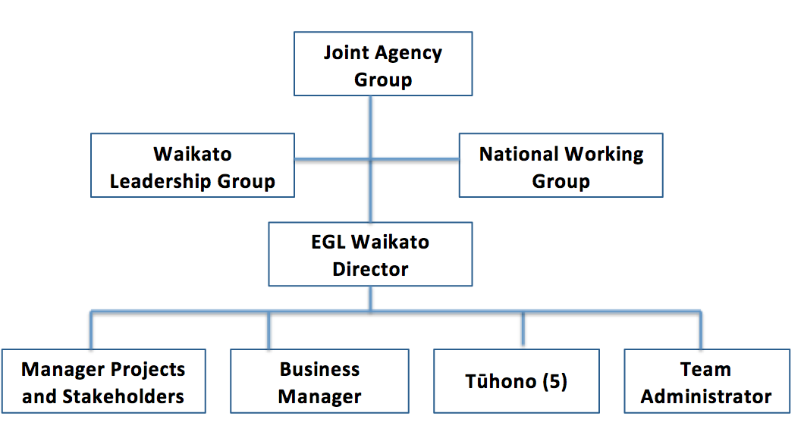
Figure 13: Current EGL Waikato structure

Appendix Five | Evaluative Rubric – Success Criteria
- The EGL Principles provide the guiding framework for the Waikato Demonstration and initial outcome statements developed during the co-design process were written to reflect them.
- You will note that the EGL Principles provide the high level framework for the criteria, as this ensures that the principles provide the initial measure of quality.
- It is also important to show the synergy between the EGL Christchurch Quality of Life Domains and how they link to the EGL Waikato approach to understanding the implementation and over the life of the evaluation, the expression of quality of life.
EGL Principles | EGL Waikato Demonstration  Implementation Criteria | EGL Waikato Outcomes Criteria |  | EGL Christchurch  Quality of Life Domains
 |  | Disabled People | Families and Whānau
Self- Determination | The EGL Waikato Demonstration increases and supports disabled people, and their families and whānau to have control of their lives. | I am in control of my life and what happens to me.  I can say what I want and carry out my choices and decisions. | Family and whānau are empowered to express their goals and aspirations and those they care for. | Self-Determination  - Autonomy/personal control  - Goals and personal values (desires, expectations)  - Choices (opportunities, options, preferences)
Person-centred | Disabled people, and their families and whānau have increased choice and control over supports. These supports take a whole of life approach over time and are tailored to their needs, goals, and aspirations. | I control and direct my life, including my disability supports.  I can choose who can assist me with my on-going support.  Supports work for me when and how I want them.  I can do things that are important to me. | Supports work for families and whānau when and how they want these.

EGL Principles | EGL Waikato Demonstration  Implementation Criteria | EGL Waikato Outcomes Criteria |  | EGL Christchurch  Quality of Life Domains
 |  | Disabled People | Families and Whānau
Beginning early | The EGL Waikato Demonstration ensures that their core systems (Tūhono/Connectors, community connections, supported self-assessment and planning, and personal budgets) are accessible, flexible and easy to navigate. | I have aspirations and can plan for them.  I am in control of my life and what happens to me.  I have the supports I need, when I need them. | Families and whānau are aspirational for their child’s life and future.  We have access to support and funding that contributes to our family and whānau living the life we want.  We are known and connected in our community. | Emotional Well-Being  - Contentment (satisfaction, moods, enjoyment)  - Self-concept (identity, self-worth, self-esteem)  - Lack of stress (predictability and control)  - Safety and security  Spirituality/ culture  Physical Well-Being  - Health and wellness (functioning, symptoms, fitness, nutrition)  - Activities of daily living (self-care, mobility)  Physical activities including recreation  Material Well-Being  - Financial status  - Employment status; job-related skills and behaviours  - Housing status  Having possessions  Personal Development  - Education (achievements, education status)  - Performance (success, achievement, productivity)  - Personal competence (cognitive, social, practical skills)
Mana enhancing | EGL Waikato demonstration creates opportunities for the abilities of disabled people; values the abilities and contribution of disabled people and their families and whānau. | The contribution I can make is recognised and respected.  I can contribute to the lives of others and to my community.  EGL Waikato is culturally respectful of me. | The abilities and contributions of families and whānau are recognised and respected.  EGL Waikato is culturally respectful of our family and whānau.
Ordinary Life Outcomes | The EGL Waikato Demonstration supports equity and citizenship for disabled people, families and whānau. | I am supported to live an everyday life in everyday places, like others at similar stages of life.  I have citizenship rights, including opportunities for learning and contribution, having a home and family, friends and connections and employment. | Families and whānau are supported to live an everyday life in everyday places.

EGL Principles | EGL Waikato Demonstration  Implementation Criteria | EGL Waikato Outcomes Criteria |  | EGL Christchurch  Quality of Life Domains
 |  | Disabled People | Families and Whānau
Easy to use | The EGL Waikato Demonstration ensures that their core systems (Tūhono/Connectors, community connections, supported self-assessment and planning, and personal budgets) are accessible, flexible and easy to navigate. | I find the EGL system easy to use and flexible.  I have supports that are simple to use and flexible.  I know how to and can access information, support and funding at the time I need it.  I have one plan and one amount of funding. | We find the EGL system easy to use and flexible.  Families and whānau have supports that are simple to use and flexible.  We know how to and can access all the information our family and whānau needs.  We have one plan and one amount of funding. | Rights  - Human (respect, dignity, equality)  - Legal (citizenship, access, fair treatment)
Mainstream First | Disabled people, families and whānau are supported to access community options, connections and services before specialist disability services. | I am known and connected in my community.  I know how to and can access all the information at the time I need it.  Community options, connections and services that are for everyone can be used before disability services. | We know how to, and can access all the information our family and whānau needs.  We are known and connected in our community.  Community options, connections and services that are for everyone can be used before disability services.

EGL Principles | EGL Waikato Demonstration  Implementation Criteria | EGL Waikato Outcomes Criteria |  | EGL Christchurch  Quality of Life Domains
 |  | Disabled People | Families and Whānau
Relationship Building | EGL Waikato builds and strengthens relationships between EGL Waikato Partners – disabled people, families and whānau, community and government. | I can build strong relationships that are important to me.  I can contribute to the lives of others and to my community. | We are known and connected in our community.  We know how to, and can access all the information our family and whānau needs. | Interpersonal Relations  - Interactions (social networks, social contacts)  - Relationships (family, friends, peers)  - Supports (emotional, physical, financial)  - Social activities
Social Inclusion
- Community integration and participation
- Community roles (contributor, volunteer)
- Social supports (support networks, services

Figure 14: Evaluative Rubric – Success criteria

Appendix Six | Evaluative Rubric – Performance Criteria
- Appendix Six provides a draft set of performance criteria to help us to determine or make a judgement about how well the Demonstration has been implemented.
- Performance criteria can also be used to determine to what level outcomes are achieved. However for Phase One it is acknowledged that EGL Waikato participants are only in early stages of engagement, so reflection and judgement on participant outcomes is still emerging.
- This set of performance criteria will therefore only be utilised in Phase One to determine how and how well implementation has occurred. Further performance criteria will be developed in Phase Two.

Figure 15: Evaluative Rubric – Performance criteria

References

Anderson, D., Ferguson, B., and Janes, R. (2014). Enabling Good Lives Christchurch Demonstration: Phase 1 Evaluation Report. Retrieved from http://www.odi.govt.nz/what-we-do/improving-disability-supports/enabling-good-lives/index.html

Enabling Good Lives (2016). Enabling Good Lives – Key Characteristics. Retrieved from http://www.enablinggoodlives.co.nz/about-egl/egl-approach/key-characteristics/

Enabling Good Lives Waikato. (2015). Who can take part in Enabling Good Lives Waikato guidelines. Unpublished.

Enabling Good Lives Waikato. (2015b). Evaluation Pre-Design. Unpublished.

Independent Working Group on ‘Day Options’. (2011). Enabling Good Lives – A report to the Minister of Disability Issues. Retrieved from http://www.odi.govt.nz/what-we-do/improving-disability-supports/enabling-good-lives/what-is-enabling-good-lives.html

Mikkelson & Cosgriff (2016). Internal Team Reflections – Enabling Good Lives Waikato. Unpublished.

Office of Disability Issues (2016). What is Enabling Good Lives? Retrieved from http://www.odi.govt.nz/what-we-do/improving-disability-supports/enabling-good-lives/what-is-enabling-good-lives.html

Office of Disability Issues (2016b). Enabling Good Lives Waikato. Retrieved from http://www.odi.govt.nz/what-we-do/improving-disability-supports/enabling-good-lives/waikato.html

Office of the Minister of Disability Issues, (2014). Demonstrations of the Enabling Good Lives approach in Christchurch and the Waikato – paper to the Cabinet Social Policy Committee. Retrieved from http://www.odi.govt.nz/what-we-do/improving-disability-supports/enabling-good-lives/cabinet-paper-december-2014-enabling-good-lives-demonstrations.html

Previous systems and support refers generally to the Disability Support Services that have been offered and provided through Needs Assessment Services Co-ordination, the range of contracted providers offering support and services to disabled people, families and whānau in the Waikato.
Government recognised the need and broad direction for change to the disability support system. In January 2009, the Government established a work programme to address long-standing concerns with the disability support system. In 2012, the Ministries of Social Development and Health worked in consultation with disability sector organisations to test the ‘Enabling Good Lives’ approach in Wellington, Christchurch and Hamilton (Office of Disability Issues, 2016). Refer to Appendix Three for more detail on the origins of the approach.
The words disabled people, families and whānau have been used collectively to represent people with disabilities, and the families and whānau of persons with disabilities.
In this context co-develop means things were developed together, through discussion and seeking input and feedback.
Funding in this context refers to funds that are administered by the Ministries of Health, Social Development and Education.
Funders in this context refers to the Ministries of Health, Social Development and Education.
The Tūhono/Connector is the unique Waikato name given to the Independent Facilitator. Refer to points 141 and 142 for further detail.
Choice in Community Living was an element of Disability Support Services’ New Model within the Ministry of Health. Please refer to http://www.health.govt.nz/your-health/services-and-support/disability-services/types-disability-support/new-model-supporting-disabled-people/choice-community-living for more information.
The Ministry of Health definition is “People under 65 years who have a physical, intellectual or sensory disability (or combination of these) which is likely to continue for at least six months and which limits their ability to function independently, to the extent that on-going support is required”.
As participants can identify with multiple ethnicities the total number does not equal to the total number of participants.
88% is 14 out of 16 participants with a personal budget as at 22 December 2015.
Please note that due to the number of participants, the level of detail provided aims to protect participant identity.
A simple sampling process was undertaken by the Local Evaluator to select the evaluation participants. The process aimed to reflect the diversity of the current group engaged in the Demonstration. This was achieved by taking into consideration key variables when selecting participants, such as action area, location, age, ethnicity, and length of time in the Demonstration. 15 participants were selected, with only one participant not able to be reached, and one interview being combined to discuss two Demonstration participants, at their representative’s request.
‘Shared care’ describes a situation where funding is allocated to a family via a provider to ‘share the care’ of their family member, in most cases their child. This shared care is regularly with another family, for example two nights per week.
Participants are still negotiating or considering their personal budgets.

