A new disability support system for New Zealand
April 2018 update

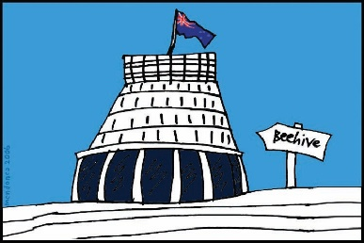
The Government of New Zealand is making big changes to the disability support system.

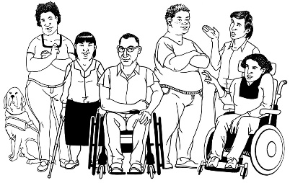
The Government has been planning the changes to the disability support system together with:
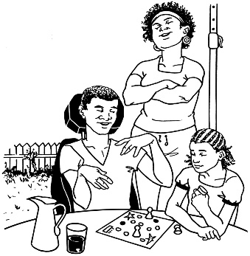
- disabled people

- family / whānau
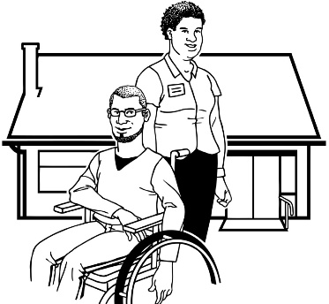
- disability support services.

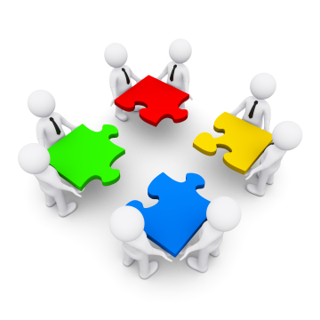
Working together like this is called co-design.

This is an update to let you know what:

- has been happening

- is going to happen next.

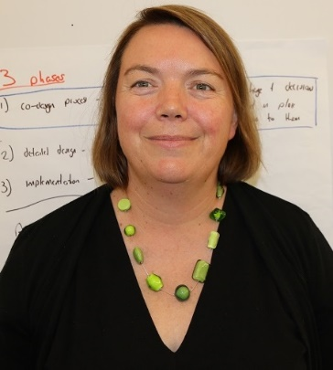

This update is from Sacha O’Dea from the Ministry of Health.

Sacha is working with the disability community on this work.

Important new information
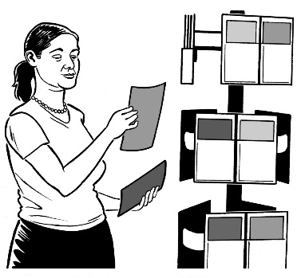

We have some news about the plans for the new disability support system.

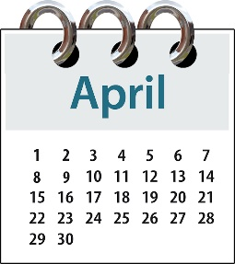
In April a lot of big things happened for this work:

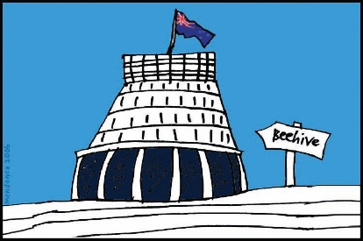
- we gave our plans for the new system to Cabinet

Cabinet is a group of senior Government Ministers.
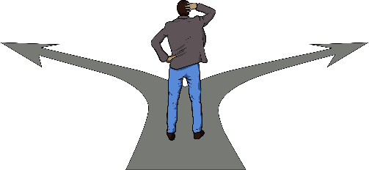

- Ministers of the Cabinet made some decisions about the plan
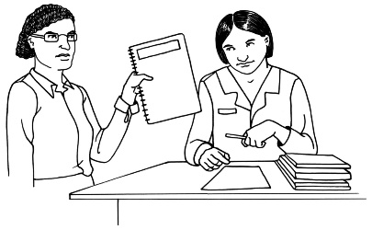

- we shared an Easy Read summary of the paper we gave to Cabinet
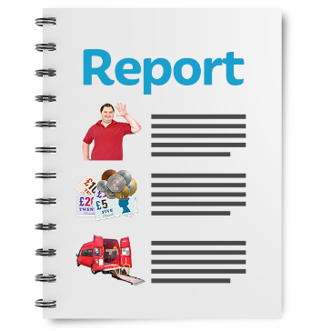
A summary is a short document that tells you the main things that are in a bigger document.

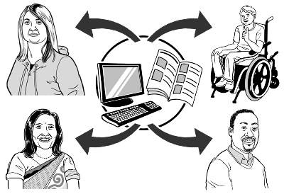
We also:

- put out an Easy Read press release about the new system

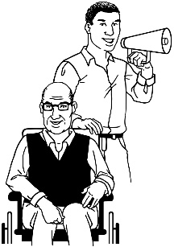
A press release is a way to get an important message to a lot of people.
A press release is sent to people and organisations that will be interested in the story.

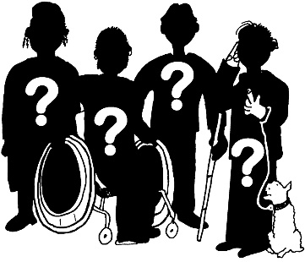
- put out a list of answers to questions people ask a lot called:

Frequently asked questions.
You can find these documents on the Enabling Good Lives website:

www.enablinggoodlives.co.nz/system-transformation/

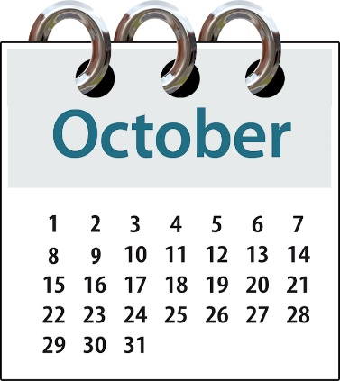
Important:
The new disability support system is going to start in MidCentral on 1 October 2018.

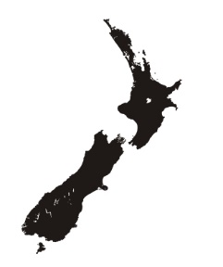
The MidCentral region covers:
- Palmerston North
- Horowhenua district
- Manawatu district
- ōtaki district
- Tararua district.

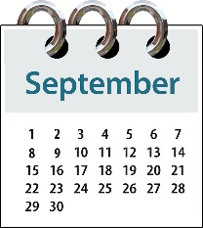
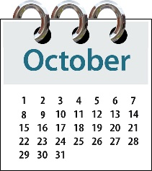
Important:
If you live in MidCentral:
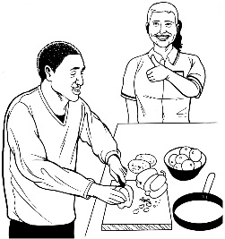
- your support will not change all of a sudden on the 1 October 2018

- the support you get now will only change if:
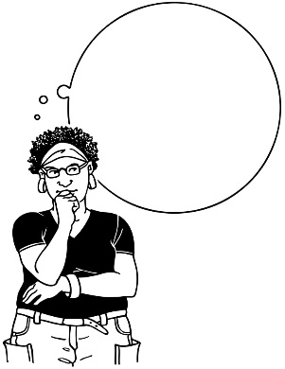
  - you ask to change it

  - you get to the date when your support is normally looked at to see if it is working for you.

Here is a little bit more information about what the new support system will look like:

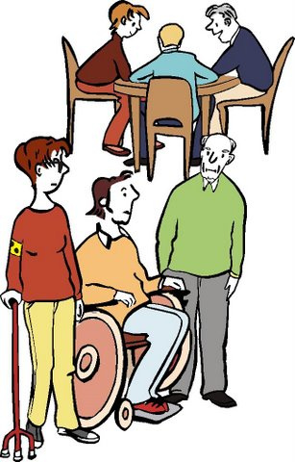
1
2 teams

When we start the new disability support system in MidCentral there will be 2 teams:
2

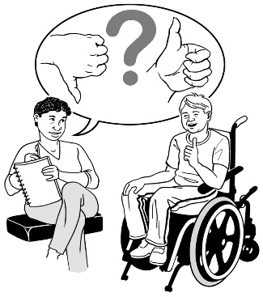
- 1 team will have the Connectors / Tūhono and other people who will work face to face with:
1
  - disabled people
  - whānau / families
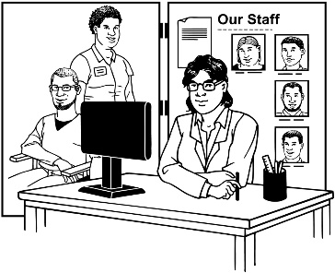
2
- the other team will have all the people who support those frontline workers.
Why do we have these workers in 2 teams?
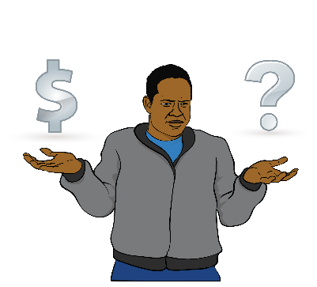
We have 2 teams as we have heard many people say it is important the Connectors / Tūhono are not the people who make choices about the funding people get.

Funding means the money the Government gives for disabled people to be able to get the support and the things they need for their disability.

Important:
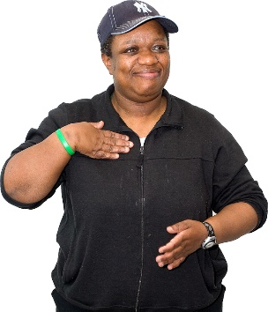
Even though the new disability support system will have Connectors / Tūhono – you do not have to have 1 if you do not want 1.

The choice is up to you.

What are we working on now?

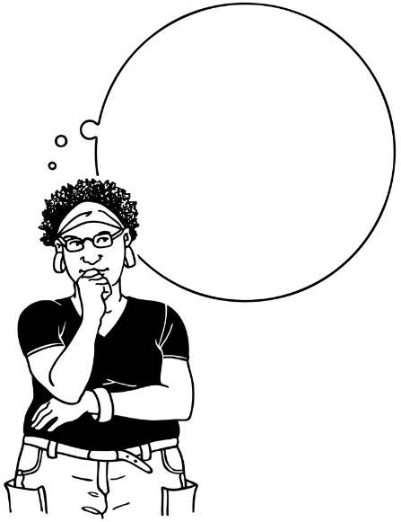
Virtual Testing groups

We are working on making a tool to decide how much funding people will be able to get.

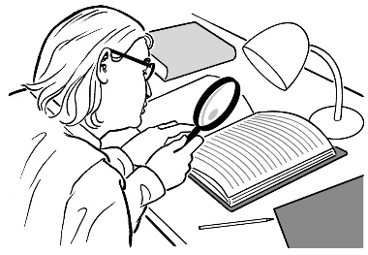
We know many people want to:
- see what these plans are
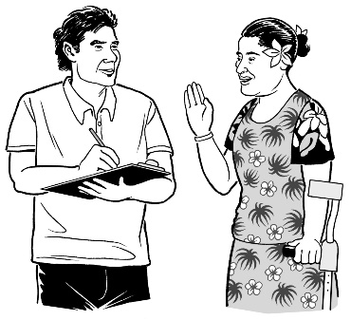
- have a say on how funding choices are going to be made.

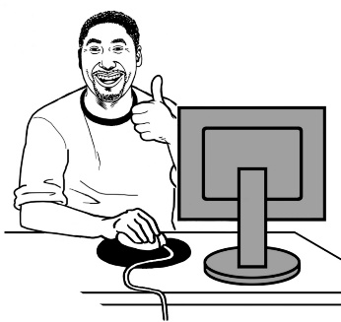
We are doing virtual testing on this work now.

People on virtual testing groups use online tools to see if the new disability support system will work well.

Online tools are things like email and Facebook.

If you want to take part in the virtual testing group you can still email us on:
STfeedback@moh.govt.nz

What are we working on now?
We are collecting information about what things are like in the disability support system we have now.

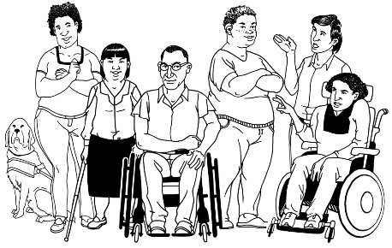
We are looking at what things are like now for:
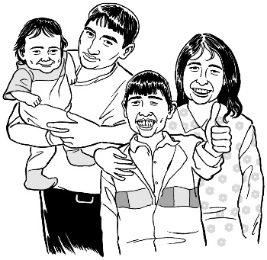
- disabled people

- whānau / families

- disability service providers
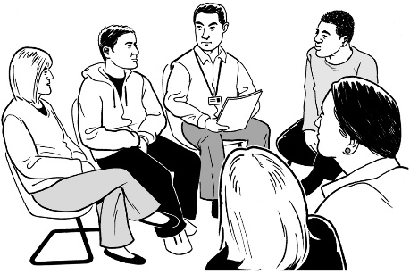
- staff who work for disability service providers.

We are doing this so we can see if things are getting better for people in the new disability support system.
What next?

We know that it is really important to make sure people have good information about what the changes may mean for them.

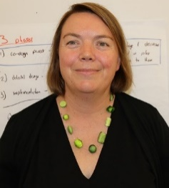
1 way we are going to give people good information is by doing some live streaming sessions with me online.

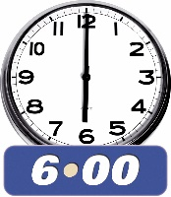
Live streaming means:
- playing a video on the internet at a set time – for example 6 o’clock at night

- people sending in the questions they have
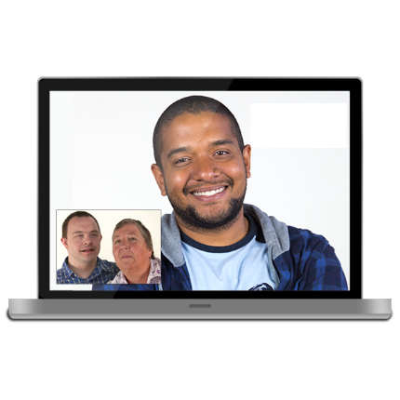
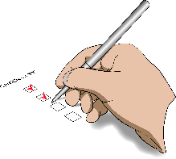
- the person in the video giving answers to all the questions people are sending in

Live streaming is a bit like getting to talk with someone on the internet.
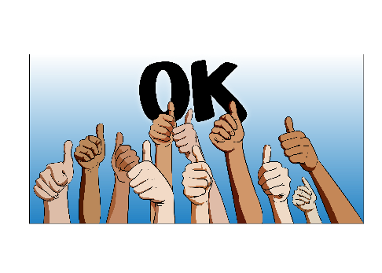

Anyone can watch the live streaming sessions.

The sessions will be about different topics, like:
- what disabled people want to know

- what whānau / families want to know

- what disability service providers want to know.

We will give people lots of warning about when these sessions are going to happen.

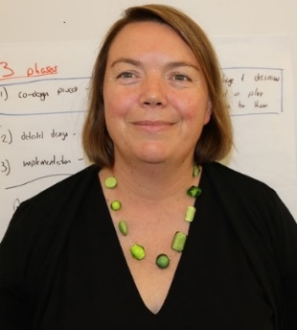
I also have a message for everyone who has worked so hard to get the plans for the new system ready to roll out in MidCentral.

I want to say:
- thank you
- congratulations.

Your hard work has helped us to make this all happen.

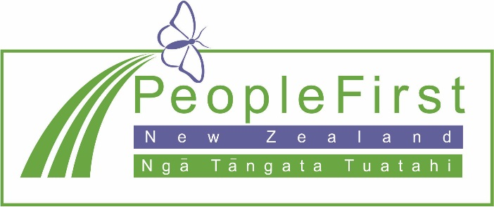

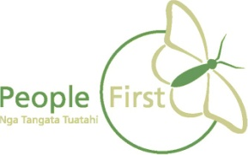
This information has been translated into Easy Read
by People First New Zealand Inc. Ngā Tāngata Tuatahi
