A new disability support system for New Zealand
May 2018 update

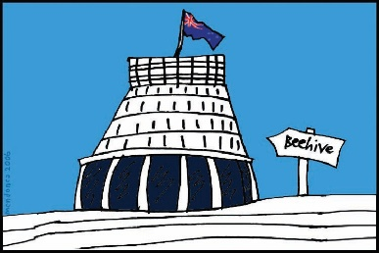
The Government of New Zealand is making big changes to the disability support system.

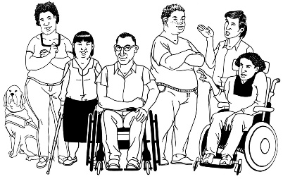
The Government has been planning the changes to the disability support system together with:
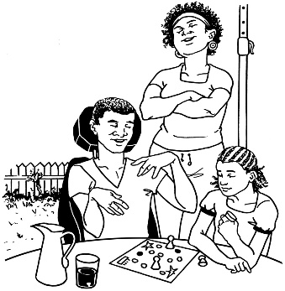
- disabled people

- family / whānau
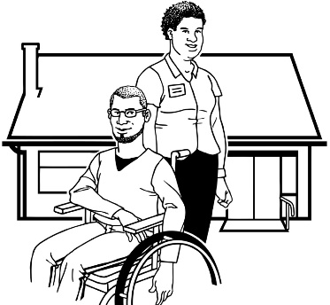
- disability support services.

Working together like this is called co-design.

This is an update to let you know what:

- has been happening

- is going to happen next.

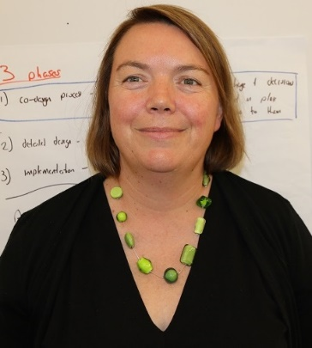

This update is from Sacha O’Dea from the Ministry of Health.

Sacha is working with the disability community on this work.

What have we been working on?

It has been a very busy month.
We had 3 livestream sessions online in May.

Live streaming means:
- playing a video on the internet at a set time – for example 6 o’clock at night

- people sending in the questions they have

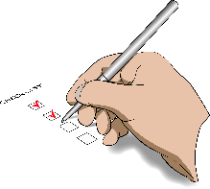
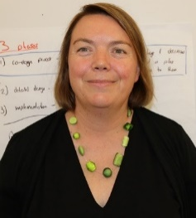
- the person in the video gives answers to all the questions people are sending in

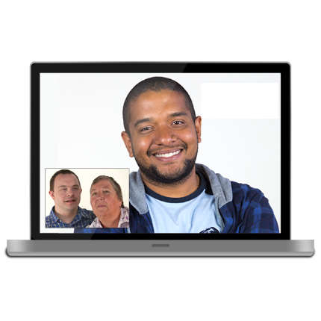
Live streaming is a bit like getting to talk with someone on the internet.

The 3 livestream sessions were for:
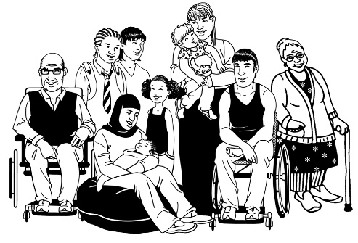
- disabled people

- whānau

- providers.

2 of the livestreams went really well.
We had a small problem with the whānau livestream.

We have been busy working to recruit people for the 2 new teams in MidCentral region.
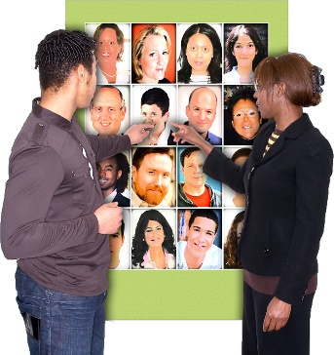

Recruiting means to looks for people to take up jobs.

We have sent out information about the Director roles on each team.

A Director is the person in charge.

The 2 Directors will be in charge of the new:
- Disabled People and Whānau Supporting Team

- System Enabling Team.

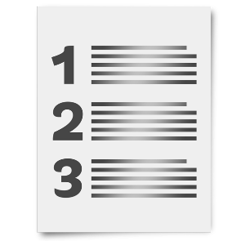
We want to find people for the Director roles first.

We want to find the best people for all the roles on the 2 new teams.
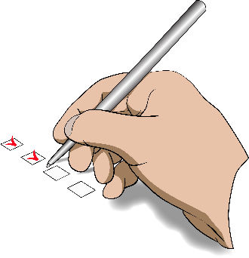

We want people from all areas of the disability sector who have the right skills.

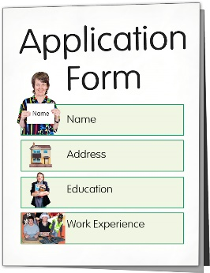
We would most like to get job applications from:
- disabled people

- whānau of a disabled person.

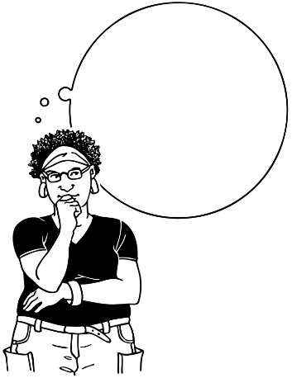
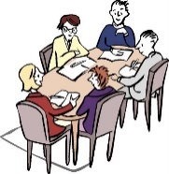
We have also thought a lot about the MidCentral:
- governance group

- how to pick people to be a part of the governance group.

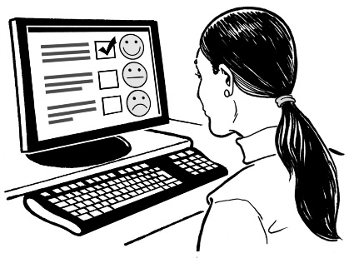
We will get feedback on this from the MidCentral Regional Leadership Group.

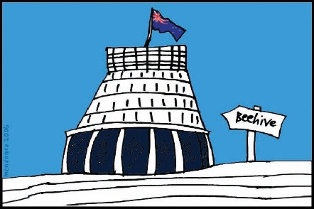
Ministers will tell us that they support how we will choose people for the governance group in the next few weeks.

We have been reviewing all our provider contracts this month.

Reviewing means to look through a document to see what changes need to be made

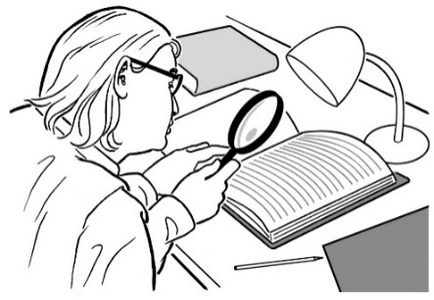
We have looked at them to see:
- how we can make changes

- how long it will take to make changes

- when we can make new contracts.
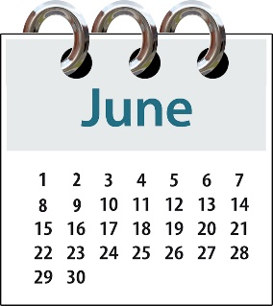
In June we will start talking to providers about our contracts.

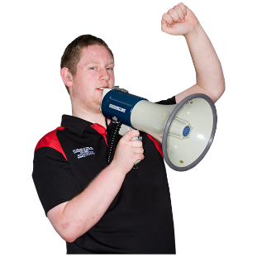
Another thing we have been thinking about this month is our communication.

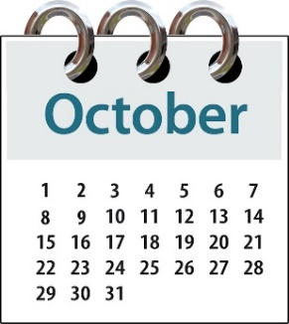
We have looked at how we:
- have communicated with people so far

- will communicate with people until October 1.

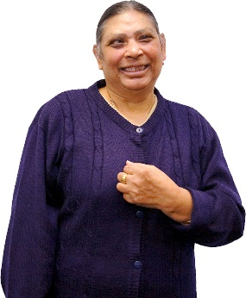
We know that we need to do better at communicating with disabled people in MidCentral so they know:
- what the new changes will mean for them

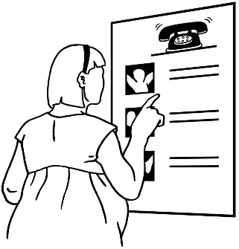
- who they should contact if they need to

- what the new changes will look like.

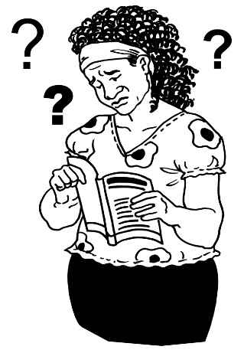
We have been looking at what we need for people with learning disabilities so they can understand what we are working on.

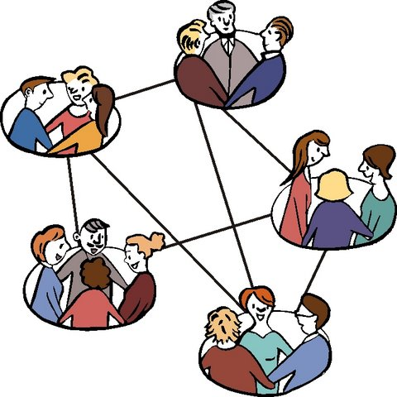
We have also been looking at how we can communicate better with different groups.

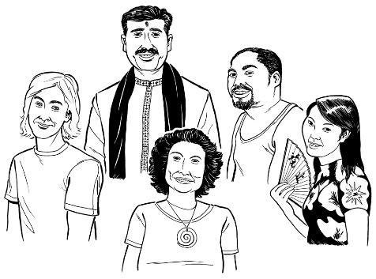
Some of these groups are:
- Te Ao Māori

- Pacific people.

We have also thought about how can we change things so that Deaf people are better included.

What next?
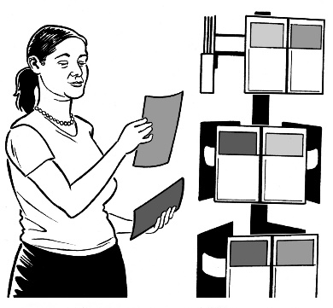
We will start communicating more with you.

We will keep trying to:
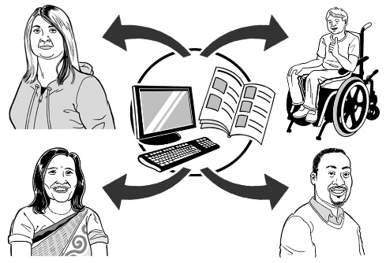
- give feedback

- communicate in a way that works for different groups of people across the community.

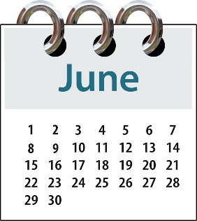
In June we will start sending out information for all the roles on the new:
- Disabled People and Whānau Supporting Team

- System Enabling Team.

Look out for the information for these jobs.

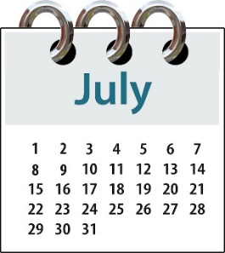
We will also start choosing people to be a part of the governance group in July.

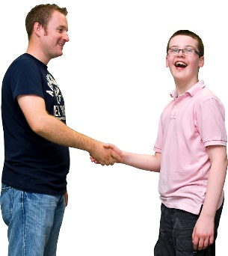
There will chances for you to meet with us in person to talk about what we are doing.
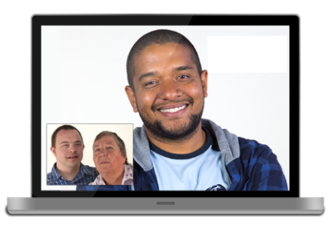

We will also have more livestreaming in June.

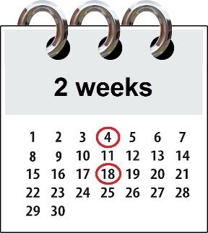
We will tell you 2 weeks before the next livestream starts.

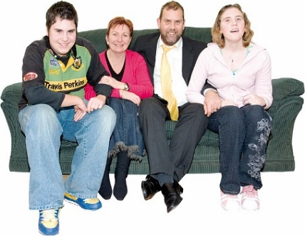
The next livestream sessions will start with whānau because of the problem with the last whānau livestream session.

We look forward to getting your questions in the livestream sessions in June.

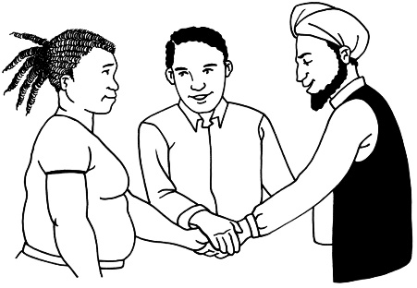
Thank you to everybody who has been working with us over the last month.

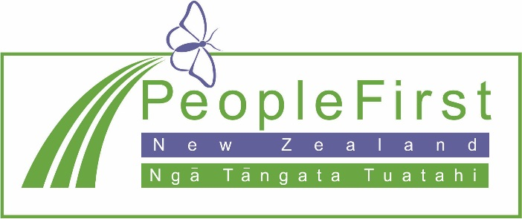

This information has been translated into Easy Read
by People First New Zealand Inc. Ngā Tāngata Tuatahi
