Evaluation Report Phase 1
Enabling Good Lives
Waikato Demonstration

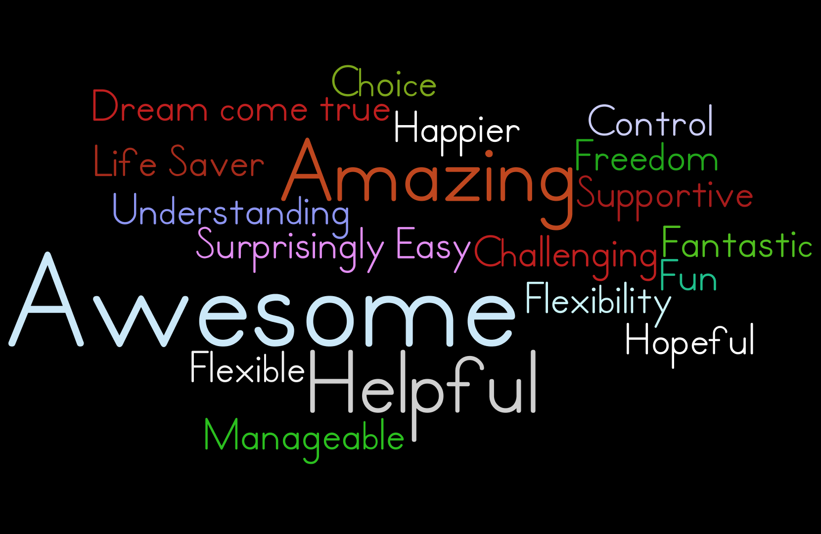

Edited by Glen Terry – Readable by Glen

The Enabling Good Lives Waikato evaluation is to look at how Enabling Good Lives is changing lives for disabled people, their families/whānau, different providers, and how it is changing the system.
The Enabling Good Lives Waikato evaluation is in 4 parts. The first part is looking at the Enabling Good Lives demonstration from July 2015 to December 2015.
There were 6 key questions that were asked about the Enabling Good Lives demonstration;

Question 1 – What is Enabling Good Lives Waikato and how is it being put into action?
Question 2 – What do people want to get out of the Enabling Good Lives demonstration? What goals do disabled people, family/whānau, communities, providers, and government have?
Question 3 – What goals did people achieve in the Enabling Good Lives Waikato demonstration? How did they achieve these goals and how did Enabling Good Lives support them to do it?
Question 4 – Has the Enabling Good Lives Waikato demonstration reached the Māori community? How has Enabling Good Lives supported disabled Māori and their whānau?
Question 5 – What is the cost of the Enabling Good Lives Waikato demonstration for disabled people, the community, and providers? What value do you get for the cost?
Question 6 - How has Enabling Good Lives Waikato changed how disabled people and their family/whānau are supported?

Lots of people were asked to give their views of the Enabling Good Lives Waikato demonstration including;
- 14 disabled people or family and whānau who are part of the demonstration
- EGL leadership group members
- Maori co-design group members
- 27 Community of Practice members from 9 different providers
- Members of the Enabling Good Lives Waikato team
Things that we learnt from the evaluation:
- The Enabling Good Lives demonstration is new but it is going as planned by the Waikato leadership group.
- The Enabling Good Lives demonstration changes to fit with what people want and need.
- Enabling Good Lives has worked with local leadership to build the demonstration, using their skills, what they know, and who they know.
- The 14 people were asked questions about the Enabling Good Lives demonstration and were happy with their experience so far. They felt that the Enabling Good Lives demonstration was making good changes to the way they are supported.
- Lots of the people in the demonstration are starting to live their life the way they want. With Enabling Good Lives’ support, they can make choices and decisions for themselves about what they want their life to look like. They can make choices about who to live with, who their staff are, where they live etc.
- Some people have needed extra time, information, and support to build the kind of life they want.
- Many people within the Māori community want to be part of the Enabling Good Lives demonstration. The reason for this will be looked at in part 2 of the evaluation.
Things that went well in phase 1 of the Enabling Good Lives demonstration;
- Enabling Good Lives talking to families early about the demonstration so that they know what Enabling Good Lives can offer.
- Having people and groups involved in the Enabling Good Lives demonstration that understand the Enabling Good Lives values and work hard to support people to live the life they want.
- Having lots of different people and groups working together on the Enabling Good Lives demonstration.
- Enabling Good Lives being honest, open, and clear about what the demonstration is.
- Listening to what people want and changing to fit with how people want to live their lives. This is shown by the goals that people have achieved as part of the Enabling Good Lives demonstration.
Some of the good things that people have said about Enabling Good Lives;
- “I love it, my friends are blown away…I’m the one with the power and control” (Individual choice action area participant).
- “I have a lot more support to do what I want when I want [now] … no more middleman – they really grind your gears” (Individual choice action area participant).
- “Best thing I ever joined him up to” [Enabling Good Lives Waikato] (Māori action area participant).
- “Life changing for (my son) …he now has someone else he relates to” (Individual choice action area participant).
- “Now he experiences things he used to watch on TV” (Māori action area participant).
- “Thought it would be problem after problem, but it’s been surprisingly easy, stress-free and convenient” (Individual choice action area participant).
- “Within 10 minutes I could see this (the Demonstration) was good for him” (Māori action area participant).
- “The budget goes exactly where it should go, and that’s how it should be” (Children and Young People action area participant).
- “The Tūhono told us about future possibilities and that’s the direction we want to head in” (Individual choice action area participant).
Things to work on in phase 2 of the Enabling Good Lives demonstration;
- The self-assessment tool needs to be made easier for people to use.
- People need to be able to understand all areas of the Enabling Good Lives demonstration. The Finance and Human Resource processes need to be made easier to use.
- There needs to be good communication for getting information from people in the Enabling Good Lives demonstration. This will help to give a clear idea of how well the demonstration is going.
- Making sure that people who are looking to join Enabling Good Lives get all the information they need so they can make a choice.
- Giving participants more information about how EGL is going and any changes that Enabling Good Lives is working on.
- Spreading the word about the Enabling Good Lives values, and making sure that people understand them so they are used in the same way by everyone.
- Helping people to get the life they want and communicating this with providers and services.
- Giving people time to think about what they want in their life and giving them time to get used to the different way they are supported by Enabling Good Lives.
- Making sure that the connectors (Tūhono) and other Enabling Good Lives participants support each other and help each other reach their goals.
- Building a better relationship between providers and Enabling Good Lives participants to make it easier and faster so that things keep moving forward.
The Enabling Good Lives demonstration is going well so far but there are some things that need to be worked on in the next phase. It is important to look at the demonstration regularly.

