A new disability support system

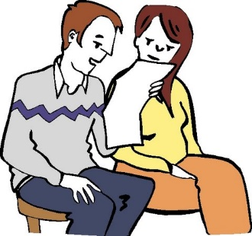
This is an Easy Read letter about the new disability support system.

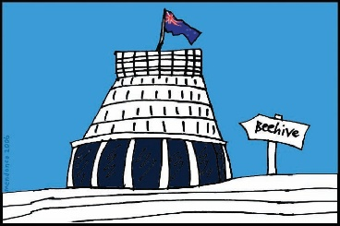
The Government will have a new way of giving disability support services in the area where you live.

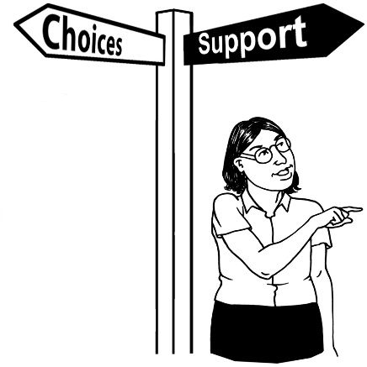
The new system will give people more choices about their:

- lives

- disability support services.
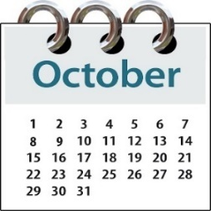
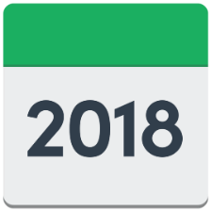
The new system will start on
1 October 2018.

It will start in the MidCentral District Health Board region.

MidCentral includes:

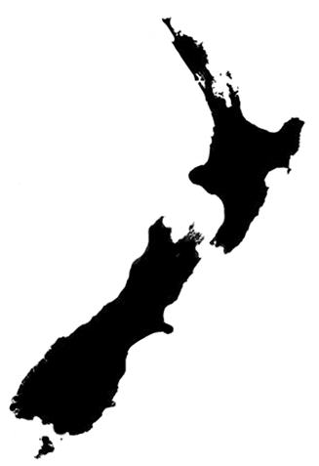
- Palmerston North

- Horowhenua

- Manawatu

- Ōtaki

- Tararua districts.
You will be in the new system because you:

- use Disability Support Services funding

- live in the MidCentral DHB region.

From 1 October 2018 you can choose to:
- continue with your disability support, until your usual review date
Or
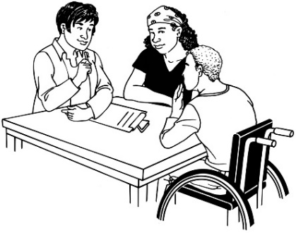
- make changes to the disability support you are getting.

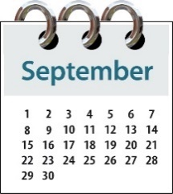
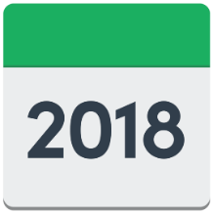
In September 2018 you will be sent a letter which will have more information about:

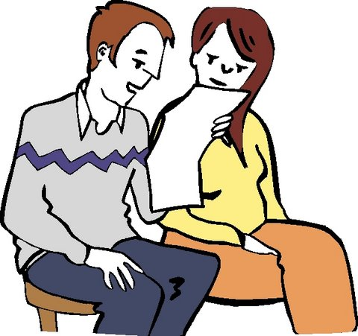
- what the new system will look like

- how you can make contact if you:

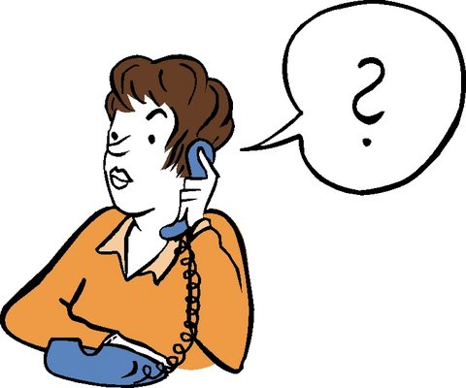
- want to make changes to your support services

- have any questions about your support services.

How do I find out more?
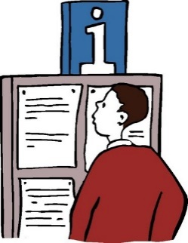

If you want to find out more information about this new disability support system you can:

- Look at the Enabling Good Lives website:

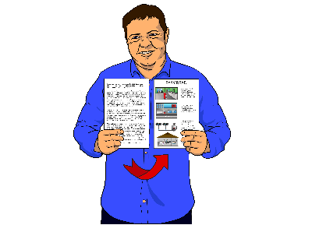
www.enablinggoodlives.co.nz

There are some more Easy Read documents on this website.

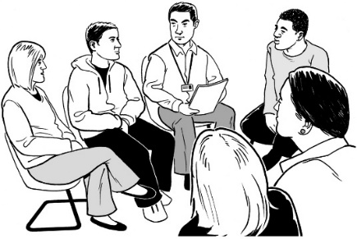
- Go to public meetings being held in your area.

To find out about these meetings look at this website:
www.enablinggoodlives.co.nz/ system-transformation
- Watch Live streaming sessions on the internet.

Live streaming means:

- playing a video on the internet at a set time – for example 2 o’clock in the afternoon
- people send in the questions they have by email

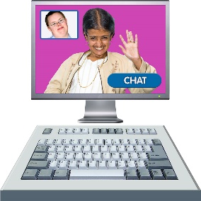
- the person in the video gives answers to all the questions that people are sending in.

More information on how you can take part in Live Streaming sessions is on this website:
www.enablinggoodlives.co.nz/ system-transformation.

