**A new disability support system for New Zealand**

**July 2018 update**

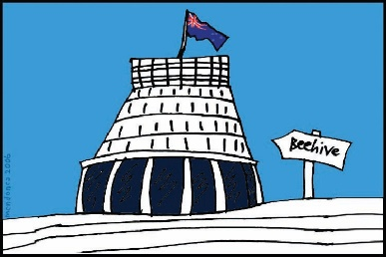

The Government of New Zealand is making changes to the disability support system.

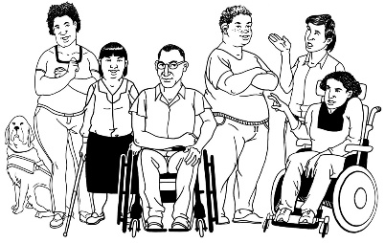

The Government has been planning the changes to the disability support system together with:

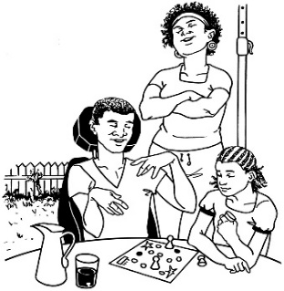

* disabled people
* 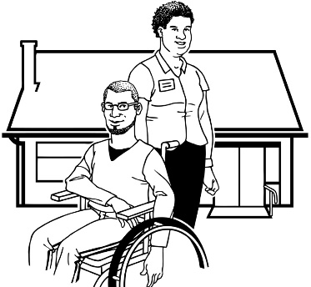family / whānau
* disability support services.

Working together like this is called **co-design**.



This is an update to let you know what:

* has been happening



* is going to happen next.

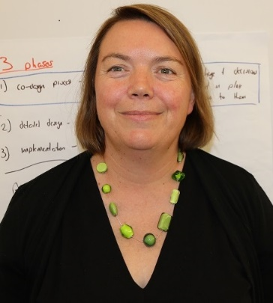

This update is from Sacha O’Dea from the Ministry of Health.



Sacha is working with the disability community on this work.

**New people joining our team**



We are pleased to tell you we have 2 new people joining our team.



They will be our 2 new **directors** for 2 new teams in MidCentral.

A **director** is the boss of a team.

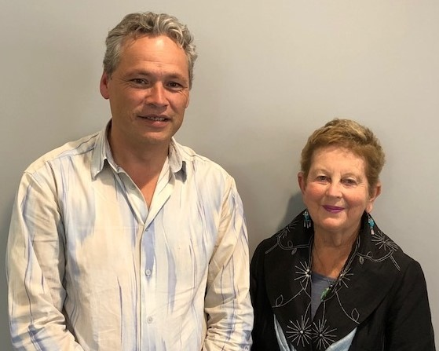Our new team members are:

* **Lorna Sullivan**

and

* **Marshall Te Tau**.

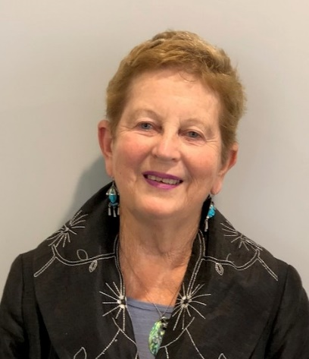**Lorna Sullivan** will be the **Director** of the **Disabled People and Whānau** **supporting team**.

Lots of people in the disability community know Lorna.

Lorna has been a good leader in the disability community.

cid:03C2CEB5-3D84-4D2D-8742-A7C8E2E71924She was in the group that wrote the Enabling Good Lives vision and principles.

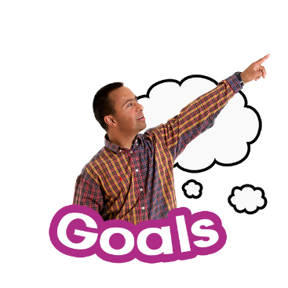

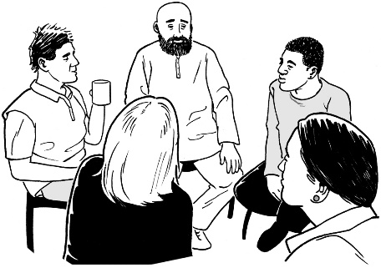A **vision** is a goal that an organisation makes to reach in the future.

A **principle** is something that helps guide an organisation to reach its goals.

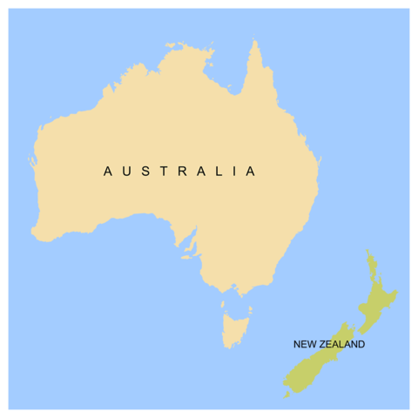Lorna has worked in a place called Queensland in Australia for the last 5 years.

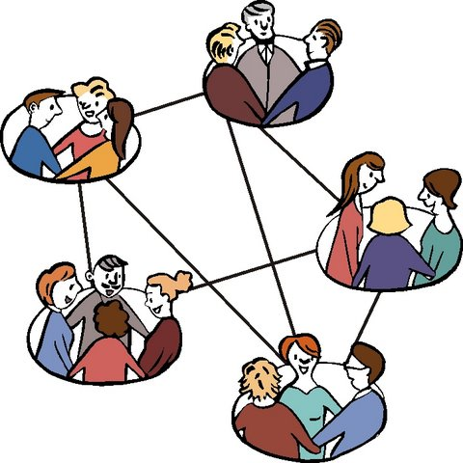She worked at a place called **United Care Queensland** when they changed to the **National Disability Insurance Scheme**.

The **National Disability Insurance Scheme** is a new system to support disabled people and their families in Australia.

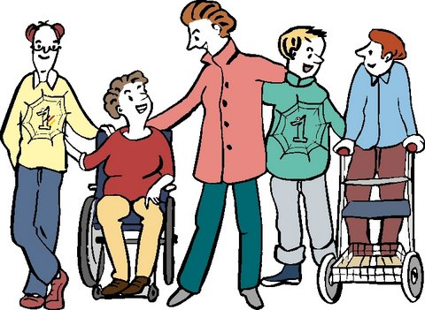Lorna is **passionate** about supporting disabled people and whānau.

A **passionate** person has very strong feelings about something.

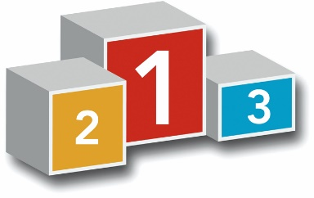

She will be an important member of   
our team.

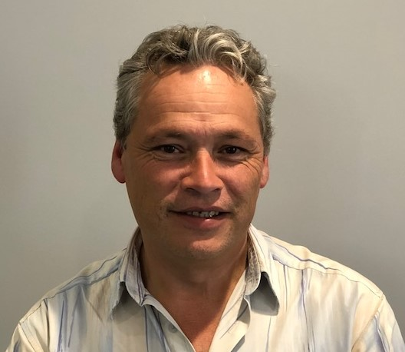**Marshall Te Tau** will be the **Director** of the **System Enabling team**.

Marshall has worked in the disability sector for many years.

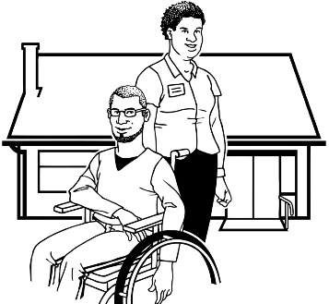

He has worked for some disability service providers.

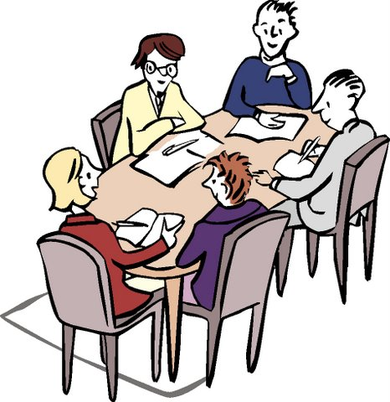

Marshall has also been on the Regional Leadership Group in MidCentral.

  
He has been a leader in lots of the talks about getting ready for the new disability support system.

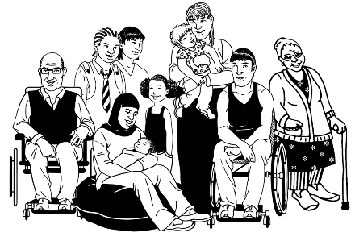Marshall is passionate about supporting disabled people and whānau.

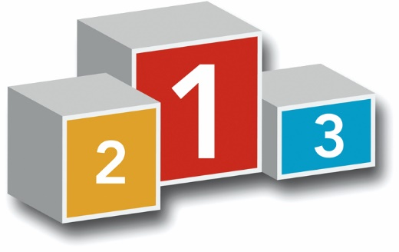

He will be important to the team as we change to the new disability support system.

**What have we been doing?**

1. **Building our new team**

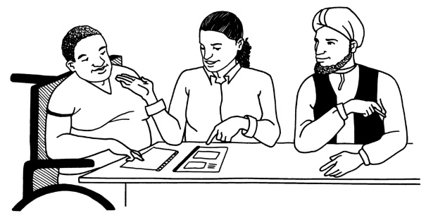

The System Transformation team has been busy doing lots of things.

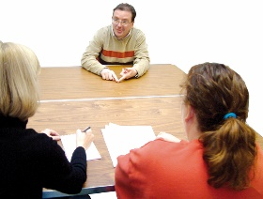

We have been doing a lot of **interviewing**.

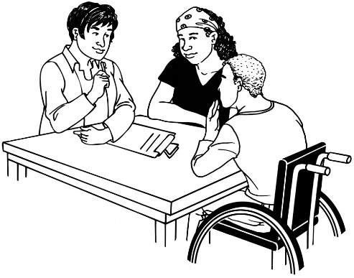This means we have been:

* talking to the people who have applied for one of our jobs
* asking questions to find out if they will be the right person for the job.

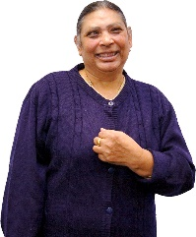

It is very important we get the right people to do the jobs on our teams.

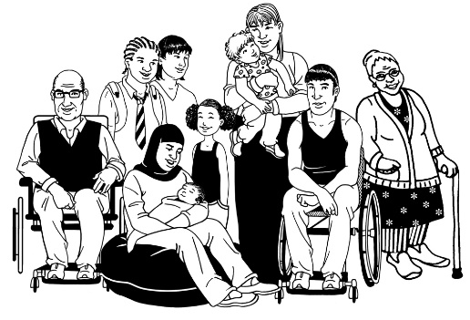We want our new disability support system to be good for disabled people.



We need to have a good team of people working on the new disability support system so it will work well.

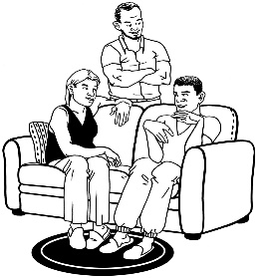

We want the disability support system to give disabled people and whānau:

* 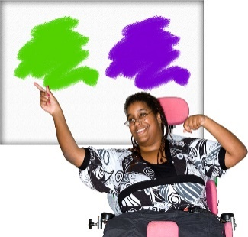flexible ways to get supports – to fit in with a disabled person’s life
* 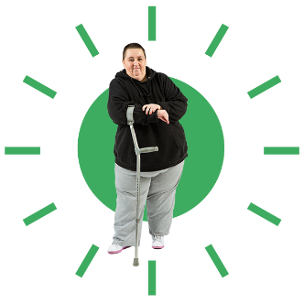have more choices about their supports
* have more control over their lives.

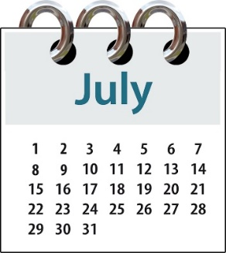

We closed the applications for jobs in the **1st week of July**.

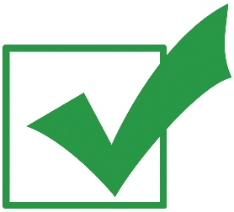

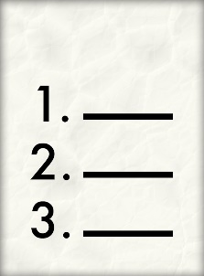We have finished interviewing people for all the jobs.

We have made a **short list** of the people we think will be good for each job.

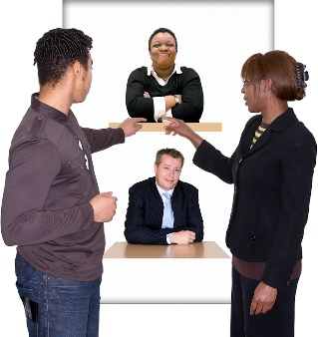  
A short list means we made a short list of the people we think will be good for each job.

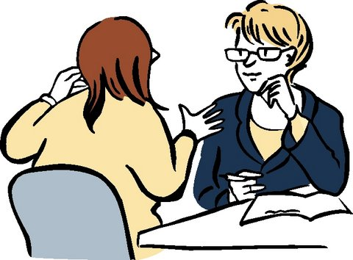We will:

* talk to each person on the short list

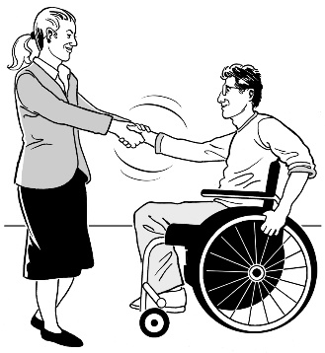**and then**

* decide who will be the best person for the job.

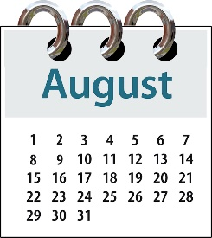  
We hope we will have everyone we need on our team **by the end of August**.

**Regional Governance Group**

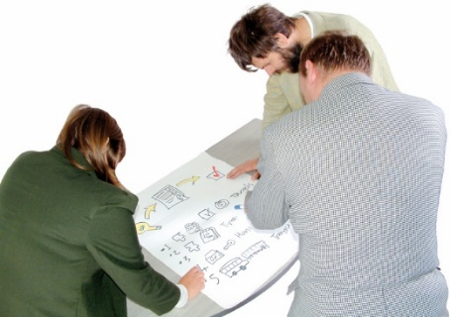

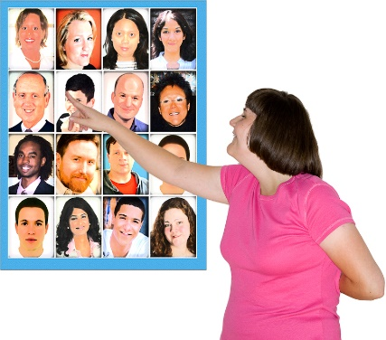The System Transformation team is working on building the **Regional Governance Group**.

There are **6** people we think will work well on the Regional Governance Group.

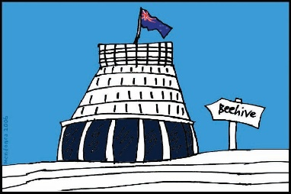

**6**

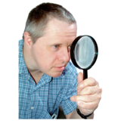We have told the Ministers of Parliament about these 6 people.  
  
  
We have also told the Ministers about a workforce person we think will work well on the group.

**1**

We are looking for 2 more people to be on the Regional Governance Group.

1. 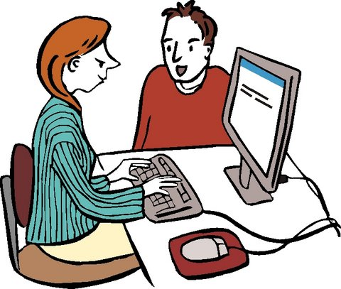**Business processes**

We are doing work to make new business **processes**.

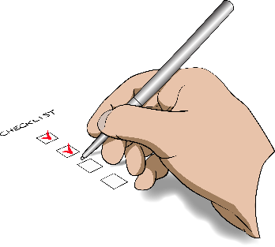

**Processes** are things you need to do to get something done.

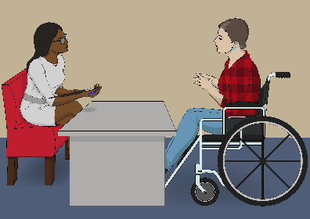  
We will test the new processes with disabled people and whānau in MidCentral.



This will happen in the next 2 weeks.

1. **Other work we are doing**

We are also doing work to:



* 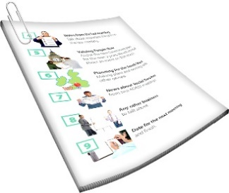make a new website
* write 3 **Cabinet papers.**

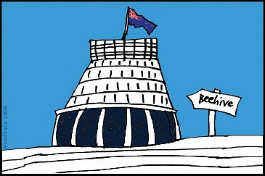

**Cabinet** is a group of Government Ministers.



We write **Cabinet papers** to let them know what we need to set up the new disability support system.

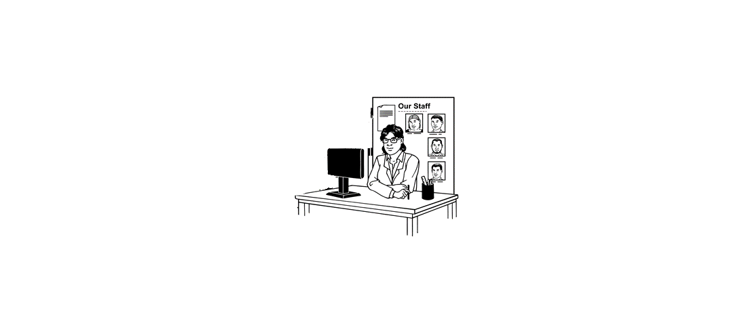We are doing lots of work to get ready to start the new disability support system.

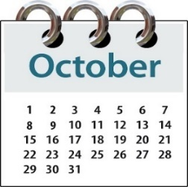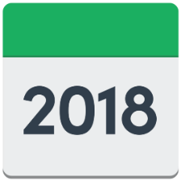

We still have lots more work to do so we can **start** our new disability support system on **1 October 2018**.



More information can be found on this **website**:

**www.enablinggoodlives.co.nz/**

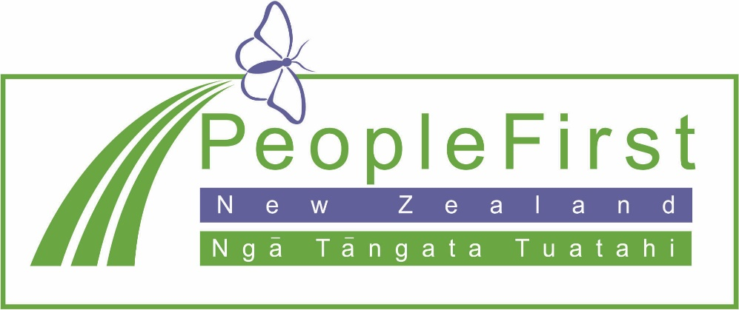

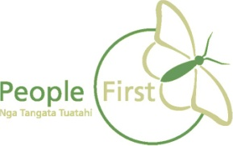**This information has been translated into Easy Read**

**by People First New Zealand Inc. Ngā Tāngata Tuatahi**

