A new disability support system: Mana Whaikaha
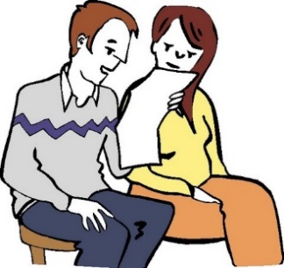

This is an Easy Read letter about the new disability support system.

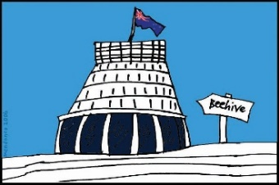
The Government will have a new way of giving disability support in the area where you live.

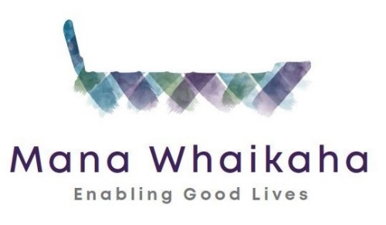
The new disability support system is going to be called Mana Whaikaha.

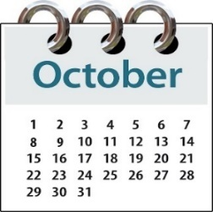
The new system will start on
1 October 2018.

It will start in the MidCentral District Health Board region.

The MidCentral DHB region includes:
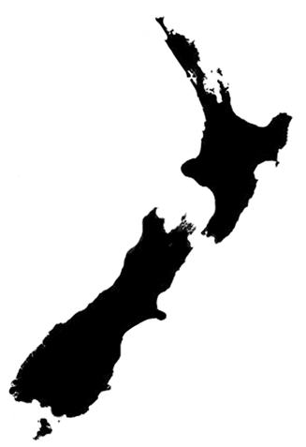
- Palmerston North

- Horowhenua

- Manawatu

- Ōtaki

- Tararua districts.

You will be in the new system because you:

- use disability support services funding

- live in MidCentral.

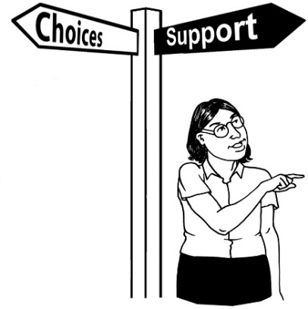
The new system will give you more:
- choices about your life

- control of your disability support.
What will happen from 1 October 2018?

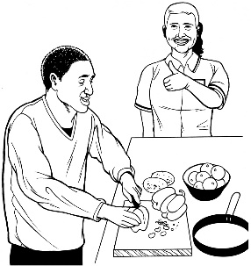
- You will keep getting disability support.

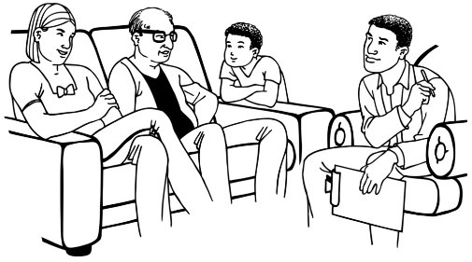
- You can ask to make changes to the disability support you are getting.

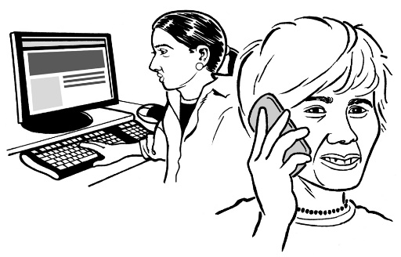
- You will be contacted by us at your review time.

The review is when we meet with you to talk about:

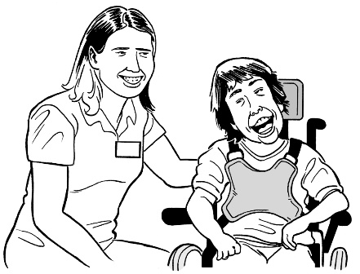
- the support you are getting now

- how well these supports are working for you.
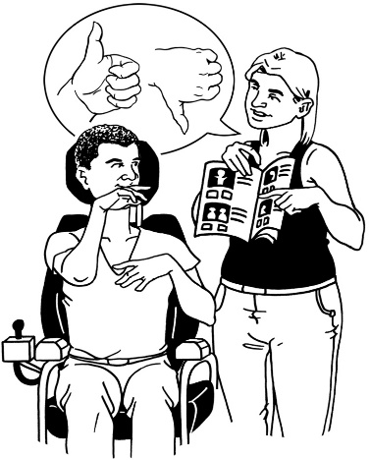
The review is also about:

- what changes you may need to your supports

- what you will be able to do in this new system.

Before the changes to the system you talked to people from Enable NASC.
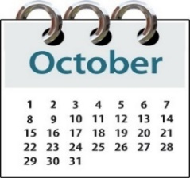

From 1 October 2018 you will talk to people from Mana Whaikaha.

A Connector can help

A Connector is someone who will work with:
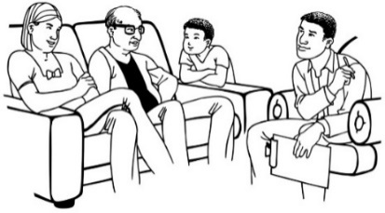
- disabled people

- family / whānau.

Connectors can help you think about what supports you need to live the life you want.

You can choose if you want to have a Connector.

You can choose who you would like as your Connector.
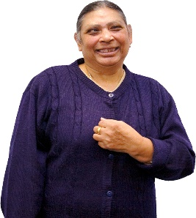
No thanks

You do not have to have a Connector if you do not want to.

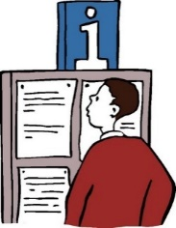
How to find out more information

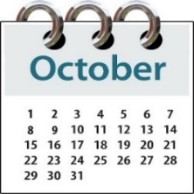
From 1 October 2018 you can find out more by:

- looking at the Mana Whaikaha website:

www.manawhaikaha.co.nz

- talking to us on the phone: 0800 626 255

It is free to call this number.
This means it will not cost you money to talk to us on the phone.

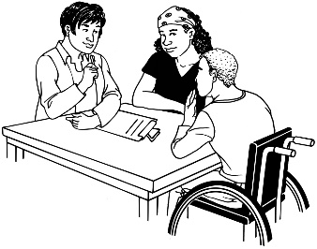
- coming in to see us at one of our offices in:

- Palmerston North

- Levin

- Ōtaki

- Woodville.

The Mana Whaikaha website will have information about:

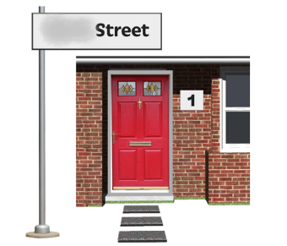
- the street address of where to find these offices

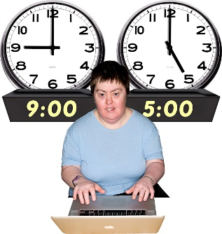
- times / days when the offices are open.

From:

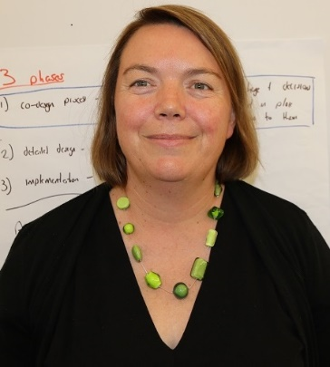
Sacha O'Dea
Programme Lead, System Transformation
Ministry of Health

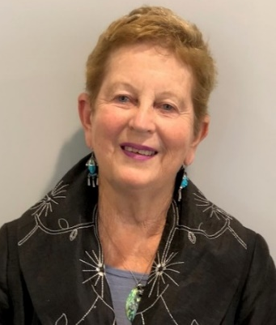
Lorna Sullivan
Director
Kaitūhono / Connectors team

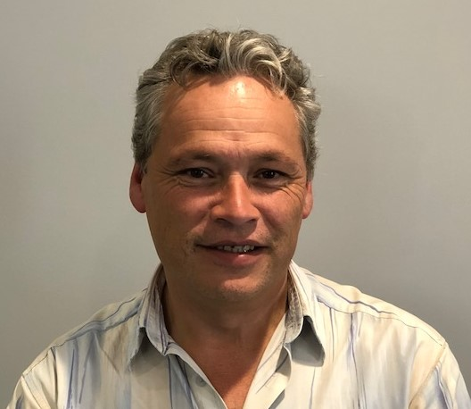
Marshall Te Tau
Director
Tari / System team

