A new disability support system
September 2018 update

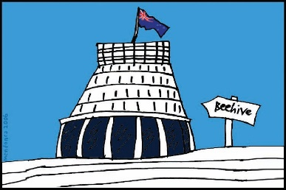
The Government of New Zealand is making changes to the disability support system.

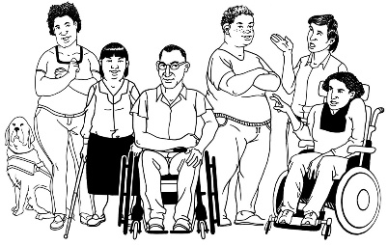
The Government has been planning the changes to the disability support system together with:
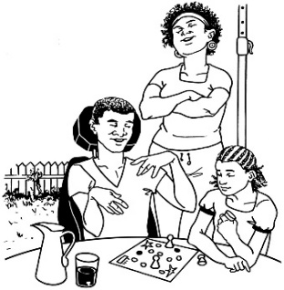
- disabled people

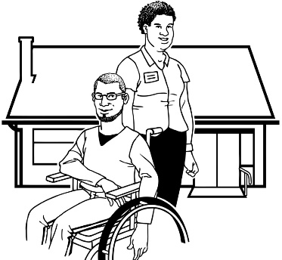
- family / whānau

- disability support services.

Working together like this is called co-design.

This is an update to let you know what:

- has been happening

- is going to happen next.

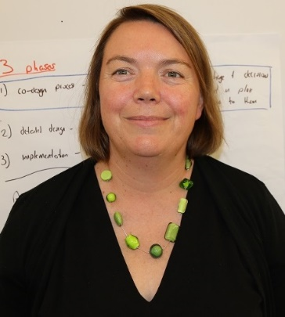

This update is from Sacha O’Dea from the Ministry of Health.

Sacha is working with the disability community on this work.

Monday 1 October 2018

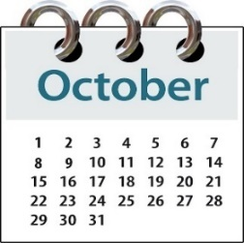
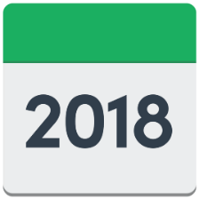
Monday 1 October 2018 is the start date of the new disability support system in the MidCentral DHB region.

The MidCentral DHB region includes:
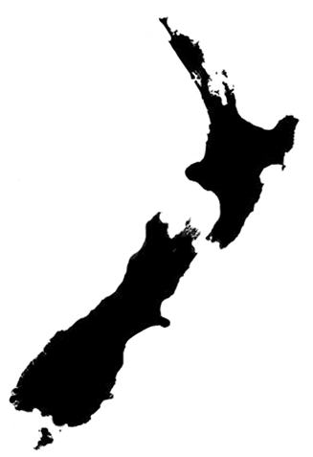
- Palmerston North

- Horowhenua

- Manawatu

- Ōtaki

- Tararua.
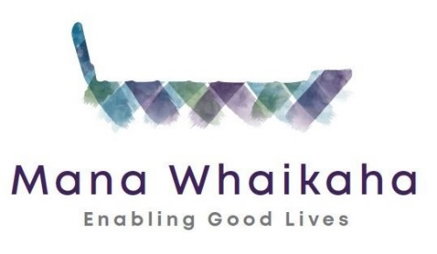

The name of this new disability support system is Mana Whaikaha.

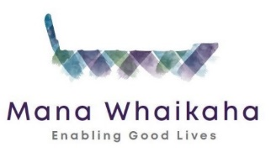
Mana Whaikaha will be for people who:
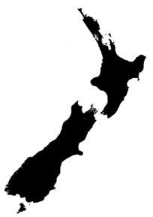
- live in MidCentral
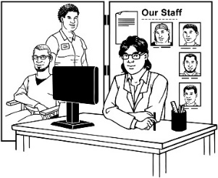
and
- use disability support services.

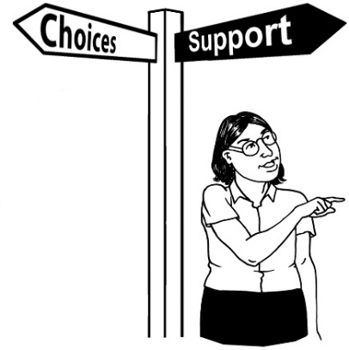
The new system will give people more:

- choices about their life

- control of their disability support.

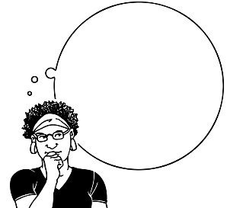
This will mean people thinking about:

- What a good life looks like for a person?
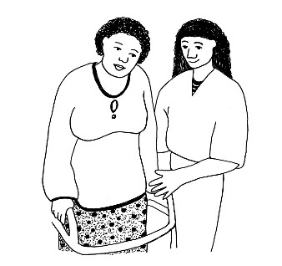

- What support is needed to get this good life?
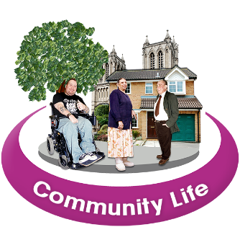

- What is in our community that could help us live a good life?

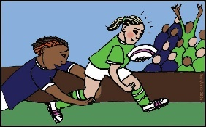
Our community includes groups like:
- sporting groups
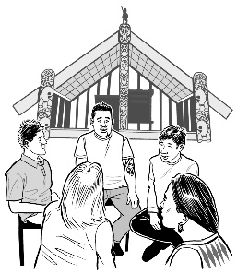
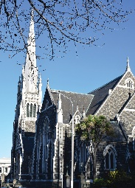
- cultural groups

- church groups.
- What support might need to come from government funding?

What will happen from Monday 1 October 2018?
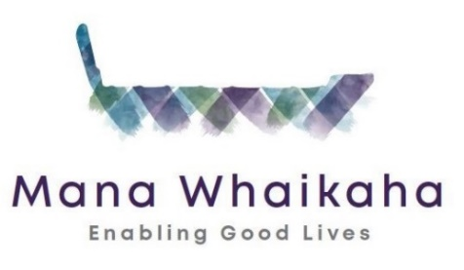

Mana Whaikaha will start on Monday 1 October 2018.

From Monday 1 October 2018:

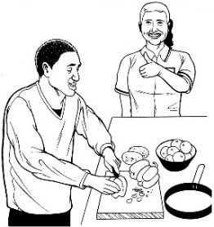
- People will keep getting the same support they are getting now.

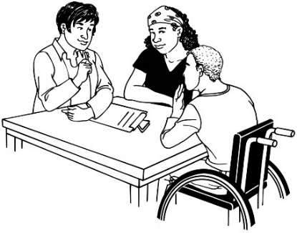
- People can ask to make changes to the disability support they are getting.

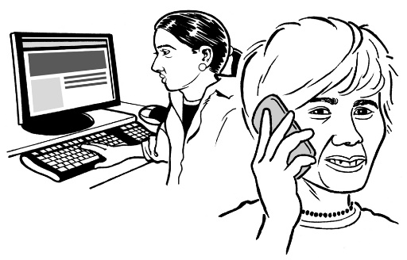
- A Kaitūhono/Connector from Mana Whaikaha will get in touch with people closer to their review time to organise a meeting.

At Mana Whaikaha there will be Kaitūhono/Connectors

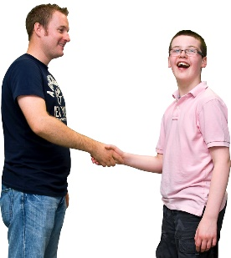
A Connector is someone who will work alongside:

- disabled people
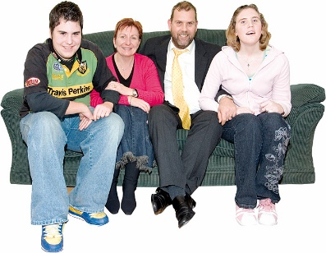

- family / whānau.

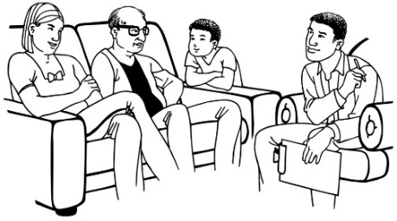
People will meet their Connector and they will be able to talk about:

- the support they are getting now

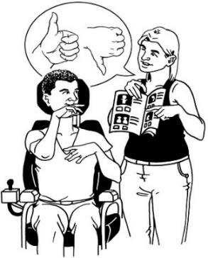
- how well these supports are working for them

- what changes they may need to their supports

- what might be possible for them in this new system.
How to contact Mana Whaikaha

From Monday 1 October 2018 people can contact Mana Whaikaha in the following ways:

- Website:

www.manawhaikaha.co.nz

- Email:

info@manawhaikaha.co.nz

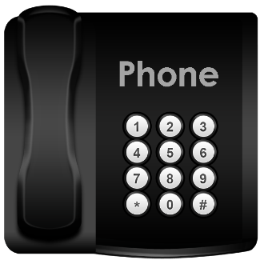
- Phone:

0800 626 255

0800 MANA 55
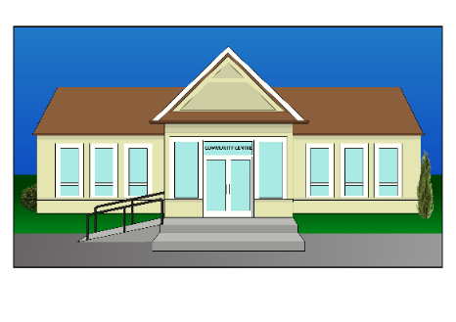
- Visit our Mana Whaikaha hubs

A hub is a place people can visit that:
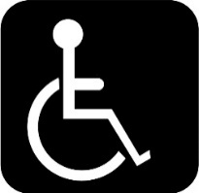
- is an accessible building in the local area

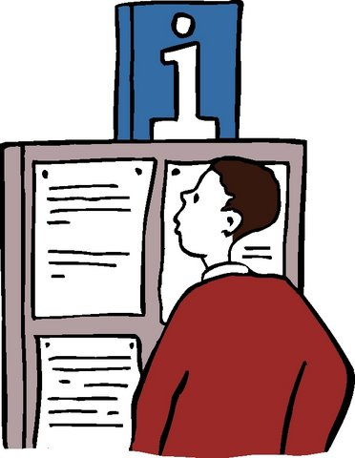
- may have other community groups working from the same building

- provides information and support.

At our hubs people can:

- get information about Mana Whaikaha

- meet a Connector
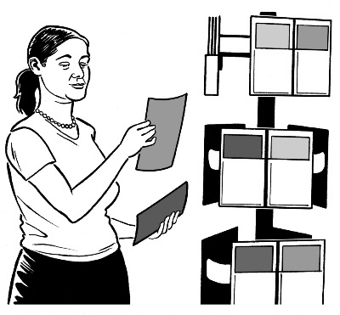
- get information about supports in their area

- organise their review meeting.
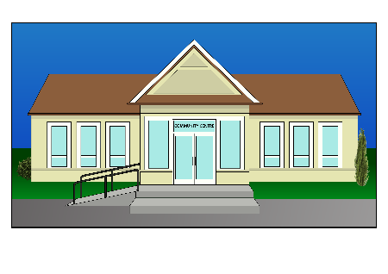
There are 4 Mana Whaikaha hubs that people can visit.

- Palmerston North hub

Hancock Community House

77 – 85 King Street
Palmerston North

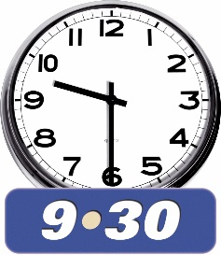
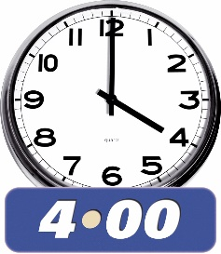
We will be there:

9.30 am to 4.00 pm
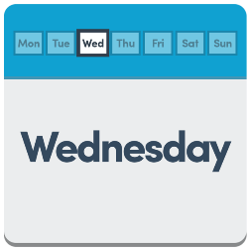
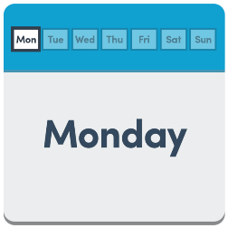
- Monday

- Wednesday
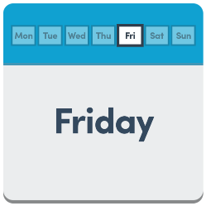
- Friday

We will start at this hub from Monday 8 October 2018.
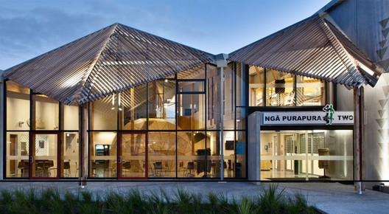
- Ōtaki hub

Te Wānanga o Raukawa Ngā Purapura building

144 Tasman Road
Ōtaki

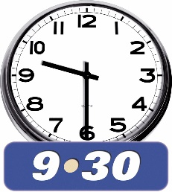
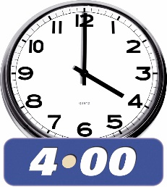
We will be there:

9.30 am to 4.00 pm

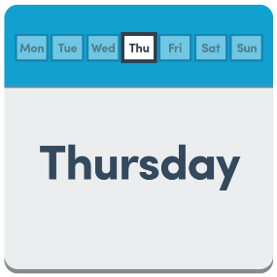
- .Thursday

It is a good idea to call us on
0800 626 255 before you visit to check these days and times are the same.

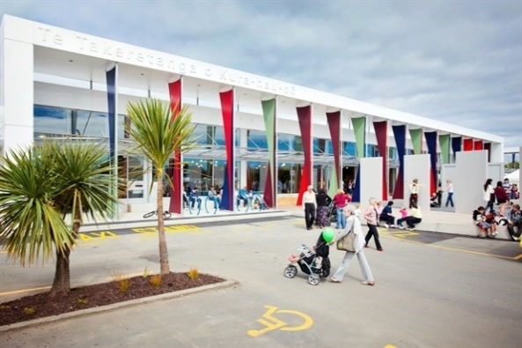
- Levin hub

Te Takeretanga o Kura-hau-pō

Levin Community Centre
Kowhai and Hebe Rooms

10 Bath Street
Levin

We will be there:

9.30 am to 4.00 pm

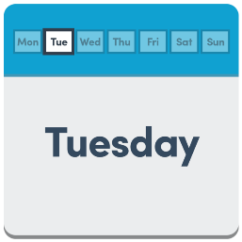
- Tuesday

- Wednesday

It is a good idea to call us on
0800 626 255 to check these days and times are the same.

- Woodville hub

Woodville Community Centre
62 Ross Street
Woodville

We will be there:

9.30 am to 4.00 pm

- Thursday

It is a good idea to call us on 0800 626 255 to check these days and times are the same.

Kaitūhono/Connectors working hours

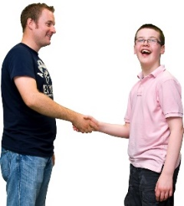
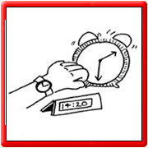
Our Kaitūhono/Connectorsare also able to meet with people at a time and day that works best for them.

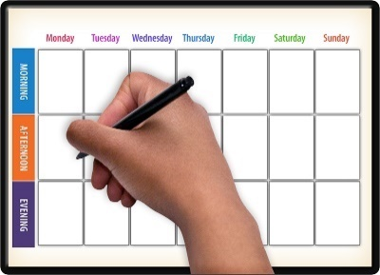
Connectors will work 37.5 hours each week.

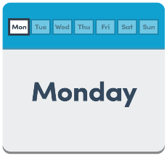
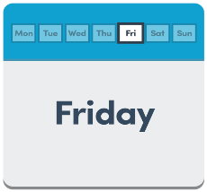
Connectors will be available between:

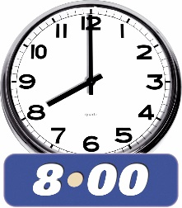
Monday to Friday
8:00 am to 8:00 pm

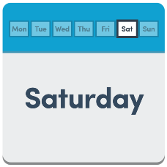

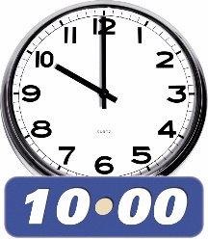
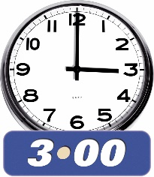
Saturday
10:00 am to 3.00 pm

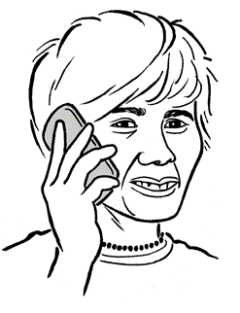
There is also an on-call Connector for emergencies only.

The emergency on-call mobile number is 027 236 6145.

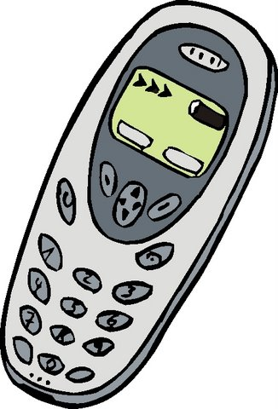
On-call means there is a Connector with a mobile phone who is able to take emergency calls outside the normal working days / times.

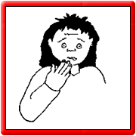
An emergency is when something happens that:
- has to be sorted out right away
and
- cannot wait until the next working day to be sorted out.

For example a person may need access to support straight away.
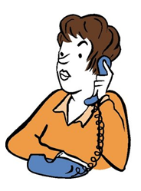
It is important to remember that you only call this mobile phone number in an emergency.

What other things are we working on?

- More information

We will keep making up to date information available to:

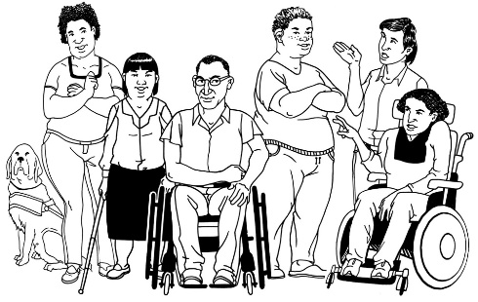
- disabled people

- family / whānau

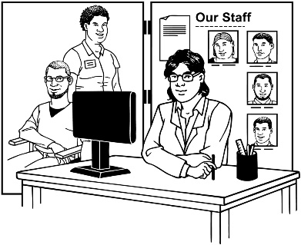
- service providers

- community groups.

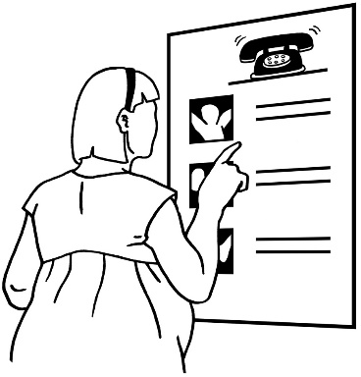
It is important to us that the information we give is accessible to everyone.

Accessible information means that everyone can get the information in the way that they can understand.

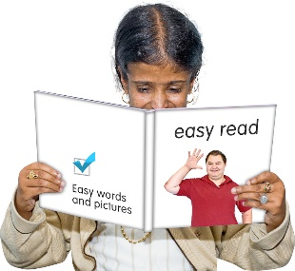
For example we want information to be available in:

- Easy Read
- New Zealand Sign Language videos
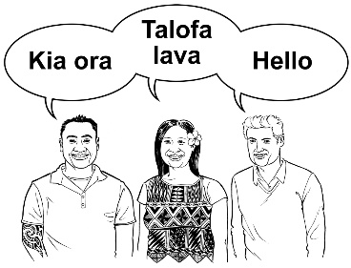
- other languages like
Te Reo Māori.

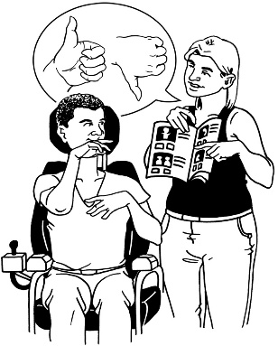
We also want to find out how people would like to get information.

This includes how people:
- want to get information

- what information will be useful.
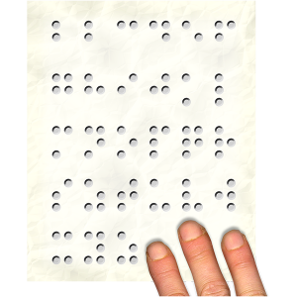

People can tell us what accessible information they think should be on our website:
www.manawhaikaha.co.nz
Email us at: info@manawhaikaha.co.nz
Or call:
0800 626 255
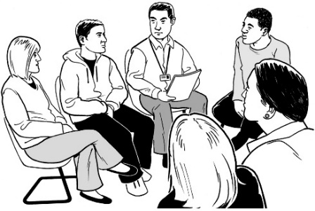
- MidCentral Governance Group

We have set up the MidCentral Governance Group.

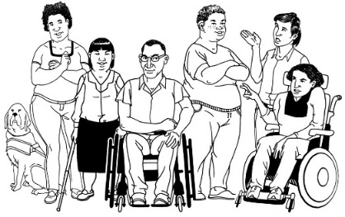
This MidCentral Governance Group is made up of:

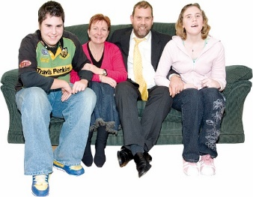
- disabled people

- family / whānau.

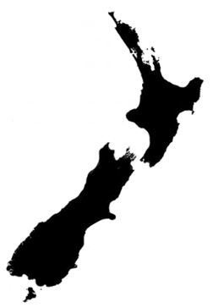
The people on the MidCentral Governance group all live in MidCentral.

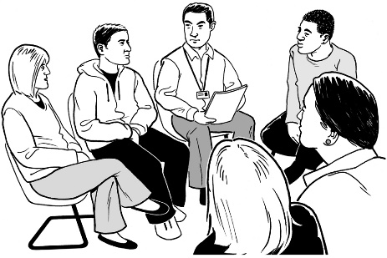
The people on the MidCentral Governance Group will:
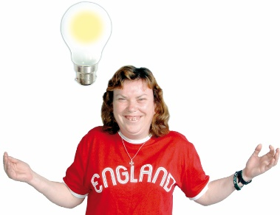
- make recommendations about the way disability support is working in MidCentral.

Recommendations are ideas about something that might make things better.
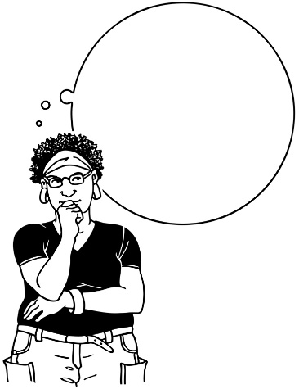
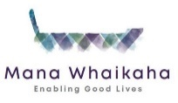

- share their thoughts about how Mana Whaikaha is going.

The people on the MidCentral Governance Group are:

- Peter Allen

- Martin Sullivan

- Rachel Kenny

- Zandra Vaccarino

- Rasela Fuauli

- Maxine Dale

- Peter Ireland

- Angela Hobden

- Heather Browning.
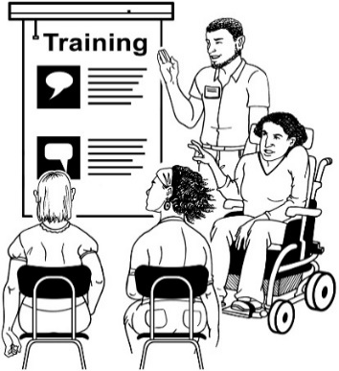

This group is about to start its governance training.

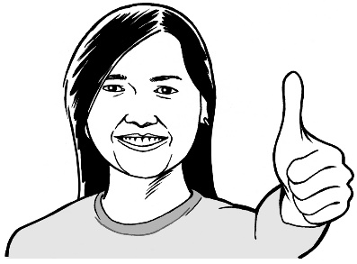
- Thank you

Thank you to everyone who has been involved so far.

From the 1st October you will be hearing more from:

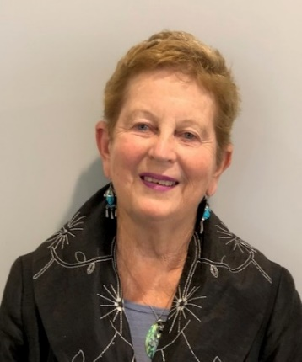

Lorna Sullivan
Director
Kaitūhono / Connectors team

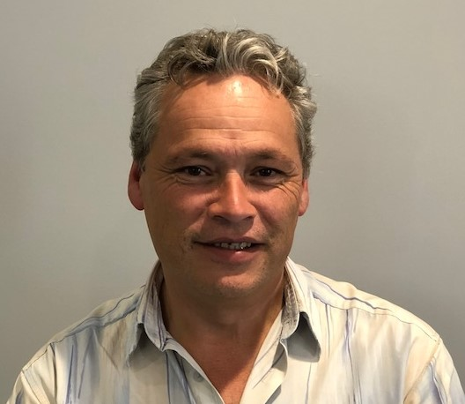

Marshall Te Tau
Director
Tari / System team.

