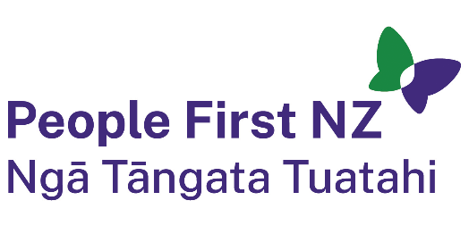
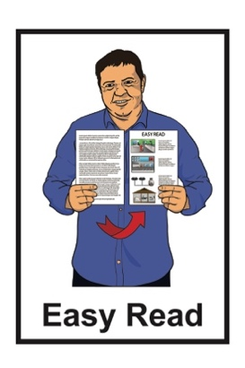

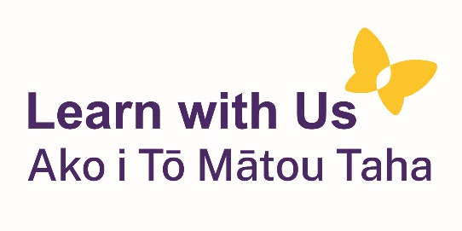

What does an

Enabling Good Lives

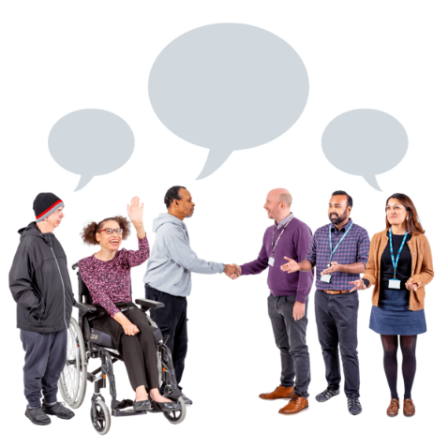
Kaitūhono / Connector do?

Published: August 2024

About this document

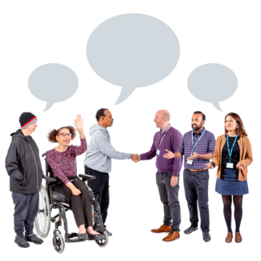
This Easy Read document is about the role of an Enabling Good Lives Kaitūhono / Connector.

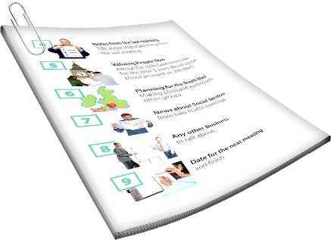
We will talk more about what the Kaitūhono / Connector does on pages 3 to 4 of this document.

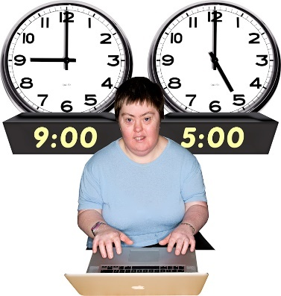
A role:
is another word for a job
says what kind of things someone does in a job.

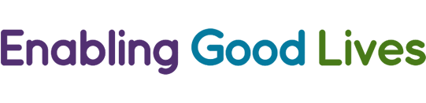
Enabling Good Lives is a different way of thinking about disability support.
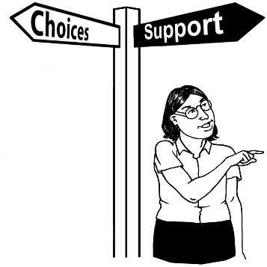

Enabling Good Lives is about having:
choice and control in your life
the support you need and want.
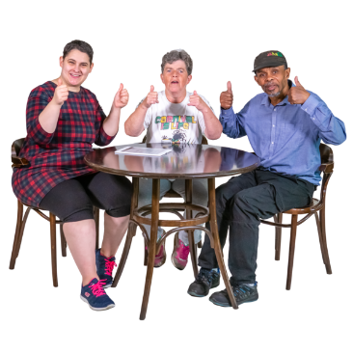

Enabling Good Lives is sometimes called EGL for short.

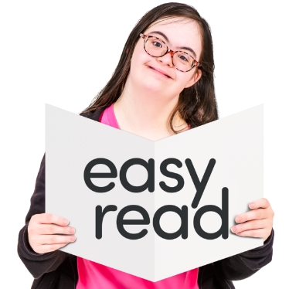
You can find out more about EGL in this Easy Read document:

https://tinyurl.com/2p8x3fz8

What does the Kaitūhono / Connector do?

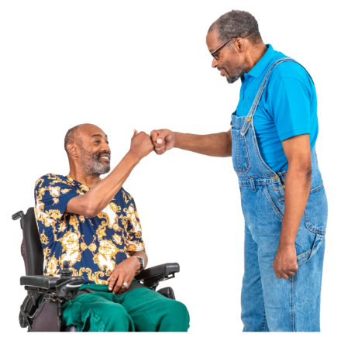
The Kaitūhono / Connector is someone who works with EGL to support the needs of disabled
people and their whānau.

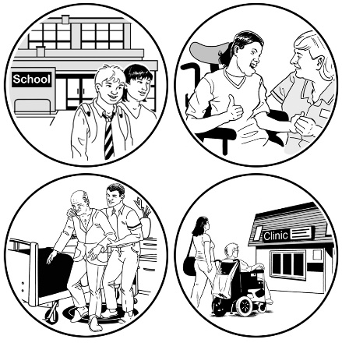
They do this by connecting people with:
support services
their community.

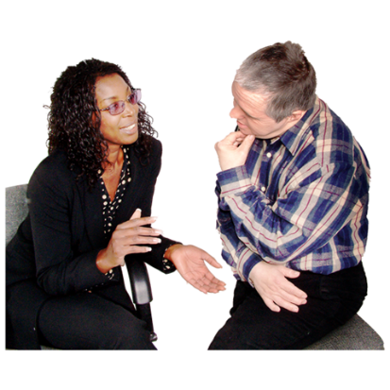
The Kaitūhono / Connector listens to disabled peopl and their whānau to find out what they:
want
need.

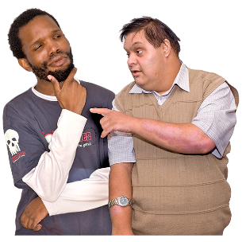

The Kaitūhono / Connector does not tell disabled people and their whānau what to do.

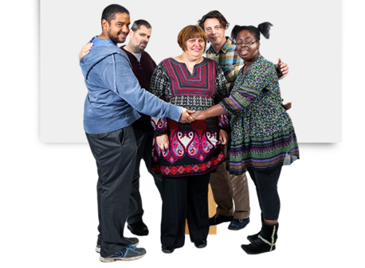
The Kaitūhono / Connector knows it is important that disabled people are part of a community that:
supports them
they feel supported by.

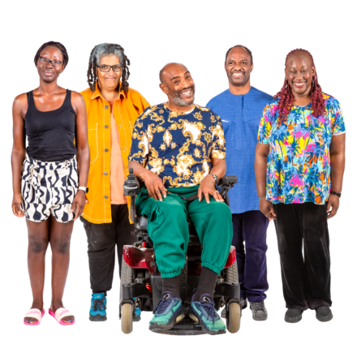
The Kaitūhono / Connector is well connected which means they know lots of different people / support services in the community.

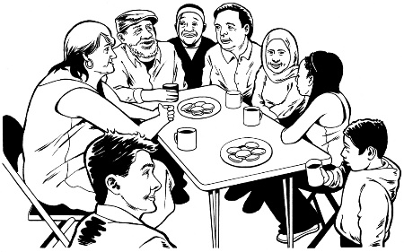
They use this knowledge to better support disabled people and their whānau.

What makes a good

Kaitūhono / Connector?


The Kaitūhono / Connector has a good relationship with the people they are supporting.

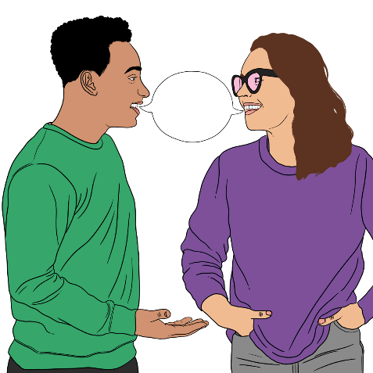
A good relationship is when people:
work well together
like / get on with each other
have the same kinds of ideas.

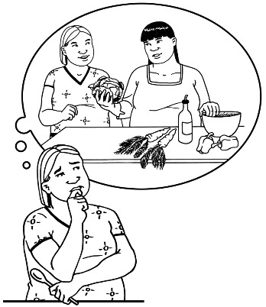
The Kaitūhono / Connector will not try to change your mind about the things you want / think.

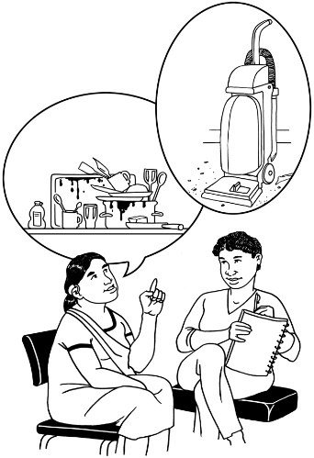
The Kaitūhono / Connector can support you to think about how you want to live a good life.

The Kaitūhono / Connector is an ally to the people they are supporting.
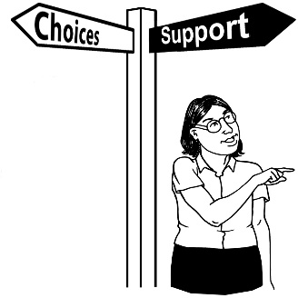

An ally is someone who gives other people:
support
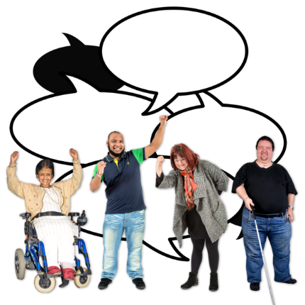
advice.

An ally is also a person who speaks up for others.

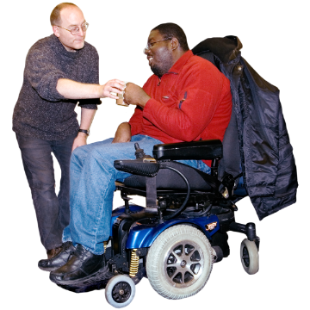
The Kaitūhono / connector always acts in a way that puts disabled people and their whānau first.


The Kaitūhono / Connector is someone you can trust.

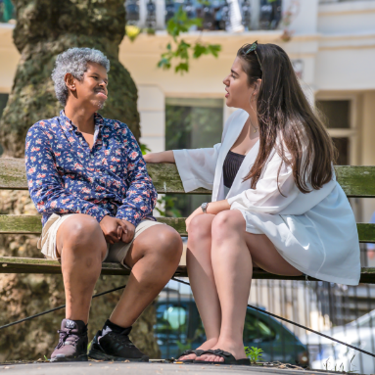
Trust means that someone is:
good / safe to talk to
will always act / do things in a way that supports you.

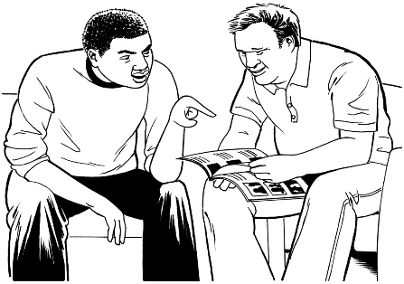
The Kaitūhono / Connector will also:
explain things in a way that makes sense to you
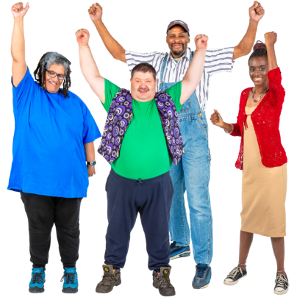
support you to think about all the choices you have
encourage you to make big plans for the future.

The future is a time that has not yet happened.
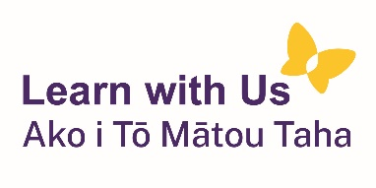
This information has been written by Learn with Us Ako i Tō Mātou Taha

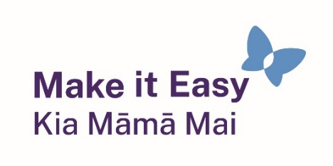
It has been translated into Easy Read by the Make it Easy Kia Māmā Mai service of People First New Zealand Ngā Tāngata Tuatahi.

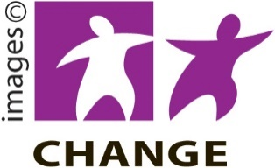
Make it Easy uses images from:


- Changepeople.org

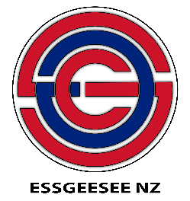
            - Photosymbols.com

- SGC Image Works

- Huriana Kopeke-Te Aho
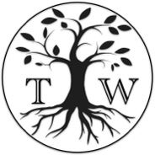
- T.Wood.

All images used in this Easy Read document are subject to copyright rules and cannot be used without permission.

