David Galbraith

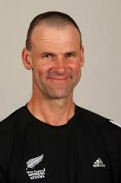 | He has worked with the New Zealand Olympic team, the Chiefs and the All Blacks Seven Squad.  Now you have the opportunity to hear from sports psychologist and author David Galbraith about his journey.
 | David will be speaking in the Pavilion at the Hamilton Gardens, Hungerford Crescent, Hamilton
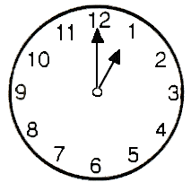 | On Friday, July 15  from 1:00 to 3:00pm
A sign language interpreter can be made available.

Please text or call Vaughan to RSVP on 029 201 2608

Let him know how we can make this event accessible for you.
 | This event is free and everyone is welcome.

