‘System Transformation co-design process’
Easy Read key points from the
11 April 2017 workshop:

What is this about?

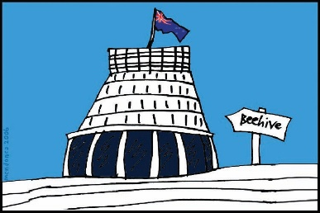
The Government of New Zealand is looking at making big changes to the disability support system.

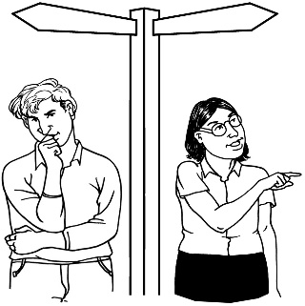
The long name for this is system transformation.

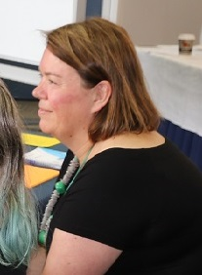
Sacha O’Dea from the Ministry of Health is leading this work.

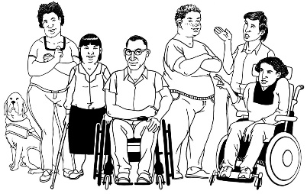
The Government has said it will plan the changes to the disability support system together with:
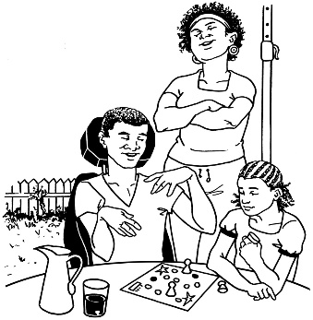
- disabled people

- family / whanau
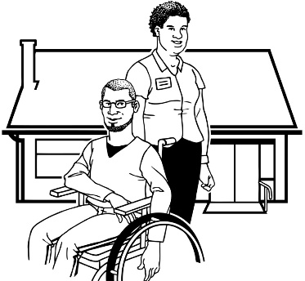
- disability support services.

Working together like this is called co-design.
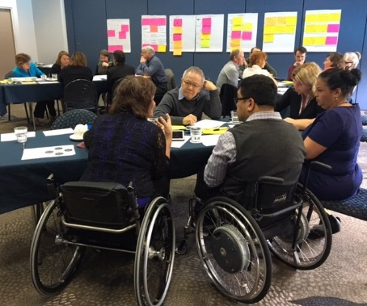

A co-design group has been put together.

The co-design group will work together over 9 workshops.
9

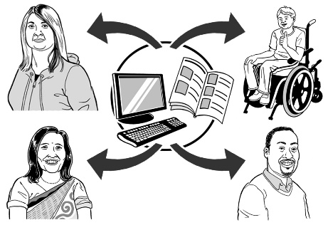
The key points of every workshop will be sent out so the rest of New Zealand can see what is being talked about.

11 April 2017
The first co-design workshop was on 11 April 2017.

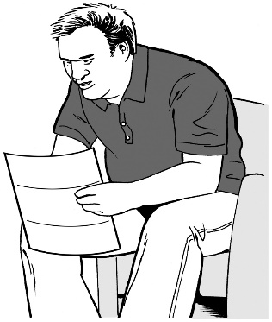
Keep reading to find the key points from that meeting.

Key point 1:
Who is on the co-design group?

There are 5 disabled people:
- Jade Farrar
5
- Shane McInroe

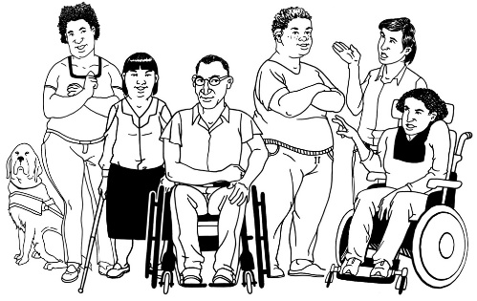
- Gerri Pomeroy

- Helena Tuteao

- Esther Woodbury

2

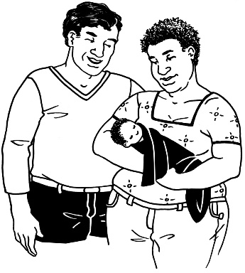
There are 2 people from family / whānau groups:
- Lawrence Chok

- Tina Lincoln
There are 2 people from Disability Service organisations:
2
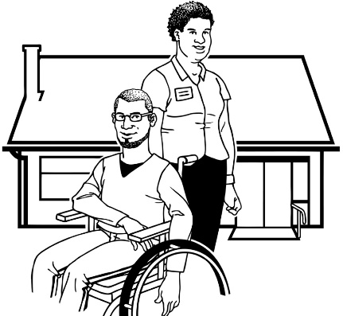
- David Matthews

- John Taylor

There are 4 people from the Government:
4
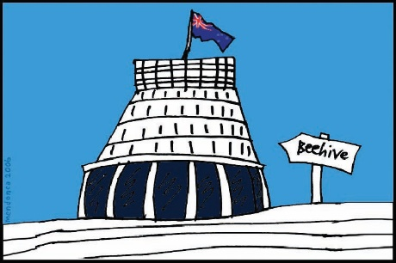
- Scott Ambridge

- Toni Atkinson

- Georgina Muir

- Sacha O’Dea

Key point 2: Working together
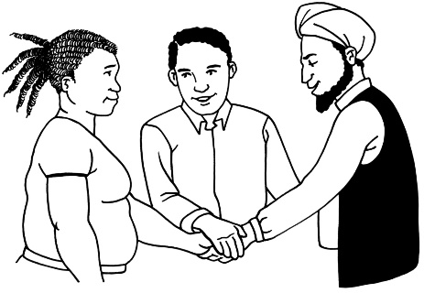
The co-design group talked about:

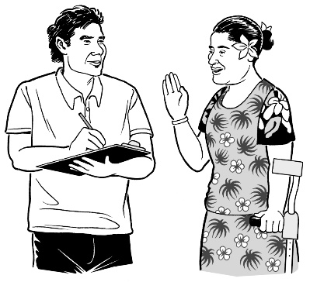
- how the people in the group will work together

- how to make sure everyone from the disability community has a say in the work
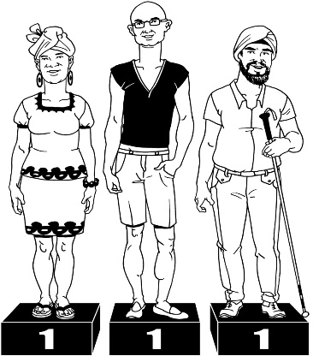
- how to make sure people feel they have the same rights to have a say in the work that is being done.

Key point 3: This is big

The co-design group talked about:

- how important it is to do a good job with this work
- how the rest of New Zealand is looking to see that a good job is being done

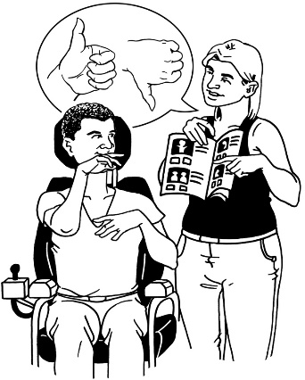
- what a good chance this is to make some changes that are really needed

- disabled people must have more choice and control in the new system.

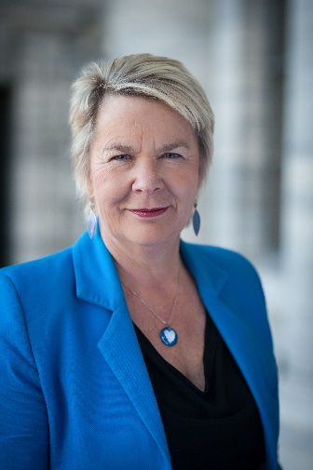
Key point 4: A message from the Minister for Disability Issues

Nicky Wagner is the Minister for Disability Issues.

She had a message for the co-design group.

The chance to change the disability support system is exciting and will be a big challenge.

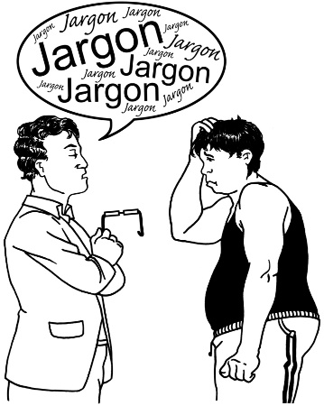
The new system needs to be easy to use.

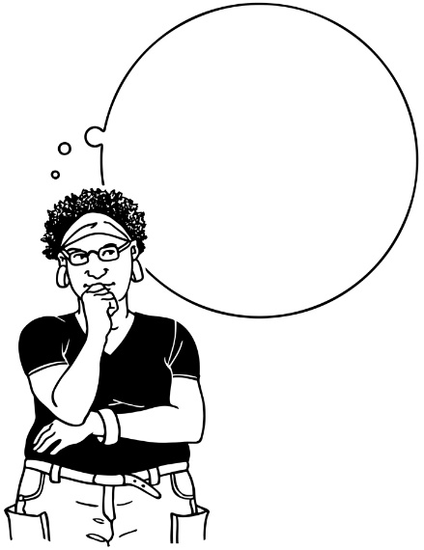
When looking at what changes to make we need to think about a few things:
$

- the Government is spending the money of New Zealand so they must be careful with it

- we need to make sure we put the money into the right places

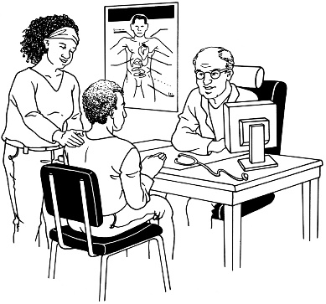
- the new disability support system needs to work easily with:

  - the health system
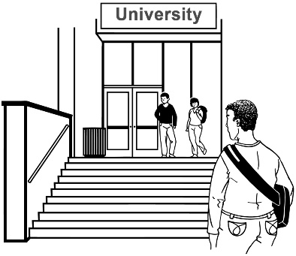
  - the education system

  - other systems that we have in New Zealand.

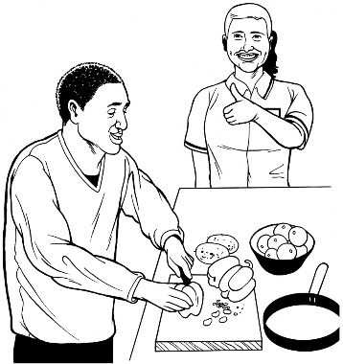
We will know we have done a good job making changes to the disability support system if:

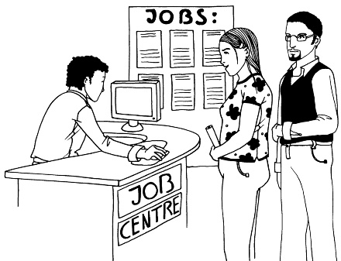
- disabled people have better lives

- disabled people have more chances to do the things they want to, like work and study.

What now?

The co-design group talked about Enabling Good Lives.

Enabling Good Lives is a way of giving disability support that has been tried in some parts of New Zealand.

The co-design group will talk more about this at the next workshop.

Talk to us
?

You can talk to us if you:
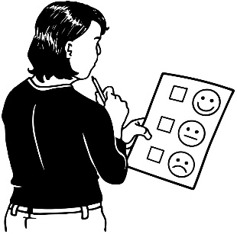
- have any questions

- want to tell us what you think about the work that is being done
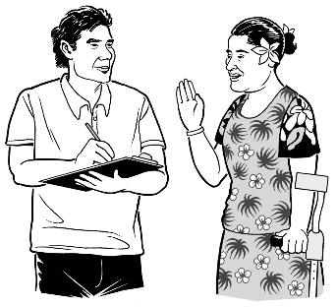
- want to tell us an idea.

Our email address is:
STfeedback@moh.govt.nz

Thank you,
Sacha O’Dea

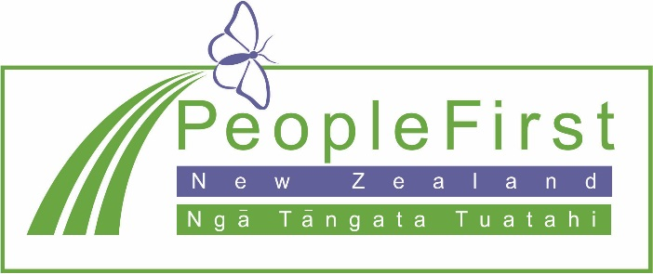

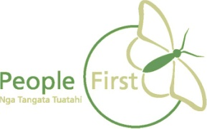
This information has been translated into Easy Read
by People First New Zealand Inc. Ngā Tāngata Tuatahi
